The
Mixed Martial Arts
Primer

”A starting point for those
interested in training to fight...”

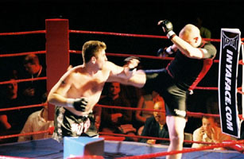

By
Jakob
“the Striking Viking”
Løvstad
Intention of this document

There are lots and lots of technique manuals for martial arts out there today and many of them address the sport of Mixed Martial Arts (MMA) or some aspect of it. There are, however, very few books on the subject of how to get started, what to train and how. Most books show a lot of pictures and explain well how to perform armbars, leglocks, kimuras and so on.
The intention of this book is to answer some of the questions that beginners in MMA have and structure to some extent how to get into fighting this way. I’ll try to put into system what you need to know to get ready for your first fight and explain from a more academic point of view what it’s all about.
I’ll talk about the different martial arts you should look at to get good training, which techniques are the most popular and what basic skills you should posess. After that, it’s up to you to get the job done in the cage or ring…

Note that you may distribute this document freely as long as you don’t try to make any money out of it or change the contents!
The author

My name is Jakob Sverre Løvstad and I’m from Oslo, Norway. I currently study to get my Master of Science degree in Computer Science at Norway’s best technical University: NTNU. I have about one and a half years left of a five year study (at the time of writing this document).
In addition to being a full time student, I’m also a professional fighter in the great sport of Mixed Martial Arts. I train about 10-12 sessions every week. My arts of choice are: Brazilian Jiu-Jitsu, Wrestling (mainly Greco-Roman), Kickboxing (with lowkicks) and Boxing. I train about two sessions of each art every week (not doing Kickboxing and Boxing the same week) as well as endurance and strength work. My record this far is 2-1 in Pro MMA and 1-0 in Amateur MMA.
In short, it is entirely possible to train and compete in MMA and still manage a job, study at the University or go to school ☺
A big thanks to all my instructors, coaches, family and girlfriend for helping me out and supporting me!
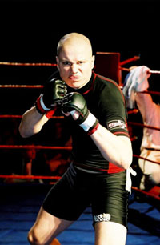

Jakob “the Striking Viking” Løvstad
(after Reality Fighting in Worcester, MA)

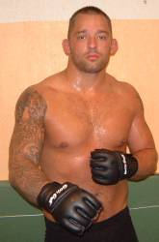 | 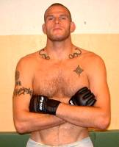 | 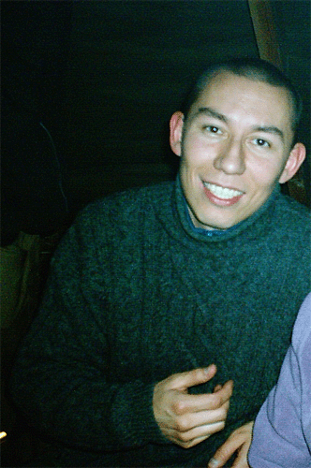 | 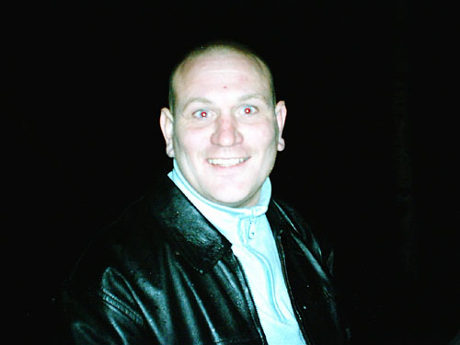
My Brazilian Jiu-Jitsu/MMA instructors Richard Bohlenius (left) and John Olav Einemo (right). |  | My Kickboxing/Boxing instructors Paul Dromnes (left) and Arnstein (right)
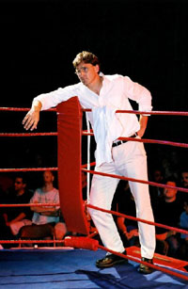
My coach Kirik – the best motivator I know!

Table of Contents

1 What arts to train
The first problem you’ll encounter is to decide where to start training. To compete in MMA, you’ll need a variety of skills, so the question is: where can you acquire them? Finding the schools you want to train at is often a big challenge for most fighters (which is proven by some fighters constantly changing schools).

What to take into consideration
To understand what you should train, let’s look at an illustration of the ranges you need to learn in illustration 1.1.

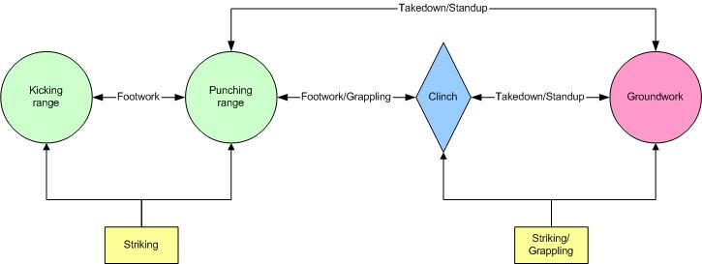
Illustraion 1.1 – Ranges where fighting takes place

The first range at the very left is the kicking range. This is the range where you’re just close enough to attack with your longest weapons, your legs, but not with any other part of your body. The most typical attack at this range is the lowkick.
The next range is the punching range. This is the range where you’re close enough to touch your opponent with the knuckles on your hand when you stretch your arm. You can still kick and may even knee at this range, but I call this the punching range since the most typical attack here are the straight punches, like the jab.
The next range is the clinch. This is where you’re so close to the opponent that you can launch all your striking attacks (headbutts, elbows, punches, knees and kicks) as well as grab your opponent to apply holds or take him down. Sometimes the clinch just doesn’t happen. As shown in illustration 1.1, you may take your opponent to the ground straight from the punching range. You still need to learn the clinch, however as it is very common and not knowing it can get you in a lot of trouble.
The last range shown is groundwork. When you and your opponent hit the ground as a result of a takedown or just happen to fall down, you start doing groundwork. Almost every fight in MMA end up on the ground sooner or later. The point here is to get a good position where you control your opponent and can make him give up by applying locks and chokes or striking him.
So there are many things you must know to become an MMA fighter. There are some schools out there that teach all the concepts (special MMA schools exist), but usually you have to train several places to get all the knowledge you need. We’ll discuss this in the next section.

Most common arts for fighters and combinations
As mentioned, you can either go to a special MMA school or practice several arts simultaneously. There are many MMA schools out there and I don’t intend to list them here. You may have heard of the Lion’s Den, the Shark Tank, Massachussets Submissions Academy, Finnfighter’s Gym and such. If you have one of these close to you, check it out! If not, I’ll now go into a short description of the different arts that are common to train in MMA (chapter 1.2.1) and then discuss some common combinations of these (chapter 1.2.2).

Common arts
I’ve put up a table, table 1.1, to give a short description of the common arts trained by the MMA fighter. It’s very general and the descriptions short, but if you need more in-depth explanations of the arts, there are many books out there you can buy that will give you what you need. This document is, as said initially, not meant to teach you or discuss any art in particular.
I classify arts as either Striking, meaning they mainly teach how to attack your opponent with ballistic weapons like punches, elbows, knees and kicks, or I classify them as Grappling, meaning they favour grabbing hold of the opponent and using body mechanics to take down, lock, choke or pin the opponent

Name | Type | Picture | Description
Brazilian Jiu-Jitsu | Grappling (groundwork) | 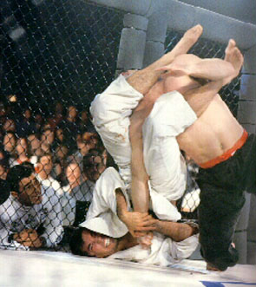 | Brazilian Jiu-Jitsu (BJJ) is one of the world’s most famous arts used in MMA. It consists mainly of groundwork with some takedowns as well. The focus is on proper positioning on the ground as well as locks and chokes. In BJJ, you usually train both with and without the Gi/Kimono.
Judo | Grappling (takedowns/  groundwork) | 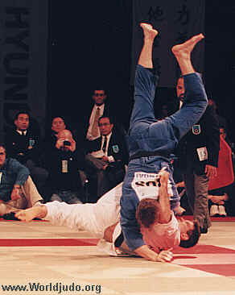 | Judo consists of a lot of takedowns and groundwork, but almost all schools train purely with the Gi. Most schools also favour takedowns over groundwork since most of today’s matches are won by throws and little time is allotted groundwork in tournaments. Most groundfighting wins are done through pins rather than locks and chokes and most submissions taught are attacks on the upper body rather than the legs.  Judo is also an Olympic sport.
Wrestling | Grappling (takedowns) | 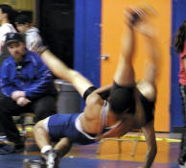 | The basic goal of wrestling is getting the other guy on his back. And nobody does that better than wrestlers. There are mainly four kinds of wrestling: Folkstyle, Freestyle, Greco-Roman and Sumo. All except Sumo are common in MMA. Freestyle and Greco-Roman are in the Olympics.  Wrestling also has some groundwork, but this is mostly positions, not locks and chokes.
Sambo | Grappling (takedowns/ groundwork) | 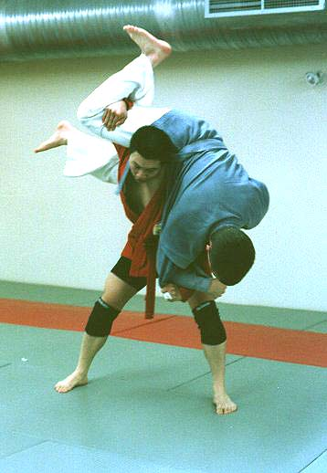 | Sambo is a Russion grappling art. In Sambo they wear a type of Gi jacket, but shorts instead of Gi pants. It contains upper body takedowns similar to Judo, lower body takedowns similar to Freestyle wrestling and heaps of leglocks and chokes. While Judo often goes for pins and upper body submissions, they often go for leglocks in Sambo and most acknowledge practitioners of this sport as proficient in this area.  There is also a non-sport aspect of Sambo that the Russion military forces use. This part involves more strikes, weapon use and such and is more often referred to as Sombo.
Boxing | Striking (punches) | 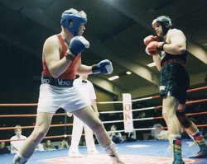 | No matter what anyone tells you, nobody punches better than boxers. After all, it’s all boxers do basically. Boxing is about hitting somebody without getting hit yourself.
Muay Thai (also known as Thai boxing) | Striking (punches, elbows, knees, kicks) | 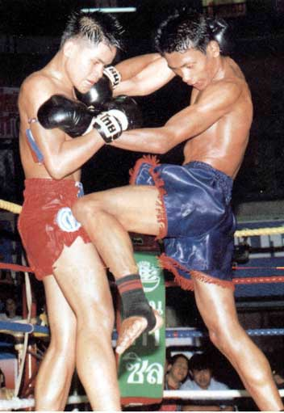 | Muay Thai is probably the most popular striking art for MMA because it teaches you to strike with all parts of the body except the head. Training Muay Thai is very stressful for the body and the techniques are very effective and forceful.  Muay Thai also includes some throws, but grappling is no big part of the art.
Kickboxing | Striking (punches, kicks, sometimes knees) | 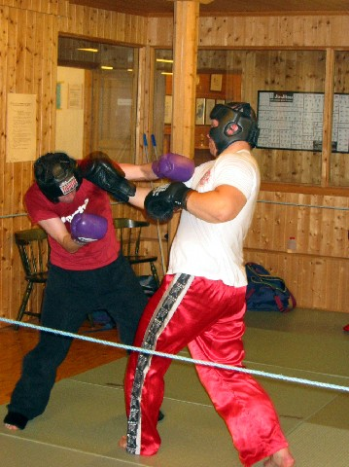 | Kickboxing is basically boxing with kicks. There are several types of kickboxing – some include knees and lowkicks, others only kick above the waist and have no knees. Usually, kickboxing does more pure boxing than Muay Thai and have faster, but less forceful kicks.  Especially the kickboxing with no knees and lowkicks tend to use lots of boxing with a few kicks in between.  You can also sweep and throw in most styles of kickboxing, but this is no big part of the art.
Table 1.1

Possible combinations
Now that we’ve had a quick look at some of the arts, let’s go on to check out some possible combinations. These are just some popular ways to crosstrain – if you find another combination that works for you, that’s great. Maybe you’ll be the one to set the standard in a few years… Table 1.2 through 1.x shows information on the different combinations.

Combination | Description | Fighters in this category | Advice
BJJ  Muay Thai or  Kickboxing | This is a very common and popular way to crosstrain. You get powerful standup fighting skills and if you end up on the ground, you also know what to do. Usually this combination is used by either Muay Thai fighters who need skills to survive on the ground or BJJ players who need to learn standup fighting. | - Vanderlei “the Axe Murderer” Silva  - Murilo “Ninja” Rua | If you choose this combination, though, you should look into learning some takedowns and takedown defence to compliment the rest of your training, so you don’t end up in unwanted situations.
Strategy | Pros | Cons | Example pictures
Usually these fighters either try to take their opponents out with strikes standing and use their groundgame to survive if they get taken down or use their striking skills to survive until they can take their opponent down and finish them on the ground. | ☺ Varied and solid striking  ☺ Good groundwork  ☺ Exciting to watch | ☹ Weak takedowns  ☹ Weak takedown defence  ☹ Hard to defend against those who are interested in just laying on you (so called Lay & Pray) | 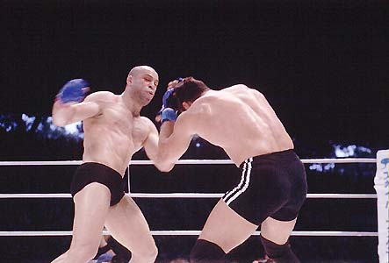  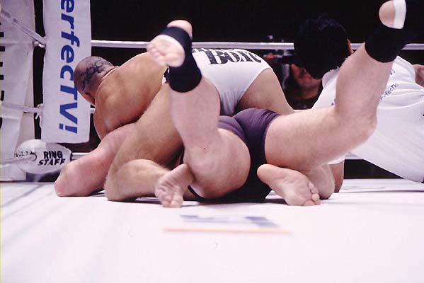
Table 1.2

Combination | Description | Fighters in this category | Advice
Wrestling (usually freestyle)  Boxing | This is a very quick route to becoming a dangerous opponent. By learning how to put people on their back and also how to hit them effectively, you can control the fight well and often ruin the opponent’s gameplan. | - Randy “The Natural” Couture  - Dan Henderson | Learn some basic submissions and submission defence as well as how to survive and escape if you end up on the bottom with your opponent on top of you.  Also learn to defend kicks by blocking, catching them or shooting in when the opponent kicks you.
Strategy | Pros | Cons | Example pictures
These fighters will want to either outbox their opponents standing up from punching and clinching range or take them down to pin them and then strike them into submission (called Ground & Pound among fighters). | ☺ Great takedowns  ☺ Great takedown defence  ☺ Good punching  ☺ Good control of the fight | ☹ May be less exciting to watch  ☹ Danger of being punished by kicks  ☹ Poor submissions  ☹ Poor submission defence | 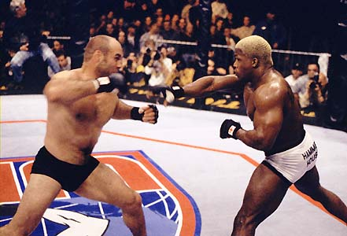  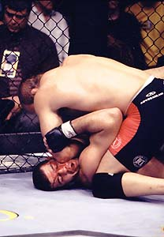
Table 1.3

Combination | Description | Fighters in this category | Advice
BJJ  Wrestling (usually freestyle)  Boxing or  Muay Thai or  Kickboxing | This is the way most of the top guys in the world train. By training all the aspects, it’s easier to control the match and bring it where you want it. | - Murilo Bustamente  - Mario “the Zen Machine” Sperry  - Vitor Belfort | For some reason, Boxing is more favoured in this combination than Muay Thai and Kickboxing, so learning about kicking and defending kicks is smart.  Since your time will be more split between several arts, you may have less in-depth knowledge about each aspect. This may work against you in the future when opponents you fight are better, so you may think about spending more time on one art in periods, so you can concentrate on certain aspects of the game.  It’s also possible to get confused when doing several arts like this. You may learn certain clinch techniques in Boxing/Muay Thai and others in Wrestling. Be sure to spend time on integrating your techniques so you don’t hesitate in the ring or cage.
Strategy | Pros | Cons | Example pictures
Since these fighters are well versed in most aspects of MMA, they’re generally ok wherever the fight goes.  However, they may lack some depth in some aspects of the game, so the best thing to do is to bring the fight where the opponent is least experienced. If you fight a striker, work him to the ground and finish him there. If you fight a grappler, stay up and strike him. | ☺ Good takedowns  ☺ Good takedown defence  ☺ Good punching  ☺ Good control of the fight  ☺ Versatility  ☺ Can surprise the opponent  ☺ Decent submissions | ☹ Lack of in-depth knowledge in the different aspects because training is more spread out  ☹ Can be confused from learning too many different ways of dealing with a situation  ☹ May lose if forced to fight an expert in one range (such as ending up fighting guard with a BJJ expert) | 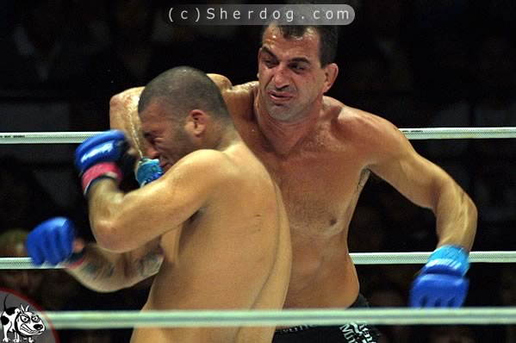  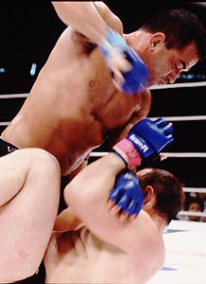
Table 1.4

Combination | Description | Fighters in this category | Advice
Sambo or  Judo  Boxing or  Kickboxing | Eastern block fighters often have these arts as their base since they are easily accessible. You get the striking from Boxing and Kickboxing and the takedowns and locks from Sambo. | - Andrei Semenov  - Sergei Bytchkov | It depends a little on which arts you combine. If Judo is your grappling art, then more leglocks and lower body takedowns may be needed. If you do Sambo, then some more guardwork and upper body submissions may be needed.  The same thing goes for Boxing – you may need some more kicks and defence against kicks if you choose Boxing.  Since both Sambo and Judo are done with Gi jackets, it is important to also do training without the Gi to get used to the situation in an MMA match.
Strategy | Pros | Cons | Example pictures
With these arts you are pretty much a complete fighter. One may stay up and trade punches or use takedowns to go for submissions on the ground. As the strategy in table 1.4, you have to take the fight where the opponent least wants to be. | ☺ Rich number of techniques  ☺ Decent takedowns, especially throws  ☺ Decent takedown defense  ☺ Good striking | ☹ Weak guardwork  ☹ Working with the Gi may give bad habits when forced to fight in fight shorts  ☹ Either somewhat weak upper body (Sambo) or lower body (Judo) submissions
Table 1.5

Summary of the Common arts in MMA
The arts presented here are the most common in MMA. Some top fighters also train various hybrids of the different arts, for example submission wrestling instead of BJJ. The description of the arts would be hundreds of pages long if I were to include all varieties of all the popular arts. The different arts themselves also have many substyles.
If you’re worried about spending all your money on training, take a look at table 1.6. I’ve categorized the different arts by how much they generally cost.

Cheap | Normal | Expensive
Wrestling  Boxing  Judo | Muay Thai  Sambo | Brazilian Jiu-Jitsu  Kickboxing
Table 1.6

So if you’re on a tight budget, you may want to combine the three arts in the first column. If you’re a big spender, the column on the right may be your thing. As long as you get striking, takedowns and submissions into your program, you should generally be happy about it – as long as the schools teaching these concepts are good and give you plenty of conditioning, technique and sparring!

Less common arts for MMA and combinations
A lot of places don’t have the assortment of martial arts mentioned in chapter 1.2. Therefore you might want to try some other options to attain what you need in the technique and sparring department. Most places do have some martial arts schools. If you know where to look and what to look for, you may get decent training even if you don’t have Team Punishment training around the corner. This chapter presents some less common arts to train for MMA that can get you ready to fight.

Less common arts
In table 1.7, I present briefly some arts that are less common in MMA, but can be good for fighting. Like chapter 1.2.1, I cover these very superficially. There are enough books with details on each art.

Name | Type | Picture | Description
Savate | Striking (punches, kicks) | 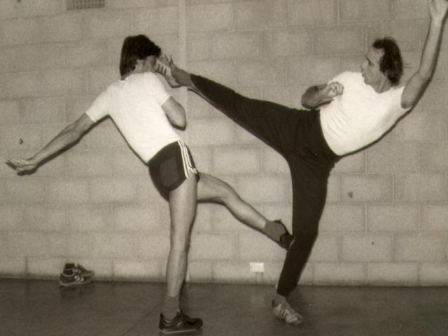 | This is French kickboxing. It has classic boxing mixed with kicks to all parts of the body. The art has more flashy kicks than kickboxing and Muay Thai and is often known for stomps and sidekicks rather than roundkicks.  Savate also has a good assortment of takedowns and in its original form even some groundwork and weapon use (since it’s a gentleman’s art, they teach the cane, or “La Canne”, at some schools).
Kyukushin Karate | Striking (punches, kicks, elbows, knees) | 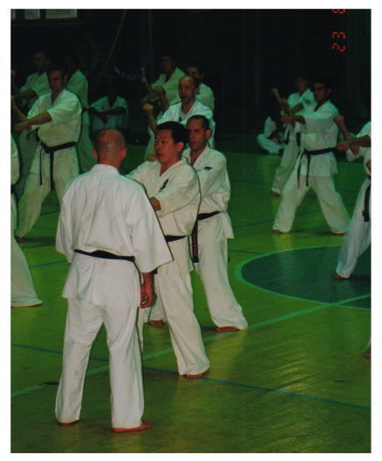 | This is full contact Karate. Kyukushin Karate is very hard physically and includes punches, kicks, knees and elbows, although little clinch techniques. Since you’re not allowed to grab your opponent except for throwing him, all strikes start at distance.  It’s also illegal in sparring to punch the head.  Many great fighters like Bas Rutten and Semmy Schilt have trained Kyukushin Karate.
Jeet Kune Do | Striking and Grappling | 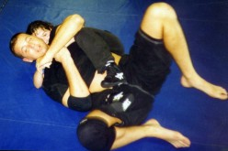 | Jeet Kune Do (JKD) is the art invented by Bruce Lee. Some schools are very MMA oriented and teach proper strikes, clinch, takedowns and groundwork while others have little knowledge in fighting.  Straight Blast Gym is a good example of a school that teaches the more effective kind of JKD, known as Funtional JKD.
Turk Oil Wrestling | Grappling | 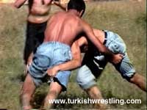 | A very odd kind of wrestling practiced in Turkey. It has much of the takedowns also seen in Freestyle and Greco-Roman wrestling, but the wrestlers are oiled up and wear only clothes on the lower body.  It’s probably unlikely that you have a school of this kind near you unless you live in Turkey.
Japanese Ju Jutsu | Striking and  Grappling | 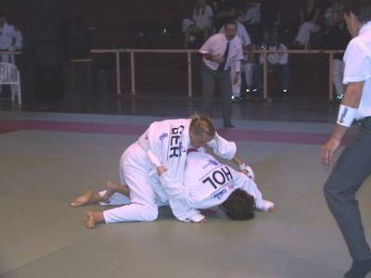 | Japanese Ju Jutsu (JJJ) is not to be confused with BJJ. It teaches strikes, takedowns and groundwork, but is usually a lot less fighting oriented and mostly does semi contact sparring.  You may get some of the basics of standup and groundwork there, however as they teach many of the positions, holds and locks from Judo as well as some strikes similar to semi-contact Karate.  There are also some teachers out there that focus more on full contact and proper grappling, so maybe you’re lucky and stumble upon one of these.

1.3.2 Possible combinations
As with the most common arts, you should try to combine some sort of grappling with some sort of striking. It’s hard for me to say exactly what combinations are best and how they work, so I’m not going to do a list like the one on common arts. The reason it’s so hard to say what will work is that traditional schools of martial arts vary incredibly in skill level with fighting in mind. I’ve met practitioners from these arts that kick ass and others that I beat up half asleep. As a rule, don’t train there unless they practice full contact sparring of some sort. Sorry about not listing a bunch of combinations, but I jumped into my current combination at first chance and didn’t really try to stick to the more uncommon combinations (with the logic that if it wasn’t common, it was probably for a reason).

2 Basic techniques
As mentioned before, this is by no means a technique manual. But I feel I have to go through the techniques you have to know to have a fair chance at surviving in the ring/cage. I’ll just quickly show and describe these – get a proper manual or seek out instruction for the details of them!

2.1 Strikes
Basically, you can hit someone with either your fist, elbow, forehead, knee or shin. Some also use shoulders like in Dirty Boxing ™ or even their cup (from north-south position and such). I’ll go through the basics the way I usually do with my own students…

2.1.1 Punching
There are really only three punches (ok, there are a few more, but let’s stick to the high percentage moves): straight punch, hook and uppercut. Since most of us have two arms, we have six ways of attacking with punches. This is plenty and enough to think about for most beginners. Concentrate on becoming a master of combinations with these six attacks instead of learning lots of fancy crap that’ll fail you when you’re in the ring shivering from nerves. Pictures 2.1 to 2.3 show the different punches.

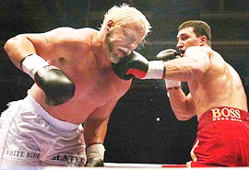
Picture 2.1 – A straight left

2.1.2 Elbows
Like with punches, there are really only three ways to throw an elbow, six attacks in total. These are: sideways elbow (like a hook, but tuck your hand, so the elbow hits), uppercut elbow (same as uppercut, but tuck the hand) and downwards elbow (thrown either with the tip or the bottom of the elbow, depending on your preference). Elbows in MMA are mostly used on the ground, but it’s possible to use them at close range standing up as well.
To be honest, elbows don’t seem like a priority to most fighters, but you should know them and how to block them as they can open up huge cuts from the clinch and on the ground. They don’t KO people very often, but many fighters have lost due to the ringdoctor stepping in and stopping the fight because of cuts. Picture 2.6 shows an elbow on the ground.
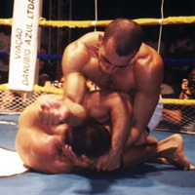
Picture 2.6 – Throwing elbows on the ground

2.1.3 Kicks
Kicks are theoretically very simple, but hard to do well in practice. Basically, there are only two kicks… Yes, two: roundhouse kick and front kick. The thaiboxing style roundhouse kick can be used against the legs, body or head of your opponent, but the way I teach this kick, it’s the same no matter what you aim to hit. This makes it easier to learn and more effective in a fight. Remember to step out with the foot you’re not kicking with, relax the kicking leg and use your hip to generate force. Picture 2.7 to 2.9 show some nice roundhouse kicks.
The front kick is done by lifting your leg up in front of you (put your knee up to your chest) and then shoving it forwards to hit with either the balls of your toe or the heel. This kick is used mostly to push the opponent away or get him to lower the guard to open up for other techniques. A hard front kick to the head or sternum can finish an opponent if you hit well, but it’s not very common. Picture 2.10 shows a front kick.

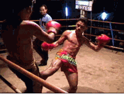  Picture 2.7 – A lowkick | 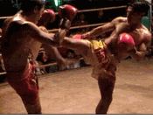  Picture 2.8 – A kick to the body | 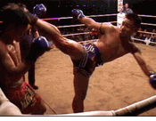  Picture 2.9 – A high kick
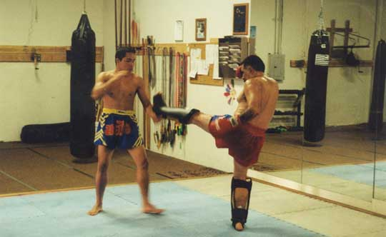
Picture 2.10 – A front kick

2.1.4 Knees
For the beginner, learning the straight knee should be enough. This is like the front kick, only you don’t extend your foot, so your knee is pushed into your opponent by using your hip to generate force. This technique can be done from jab range, in the clinch or on the ground (especially from sidemount and north-south position). You can go for the legs, body or head. All in all, it’s a very useful and versatile weapon for those who master it. Check out picture 2.11 for a knee in action.
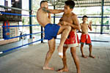
Picture 2.11 – Throwing a knee at the body

2.1.5 Headbutts
Headbutts are great for giving your opponent nasty cuts and bruises at point blank range. When headbutts are legal in competition, even lying in guard is suddenly dangerous. The goal of the headbutt is to put a hard part of your head into a soft part of your opponent’s head. Use either the top your head, the forehead or the sides of your head to strike your opponent’s nose, mouth, temples and eyes. Some people use headbutts to attack other parts of their opponent’s body than the head – don’t! (unless head/brain injury is popular in your part of the world)

2.2 Takedowns and stopping takedowns
Being good at takedowns means you control the fight. If you can decide whether you want the fight to be on the ground or standing up, you can manipulate your opponent to play a game he doesn’t want to be any part of.

2.2.1 Shoots/lower body takedowns
This is the standard way to get someone to the floor at a distance (usually punching range). There are only three types of lower body takedowns (commonly known as shoots): double-leg, single-leg and high-crotch. So you either take the opponent by grabbing one leg, both legs or you go in between for the crotch. Learning one of each and practicing them well should be enough for starters! Don’t complicate things too much. Learn the simplest takedown you can find from each category and practice them until you do them in your sleep.

2.2.2 Upper body takedowns
There are infinitely many takedowns on the upper body. Usually it’s either a hip throw of some kind, a trip, a souplesse, or a headlock kind of throw. The best thing to do is really learn a few basic and super-easy principles like the underhooks, basic grips and so on and then just wrestle a lot in the clinch with different people. Learn to step away from attempted takedowns, keep your balance and find out how to leverage the opponent to the ground. Remember that the clinch will also involve a lot of knees and punches, maybe even headbutts and elbows, so keep things simple - you’ll be better off knowing a few sure things you can do under fire than a million cool throws. Even the greatest Greco-Roman wrestlers and Judo guys usually end up having a handful of favourites they know a lot of ways to do than a million different throws they’re less likely to pull off. Check out picture 2.16 to see a nice upper body takedown!

Picture 2.16 - A nice upper body takedown

2.2.3 Stopping takedowns
In MMA there are many ways to stop takedowns. You should focus on learning to sprawl for stopping the lower body takedowns. This means jumping back while smashing your hip into the head and shoulders of your opponent to stop his forward movement and get control over him. For upper body takedowns, you really have to learn how position your legs, maintain balance and control your opponents arms and torso - it is easier to avoid the takedown altogether than counter it once it starts…
From a striker’s point of view, there are also many good ways to stop takedowns. Popular ways of stopping shoots include straight knees to the head (see section 2.1.4), steering the head into roundhouse kicks (see section 2.1.3) or circling out while punching (see section 2.1.1).

2.3 Groundwork (positions)
Last, but definitely not least, is groundwork. This sport was invented (if you can use that word in this context) in its current form by grapplers from the art of Brazilian Jiu-Jitsu and knowing how to control, strike and submit opponents on the ground is crucial. Often you will find yourself on the ground whether you want to or not. If you don’t know what to do there, you’ll be flopping around to the amusement of the crowd while being beat down.
I’ve categorized this section according to the different main positions involved in groundwork: Guard, Half Guard, Mount, Sidemount, North-South, Sit-out, Knee-on-belly and Backmount. I also explain a couple of lesser known positions like the Reverse Mount and Reverse Knee-on-belly. Illustration 2.1 shows an overview of where you can get from the different positions. Knowing these transitions and being able to hold the positions is the key to dominating your opponent from the top. I also suggest some pretty basic submissions from each position (more on this in section 2.4).

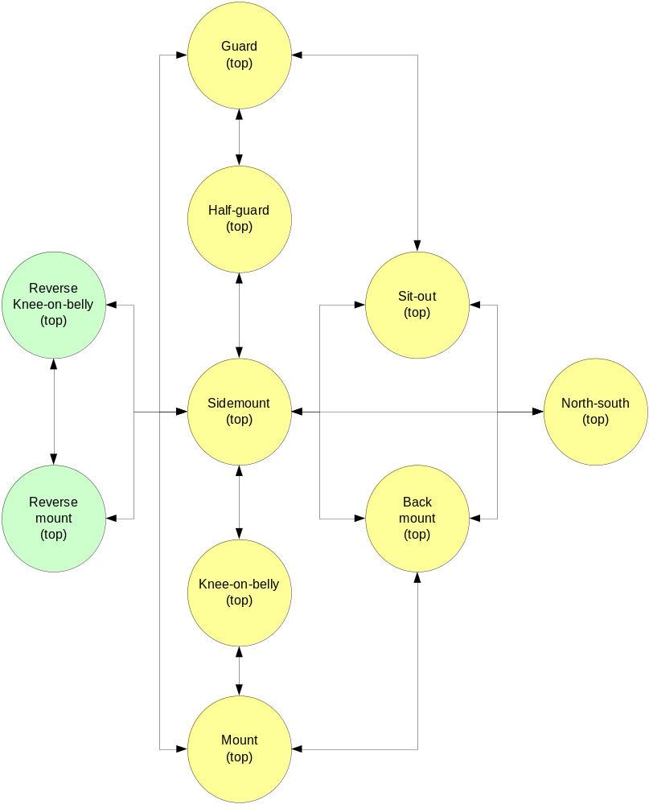
Illustration 2.1 - Positions and transitions from the top

Last, but definitely not least, is groundwork. This sport was invented (if you can use that word in this context) in its current form by grapplers from the art of Brazilian Jiu-Jitsu and knowing how to control, strike and submit opponents on the ground is crucial. Often you will find yourself on the ground whether you want to or not. If you don’t know what to do there, you’ll be flopping around to the amusement of the crowd while being beat down.

2.3.1 Guard
This position is extremely common when doing sparring on the ground. One of you will be on his back with his legs wrapped around the other. The other will be normally sitting on his shins or standing up, depending on what he’s planning to do next. From this position, both fighters may use both offensive and defensive techniques. No one is really at an advantage - it really just depends on whether you’re better on top or on the bottom. The one on top will have an advantage for striking, though (it’s called Gravity). There are also many types of Guard like the Butterfly Guard, Far Guard, Open Guard and so on, but I just call it all the Guard here. I suggest you learn the normal closed Guard before getting into all the variations.
In general, the guy on the bottom will try to do submissions, sweeps or reversals. In other words, if your on the bottom, you’d like to find a way to either make him tap out or get him on his back. You may also do strikes from the bottom, but it’s harder to get a good angle - the best striking attack from the bottom is usually elbows if you can pull your opponent down close to you.
From the top, you’ll usually want to submit or strike the other guy or go for a guard pass. So either you’ll work on pounding and submitting him or you’re going to try to get to a better position.
It’s a bit misleading to say you’ll be doing this OR that. Most people with some skills are constantly flowing from one technique to the other, working submissions while looking for openings to pass or reverse. Picture 2.19 shows the Guard.
Remember that if you’re on the bottom, you’d like to get your opponent down close to you to prevent striking power and make it easier to attack. If you’re on top, you want to stay upright with your back straight to get maximum power for strikes and prevent losing your balance. It’s very, very common for people to forget this - don’t be one of them!

Submissions:
From top: Heelhook, figure-4 footlock, toehold, Achilles lock, canopener
From bottom: Armbar, kimura, omo plata, guillotine, figure-4 armlock, side choke

Picture 2.19 - The Guard (look at that handsome guy on top)

2.3.2 Half Guard
When you pass the guard, you more often than not end up in half guard unless you spar with people far below your own skill level. This is sort of a transitional position where the guy on top is trying to continue passing to a better position while the guy on the bottom is trying to push back into Guard or do reversals or sweeps. There are, however submissions available to both the guy on top and the guy on the bottom. The guy on top also has a good opportunity to make some space and punch the opponent or use elbow strikes and headbutts. Since both legs are tied up in this position, you won’t be able to do any kicking or kneeing.
Knowing how to get back to guard as well as a few ways of passing to better positions should be adequate for starters. When you get more advanced, you might want to look at more sweeps and reversals. You should also know at least some basic submissions from here. Note that some also call this position the Half Mount, especially when the guy on top has managed to secure the position well and is more halfway to Mount then halfway to Guard. Don’t get all caught up in this, however (it’s one of those discussions that are popular among the martial arts nerds – fighters don’t really care as long as they get to kick some butt). Check out Picture 2.20 for the Half Guard.

Submissions:
From top: kimura, figure-4 shoulderlock, kneebar, calf crush, neckcrank, cross arm choke
From bottom: calf crush, side choke, shoulder stretch, kimura

Picture 2.20 – The Half Guard

2.3.3 Mount
This is the most common position for raining down strikes in MMA. As the attacker you’ll be sitting on top straddling your opponent like a horse. The defender will be on his back with his knees bent covering himself to avoid strikes and submissions. From this position, there are many options for the attacker and very few for the defender. If you’re on the bottom, you want to get the heck out of there and escape to a safer position. See Picture 2.21 to see the mount - you’ve probably used it already in some schoolyard scuffles.
You should train a lot on escapes from this position as well as good striking and submissions attacks. A problem that’s emerged in some fights is that the guy on top has exhausted himself striking without doing enough damage to end the fight. Don’t take it for granted that you’ll take the other guy out just because you’re on top - train properly for making maximum damage without running out of gas.

Submissions:
From top: Kimura, figure-4 shoulderlock, figure-4 armlock, armbar, triangle choke, arm triangle choke, figure-4 wristlock
From bottom: Achilles lock, heelhook, toehold, figure-4 footlock (but all these are HARD to pull off – concentrate on escaping!!!)

Picture 2.21 - The Mount

2.3.4 Sidemount
From a pure grappling standpoint, this is known to be the best position since you have great balance and access to all limbs as well as the head. In MMA, you also have some neat strikes here, especially with the elbows and knees. It’ s hard to build up enough power for normal punching, though.
Like the mount, this position is very favourable for the guy on top attacking and a real problem for the guy on the bottom trying to defend. So try to avoid getting on the bottom and work hard on those escapes. From the top, you should concentrate on your submission game and use knees and elbows to open up for other techniques and maybe damage the opponent enough to stop the fight – opening cuts to force a doctor’s stoppage is a good strategy here. Check out Picture 2.22 to see the Sidemount.

Submissions:
From top: Kimura, armbar, figure-4 shoulderlock, figure-4 armlock, cross arm choke, scissor neckcrank
From bottom: armbar (once again, concentrate on escaping)

Picture 2.22 – The Sidemount

2.3.5 North-South
This position is often just called the 69, but it’s probably better to call it the North-South position. You and your opponent are lying chest on chest in opposite directions. This is a great position for unleashing some mean knees and there are some nice ways to attack with submissions here as well. The guy on the bottom will be in trouble and should concentrate on getting to a safer position. There are some good techniques from the bottom that will immediately get you into a dominating position – you can even take your opponents back.
North-South is most often a position you stay in for a short time since it’s often difficult to hold against a good opponent and you need to be quick to get submissions from here. And attacking with knees often makes it easier for the guy on the bottom to make room and get out, so you should try to get a submission or do some damage quickly, then transition to a more stable if you don’t manage to finish off your opponent. See Picture 2.23 for the North-South position.

Picture 2..23 – The North-South position

2.3.6 Sit-out
This position goes by different names depending on where you learn your grappling, but I like to call it the Sit-out since that’s what you do. Basically you sit on your butt with your legs spread out for balance while controlling your opponent’s arms and head to prevent him from taking your back or escaping. The guy on top can attack with various submissions, but it’s hard to do any good striking from here since you’re using your arms to keep your opponent down and your legs need to stay active to keep your balance. So basically it’s a grappler’s position. It’s a useful transitional position to use to get from Sidemount to North-South smoothly as well. Picture 2.24 shows the Sit-out.

Picture 2.24 – The Sit-out

2.3.7 Knee-on-belly
Like the name suggests, you’re sitting on your opponent with a knee on his belly. Your other leg is used to stabilize the position, so you don’t fall off. From here you can do some great punching as long as you manage to keep your balance and there are quite a few submissions available (though many of these require some agility and speed). For the guy on the bottom, there aren’t many attacks available, but there are some escapes as well as some nice reversals that’ll turn the tables on the guy dominating.
It’s quite common for people to place their stabilizing leg incorrectly in this position, so make sure you get it right. You should have it bent so that you’re sitting comfortably and don’t feel immobile or put too much weight on one side. You can also use the your knee to cause a lot of discomfort for the guy on the bottom. Picture 2.25 shows the Knee-on-belly.

Picture 2.25 – The Knee-on-belly

2.3.8 Backmount
When you start grappling, this position will most often lead to the fight being over and a lot of MMA fights end from here. Giving your back to your opponent is a big no-no in fighting, both standing and on the ground. In this position, you’re on your opponents back with your legs wrapped around him. Remember to not cross your legs at any time! You’ll be countered quite painfully if you do! From this position you can do submissions on the head and arms mainly. The signature move for this position is the rear naked choke. You can also strike the back of the head with punches and elbows (it’s usually illegal to strike the spine and neck, but the rest is there for you to pound).
The guy who’s being attacked is in a lot of trouble here and shouldn’t be thinking of anything except escaping as quickly as possible while protecting himself properly from attacks. The only submission that is considered realistic in MMA for the defender in this position is a leglock provided the attacker is stupid enough to cross his legs. Check out picture 2.26 for the Backmount.

Picture 2.26 – Backmount

3 Gear for training and sparring
When you start training for MMA fighting, you’ll need some gear to keep you safe and make you get the most out of your training. This chapter presents various recommended gear.

3.1 For conditioning
To start working on your conditioning, you’ll need a few basic items. I recommend getting a good pair of running shoes for roadwork. Don’t buy some cheap shoes that’ll ruin your feet. Make sure you get some that fit well, take into consideration your running style and are meant for the type of surface you’ll be running on (grass, concrete, gravel, indoors etc) – take care of your feet!
Next you’ll need a jump rope. I personally like the slightly heavy leather ones – they hurt less if you train barefoot and have a better feel to them.
For strength training, I recommend getting a pair of weightlifting gloves and a lifting belt. Your hands, wrists and back will thank you. I also feel I get a much better grip with lifting gloves which makes it easier to uphold proper form when lifting weights.

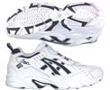  Picture 3.1 – Running shoes | 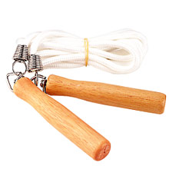  Picture 3.2 – Jump rope | 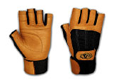  Picture 3.3 – Lifting gloves | 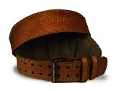  Picture 3.4 – Lifting belt

3.2 For fighttraining
You can usually borrow some gear where you train when you start out, but you should have some personal gear. All fighters should possess a mouthpiece and a proper steel cup – you don’t want to share gear like that with others! You should also have a pair of fight shorts and if you do a sport that uses a Gi, you should buy a personal Gi.

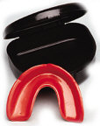  Picture 3.5 – Mouthpiece | 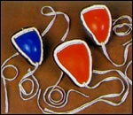  Picture 3.6 – Steel cups | 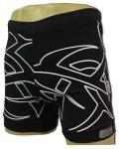  Picture 3.7 – Fight shorts | 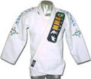  Picture 3.8 – A BJJ Gi

When you get a little more serious about your training, you should also get your own shin protectors, headgear, boxing gloves, hand wraps, MMA gloves and bag gloves. Most boxing gyms have extra gloves that beginners may use at first, but it’s better to have your own and your instructors will probably also expect you to get your own gear after a while, so that other beginners may use the gear they have to lend out.

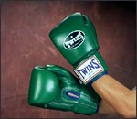  Picture 3.9 – Boxing gloves | 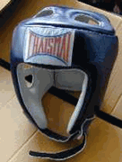  Picture 3.10 – Headgear | 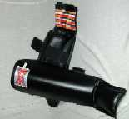  Picture 3.11 – Shin protectors
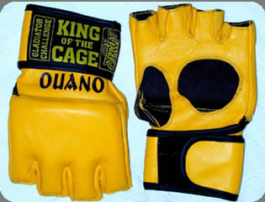  Picture 3.12 – MMA gloves | 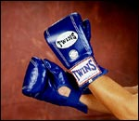  Picture 3.13 – Bag gloves | 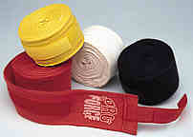  Picture 3.14 – Hand wraps

3.3 For drills and coaching
If you want to work on various striking, wrestling and groundwork drills outside the gym, with friends or maybe you’re starting your own group of guys to train MMA with, you’ll need a few more items for optimal training. These items will help you to varying degrees – I’d say the most important items are those meant for doing striking since you can’t drill full force on your friends (assuming you want to keep them as friends…).
So you might want to get a pair of focus mitts, thai pads, thai leg kick shield, belly pad and maybe some punching bags (if you only want one, then buy a tall banana bag you can use for all strikes). These various striking targets are great for many different drills. I’ll get back to some useful drills in chapter 4.

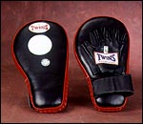  Picture 3.15 – Focus mitts | 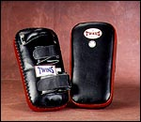  Picture 3.16 – Thai pads | 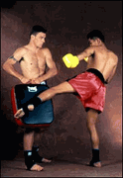  Picture 3.17 – Thai leg kick shield
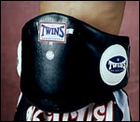  Picture 3.18 –Belly pad | 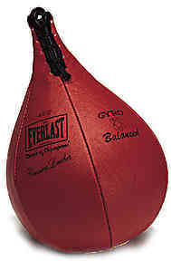  Picture 3.19 – Speed bag | 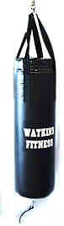  Picture 3.20 – Heavy bag
If you want, you can also get gear to help your takedowns and groundwork. There are plenty of dummies sold for practicing both disciplines. These tend to cost quite a bit, but they enable you to train when you don’t have a partner to work on and you can abuse the dummies a lot more. A training partner will probably mind getting thrown on his head over and over – the dummies don’t complain!

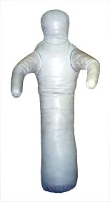  Picture 3.21 – Wrestling dummy | 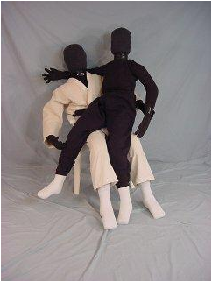  Picture 3.22 – The Bubba grappling dummy (known to be one of the very best out there)

4 Training drills
Training generally consists of two things for fighters: training drills for technique and sparring. This chapter will explain some training drills that will help you get those techniques and combinations nailed down, so you have some weapons for the sparring explained in chapter 5. I’ve divided this chapter into separate parts for striking, takedowns, groundwork and MMA.

4.1 Striking drills
There must be a million or more striking drills out there. Basically, you can have an infinite amount of them as you string out combinations on the different pads. I’ll suggest some drills that are common at the gyms I train at as well as some nice combinations for the pads.

4.1.1 Rope jumping
This is more of a conditioning drill, but it’s great for developing a sense of round time and get used to moving in a similar way to footwork in boxing and kickboxing. Use this drill for warming up and use a timer to make sure you jump the same amount of time you usually spar. So normally in a boxing gym, you’ll do this drill for 2 or 3 minutes with 30 seconds or a minute rest in between. Do 2 or 3 rounds at first and you can do more as you get used to it.
Remember to jump in many different ways. Jump with both feet at the same time, jump on one foot at a time, try backwards, try twirling the rope twice under you on one jump, crossing the rope while jumping and so on. It makes it more fun and gets you used to moving well. You’ll be outmanoeuvring your opponents in no time.

Gear needed: jump rope (no kidding!), stopwatch/timer

4.1.2 Tennis balls (coordination drill)
This is yet another drill often used when we warm up. It’s great for coordination. You’ll need a tennis ball and like the rope jumping, you’ll want to do this the same amount of time you usually spar. The task here is to bounce the ball while keeping a boxing guard and moving around correctly (you’ll learn how to move if you join a boxing/kickboxing gym – you shuffle around using the foot in the direction you’re going to start the movement). So you’ll have to concentrate to make it all happen at the same time. Use both hands and once in a while, you hold the ball in your hand while executing a short punching combination like the jab-cross or jab-cross-hook. Then it’s back to bouncing again.

Gear needed: tennis ball, stopwatch/timer

4.1.3 Shadow boxing
This is the cheapest and most common drill among strikers. You simply set the timer for a roundtime and execute techniques in combinations in the air imagining an opponent. Move around using proper stance, footwork and guard, then launch various combinations while imagining fighting an opponent. Slip his imaginary punches, counter with punches, kicks, elbows and knees. You may also work only on certain strikes if you want – work on your weak points.
This can get really exhausting if done right. Keep your pace and don’t slow down! Stay loose in your body, don’t use rigid movements. Lay the smack down on that imaginary opponent!

Gear needed: none

4.1.4 Technique sparring
We often use this drill to warm up when we’re about to do a session with much sparring. It gets you ready for sparring in a safe environment and you get into the right frame of mind. You and a partner square off and start attacking and each other and defending just like in real sparring, but everything is done very relaxed. Go at a slower speed, work different combinations, use common counters and generally have fun with it. Don’t try to cause any injury to your opponent – just put the technique out there without force. You may also use open hand slaps when you manage to get through to his head.
The great thing about this drill is that you can try different techniques and combinations on a moving target that’ll hit back, but you don’t need to be afraid of getting injured in any way. It’s really just a chess game where you’re both showcasing and testing techniques. To actually hit your target, you need to outmanoeuvre your opponent since you can’t rely on speed and surprise. This is great since it forces you to do more than just stick to the basics (since your partner will see all the common stuff coming).
As with shadowboxing, you may restrict yourselves to only certain techniques to concentrate on skills in one or more areas. Experiment with the drill. As mentioned, it’s a good way to get people ready for sparring.

Gear needed: cup, mouthpiece (just in case)

4.1.5 Slap sparring
This drill has a little more speed to it than the technique sparring from section 4.1.4. The head is off limits. Your task is to hit the shoulders and body with straight and hook punches, but you only hit open handed (hence the term “slap sparring”). You can also include lowkicks and front kicks.
Frankly, this is very much a beginner’s drill, but it’s a good way to get people used to some of the intensity of sparring. As you get better, you may want to stick to technique sparring and real sparring of different sorts (explained in section 5). But since this is a document for those who’re pretty new to MMA and fighting, I feel it’s good to include this drill as well.

Gear needed: none

4.1.6 15-15
The 15-15 drill is great for conditioning and gets you really tired. My instructors often use it at the very end of our training sessions to make use spend that last little drop of energy after all the drills and sparring throughout the session.
The drill goes like this: you and a partner put on wraps and boxing gloves (you’re probably already wearing these if you’re at a striking type training). One of you will hold a thai leg kick shield or similar big pad in front of his chest/belly and should stand with his back up against a wall. As the drill starts, the one not holding the pad should stand at arm’s length from the pad and hit it with full force and as quickly as possible using only straight punches. Every fifteen seconds, the two of you change place, so you work the pad for fifteen seconds, then hold it for your partner for 15 seconds (hence the name 15-15).
It’s up to you and your instructors how long you want to keep going, but normally we go for 2-3 minutes and do a couple of rounds (since this is usually done after plenty of hard training and people are already pretty tired).

Gear needed: Boxing gloves, wraps, thai leg kick shield or similar big pad

4.1.7 4 minutes (also known as “the hell drill”)
This drill is a killer!

5 Sparring
Sparring is what transforms you from someone who just knows some moves into a fighter. Even if you’re the master of drilling techniques, doing padwork and so on, you still don’t know much about fighting until you have to make your stuff work on a resisting opponent who’s trying to impose his own techniques on you. You’ll also quickly realise how important conditioning is once you start sparring.
This chapter suggests some common methods of sparring that should get you ready for actual fights. Remember to use proper gear for protection at all times. Those who act tough and spar too hard with crappy gear will quickly end up injured while you can continue sparring and improving.

5.1 Rolling
This is the favoured method of sparring for most grapplers and is necessary to hone your groundwork. You get to practice submissions and positioning as well as develop your endurance and strength. You and your sparring partner begin on your knees, shake hands and sparring begins. Your goal is to submit your opponent using submissions (submissions are anything that will make your partner quit). To attack with submissions, you need to be good at positioning and escaping when your opponent has managed to get you in a bad position. You also need to know how to avoid and escape submissions.
To signal that you submit, you tap the mat or your opponent with your hand or feet a few times. You can also submit verbally. Make sure you’re both clear on this before you begin. Usually we just spar/roll until we want to change sparring partner, need a breather or want to drill some technique. Before fights, you should get used to rolling the amount of time your fight is. If you’re going to fight 2x5 minutes, you should roll in five minute intervals.
Remember to never do submissions too hard or too sudden. You and your partner should exercise control and make sure no one gets injured.

Recommended gear: Shorts and shirt, cup, mouthpiece and some kind of protection for the knees to avoid tearing off skin on the mats. If you do arts like Judo, BJJ and the like, you may have to use a Gi for rolling in class.

5.2 Takedown sparring/wrestling
Getting someone down to the mat or preventing others from taking you there is the key to controlling a fight. So you have to spar with takedowns. The goal is to take someone to the mat and establish top position. You and your sparring partner start standing up and every time one of you manages to take the other down and establish position, a point is scored. Then you stand up quickly and go again. You should have a timer and go at it for a set time. For a bit more competitiveness, you can have a third person counting the points to declare a winner of each round. This person should also remind those sparring to get back up once they’ve gotten into position (people have a tendency to stay down for longer periods of time once they get tired).
Normally 3 minutes is an appropriate round time for this sort of sparring. You can adjust this to fit the competition you’re going to compete in.

Recommended gear: Shorts and shirt, cup, mouthpiece and some kind of protection for the knees to avoid tearing off skin on the mats. If you do arts like Judo, BJJ and the like, you may have to use a Gi for takedown sparring in class.

5.3 Submission wrestling sparring
This sort of sparring is very important and combines the two formerly explained ways of sparring in 3.1 and 3.2. You start standing up and go until the tap. Whenever someone submits, you get back up and go again. The great thing about this sparring is that you start to understand how takedowns and groundwork fit together and you don’t just take someone down and hold on anymore – you have to start working for position and submission as soon as you hit the ground regardless of whether you land on top or on the bottom. This is also the best form of sparring if you intend to compete in submission wrestling.
Normally 5 minutes is an appropriate time for this sparring since this is standard roundtime in MMA most places. The world championship in submission wrestling (organized by the Abu Dhabi Combat Club) uses 10 minute rounds and 20 minutes in the finals, so if you have ambitions there, you might want to sometimes spar for longer periods.

Recommended gear: Shorts and shirt, cup, mouthpiece and some kind of protection for the knees to avoid tearing off skin on the mats.

5.4 Boxing sparring
Boxing is all about punching someone and avoid getting punched yourself and it is a crucial skill in MMA. Without sparring with punches, you will quite probably panic when someone starts hitting your head and body with force.
In boxing sparring, you should take care to not knock each other out. Getting knocked out sucks and might force you to not spar with strikes for a long time! Try to keep your punches explosive and fast and focus on head movement, correct footwork and good defence while staying relaxed to avoid getting too rigid (which leads to slow movement).
Boxing is usually done in 2 or 3 minute rounds with either 30 seconds or 1 minute breaks in between depending on your conditioning. Doing three rounds at a time is normal where I train since it is normal for amateur boxing in Norway.
Take care of yourself and your sparring partner when sparring with strikes. Don’t go faster or harder than you can handle. Preferably this type of sparring should be done with a proper boxing coach watching and controlling what is going on. There are boxing gyms just about everywhere, so getting proper sparring shouldn’t be a problem.

Recommended gear: Shorts and shirt, cup, mouthpiece, training shoes (preferably with thin soles, so you don’t injure your ankles), hand wraps, boxing gloves (use 12 oz or bigger for sparring, depending on your own weight) and headgear.

5.5 Kickboxing/Muay Thai sparring
This is a more complete form of striking sparring than pure boxing sparring. You are also allowed to kick and use knees and elbows. As with boxing, you should take care to not knock out or seriously injure your sparring partner. You may use all your striking techniques to all parts of your opponents body except the groin and knees (some also allow strikes to the knee – like the stomps in Savate). Since kickboxing and Muay Thai sparring is done in many forms under many different sets of rules, you should be sure that you and your opponent are in agreement of what you may and may not do, so you don’t end up being mad at each other.
This sort of sparring is usually done in 2, 3 or 5 minute rounds with 30 seconds or 1 minute breaks in between depending on your conditioning and the competition you want to fight in next. It’s pretty much up to you or the instructors where you train how the rounds and time limits are set up.
As with boxing, you should have a coach overseeing this type of sparring to make sure things work out well and that you both get good sparring with minimal chance of injury.

Recommended gear: Shorts and shirt, cup, mouthpiece, hand wraps, boxing gloves (use 12 oz or bigger for sparring, depending on your own weight), headgear and shin protection.

5.6 Full MMA sparring
After sparring in all the different aspects of MMA, it’s appropriate to try to put it all together in MMA sparring. You wear only what you would wear in the ring, which means mouthpiece, cup and those thin MMA gloves. The goal is to try to put it all together. You should try to combine strikes with takedowns, takedowns with submissions and ground & pound and so on. This sparring will help you learn how to flow between the different elements of MMA fighting.
It’s very important when sparring like this that you make sure you don’t hurt each other too much. There will always be bruises and aches and pains when you go at it with almost no protection, but avoid knockouts and injuries that will keep you out of training.
Go with enough contact to keep things interesting and recreate the stress and pain of real fighting, but don’t go berserk. The ultimate goal is to make you a complete fighter, so that you’ll get in the ring or cage as an MMA practitioner, not just a guy who’s done boxing, wrestling and BJJ. You have to be able to combine everything intelligently instead of just becoming good at each of the parts that the sport consists of.
Rounds are usually 5 minutes or whatever time your upcoming match is. Try to keep this type of sparring as similar to your fight as possible with regards to gear worn, number of rounds and length of each round.

Recommended gear: Fight shorts, cup, mouthpiece and MMA gloves (I recommend Ouano’s UFC or KOTC gloves).

Appendix A – Motivational quotes
It’s good to have some more or less macho quotes to make you feel better and more motivated when the going gets tough. Here are some good ones I picked from various places, mostly The Underground (www.mma.tv):

“Blood is just red sweat” – Enson Inoue

"When in doubt, choke him out!” – Gene Lebell

I do not fear failure. I only fear the "slowing up" of the engine inside of me which is pounding, saying, "Keep going, someone must be on top, why not you?" - General George S Patton
"A man is not finished when he is defeated, he is finished when he quits" - Richard Nixon
"Better to die on one's feet than live on one's knees" - UNKNOWN
"Never give in, never, in nothing great or small, large or petty, never give in except to convictions of honour and good sense. Never yield to force; never yield to the apparently overwhelming might of the enemy" - Winston Churchill
"Victory at all costs, victory in spite of all terror, victory however long and hard the road may be; for without victory, there is no survival" - Winston Churchill
"The ultimate measure of a man is not where he stands in moments of comfort and convenience, but where he stands at times of challenge and controversy" - Martin Luther King
"I firmly believe that any man's finest hour, the greatest fulfillment of all that he holds dear, is that moment when he has worked his heart out in a good cause and lies exhausted on the field of battle - victorious" - Vince Lombardi
"It's not the critic who counts. It's not the man who points out how the strong man stumbles, or where the doer of the deed could have done it better. The credit belongs to the man in the arena, whose face is marred by dust and sweat and blood, who spends himself in a worthy cause, who strives vailantly, who errs and comes up short again and again, who at best knows the high achievement of triumph, who at worst, fails while daring greatly for he knows his place shall never be with those cold and timid souls who know neither victory no defeat"
"Courage is fear holding on a minute longer" - General George S. Patton
"Training should be like a bloodless battle so a battle is just like bloody training" – A motto of the Roman Legions, as quoted by Tony Blauer

"Pain is just weakness leaving your body" – UNKNOWN

"I'd rather injure my body than injure my pride" - Fernando Vargas
"I would rather lose knowing that my opponent was running for his life, than win knowing I was running for mine" - JJ Machado on winning a fight on points.
"Quitters never win, and winners never quit" – UNKNOWN

"The more skill you have, the less luck you need." – UNKNOWN

"Two hits: I hit you, you hit the floor." – UNKNOWN

"Keep away from people who try to belittle your ambitions. Small people always do that, but the really great make you feel that you, too, can become great." -- Mark Twain
"Getting ahead in a difficult profession requires avid faith in yourself. You must be able to sustain yourself against staggering blows. There is no code of conduct to help beginners. That is why some people with mediocre talent, but with great inner drive, go much further than people with vastly superior talent." -- Sophia Loren
"You will never do anything in this world without courage. It is the greatest quality of the mind next to honor" -- Aristotle
"You can measure a man by the opposition it takes to discourage him"
"The good fighters of old first put themselves beyond the possibility of defeat, and then waited for an opportunity of defeating the enemy" -Sun Tzu
"Press on: nothing in the world can take the place of perseverance. Talent will not, nothing is more common than unsuccessful men with talent, Genius will not; unrewarded genius is almost a proverb, Education will not; the world is full of educated derelicts. Persistence and determination alone are omnipotent." -- Calvin Coolidge
"It's one thing calling the Devil out, it's another entirely to see him across the ring from you" - Felix Trinidad

The more thou sweateth in training, the less you bleedeth in combat." - Dick Marcinko
"Pain exists to ensure that I know I am still alive." - Dick Marcinko

