BUTTERFLIES AND SKIPPERS
OF THE AFROTROPICAL REGION

(PAPILIONOIDEA AND HESPERIOIDEA)

© Seventh edition (2008)
(Copyright Reserved)

FILE H – CHARAXINAE (NYMPHALIDAE)

Compiled by Mark C. Williams

183 van der Merwe Street, Rietondale

PRETORIA 0001

E-mail: mark.williams@up.ac.za

FAMILY NYMPHALIDAE

Swainson, 1827

SUBFAMILY CHARAXINAE
Guenée, 1865

Subfamily Charaxinae Guenée, 1865
Tribe Charaxini Guenée, 1865
Tribe Euxanthini Rydon, 1971
Tribe Pallini Rydon, 1971
Tribe Prothoini Roepke, 1938 [not Afrotropical]
Tribe Preponini Rydon, 1971 [not Afrotropical]
Tribe Anaeini Reuter, 1896 [not Afrotropical]

TRIBE CHARAXINI

Guenée, 1865

Genus Charaxes Ochsenheimer, 1816

Die Schmetterlinge von Europa 4: 18 (212 pp.). Leipzig.
Type-species: Papilio jasius Linnaeus, by monotypy.

= Paphia Fabricius, 1807. In: Illiger, K., Magazin für Insektenkunde 6: 277-289. Type-species: Papilio jasius Linnaeus, by subsequent designation (Crotch, 1872). Cistula Entomologica 1: 66 (59-71). [Invalid; junior homonym of Paphia Röding, 1798, and Paphia Lamarck, 1799.] [Placed on the Official List of Rejected and Invalid Names in Zoology; Opinion 577, 1959. Bulletin of Zoological Nomenclature 17: 140-142.]

= Eriboea Hübner, 1819 in Hübner, [1816-[1826]. Verzeichniss bekannter Schmettlinge 46 (432 + 72 pp.). Augsburg. Type-species: Papilio etheocles Cramer, by subsequent designation (Scudder, 1875. Proceedings of the American Academy of Arts and Sciences 10: 166 (91-293).).

= Jasia Swainson, 1832 in Swainson, 1832-3. Zoological illustrations, or original figures and descriptions of new, rare or interesting animals selected chiefly from the class of Ornithology, Entomology and conchology (1) 1: pl. 90 ([xxvii] pp.). London. Type-species: Papilio jasius Linnaeus, by original designation. [Placed on the Official List of Rejected and Invalid Names in Zoology; Opinion 577, 1959. Bulletin of Zoological Nomenclature 17: 140-142.]

= Monura Mabille, 1876. Bulletin de la Société Zoologique de France 1: 280 (194-203, 274-281). Type-species: Papilio zingha Stoll, by monotypy. [Invalid; junior homonym of Monura Ehrenburg, 1831, and Monura Gistl, 1874.]

= Zingha Hemming, 1939. Proceedings of the Royal Entomological Society of London (B) 8: 136 (133-138). [Replacement name for Monura Mabille.]

= Hadrodontes Stoneham, 1964: 102. Get ref. - no ref. in Ackery, et al., 1995. [Invalid; no type-species designated.]

= Stonehamia Cowan, 1968. Annotationes Rhopalocerologiae 1968 6 (20 pp.). Berkhamsted. Type-species: Papilio varanes Cramer, by original designation. [Replacement name for Hadrodontes Stoneham.]

Synonym based on extralimital type-species: Haridra Moore.

A large Old World genus containing 193 species, 169 of which are Afrotropical. A single Afrotropical species extends into the Palaearctic Region. Comprehensively reviewed by S. Henning (1989). Species groups follow Henning.

VARANES GROUP

Charaxes varanes (Cramer, 1777)

Papilio varanes Cramer, 1777. Die Uitlandsche Kapellen voorkomende in de drie waereld-deelen Asia, Africa en America 2: 100 (151 pp.). Amsteldam & Utrecht.

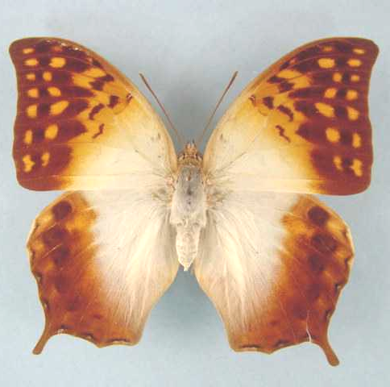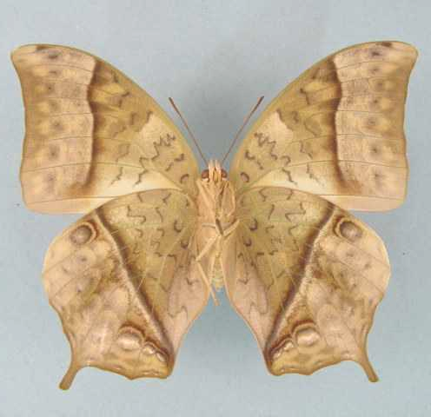

Charaxes varanes varanes. Male. Left – upperside; right – underside. Wingspan: 81mm. Yellowwoods, Natal. 27.II.1960. K.M. Pennington. (Transvaal Museum - TM3333).

Type locality: [South Africa]: “sur l’Isle d’Amboine and sur la Cote de Coromandel”. [False locality.]
Diagnosis: Basal areas of wings whiter than in C. acuminatus and c. fulvescens (Kielland, 1990).
Distribution: Senegal (Kielland, 1990), Gambia (Larsen, pers comm. 2002), Guinea-Bissau (Larsen, pers comm. 2002), Guinea, Burkina Faso (Larsen, pers comm. 2002), Sierra Leone, Liberia, Ivory Coast (Larsen, pers comm. 2002), Ghana, Togo (Larsen, pers comm. 2002), Benin (Larsen, pers comm. 2002), Nigeria, Equatorial Guinea, to Central African Republic, Sudan, Ethiopia, Yemen, Oman, to Kenya, Tanzania, Zambia, Angola, Mozambique, Zimbabwe, Botswana, Namibia, South Africa, Swaziland.
Common name: Common pearl charaxes; pearl charaxes.
Habitat: Mainly in dry forest, open forest and dense savanna. Readily colonizes degraded wet forest (Larsen, 2005a). In Tanzania ssp. vologeses is found from sea-level to 2 300 m (Kielland, 1990). Rarely found in wetter forests (Larsen, 2005a).
Habits: A common charaxes. The flight is moderately fast and flapping. Males defend territories from prominent perches on trees, usually two to eight metres above the ground (Larsen, 2005a). Both sexes are attracted to fermenting fruit (Pringle, et al., 1994). Males are not attracted to animal scats or carrion. Van Someren and Rogers (1928) noted that they feed from the stems of maize plants damaged by cetoniid beetles, on the Kenyan coast. Bampton observed them migrating northwards from central Tanzania, over a distance of at least 480 km, together with individuals of Charaxes candiope (Henning, 1989; Larsen, 1991; Larsen, 2005a).
Flight period: All year.
Early stages:

Trimen & Bowker, 1887, Vol. 1: 323 [as Charaxes Varanes (Cramer)] (C. v. varanes).
“Larva. Dull bluish-green above; pale whitish-green beneath, irrorated with very minute silvery dots. On 6th, 8th, and 10th segments, a pale-ochreous, somewhat crescentic, mark on the back, - that on the 10th segment very faint and only found in full-grown specimens. A thin, sinuated, silvery lateral stripe. Head flat, armed with four backward-sloping, recurved, somewhat serrated horns, bright turquoise-blue beneath, and in young specimens edged with reddish. Anal segment flattened, bifid.” “Pupa. Pellucid blue-green with a delicate plum-like bloom. On each side of abdomen a row of six black dots. On anal pedicel two pairs of small yellowish tubercles, and a similar pair on ventral surface, close to pedicel, facing towards the head. Mr. Mansel Weale, who sent me the notes and drawings from which the above description of the larva and pupa (found near King William’s Town, Cape Colony) are drawn up, informed me that the chrysalis state lasted for fourteen days. Colonel Bowker also reared Varanes in Natal, and in 1882 sent me a specimen with the skin of the pupa from which it had emerged. On this skin the tubercles on and near the tail described by Mr. Weale were very prominent and conspicuous, being tipped with black; it further presented two raised black spots, one on each side of the bluntly bifid head. This pupa was attached to the edge of a green leaf.”

Trimen & Bowker, 1889: 406 [as Charaxes Varanes] (C. v. varanes).
“Pupa. In June 1887 I received from Colonel Bowker two living pupae of this butterfly, from which I obtained a ♂ perfect insect on June 19 (pupation 18th May), and a female on June 26th. These pupae were semi-transparent, of a uniform bright-green, with a wax-like surface; six abdominal spiracles on each side, and six caudal tubercles, black. They were very thick and swollen abdominally, but became gradually slenderer and narrower anteriorly. Head very shallowly bifid. Inferior outline, along middle line of head and thorax, almost straight; dorsal median line of thorax and inner-marginal edges of wing-cases somewhat prominently but smoothly ridged or keeled. Length, about 1 inch; greatest width and also greatest depth – across third abdominal segment – ½ inch. The band of light reddish-brown silk to which these pupae were attached completely encircled the slender stem of Cardiospermum halicacabum, on which the insects were suspended. Colonel Bowker found the larvae feeding on this widely-spread tropical climber near D’Urban, Natal, and called my attention to the general resemblance borne by the pupae to the younger somewhat heart-shaped inflated seed-vessels of the plant, which hang similarly, though by a much longer pedicel”.

Fawcett, 1903: 168. (C. v. varanes).

Van Someren and Rogers, 1928: 113. (C. v. vologeses).

Dickson, 1972: 41 [as Charaxes varanes] (C. v. varanes).

Clark, in Van Son, 1979: 143 [as Charaxes varanes varanes] (C. v. varanes).
“Eggs are laid singly on the surface of a leaf. They are 1,5 mm in diameter by 1,25 mm high, with 20 faint undeveloped ribs composed of seven to eight faint moles. Pale watery yellow when laid, they develop a reddish circlet. The larva hatches after five days. It eats its way out near the top of the egg and after a short rest consumes the shell. It takes a stance on the midrib of a leaf where it spins a silken mat on which it rests. It crawls away to feed but returns to its mat. This procedure is followed throughout the larval state. The larvae have a habit of holding to the leaf with the centre claspers and raising their extremities. There are normally five instars, but sometimes there are six. The five-instar larvae grow in the 1st instar from 4 to 7 mm in five days, in the 2nd instar to 11 mm in five days, in the 3rd to 16 mm in six days, in the 4th to 28 mm in seven days, and in the 5th instar to 50 mm in 14 days. The six-instar larvae grow in the 1st instar from 4 to 6,5 mm in five to seven days, in the 2nd to 9 mm in six days, in the 3rd to 13 mm in six days, in the 4th to 23 mm in six days, in the 5th to 35 mm in six days, and in the 6th to 50 mm in 14 days. The pupa is 28 mm long and is suspended by cremastral hooks. The imago emerges after some 14-18 days. The species is many-brooded.”

Henning, 1989.

Larval food:
(Probably) Rhus laevigata L. (syn. viminalis Vahl) (Anacardiaceae) [Mansel Weale, in Trimen & Bowker, 1887, Vol. 1: 324] (C. v. varanes).
Cardiospermum halicacabum L. (Sapindaceae) (exotic) [Bowker, in Trimen & Bowker, 1889: 406; Durban] (C. v. varanes).
Allophylus africanus Beauv. (Sapindaceae) [Platt, 1921: 102 (South Africa); Blandin, et al., 1975 (Ivory Coast)] (C. v. varanes and C. v. vologeses).
Allophylus macrostachys Radlk. (Sapindaceae) [Van Someren, 1974: 321] (C. v. vologeses).
Allophylus subcoriaceus Bak. f. (Sapindaceae) [Van Someren, 1974: 321] (C. v. vologeses).
Allophylus glaucescens (Sapindaceae) [Van Someren, 1974: 321].
Allophylus natalensis (Sond.) De Winter (Sapindaceae) [Dickson and Kroon, 1978: 58] (C. v. varanes).
Allophylus melanocarpus (Sond.) Radlk. (Sapindaceae) [Dickson and Kroon, 1978: 58] (C. v. varanes).
Schmidelia species (Sapindaceae) [Kielland, 1990: 110].
Allophylus dregeanus (Sond.) De Winter (Sapindaceae) [Oberprieler, in Pringle, et al., 1994: 86; KwaZulu-Natal] (C. v. varanes).
Rhus longispina (Anacardiaceae) [Claassens, 2005].
Note: The population of C. varanes on Pemba Island, Tanzania appears to belong to a distinct subspecies but too few specimens are available for a description to be made (Kielland, 1990: 110).

Charaxes varanes varanes (Cramer, 1777)

Papilio varanes Cramer, 1777. Die Uitlandsche Kapellen voorkomende in de drie waereld-deelen Asia, Africa en America 2: 100 (151 pp.). Amsteldam & Utrecht.

Charaxes varanes varanes. Male. Left – upperside; right – underside. Wingspan: 81mm. Yellowwoods, Natal. 27.II.1960. K.M. Pennington. (Transvaal Museum - TM3333).

Type locality: [South Africa]: “sur l’Isle d’Amboine and sur la Cote de Coromandel”. [False locality.]
Distribution: Mozambique (south), South Africa (Limpopo Province, Mpumalanga, KwaZulu-Natal, Eastern Cape Province, Western Cape Province - south-east), Swaziland.
Specific localities:
Limpopo Province – Mica (Swanepoel, 1953); Tubex (Swanepoel, 1953); Chuniespoort (Swanepoel, 1953); Woodbush (Swanepoel, 1953); Mokeetsi (Swanepoel, 1953); Groot Spelonken (Swanepoel, 1953); Sibasa (Swanepoel, 1953); Entabeni Forest (Swanepoel, 1953); Lousi Trichardt (Swanepoel, 1953); Waterpoort (Swanepoel, 1953); Saltpan (Swanepoel, 1953); Blouberg (Swanepoel, 1953); Legalameetse Nature Reserve (“Malta Forest”).
Mpumalanga – Barberton (Swanepoel, 1953); Lydenburg district (Swanepoel, 1953); Graskop (Swanepoel, 1953); Marieps Kop (Swanepoel, 1953); Buffelskloof Nature Reserve (Williams).
KwaZulu-Natal – Oribi Gorge (Swanepoel, 1953); Umkomaas (Swanepoel, 1953); Durban (Swanepoel, 1953); Hluhluwe (Swanepoel, 1953); Pietermaritzburg (Swanepoel, 1953); Estcourt (Swanepoel, 1953); Tugela River (Swanepoel, 1953); Eshowe (Swanepoel, 1953).
Eastern Cape Province – Port Elizabeth (Swanepoel, 1953); Suurberg (Swanepoel, 1953); Somerset East (Swanepoel, 1953); Katberg (Swanepoel, 1953); Grahamstown (Swanepoel, 1953); Port Alfred (Swanepoel, 1953); East London (Swanepoel, 1953); Stutterheim (Swanepoel, 1953); Butterworth (Swanepoel, 1953); Bashee River (Swanepoel, 1953); Port St Johns (Swanepoel, 1953).
Western Cape Province – Wilderness (Swanepoel, 1953); Knysna (Swanepoel, 1953); Plettenberg Bay (Swanepoel, 1953); Mossel Bay (Pringle, et al., 1994); Cape Peninsula (Pringle, et al., 1994; strays).
Swaziland – Mlawula N. R. (www.sntc.org.sz).

Charaxes varanes bertrami Riley, 1931

Charaxes varanes bertrami Riley, 1931. Entomologist 64: 279 (279-280).
Type locality: Oman: “Wadi Arbot; Gurgaz, N.E. of Salalah”. Holotype (male) in the Natural History Museum, London.
Distribution: Oman, Yemen (extreme east) (Larsen, pers comm. 2002).

Charaxes varanes torbeni Turlin, 1999

Charaxes varanes torbeni Turlin, 1999. Lambillionea 99: 181 (171-182).
Type locality: Yemen: “Wadi Dhabab, 15 Km sud de Taïz, 1100m, Nord Yemen, 23-VIII-1993.” In M.N.H.N., Paris.
Distribution: Yemen (Larsen, pers comm. 2002).

Charaxes varanes vologeses (Mabille, 1876)

Palla vologeses Mabille, 1876. Bulletin de la Société Zoologique de France 1: 280 (194-203, 274-281).
Type locality: Democratic Republic of Congo: “Congo ... Landana”.
Diagnosis: In ssp. vologeses the white markings on the upperside are broader than in the nominate subspecies (Pringle, et al., 1994).
Distribution: Senegal (Larsen, pers comm. 2002), Gambia (Larsen, pers comm. 2002), Guinea, Guinea- Bissau (Larsen, pers comm. 2002), Burkina Faso (Larsen, pers comm. 2002), Liberia, Ivory Coast (Larsen, pers comm. 2002), Sierra Leone, Ghana, Togo (Larsen, pers comm. 2002), Benin (Larsen, pers comm. 2002), Nigeria, Equatorial Guinea, to Central African Republic, Sudan, Ethiopia, Kenya, Tanzania, Zambia (throughout), Angola, Mozambique (north), Zimbabwe, Botswana, Namibia (north).
Specific localities:
Sierra Leone – Freetown (Owen & Chanter, 1972).
Ghana – Atewa Range (Joly, 2003).
Benin – Noyau Central, Lama Forest (Fermon, et al., 2001).
Nigeria – Vom (Owen, 1977); Warri (H. Boersma teste Larsen, 2005a); Kaduna (R. St Leger teste Larsen, 2005a); Oban Hills (Larsen, 2005a).
Tanzania – widespread, including Pemba Island (the population on Pemba may represent an undescribed subspecies) (Kielland, 1990).
Namibia - Waterberg Plateau Park (Swart, 2004)

nigrescens Butler, 1896 (as sp. of Charaxes). Journal of the Linnean Society of London 25: 401 (348-404). Sierra Leone.

brachycauda Le Cerf, 1923 (as ?ssp. of Charaxes varanes). Bulletin du Muséum National d’Histoire Naturelle. Paris 29: 367 (360-367, 428-429). Mozambique: “Mozambique, Guenère, Haute Vallée de Pungoué”.

minor Storace, 1948 (as ab. of Charaxes varanes vologeses). Annali del Museo Civico di Storia Naturale (di Genova) Giacomo Doria 63: 140 (132-141). Ethiopia: “Sciotalit (Scioa, Abissinia)”.

antinorii Storace, 1948 (as ab. of Charaxes varanes vologeses). Annali del Museo Civico di Storia Naturale (di Genova) Giacomo Doria 63: 141 (132-141). Ethiopia: “Sciotalit (Scioa, Abissinia)”.

Charaxes defulvata Joicey & Talbot, 1926

Charaxes varanes defulvata Joicey & Talbot, 1926. Entomologist 59: 221 (220-226).
Type locality: Sao Tome and Principe: “Sao Thomé”. Holotype (male) in the Natural History Museum, London.
Distribution: Sao Tome and Principe (island of Sao Tome).
Habitat: Forest.
Early stages: Nothing published.
Larval food: Nothing published.
Note: C. defulvata Joicey & Talbot, 1926 is treated as a subspecies of varanes (Cramer, 1777) by Van Someren (1974: 480). Henning (1989: 40) treats defulvata as a distinct species on the authority of Plantrou (1983). Plantrou’s paper is, however, an unpublished thesis; thus the taxonomic change is, strictly speaking, not valid.

Charaxes fulvescens (Aurivillius, 1891)

Palla varanes var. fulvescens Aurivillius, 1891. Entomologisk Tidskrift 12: 216 (193-228).
Type locality: Cameroon: “Camerun”.
Distribution: Senegal, Guinea-Bissau, Guinea, Sierra Leone, Liberia, Ivory Coast, Ghana, Togo, Benin (Fermon et al., 2001), Nigeria, Cameroon, Equatorial Guinea, Gabon, Congo, Central African Republic, Democratic Republic of Congo, Central African Republic, Sudan, Uganda, Rwanda, Burundi, Kenya, Tanzania, Zambia.
Kielland (1990) gives the Comoro Islands (in error?).
Common name: Forest pearl charaxes.
Habitat: Dense evergreen forest at low to moderate altitudes. In Tanzania at altitudes of 800 to 2 000 m (Kielland, 1990).
Habits: A reasonably common species that often settles on tree trunks and on the underside of thick branches (Larsen, 2005a). It usually flies in the forest understorey, rather than the canopy.
Early stages:

Van Someren and Van Someren, 1926: 336 [ssp. monitor].

Henning, 1989: 43 [ssp. monitor].

Larval food:
Allophylus macrobothrys Gilg. (Sapindaceae) [Van Someren, 1974: 321].
Allophylus africanus Beauv. (Sapindaceae) [Blandin, et al., 1975 (Ivory Coast); Henning, 1989: 43].
Allophylus macrostachys Radlk (Sapindaceae) (exotic) [Henning, 1989: 43].
Allophylus subcoriaceus Baker (Sapindaceae) [Henning, 1989: 43].

Charaxes fulvescens fulvescens (Aurivillius, 1891)

Palla varanes var. fulvescens Aurivillius, 1891. Entomologisk Tidskrift 12: 216 (193-228).
Type locality: Cameroon: “Camerun”.
Distribution: Nigeria (east), Cameroon, Gabon, Congo, Central African Republic, Democratic Republic of Congo.
Specific localities:
Nigeria – Kagoro (Larsen, 2005a: 321).

ocellatus Schultze, 1917 (as ab. of Charaxes fulvescens). Ergebnisse der Zweiten Deutschen Zentral-Afrika Expedition 1 (12): 588 (511-597). Cameroon: “Süd-Kamerun Molundu”.

Charaxes fulvescens imenti Plantrou, 1989

Charaxes fulvescens imenti Plantrou, 1989. In: Henning, 1989. The Charaxinae butterflies of Africa 43 (457 pp.). Johannesburg. Type locality: Kenya: “Imenti, Mt Meru”. Holotype male in the Natural History Museum, London.
Distribution: Kenya (central).
Specific localities:
Kenya – lower Meru Forest on Mt Kenya; Nyambeni (=Imenti) Hills (Larsen, 1991).

Charaxes fulvescens marialuisae Canu, 1989

Charaxes fulvescens marialuisae Canu, 1989. In: Henning, 1989. The Charaxinae butterflies of Africa 41, 42 (457 pp.). Johannesburg. Holotype (male) in the collection of Dr J.G. Canu.
Type locality: Equatorial Guinea: “Bioko”.
Distribution: Equatorial Guinea (Bioko Island).

Charaxes fulvescens monitor Rothschild, 1900

Charaxes fulvescens monitor Rothschild, 1900 in Rothschild and Jordan, 1900. Novitates Zoologicae 7: 361 (287-524). Type in the Natural History Museum, London.

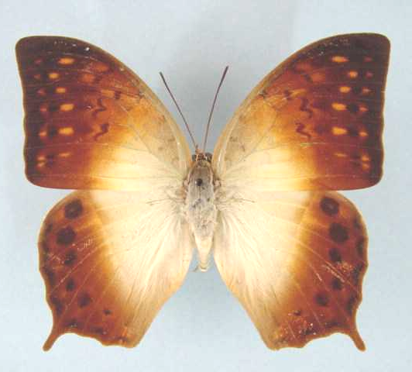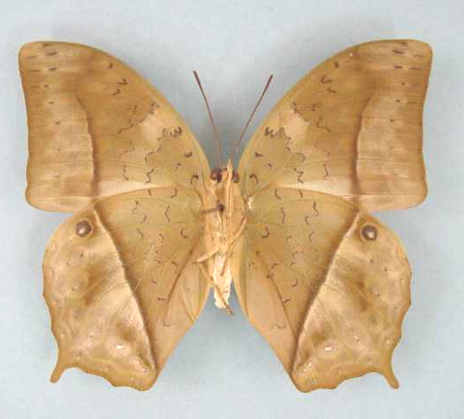

Charaxes fulvescens monitor. Male. Left – upperside; right – underside. Wingspan: 79mm. Entebbe, Uganda. 27-11-68. Rev. H. Falke. (Henning collection - H251).

Type locality: Uganda: “Fajao, Unyoro”.
Distribution: Central African Republic, Sudan (south), Democratic Republic of Congo (east), Uganda, Rwanda, Burundi, Kenya (west), Tanzania (north-west), Zambia (north-west).
Specific localities:
Tanzania – From Mpanda to the Ugandan border (Kielland, 1990).
Zambia – A single record from Ikelenge (Heath and Fisher) (Heath, et al., 2002).

stonehami Jeffery, 1931 (as ssp. of Charaxes fulvescens). Bulletin of the Stoneham Museum (4): [1] ([1 p.]). Kenya: “Kitale”.

Charaxes fulvescens senegala van Someren, 1975

Charaxes fulvescens senegala van Someren, 1975. Bulletin of the British Museum (Natural History) (Entomology) 32: 103 (65-136).
Type locality: Senegal: “Foret classée Santiaba-Mandjak”. Holotype (male) in the Museum national d’Histoire naturelle de Paris.
Distribution: Senegal, Guinea-Bissau, Guinea, Sierra Leone, Liberia, Ivory Coast, Ghana, Togo, Benin (Fermon, et al., 2001), Nigeria (west).
Specific localities:
Senegal – Santiaba-Mandjak (TL); Basse Casamance (Larsen, 2005a).
Sierra Leone – Freetown (Owen & Chanter, 1972).
Ivory Coast – Bossematie (Fermon teste Larsen, 2005a).
Ghana – Atewa Range (Joly, 2003).
Benin – Noyau Central, Lama Forest (Fermon et al., 2001).
Nigeria – Warri (H. Boersma teste Larsen, 2005a).

maesseni Plantrou, 1989 (as ssp. of Charaxes fulvescens). In: Henning, 1989. The Charaxinae butterflies of Africa 42 (457 pp.). Johannesburg. Holotype (male) in the Muséum nationale d’Histoire naturelle de Paris. Type locality: Ghana: “Anfoega”. Synonymized with C. fulvescens senegala van Someren, 1975 by Larsen, 2005a, syn. nov.

Charaxes saperanus Poulton, 1926

Charaxes saperanus Poulton, 1926. Internationaler Entomologen-Kongress 2: 569 (518-575).
Type locality: Comoro Islands: “Mayotte (Comoren)”.
Distribution: Comoro Islands (Mayotte).
Habitat: Dry forest and patches of vegetation between plantations (Henning, 1989).
Early stages:

Henning, 1989: 44.

Larval food:
Allophylus sp. (Sapindaceae) [Henning, 1989: 44].

comoranus Aurivillius, 1909 (as var. of Charaxes varanes). In: Voeltzkow, A., Reise in Ostafrika in den Jahren 1903-1905 2: 321 (309-348). Stuttgart. Comoro Islands: “Mayotte (Comoren)”. [Invalid; junior primary homonym of Charaxes castor comoranus Rothschild, 1903 [Charaxinae].]

Charaxes acuminatus Thurau, 1903

Charaxes acuminatus Thurau, 1903. Berliner Entomologische Zeitschrift 48: 139 (117-143).
Type locality: Tanzania: “Langenburg”. Holotype (female) in the Berlin Museum.
Diagnosis: Characterized, as the specific name implies, by the acuminate (pointed) forewings (Kielland, 1990).
Distribution: Uganda, Rwanda, Burundi (Kielland, 1990), Kenya, Tanzania, Democratic Republic of Congo, Malawi, Zambia, Zimbabwe.
Common name: Pointed pearl charaxes; mountain pearl charaxes.
Habitat: Montane forest, mostly at altitudes above 1 800 m. In Tanzania the nominate subspecies is found at altitudes from 300 to over 2 000 m; ssp. usambarensis from 500 to 1 800 m; ssp. teitensis from 1 700 to 2 600 m; ssp. rondonis up to 870 m (Kielland, 1990).
Habits: The flight is relatively slow and specimens often settle on exposed leaves (Kielland, 1990). Specimens usually fly in the forest understorey rather than the canopy. Males defend territories from bushes or low trees on forest margins and in forest clearings. Both sexes come to fermenting fruit and males also come to damp patches (Larsen, 1991). In Tanzania, on some mountains, specimens are much attracted to fermenting bananas while on other mountains specimens seem to prefer sap oozing from wounds in the trunks and branches of trees and shrubs (Kielland, 1990).
Flight period: September to June for ssp. vumba (Pringle, et al., 1994).
Early stages:

Van Someren and Rogers, 1928: 118 [ssp. kigezia; see also Van Son, 1979: 145].
“This alpine race of fulvescens selects as the food plant of the larva a small shrub allied to that known to the Baganda as “Nkuzanyana”. We have also taken their eggs and larvae on a further species of Allophylus as yet undetermined. The eggs are similar to those of the race monitor [of fulvescens], but are larger and rather yellower in colour when first laid. At the first instar the young larvae are dull brownish-olive, with a black head carrying white spines. The anal “tails” are pronounced and whitish. In the second stage the head and body become more greyish-green while the head horns are well developed and strongly divergent. At the end of this stage the larva is 15 mm long and has one or two dorsal spots. The larva grows to about 30 mm and then moults for the last time. The mature larva is very like that of monitor or even varanes, but is much more ornamented with white-tipped papillae on the body segments and possesses oblique segmental lines which reach the spiracular line which is greyish-white. The segments 6, 8 and 10 carry crescentic or trident-like marks which are either greyish with a bluish outline or reddish with a pale green margin. Just before pupating it measures 55 mm. The pupa is like that of monitor in shape but is rather more ornamented with bluish-grey marks.”

Henning, 1989: 50. [ssp. mlanje; ssp. shimbanus; ssp. oreas; ssp. stonehamiana].

Mullin, 1994 in Pringle, et al., 1994: 86 (ssp. vumba).

Larval food:
Allophylus species (Sapindaceae) [Van Someren and Rogers, 1928: 118 (ssp. oreas).].
Bersama abyssinica Fresen. (Melianthaceae) [Van Someren, 1974: 321 (ssp. oreas).].
Allophylus alnifolius (Bak.) Radlk. (Sapindaceae) [Henning, 1989: 52 (for ssp. shimbanus).].
Allophylus chirindensis E.G. Baker (Sapindaceae) [Pringle, et al., 1994: 86 (ssp. vumba).].
Allophylus abyssinicus (Hochst.) Radlk. (Sapindaceae) [Henning, 1989: 52 (ssp. stonehamiana).].
Allophylus chaunostachys Gilg. (Sapindaceae) [Henning, 1989: 51 (for ssp. mlanje); Mullin, in Pringle, et al., 1994: 86 (ssp. vumba).].
Allophylus africanus Beauv. (Sapindaceae) [Mullin, in Pringle, et al., 1994: 86; in captivity (ssp. vumba).].
Note: Larsen (1991: 283) suggests that the population of C. aciminatus in the Loita Hills, Kenya may deserve subspecific status.

Charaxes acuminatus acuminatus Thurau, 1903

Charaxes acuminatus Thurau, 1903. Berliner Entomologische Zeitschrift 48: 139 (117-143).
Type locality: Tanzania: “Langenburg”.
Diagnosis: Different populations of this subspecies, in Tanzania, are very variable (Kielland, 1990).
Distribution: Tanzania, Malawi (extreme north).
Specific localities:
Tanzania – Rungwe Mountains; Livingstone Mountains (Henning, 1989); Kitesa Forest; Uzungwa Range; Masagati Forest; mountains of Mpwapwa District; Ukaguru Mountains; Nguru Mountains; Nguu Mountains; Uluguru Mountains (Kielland, 1990).
Malawi – Mughesse Forest: Misuku hills (Roger White, pers. comm., 2003).

Charaxes acuminatus cottrelli van Someren, 1963

Charaxes acuminatus cottrelli van Someren, 1963. Bulletin of the British Museum (Natural History) (Entomology) 13: 213 (195-242).

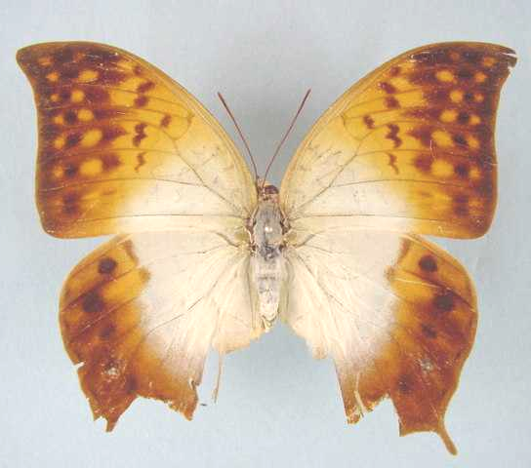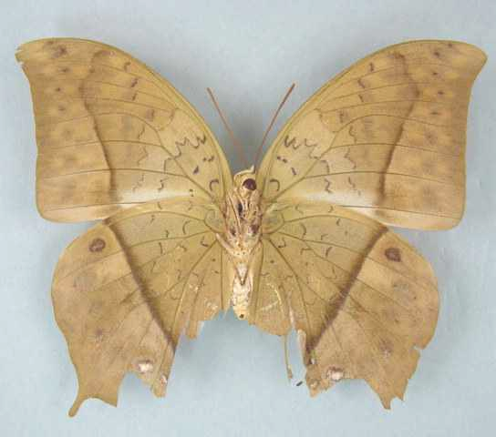

Charaxes acuminatus cottrelli. Male. Left – upperside; right – underside. Wingspan: 92mm. Mudwiji Plains, Mwinilunga dist., Zambia. 15 December, 1983. A.J. Gardiner. (Gardiner Collection).

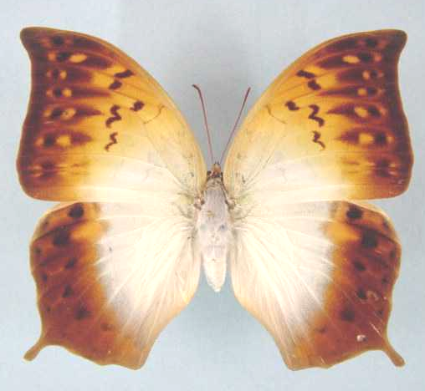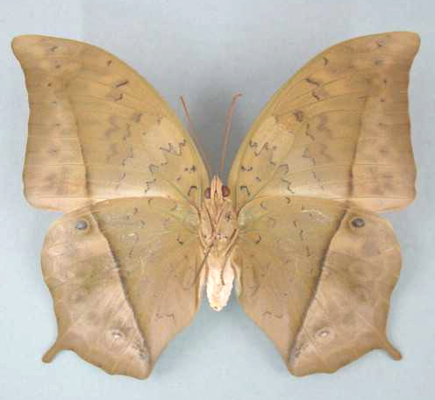

Charaxes acuminatus cottrelli. Male. Left – upperside; right – underside. Wingspan: 89mm. Hillwood, N.W. Zambia. 14.IV.2000. TCE Congdon. (African Butterfly Research Institute, Nairobi).

Type locality: Zambia: “NW. Rhodesia: Mwinilunga, in gallery forest at source of Zambesi River”. Holotype (male) in the Natural History Museum (London).
Distribution: Zambia (extreme north-west), Democratic Republic of Congo (south-east - Shaba).
Specific localities:
Zambia – Zambezi River source near Ikelenge (TL); Jimbe River source; forest patches near Mundwiji Plain (Heath, et al., 2002).

Charaxes acuminatus kigezia van Someren, 1963

Charaxes acuminatus kigezia van Someren, 1963. Bulletin of the British Museum (Natural History) (Entomology) 13: 218 (195-242).
Type locality: Uganda: “SW. Uganda, Kigezi, Mafuga Forest, Rutenga”. Holotype (male) in the Natural History Museum (London).
Distribution: Uganda (west), Rwanda, Burundi, Democratic Republic of Congo (Ituri, Kivu, Lualaba), Tanzania (north-west).
Specific localities:
Tanzania – Rumanyika Game Reserve (uncommon) (Congdon and Collins, 1998).

Charaxes acuminatus kulalae van Someren, 1975

Charaxes acuminatus kulalensis van Someren, 1963. Bulletin of the British Museum (Natural History) (Entomology) 13: 217 (195-242).
Type locality: Kenya: “Northern Frontier Province, at Mt. Kulal, SE. Lake Rudolf”. Holotype (male) in the Natural History Museum (London).
Distribution: Kenya (north).
Specific localities:
Kenya – Mt Kulal (TL).

Charaxes acuminatus mlanji van Someren, 1963
Charaxes acuminatus mlanji van Someren, 1963. Bulletin of the British Museum (Natural History) (Entomology) 13: 212 (195-242).
Type locality: Malawi: “Nyassaland: Mt. Mlanji”. Holotype (male) in the Natural History Museum (London).
Distribution: Malawi (south).

Charaxes acuminatus nyika van Someren, 1963

Charaxes acuminatus nyika van Someren, 1963. Bulletin of the British Museum (Natural History) (Entomology) 13: 214 (195-242).

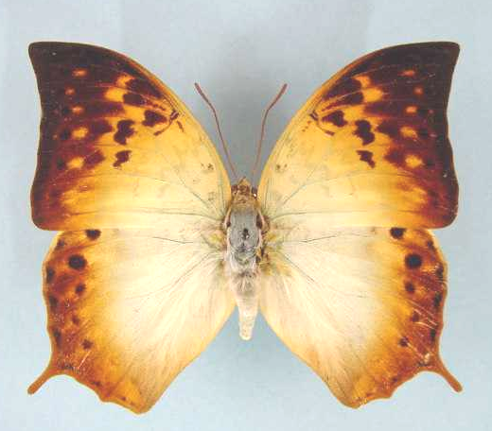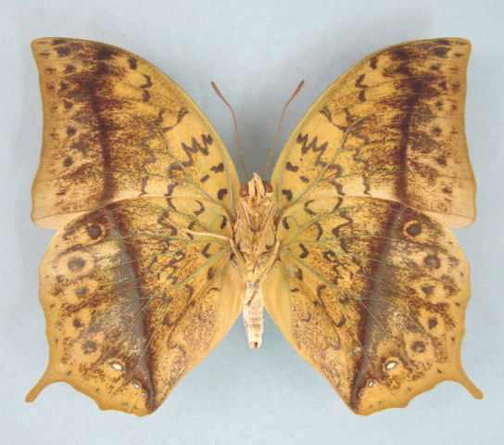

Charaxes acuminatus nyika. Male. Left – upperside; right – underside. Wingspan: 78mm. Chowa Forest, Nyika, Zambia. 26.10.71. I. Bampton. (Henning collection - H253).

Type locality: Malawi: “Nyassaland, Nyika Plateau, Manchowe”. Holotype (male) in the Natural History Museum (London).
Distribution: Malawi (Nyika Plateau), Zambia (north-east).
Specific localities:
Zambia – Nyika; Mafinga Mountains; Makutu Mountains (Heath, et al., 2002).

Charaxes acuminatus oreas Talbot, 1932

Charaxes fulvescens oreas Talbot, 1932. Bulletin of the Hill Museum, Witley 4: 181 (181).
Type locality: Kenya: “Manyuiki to Meru”.
Distribution: Kenya (central highlands east of Rift Valley).
Specific localities:
Kenya – Meru Forest (Mt Kenya); southern Aberdares; upper Kikuyu; Karita Forest; Katamayo (Henning, 1989).

Charaxes acuminatus rondonis Kielland, 1987

Charaxes acuminatus rondonis Kielland, 1987. Lambillionea 87: 123 (114-126).
Type locality: Tanzania: “Lindi, Rondo Plateau, 800 m”.
Diagnosis: Forewing distal margin almost straight, with the apex almost forming a right angle (Kielland, 1990).
Distribution: Tanzania (south-east). Holotype (male) in the Natural History Museum, London.
Specific localities:
Tanzania – Rondo Plateau, in the Lindi District (Kielland, 1990).
Note: Henning, (1989: 436) spells this taxon as rondoensis.

Charaxes acuminatus shimbanus van Someren, 1963

Charaxes acuminatus shimbanus van Someren, 1963. Bulletin of the British Museum (Natural History) (Entomology) 13: 215 (195-242).
Type locality: Kenya: “Kenya Coast, Shimba Hills, Makadara forest”. Holotype (male) in the Natural History Museum (London).
Distribution: Kenya (south-east coast).
Specific localities:
Kenya – Shimba Hills (Larsen, 1991).

Charaxes acuminatus stonehamiana Collins & Larsen, 1991

Charaxes acuminatus stonehamiana Collins & Larsen, 1991 in Larsen, 1991. In: The butterflies of Kenya and their natural history 282, 441 (490 pp.). Oxford.
Type locality: Kenya: “Mt Elgon”.
Distribution: Kenya (west).

Charaxes acuminatus teitensis van Someren, 1963

Charaxes acuminatus teitensis van Someren, 1963. Bulletin of the British Museum (Natural History) (Entomology) 13: 216 (195-242).
Type locality: Kenya: “SW. Kenya, Teita Hills, Chawia Forest”. Holotype (male) in the Natural History Museum (London).
Diagnosis: Underside of wings much darker than in other Tanzanian subspecies, with a greenish sheen (Kielland, 1990).
Distribution: Kenya (south-east), Tanzania (north - Mt Kilimanjaro, Mt Meru).
Specific localities:
Kenya – Mount Mbolo (Henning, 1989), Teita Hills; Chyulu Hills; Ol’Doinyo Orok (Larsen, 1991).
Tanzania – Mountains of Northern Highlands: Oldeani; Ngorongoro; Mount Meru; Mount Longido (Kielland, 1990).

Charaxes acuminatus thiryi Bouyer & Vingerhoedt, 2001

Charaxes acuminatus thiryi Bouyer & Vingerhoedt, 2001. Entomologia Africana 6 (1): 27 (26-30).
Type locality: Democratic Republic of Congo: “Upemba, Lusinga, Shaba, Kafwe National Park”.
Distribution: Democratic Republic of Congo.

Charaxes acuminatus usambarensis van Someren, 1963

Charaxes acuminatus usambarensis van Someren, 1963. Bulletin of the British Museum (Natural History) (Entomology) 13: 214 (195-242).
Type locality: Tanzania: “Tanganyika Territory, Usambara Range, Amani”. Holotype (male) in the Natural History Museum (London).
Diagnosis: Differs from the nominate subspecies in the less acuminate forewing, distinct ochreous submarginal spots, and paler distal portion of the hindwing upperside (Kielland, 1990).
Distribution: Tanzania (north-east).
Specific localities:
Tanzania – Usambara Mountains; South and North Pare Mountains (Kielland, 1990).

Charaxes acuminatus vumba van Someren, 1963

Charaxes acuminatus vumba van Someren, 1963. Bulletin of the British Museum (Natural History) (Entomology) 13: 211 (195-242).
Type locality: Zimbabwe: “S. Rhodesia, Vumba Mts”. Holotype (male) in the Natural History Museum, London.
Distribution: Zimbabwe (eastern border).
Specific localities:
Zimbabwe – Mutare; Chimanimani Mountains (Pringle, et al., 1994); Vumba Mountains, below Castle Beacon (Barnes); Tarka Forest near Melsetter (Roger White, pers. comm., 2003).

Charaxes obudoensis van Someren, 1969

Charaxes acuminatus obudoensis van Someren, 1969. Bulletin of the British Museum (Natural History) (Entomology) 23: 77 (75-166).
Charaxes obudoensis van Someren. Henning, S.F., 1989.
Type locality: Nigeria: “Eastern Nigeria, Obudo Plateau, 5,200 ft”. Holotype (male) in the Natural History Museum, London.
Distribution: Nigeria (east), Cameroon (west).
Specific localities:
Nigeria – Obudu Plateau (TL); Mambilla Plateau (Larsen, 2005a).
Cameroon – Bamenda (Larsen, 2005a); Mount Oku (Larsen, 2005a); Manengouba Massif (Larsen, 2005a); Rumpi Hills (Larsen, 2005a).
Common name: Obudu pearl charaxes.
Habitat: Submontane and montane forest, at elevations above 1 400 m (Larsen, 2005a).
Habits: At times it may be common (Larsen, 2005a).
Early stages: Nothing published.
Larval food: Nothing published.
Note: C. obudoensis van Someren, 1969 is treated as a subspecies of acuminatus Thurau, 1903 by Darge (1983: 63). Henning (1989: 53) treats obudoensis as a distinct species on the authority of Plantrou (1983). Plantrou’s paper is, however, an unpublished thesis; thus the taxonomic change is, strictly speaking, not valid.

Charaxes balfouri Butler, 1881

Charaxes balfouri Butler, 1881. Proceedings of the Zoological Society of London 1881: 176 (175-180).
Type locality: Yemen: “Socotra”.
Distribution: Yemen (island of Socotra).
Habitat: Forest, at altitudes of 500 to 1 000 m.
Early stages: Nothing published.
Larval food: Nothing published.

Charaxes analava Ward, 1872

Charaxes analava Ward, 1872. Entomologist’s Monthly Magazine 9: 3 (2-3).
Type locality: Madagascar: “Madagascar”.
Distribution: Madagascar (widespread).
Habitat: Forest.
Early stages: Nothing published.
Larval food: Nothing published.

CANDIOPE GROUP

Charaxes candiope (Godart, 1824)

Nymphalis candiope Godart, 1824 in Latreille and Godart, [1819], [1824]. Encyclopédie Méthodique. Histoire Naturelle [Zoologie] 9 Entomologie: 353 (1-328 [1819], 329-828 [1824]). Paris.

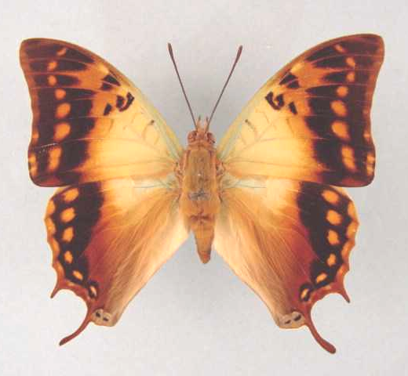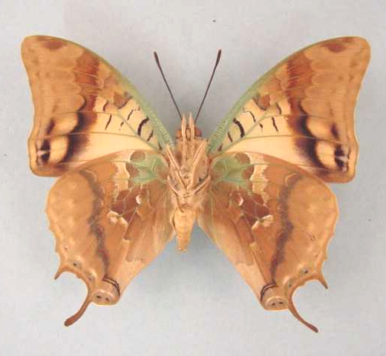

Charaxes candiope. Male. Left – upperside; right – underside. Wingspan: 77mm. Bomponi, S. Rhodesia. 11.7.57. H. Cookson. (Transvaal Museum - TM3336).

Type locality: No locality given.
Distribution: Senegal, Gambia?, Guinea, Sierra Leone, Ivory Coast, Ghana, Nigeria (south and Cross River loop), Cameroon (south), Ethiopia, Kenya, Tanzania, Zambia, Mozambique, Zimbabwe, Botswana, Namibia (north), South Africa (Limpopo Province, Mpumalanga, North West Province, Gauteng, KwaZulu-Natal, Eastern Cape Province), Swaziland.
Specific localities:
Sierra Leone – Freetown (Owen & Chanter, 1972).
Ivory Coast – Bossematie (H. Fermon teste Larsen, 2005a).
Ghana – Atewa Range (Joly, 2003).
Nigeria – Warri (H. Boersma teste Larsen, 2005a); Kaduna (R. St Leger teste Larsen, 2005a).
Cameroon – Korup (Larsen, 2005a).
Tanzania – Throughout, including Pemba Island (Kielland, 1990).
Zambia – Kasangezhi; Mufulira; Ndola; Mpongwe; Kafue; Lumangwe Falls; Sumbu; Kalambo Falls; Nyika; Mafinga Mountains (Heath, et al., 2002).
Namibia – Waterberg Plateau Park (Swart, 2004)
Limpopo Province – Warmbaths (Swanepoel, 1953); Naboomspruit (Swanepoel, 1953); Tubex (Swanepoel, 1953); Legalameetse Nature Reserve (“Malta Forest”) (Swanepoel, 1953); Mica (Swanepoel, 1953); Tzaneen (Swanepoel, 1953); Woodbush (Swanepoel, 1953); Mokeetsi (Swanepoel, 1953); Sibasa (Swanepoel, 1953); Entabeni (Swanepoel, 1953); Waterpoort (Swanepoel, 1953); Saltpan (Swanepoel, 1953).
Mpumalanga – Barberton (Swanepoel, 1953); Nelspruit (Swanepoel, 1953); Graskop (Swanepoel, 1953); Marieps Kop (Swanepoel, 1953); Buffelskloof Nature Reserve (Williams).
North West Province – Rustenburg (Swanepoel, 1953); Kgaswane Mountain Reserve (Williams); Mountain Sanctuary N.R. (Williams).
Gauteng – Pretoria (Swanepoel, 1953).
KwaZulu-Natal – Oribi Gorge (Swanepoel, 1953); Umkomaas (Swanepoel, 1953); Durban (Swanepoel, 1953); Eshowe (Swanepoel, 1953); Empangeni (Swanepoel, 1953); St Lucia Bay (Swanepoel, 1953); False Bay (Swanepoel, 1953); Kosi Bay (Swanepoel, 1953).
Eastern Cape Province – Port St Johns (Swanepoel, 1953).
Swaziland – Mlawula N. R. (www.sntc.org.sz).
Common name: Green-veined charaxes.
Habitat: Forest and savanna, but excluding arid savanna. In Tanzania at altitudes from sea-level to 2 600 m (Kielland, 1990).
Habits: A common butterfly throughout most of its range but uncommon in West Africa (Larsen, 2005a). The flight is fast and powerful. Males defend territories from perches on the tops of trees. Both sexes are attracted to sap exuding from trees and to fermenting fruit (Pringle, et al., 1994). Males are regularly seen mud-puddling (Williams, unpublished). Has been observed, by I. Bampton, migrating in large numbers, together with C. varanes, in a northerly direction in central Tanzania (Henning, 1989). During this migration the butterflies flew from three to five metres above the ground and covered a distance of at least 480 km (Larsen, 2005a).
Flight period: All year,
Early stages:

Fawcett, 1901: 296. (Trans. Zool. Soc. Lond. 15: 291-322).

Van Someren and Van Someren, 1926: 336.

Van Someren and Rogers, 1928: 121.

Clark, in Van Son, 1979: 146 (Plate 62) [as Charaxes candiope candiope].
“Eggs are laid singly on the surface of a leaf. They are 1,5 mm in diameter by 1,4 mm high. There are some 29-34 rough ribs composed mostly of seven to ten moles which start on the surface of the flattened top and end about one-fifth way down the side; there are traces of cross-bracing. They are pale watery dull yellow at first turning to almost white with a circlet composed mostly of brown dots, and a brown dot on the micropyle. The egg stage is eight to nine days. The young larva, on hatching, is 4,2 mm in length, pale green with the extremities with brown and the head is black with pale brown blotches on the adfrontals and yellowish tips to the horns. Toward the end of this instar a whitish dorsal patch develops on segment 6, and the larva is a darker green. This instar lasts seven to eight days and the larva grows to 8 mm. The illustrations show the development in subsequent instars. In the 2nd instar the larva grows to 12 mm in six to seven days; in the 3rd it grows to 18 mm in seven to eight days; in the 4th to 26,5 mm in 13-15 days and in the final instar to 50 mm in 22-28 days. The larva feeds on the edge of leaves at intervals and then crawls away to a spun mat. The pupa is 26 mm long and is suspended from cremastral hooks only from the underside of a leaf or twig. The pupal stage lasts for 20-22 days.”

Henning, S., 1989: 57 [as Charaxes candiope candiope].

Larval food:
Croton sylvaticus Hochst. (Euphorbiaceae) [Fawcett, 1901: 296].
Croton megalocarpus Hutch. (Euphorbiaceae) [Van Someren and Rogers, 1928: 121].
Croton dichogamus Pax (Euphorbiaceae) [Van Someren and Rogers, 1928: 121].
Pennisetum species (Poaceae) [Gifford, 1965: 92; requires confirmation].
Croton macrostachys Delil (Euphorbiaceae) [Van Someren, 1974: 320].
Croton gratissimus Burch. (Euphorbiaceae) [Van Son, 1979: 147].

viridicostatus Aurivillius, 1879 (as sp. of Charaxes). Ofversigt af Kongl. Vetenskaps-Akademiens Förhlhandlingar. Stockholm 36 (7): 41 (39-69). Namibia: “Damaralandet”.

uniformis Storace, 1948 (as f. of Charaxes candiope). Annali del Museo Civico di Storia Naturale (di Genova) Giacomo Doria 63: 139 (132-141). Ethiopia: “Sciotalit (Scioa, Abissinia)”.

rosae Storace, 1948 (as ab. of Charaxes candiope uniformis). Annali del Museo Civico di Storia Naturale (di Genova) Giacomo Doria 63: 140 (132-141). No locality given.

Charaxes thomasius Staudinger, 1886

Charaxes candiope thomasius Staudinger, 1886 in Staudinger and Schatz, 1884-8. Exotische Schmetterlinge 1: 169 (333 pp.). Bayern.
Charaxes thomasius Staudinger, 1886. Wojtusiak & Pyrcz, 1997: 58 stat. rev.
Type locality: Sao Tome and Principe: “Insel St. Thomas”.
Distribution: Sao Tome and Principe (Sao Tome Island).
Habitat:
Early stages: Nothing published.
Larval food: Nothing published.
Note: Treated as a subspecies of C. candiope by Larsen, 2005a.

Charaxes velox Ogilvie-Grant, 1899

Charaxes velox Ogilvie-Grant, 1899. Bulletin of the Liverpool Museums 2: 10 (10-11).
Type locality: Yemen: “Sokotra, from nearly sea-level to an elevation of at least 4000 feet”.
Distribution: Yemen (Socotra Island).
Habitat:
Early stages: Nothing published.
Larval food: Nothing published.
Note: Treated as a subspecies of C. candiope by Larsen, 2005a.

Charaxes antamboulou Lucas, 1872

Charaxes antamboulou Lucas, 1872. Annales des Sciences Naturelles (5) 15 (No. 22): 1 (4 pp.).
Type locality: Madagascar.
Distribution: Madagascar (widespread).
Habitat: Forest and well wooded areas.
Early stages: Nothing published.
Larval food:
Croton sp. (Euphorbiaceae) [Henning, 1989: 58].

meridionalis Le Cerf, 1923 (as f. (?an. ssp.) of Charaxes antamboulou). Bulletin du Muséum National d’Histoire Naturelle. Paris 29: 428 (360-367, 428-429). Madagascar: “Madagascar, Fianarantsoa”.

Charaxes cowani Butler, 1878

Charaxes cowani Butler, 1878. Annals and Magazine of Natural History (5) 2: 285 (283-297).
Type locality: Madagascar: “in the forest, Fianarantsoa”. Holotype (female) in the Natural History Museum, London.
Distribution: Madagascar (east).
Specific localities:
Madagascar – Ambositra; Ambatomtorahana; Tananarive; Beparasy; La Mandraka; Anosibe; Perinet (Henning, 1989),
Habitat: Montane forest, usually at altitudes of more than 1 000 m (Henning, 1989).
Early stages: Nothing published.
Larval food: Nothing published.

CYNTHIA GROUP

Charaxes protoclea Feisthamel, 1850

Charaxes protoclea Feisthamel, 1850. Annales de la Société Entomologique de France (2) 8: 260 (247-262).
Type locality: Senegal: “Cazamance”.
Distribution: Senegal, Gambia?, Guinea-Bissau, Guinea, Sierra Leone, Liberia, Ivory Coast, Ghana, Togo, Nigeria, Cameroon, Equatorial Guinea, Central African Republic, Gabon, Congo, Angola, Democratic Republic of Congo, Uganda, Kenya, Tanzania, Zambia, Malawi, Zimbabwe, Mozambique, South Africa.
Common name: Flame-bordered charaxes.
Habitat: Forest of all types and woodland (Henning, 1989). In Tanzania ssp. azota is found from sea-level to 1 700 m; spp. catenaria from 800 to 2 000 m (Kielland, 1990).
Habits: A common forest charaxes (Larsen, 2005a). Males do not appear to show perching and territorial bahaviours (Larsen, 2005a). Both sexes feed from fermenting fruit and males come to scats and carrion. Occasionally males come to damp patches, perhaps where animals have urinated on river banks (Larsen, 1991). It has a powerful flight and is a very wary insect (Pringle, et al., 1994). Larsen (2005) records a male specimen coming to a moth-light, together with a C. bipunctatus, at 20:00.
Flight period: All year, with dry-season specimens, especially females, having more extensive orange markings (Paré, cited by Pringle, et al., 1994).
Early stages:

Van Someren and Rogers, 1928: 128 [ssp. azota].
“Rogers describes the mature larva as being of the usual Charaxes-shape, green in colour, with the head bordered with brown. The spiracular line is orange, the tubercles being more orange. The green of the body has a somewhat mottled appearance which changes before pupation into a dull yellow, with a row of large lateral ill-defined brown spots. The dorsum of segment 6 is ornamented with a large triangular orange-brown mark, the apex directed backwards. The pupa is pinkish with chocolate-brown markings.”

Van Someren, 1935: 173 [ssp. azota].
“The eggs are laid singly or in two’s on the leaves of Afzelia quanzensis Welw. (Leguminosae) and also of Syzygium species near guineensis (Myrtaceae). They are rather barrel-shaped, flattened on top, with distinct fluting, and rounded at the base. Colour cream until the fourth day when they turn brown along the upper lip then all over, then blackish as the larva is ready to emerge. As with most species the larva devours the egg-shell. The larva is dull olive with black horns and stippled face; tail end bifid and spotted with white. It turns green at the next moult. The head of the mature larva is somewhat reminiscent of that of Ch. candiope, though with less divergent lateral horns; the horns are rusty-brown, and this colour is carried down along the border of the facial disc to just above the mouth parts which are black. There is a pale ochreous line internal to the brown border. The body of the larva is strongly irrorated, with yellowish tubercles most conspicuous along the lateral line and the “tail”. Dull ochreous oblique lines pass to the suctorial legs. The dorsal marks are well shown on the plate cited; they are putty-grey with blue dots on the edges or dull greyish-pink with blue; the central ornamentation has a distinct oblique cross. The pupa is a beautiful object, pink and chocolate, and has already been described.”

Henning, S., 1989: 64 [ssp. azota].

Larval food:
Afzelia africana Sm. ex Pers. (Fabaceae) [Blandin, et al., 1975 (Ivory Coast); Henning, S., 1989: 65 (ssp. protoclea; ssp. azota).].
Afzelia quanzensis Welw . (Fabaceae) [Van Someren, 1936: 173 (ssp. azota).].
Berlinia craibiana Bak. f. (Fabaceae) [Henning, S., 1989: 65 (ssp. azota).].
Brachystegia spiciformis Benth. (syn. edulis Hutch. and Burtt Davy) (Fabaceae) [Gifford, 1965: 94 (ssp. azota).].
Bussea occidentalis Hutch. (Fabaceae) [Henning, S., 1989: 65 (ssp. azota).].
Cassia species (Fabaceae) [Larsen, 2005a].
Julbernardia globiflora (Benth.) Troup. (Fabaceae) [Henning, S., 1989: 65 (ssp. azota).].
Oxytenanthera abyssinica (A. Rich.) Munro (Poaceae) [Gifford, 1965: 94 (ssp. azota).].
Syzygium cordatum Hochst. (Myrtaceae) [Van Someren, 1974: 320 (ssp. azota).].
Syzygium species near guineense (Willd.) DC. (Myrtaceae) [Van Someren, 1936: 173 (ssp. azota).].

Charaxes protoclea protoclea Feisthamel, 1850

Charaxes protoclea Feisthamel, 1850. Annales de la Société Entomologique de France (2) 8: 260 (247-262).
Type locality: Senegal: “Cazamance”.
Distribution: Senegal, Gambia?, Guinea-Bissau, Guinea, Sierra Leone, Liberia, Ivory Coast, Ghana, Togo, Nigeria (west).
Specific localities:
Ivory Coast – Bossematie (H. Fermon teste Larsen, 2005a).
Ghana – Atewa Range (Joly, 2003).
Nigeria – Warri (H. Boersma teste Larsen, 2005a).

aeson Herrich-Schaeffer, 1858 in Herrich-Schaeffer, [1856-8] (as sp. of Charaxes). Sammlung neuer oder wenig bekannter aussereuropäischer Schmetterlinge 1 (1): 54 (1-84). Regensburg. “Africa occid[entalis]”.

Charaxes protoclea azota (Hewitson, 1877)

Philognoma azota Hewitson, 1877. Entomologist’s Monthly Magazine 14: 82 (81-83).

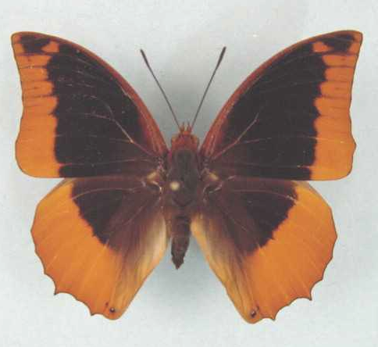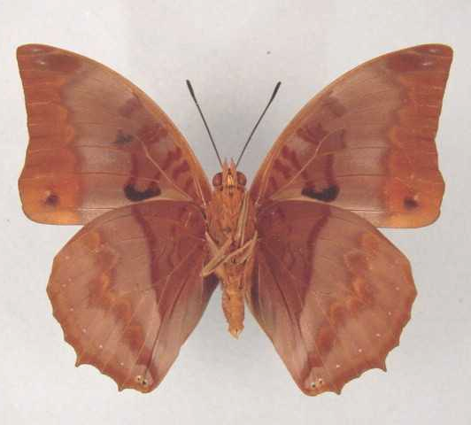

Charaxes protoclea azota. Male. Left – upperside; right – underside. Wingspan: 70mm. Moribane Forest, 20°05'S, 33°15'E, Moz. 6-11.IX.1972. K.M. Pennington. (Transvaal Museum - TM3342).

Type locality: Mozambique: “Delagoa Bay”.
Distribution: Kenya (coast and Shimba Hills), Tanzania (north-east, east, south, south-west), Zambia (north-east), Malawi, Zimbabwe (east), Mozambique (south), South Africa (KwaZulu-Natal).
Diagnosis: Extent of black scaling on upperside of wings much reduced in comparison to the nominate subspecies and ssp. protonothodes (Kielland, 1990).
Specific localities:
Tanzania – North-eastern, eastern, southern and south-western parts, inland to North Pare, Nguru and Ukaguru Mountains (Kielland, 1990); Karanga River; Rau Groundwater Forest Reserve, Moshi; Kahe Forest Reserve (Cordeiro, 1995).
Zambia – Kasama; Lumangwe Falls; Sumbu (Heath, et al., 2002).
Mozambique Salamanga (Bampton).
Zimbabwe – Mount Selinda; Nyanga (Pringle, et al., 1994); Mazoe (Chitty); Bikita (Mullin).
KwaZulu-Natal – Kosi Bay (the Pringles); Emanguzi Forest (Owen-Johnston).
Note: Populations in the north-east of Zambia are somewhat transitional between azota and catenaria but are closer to the former (Heath, et al., 2002).

calliclea Grose-Smith, 1889 (as sp. of Charaxes). Annals and Magazine of Natural History (6) 3: 130 (121-137). Kenya: “neighbourhood of Mombasa”.

nyasana Butler, 1895 (as sp. of Charaxes). Annals and Magazine of Natural History (6) 15: 249 (248-249). Malawi: “Nyasaland (Zomba)”.

aequidistans Gaede, 1916 (as var. of Charaxes protoclea). Internationale Entomologische Zeitschrift 9: 109 (105-106, 109-112, 125-126). Tanzania: “Kisserawe, Deutsch O.-Afrika”.

Charaxes protoclea catenaria Rousseau-Decelle, 1934

Charaxes protoclea catenaria Rousseau-Decelle, 1934. Bulletin de la Société Entomologique de France 39: 229 (228-236).

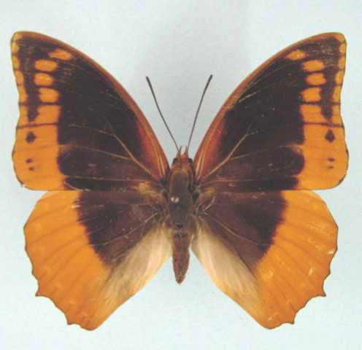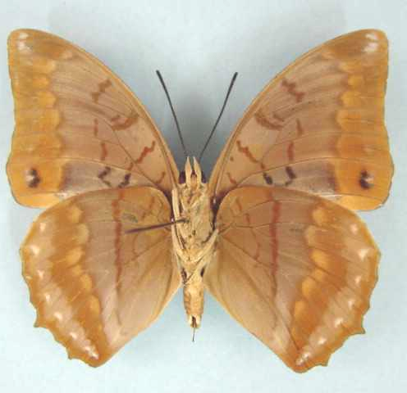

Charaxes protoclea catenaria. Male. Left – upperside; right – underside. Wingspan: 66mm. Zilo, Shaba, Zaïre. Nov 74. Dr V Allard. (Henning collection - H254).

Type locality: Democratic Republic of Congo: “Kafakumba-Katanga, Congo belge”. Holotype (male) was in the collection of Mr G. Rousseau-Decelle.
Distribution: Democratic Republic of Congo (Lualaba), Tanzania (west), Zambia (Copperbelt and north-west).
Specific localities:
Tanzania – Ufipa to Kigoma Districts (Kielland, 1990). These populations are intermediate between ssp. catenaria and ssp. azota (Kielland, 1990).
Zambia – Ikelenge; Kasangezhi; Kamapanda; Mwinilunga; 80 km south of Mwinilunga; Chingola; Mufulira; Ndola; Chisamba (Heath, et al., 2002).
Note: Specimens from the Copperbelt and north-west are intermediate between catenaria and azota but closer to the former (Heath, et al., 2002).

parcepicta Rousseau-Decelle, 1934 (as f. indiv. of Charaxes [protoclea] catenaria). Bulletin de la Société Entomologique de France 39: 230 (228-236). Democratic Republic of Congo: “Katangaji-Katanga, Congo belge”.

bifida Rousseau-Decelle, 1934 (as f. indiv. of Charaxes [protoclea] catenaria). Bulletin de la Société Entomologique de France 39: 230 (228-236). Democratic Republic of Congo: “Kafakumba-Katanga, Congo belge”.

kafakumbana Rousseau-Decelle, 1934 (as f. indiv. of Charaxes [protoclea] catenaria). Bulletin de la Société Entomologique de France 39: 231 (228-236). Democratic Republic of Congo: “Kafakumba-Katanga, Congo belge”.

mutschatschana Rousseau-Decelle, 1934 (as f. indiv. of Charaxes [protoclea] catenaria). Bulletin de la Société Entomologique de France 39: 231 (228-236). Democratic Republic of Congo: “Kafakumba-Katanga, Congo belge”.

Charaxes protoclea cedrici Canu, 1989

Charaxes protoclea cedrici Canu, 1989. In: Henning, 1989. The Charaxinae butterflies of Africa 61 (457 pp.). Johannesburg.
Type locality: Equatorial Guinea: “Bioko”. Holotype (male) in the collection of Dr J.G. Canu.
Distribution: Equatorial Guinea (Bioko Island).

Charaxes protoclea nothodes Jordan, 1911

Charaxes protoclea nothodes Jordan, 1911. Novitates Zoologicae 18: 137 (137-138).
Type locality: Democratic Republic of Congo: “Between Niembo and Kalembo, west of Lake Tanganyika”.
Diagnosis: Male differs from that of the nominate subspecies, on the forewing upperside, where the red colouration is restricted to the tornal area. Feamel with the dark markings blackish (Congdon and Collins, 1998).
Distribution: Democratic Republic of Congo (central, north and east), Uganda (west), Tanzania (north-west).
Specific localities:
Tanzania – Minziro Forest; Kikuru Forest (Congdon and Collins, 1998).

Charaxes protoclea protonothodes van Someren, 1971

Charaxes protoclea protonothodes van Someren, 1971. Bulletin of the British Museum (Natural History) (Entomology) 26: 203 (181-226).
Type locality: Central African Republic: “Bangui”. Holotype (female) in the Natural History Museum, London.
Distribution: Nigeria (Obudu Plateau and east), Cameroon, Central African Republic, Gabon, Congo, Angola (north-west), Democratic Republic of Congo (north-west).
Specific localities:
Nigeria – Obudu Plateau (Larsen, 2005a). Material from eastern Nigeria is apparently transitional (protoclea/protonothodes) (R. St Leger teste Larsen, 2005a); Kagoro (Larsen, 2005a: 321).
Cameroon – Korup (Larsen, 2005a).

maculata Strand, 1910 (as ab. of Charaxes protoclea). Wiener Entomologische Zeitung 29: 30 (29-35). Cameroon: “Kamerun”.

ablutus Schultze, 1914 (as ab. of Charaxes protoclea). Entomologische Rundschau 31: 82 (82-83). Cameroon: “Kamerun”.

nigropunctata Neustetter, 1916 (as ab. of Charaxes protoclea). Deutsche Entomologische Zeitschrift, Iris 30: 106 (95-108). Cameroon: “Kamerun”.

marginepunctata Holland, 1920 (as var. of Charaxes protoclea). Bulletin of the American Museum of Natural History 43: 206 (109-369). Gabon: “Gaboon”.

sinuosa Rousseau-Decelle, 1934 (as f. indiv. of Charaxes protoclea). Bulletin de la Société Entomologique de France 39: 229 (228-236). Congo: “Etoumbi. Congo français”.

jeromei Birket-Smith, 1960 (as f. of Charaxes protoclea protoclea). Bulletin de l’Institut Français d’Afrique Noire (A) 22: 925 (521-554, 924-983, 1259-1284). Cameroon: “river Nyon just south of Makak station”.

Charaxes boueti Feisthamel, 1850

Charaxes boueti Feisthamel, 1850. Annales de la Société Entomologique de France (2) 8: 261 (247-262).
Type locality: Gambia: “Provenant de la Gambie”.
Distribution: Senegal, Gambia, Guinea-Bissau, Guinea, Burkina Faso, Sierra Leone, Liberia, Ivory Coast, Ghana, Togo, Nigeria, Cameroon, Equatorial Guinea (Bioko), Gabon, Congo, Central African Republic, Angola, Democratic Republic of Congo, Sudan, Ethiopia, Uganda.
Common name: Bamboo charaxes.
Habitat: Forest, woodland and savanna, always in the vicinity of the larval foodplant (wild bamboo). In West and Central Africa it has become much commoner in the last 30 to 50 years due to the widespread planting and subsequent spread of alien Indian bamboo, on which the larvae feed (Larsen, 2005a).
Habits: Both sexes fly in bamboo thickets, the males often coming out, circling briefly, and then diving back into the bamboo (Larsen, 2005a). A male was recorded imbibing sap from a ‘sucking-tree’ in Ankasa, Ghana (illustrated in Larsen, 2005a). Migratory behaviour has been noted in the Kaduna district in northern Nigeria (H. Boersma teste Larsen, 2005a).
Early stages:

Darlow, 1949b.

Vuattoux and Blandin, 1977 (ssp. boueti).

Henning, S., 1989: 66 (ssp. rectans).

Larval food:
Arundinaria alpinus K. Schaumann (Poaceae) [Van Someren, 1974: 320].
Oxytenanthera abyssinica (A. Rich.) Munro (Poaceae) [Van Someren, 1974: 320 (ssp. rectans).].
Bambusa vulgaris Schrad. ex J.C. Wendl. (Poaceae) (exotic) [Henning, 1989: 67 (ssp. rectans).].
Afzelia species (Fabaceae) [(West Africa); Larsen (2005a) is sceptical about this record].

Charaxes boueti boueti Feisthamel, 1850

Charaxes boueti Feisthamel, 1850. Annales de la Société Entomologique de France (2) 8: 261 (247-262).
Type locality: Gambia: “Provenant de la Gambie”. The type is in the Oberthür collection.
Distribution: Senegal, Gambia, Guinea-Bissau, Guinea, Burkina Faso, Sierra Leone, Liberia, Ivory Coast, Ghana, Togo, Nigeria (south), Cameroon (west), Equatorial Guinea (Bioko), Gabon, Congo, Central African Republic, Democratic Republic of Congo (west).
Specific localities:
Sierra Leone – Freetown (Owen & Chanter, 1972).
Ghana – Atewa Range (Joly, 2003); Ankasa (Larsen, 2005a).
Nigeria – Vom (Owen, 1977); Warri (H. Boersma teste Larsen, 2005a); Kaduna area (H. Boersma teste Larsen, 2005a).

ghanaensis Rousseau-Decelle and Johnston, 1957 (as ssp. of Charaxes boueti). Bulletin de la Société Entomologique de France 62: 151 (151-153). Togo: “South British Togoland, Vane, près d’Amedzofe”. Synonymized with Charaxes boueti by Larsen, 2005a, syn. nov.

irradians Turlin, 1998 (as f. of Charaxes boueti). Lambillionea 98 (2) (Tome I): 187 (181-189). Guinea, Ivory Coast, Ghana.

Charaxes boueti carvalhoi Bivar de Sousa, 1983

Charaxes boueti carvalhoi Bivar de Sousa, 1983b. Actas del I Congreso Iberico de Entomologia, Facultad de Biologia, Leon, France, 7-10 June, 1983: 113 (107-119).
Type locality: Angola: “Dalatando”. Type specimen in the collection of Bivar de Sousa.
Distribution: Angola (north-west).

Charaxes boueti rectans Rothschild & Jordan, 1903

Charaxes boueti rectans Rothschild & Jordan, 1903. Novitates Zoologicae 10: 540 (491-542).
Type locality: Ethiopia: “Upper Urga, Kollu, Schoa”. Type specimen in the Natural History Museum, London.
Distribution: Sudan (south), Ethiopia (south-west), Uganda (north).
Specific localities:
Uganda – Karamoja (Larsen, 2005a).
Note: Larsen (2005a) notes that ssp. rectans should possibly be considered specifically distinct.

Charaxes macclounii Butler, 1895

Charaxes macclounii Butler, 1895. Proceedings of the Zoological Society of London 1895: 252 (250-270).

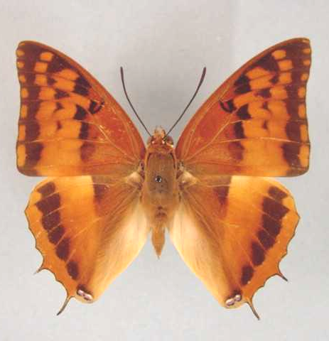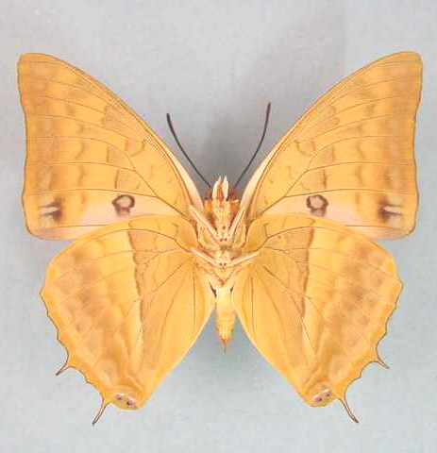

Charaxes macclounii. Male. Left – upperside; right – underside. Wingspan: 58mm. Bomponi, Vumba, S. R. 8.7.59. H. Cookson. (Transvaal Museum - TM3343).

Type locality: Malawi: “Zomba”.
Diagnosis: Close to C. lasti but underside much paler and with a less distinct silvery band (Kielland, 1990).
Distribution: Kenya (coast), Tanzania (south, west and east), Democratic Republic of Congo (Tshopo, Lualaba, Shaba), Angola (north-east), Burundi, Zambia, Malawi, Mozambique, Zimbabwe (eastern border and north).
Specific localities:
Tanzania – Sibwesa, Mpanda District; Kitesa Forest; Iringa; Image Mountain; Ukaguru Mountains; Nguru Mountains; Kanga Mountains; Nguu Mountains; Usambara Mountains (Kielland, 1990).
Zambia – Kasangezhi; Kabompo Gorge; Mufulira; Kitwe; Ndola; Chipata; Nzadzu; Musonda Falls; Kundalila Falls; Makutu Mountains; Mafinga Mountains (Heath, et al., 2002).
Mozambique – Posto de Catandica; Dondo; Amatongas (Pennington).
Zimbabwe – Mutare (Kroon); Lomagundi; Bindura (Pinhey); Dichwe Farm, near Chinhoyi (Mullin); Bomponi, Vumba (H. Cookson).
Common name: Wild-bamboo charaxes; red coast charaxes.
Habitat: Dense savanna and open forest; especially on hillsides where there are strong stands of bamboo (the larval foodplant). In Tanzania from sea-lvel to 2 000 m (Kielland, 1990).
Habits: Males defend territories from perches, high up, on bamboo leaves. Males have been noted drinking from damp patches. Apparently they are less active than most other species of Charaxes (Pringle, et al., 1994).
Flight period: All year (Pringle, et al., 1994).
Early stages:

Henning, G., 1977: 221 [as Charaxes boueti macclounii; Ndola, Zambia].

McCleery, in Van Son, 1979: 150 [as Charaxes boueti macclounii; Tanzania].
“The ova are laid singly on the upper aspects of the leaves [of bamboo], usually mature, around the periphery of the clump [of bamboo] at 0,9 to 1,5 m from the ground. Most eggs are found on the aspect of the clump which is exposed to the midday sun, for a short while. Rearing of larvae proved most difficult; sleeving larvae in situ usually resulted in the whole lot being destroyed by ants. Placing larvae in a rearing cage necessitated changing the food twice a day as bamboo fades and dries within an hour of plucking even when stems are placed in water. The young larvae spun a cushion of silk wherever they rested, and with the curling of the leaves they became entrapped along with their excreta; numbers perished in this way. Trying to remove them, even with a soft brush, is equally fatal. Larvae are prone to die from a virus infection. To secure accurate notes on all stages, some females were caught and placed in glass breeding cages. They laid fairly readily, producing 10-30 fertile eggs a piece. The most successful broods gave the following data: Nine ova laid on 24.I.1964, light green, “ringing up” on second day. Larvae hatched on 4.II.1964, pale yellowish-green with black heads. First moult commenced on 12.II.1964, larvae now green; lower third of head green, the rest black. Second moult commenced 21.II.1964, body greener; lower part of head green, upper part black with sides and tips of horns greyish in colour. Third moult commenced 28.II.1964, body green, head mostly green with pinkish-white horns; tails pinkish-white. Five larvae had a small white spot on dorsum of fifth somite. Fourth moult commenced 10.III.1964, head and body green; a continuous bold whitish line along the lateral aspect of the body, including the outer aspect of lateral horns and the tails. Five larvae retained the white spot. Final length 45-50 mm. Pupation commenced 27.III.1964. The pupae are of two types: (1) pale green with white along dorsal ridge and along dorso-lateral spiracular line; antennal sheath and wing scutas with white streaks. (2) Groundcolour chocolate-brown, with similar whitish marks. Five larvae pupated, four green, one chocolate. Length of pupa 22-23 mm. To obtain full-size imagoes, it was found more satisfactory to hunt the bamboo for mature larvae and pupae than to breed from the egg.”

Henning, S., 1989: 68.

Larval food:
Oxytenanthera abyssinica (A. Rich.) Munro (Poaceae) [Gifford, 1965: 94].
Arundinaria species (Poaceae) [Van Son, 1979: 151].
Oreobambos buchwaldii K. Schum. (Poaceae) [Pringle, et al., 1994: 87].
Bambusa vulgaris Schrad. ex Wendl. (Poaceae) [Pringle, et al., 1994: 87].
Sinarundinaria alpina (Poaceae) [Kielland, 1990: 106; as Arundinaria alpina].
Note: As pointed out by Van Someren (1970: 232) the food-plants Afzelia, Julbernardia and Macrolobium are those of Charaxes lasti Grose-Smith, which was until recently regarded to be a subspecies of C. boueti, as was C. macclounii.
Note: C. macclounii Butler, 1895 is treated as a subspecies of boueti Feisthamel, 1850 by Van Someren (1970: 227). Henning (1989: 67) treats macclounii as a distinct species on the authority of Plantrou (1983). Plantrou’s paper is, however, an unpublished thesis; thus the taxonomic change is, strictly speaking, not valid.

flavescens Lanz, 1896 (as var. of Charaxes lasti). Deutsche Entomologische Zeitschrift, Iris 9: 142 (113-147). Tanzania: “Parumbira”.

Charaxes alticola Grünberg, 1911

Charaxes boueti var. alticola Grünberg, 1911. Wissenschaftliche Ergibnisse der Deutschen Zentral-Afrika Expedition 1907-1908. 3 (17): 539 (506-560), 4 pls. Leipzig.
Type locality: Rwanda: “Nord-Ruanda, Vulcan Karissimbi, 2700 m”.
Distribution: Democratic Republic of Congo (Kivu), Rwanda, Uganda (south-west - Kigezi district).
Habitat: Montane forest, where the larval foodplant (alpine bamboo) grows.
Early stages: Nothing published.
Larval food:
Arundinaria alpinus K. Schaum. (Poaceae) [Henning, 1989: 69.].
Note: C. alticola Grünberg, 1911 is treated as a subspecies of boueti Feisthamel, 1850 by Van Someren (1970: 230). Henning (1989: 69) treats alticola as a distinct species on the authority of Plantrou (1983). Plantrou’s paper is, however, an unpublished thesis; thus the taxonomic change is, strictly speaking, not valid.

Charaxes lasti Grose-Smith, 1889

Charaxes lasti Grose-Smith, 1889. Annals and Magazine of Natural History (6) 3: 131 (121-137).
Type locality: Kenya: “in the neighbourhood of Mombasa”.
Diagnosis: Similar to C. macclounii but the upperside is darker brown and on the underside of the hind wing the silver stripe is straighter and better defined (Kielland, 1990).
Distribution: Kenya, Tanzania.
Common name: Silver-striped charaxes.
Habitat: Coastal and sub-coastal forest, and heavy woodland (Kielland, 1990). In Tanzania the nominate subspecies occurs from near sea-level to 900 m; ssp. kimbozae from 200 to 500 m; ssp. magomberae from 200 to 700 m (Kielland, 1990).
Habits: Males spend long periods perching, occasionally taking short flights in defense of their territory (Larsen, 1991).
Early stages:

Sevastopulo, in Van Someren, 1970: 234 (ssp. lasti).

Henning, S., 1989: 71 (ssp. lasti).

Larval food:
Afzelia quanzensis Welw. (Fabaceae) [Van Someren, 1974: 320].
Paramacrolobium coeruleum (Traub.) J. Leonard (Fabaceae) [Van Someren, 1974: 320].
Julbernadia magnistipulata (Harms.) Troupin (Fabaceae) [Henning, S., 1989: 71.].
Macrolobium species (Fabaceae) [Larsen, 1991: 284].

Charaxes lasti lasti Grose-Smith, 1889

Charaxes lasti Grose-Smith, 1889. Annals and Magazine of Natural History (6) 3: 131 (121-137).
Type locality: Kenya: “in the neighbourhood of Mombasa”.
Distribution: Kenya (south coast, Shimba Hills), Tanzania (north-east).
Specific localities:
Tanzania – Usambaras; Pugu Hills; Morogoro; Turiani; Moshi? (Kielland, 1990); Rau Groundwater Forest Reserve, Moshi (Baker, vide Kielland, 1984).

centralis Neustetter, 1929 (as ssp. of Charaxes boueti). Internationale Entomologische Zeitschrift 22: 391 (389-392). “Frz. Kongo”. [False locality.]

Charaxes lasti kimbozae Kielland, 1984

Charaxes lasti kimbozae Kielland, 1984. Lambillionea 83: 72 (70-77).
Type locality: Tanzania: “Morogoro, Kimboza Forest”. Holotype (male) in the Natural History Museum, London.
Diagnosis: Compared to the nominate subspecies the upperside ochreous discal band is much paler and the blackish forewing submarginal band is wider (Kielland, 1990).
Distribution: Tanzania (east).
Specific localities:
Tanzania – Confined to limestone formations in the Kimboza Forest on the eastern foot of the Uluguru Mountains (Kielland, 1990).

Charaxes lasti magomberae Kielland, 1984

Charaxes lasti magomberae Kielland, 1984. Lambillionea 83: 75 (70-77).
Type locality: Tanzania: “Ifakara, Magombera Forest”. Holotype (male) in the Natural History Museum, London.
Diagnosis: Similar to ssp. kimbozae but the upperside black markings more extensive in both sexes (Kielland, 1990).
Distribution: Tanzania (east).
Specific localities:
Tanzania – Magombera Forest and Mwanihana National Park in the Kilombero Valley (Kielland, 1990).

Charaxes cynthia Butler, 1866

Charaxes cynthia Butler, 1866. Proceedings of the Zoological Society of London 1865: 626 (622-639).
Type locality: Ghana: “Ashanti”. Holotype (male) in the Natural History Museum, London.
Diagnosis: Related to C. lasti, C. macclounii and C. boueti (Kielland, 1990).
Distribution: Senegal, Guinea, Sierra Leone, Liberia, Ivory Coast, Ghana, Nigeria, Cameroon, Gabon, Congo, Central African Republic, Democratic Republic of Congo, Uganda, Angola, Sudan, Uganda, Kenya, Tanzania, Zambia.
Common name: Western red charaxes.
Habitat: Primary forest to degraded forest. Sometimes found in quite open country (Larsen, 2005a). In Tanzania ssp. mukuyu occurs in lowland to submontane forest at altitudes from 800 to 1 500 m (Kielland, 1990).
Habits: Males fly high up in the forest, but sometimes are seen flying low down along paths. Males are very partial to animal scats and both sexes come to fermented fruit and ‘sucking-trees’ (Larsen, 2005a). Females fly in the undergrowth and are reputed to be fond of banana flowers (Larsen, 1991). Larsen (2005a) once observed a female skimming the surface of a lake, much like swallows do.
Early stages:

Vuattoux and Blandin, 1977 (ssp. cynthia).

Henning, S., 1989: 75 (ssp. kinduana; pupa).

Larval food:
Griffonia (=Bandeiraea) simplicifolia Benth. (Fabaceae) [Henning, S., 1989: 75.].

Garcinia species (Guttiferaceae) [Sevastopulo teste Van Someren, 1974: 320; requires confirmation. Apparently erroneous (see Sevastopulo, 1975: 267)].
Albizia zygia (DC.) J.F. Macbr. (Fabaceae) [Henning, S., 1989: 75.].
Griffonia species (Fabaceae) [Larsen, 1991: 285].
Klainedoxa species (Ixonanthaceae) [Larsen, 1991: 285].
Phialodiscus species (Sapindaceae) [Larsen, 1991: 285].
Celtis species (Ulmaceae) [Larsen, 2005a].
Coffea species (Rubiaceae) [Larsen, 2005a].

Charaxes cynthia cynthia Butler, 1866

Charaxes cynthia Butler, 1866. Proceedings of the Zoological Society of London 1865: 626 (622-639).
Type locality: Ghana: “Ashanti”. Holotype (male) in the Natural History Museum, London.
Distribution: Senegal, Guinea, Sierra Leone, Liberia, Ivory Coast, Ghana, Nigeria (western).
Specific localities:
Senegal – Basse Casamance (Larsen, 2005a); Djibelor Forest (Larsen, 2005a).
Sierra Leone – Freetown (Owen & Chanter, 1972).
Ivory Coast – Bossematie (H. Fermon teste Larsen, 2005a).
Ghana – Ashanti (TL); Atewa Range (Joly, 2003); Cape Coast (Larsen, 2005a).
Nigeria – Warri (H. Boersma teste Larsen, 2005a).
Note: populations in eastern Nigeria are transitional to ssp. kinduana Le Cerf, 1923 (Larsen, 2005a).

lysianassa Westwood, 1874 (as sp. of Charaxes). Thesaurus Entomologicus Oxoniensis or illustrations of new, rare, and interesting insects for the most part contained in the collection presented to the University of Oxford 181 (205 pp.). Oxford. Ghana: “Ashantee”.

guineensis Le Moult, 1933 (as ssp. of Charaxes cynthia). Novitates Entomologicae 3: 16 (16-18). Guinea: “Kérouené (Guinée Française)”.

Charaxes cynthia kinduana Le Cerf, 1923

Charaxes cynthia kinduana Le Cerf, 1923. Bulletin du Muséum National d’Histoire Naturelle. Paris 29: 366 (360-367, 428-429).
Type locality: Democratic Republic of Congo: “Congo belge oriental, Kindu”. Holotype male in the Museum nationale d’Histoire Naturelle de Paris.
Distribution: Nigeria (south-east), Cameroon, Gabon, Congo, Central African Republic, Sudan (south), Democratic Republic of Congo (north and central), Uganda (west).
Specific localities:
Nigeria – Kagoro (Larsen, 2005a: 321).

mawamba Grünberg, 1911 (as ab. of Charaxes cynthia). Wissenschaftliche Ergibnisse der Deutschen Zentral-Afrika Expedition 1907-1908. 3 (17): 538 (506-560), 4 pls. Leipzig. Democratic Republic of Congo: “Westl. vom Albert-See, Route Mawambi-Avakubi am Aruwimi”; Uganda; Central African Republic: “Njamnjam”.

albofascia Le Cerf, 1923 (as female f. of Charaxes cynthia). Bulletin du Muséum National d’Histoire Naturelle. Paris 29: 365 (360-367, 428-429). Cameroon: “Bitje, Ja River, Cameroon”.

cyzeyi Lathy, 1925 (as ab. female of Charaxes cynthia). Encyclopédie Entomologique (B.3. Lepidoptera) 1: 93 (93-97). Cameroon: “Cameroun mèridional”.

augusticlavius Rousseau-Decelle, 1934 (as f. indiv. of Charaxes cynthia). Bulletin de la Société Entomologique de France 39: 231 (228-236). Congo: “Etoumbi, Congo française”.

intermedia Dufrane, 1953 (as f. of Charaxes cynthia). Bulletin et Annales de la Société Royale Entomologique de Belgique 89: 46 (41-57). Democratic Republic of Congo: “Likimi ... Ethiopia ... Wamba et Luluabourg”.

cameroonensis van Someren, 1969 (as ssp. of Charaxes cynthia). Bulletin of the British Museum (Natural History) (Entomology) 23: 151 (75-166). No locality given.

propinqua van Someren, 1969 (as ssp. of Charaxes cynthia). Bulletin of the British Museum (Natural History) (Entomology) 23: 155 (75-166). Uganda: “Katera Forest, Masaka”.

Charaxes cynthia mukuyu van Someren, 1969

Charaxes cynthia mukuyu van Someren, 1969. Bulletin of the British Museum (Natural History) (Entomology) 23: 158 (75-166).
Type locality: Tanzania: “Kigoma District, at Mukuyu Forest”. Holotype (male) in the Natural History Museum, London.
Distribution: Tanzania (Kigoma and Mpanda Districts).
Specific localities:
Tanzania – Mukuyu Forest (TL); Mihumu Forest; Kefu Forest; Kasye Forest; Ntakatta Forest (Kielland, 1990).

Charaxes cynthia parvicaudatus Lathy, 1925

Charaxes cynthia parvicaudatus Lathy, 1925. Encyclopédie Entomologique (B.3. Lepidoptera) 1: 94 (93-97).
Type locality: Uganda: “Mabira, Ouganda”.
Distribution: Uganda (east), Kenya (west), Tanzania (north-west).
Specific localities:
Kenya – Kakamega; Nandi (Larsen, 1991).
Tanzania – Minziro Forest (Congdon and Collins, 1998).

Charaxes cynthia sabulosus Talbot, 1928

Charaxes cynthia sabulosus Talbot, 1928. Bulletin of the Hill Museum, Witley 2: 229 (229-231).
Type locality: Democratic Republic of Congo: “Kinda”. Holotype (male) in the Tervuren Museum, Belgium.
Distribution: Democratic Republic of Congo (Shaba, Lualaba, Kinda, Kafakumba), Zambia (north-west).
Specific localities:
Democratic Republic of Congo – Kinda; Kafakumba; Thisbodo; Upembe Park; lower Kasai (Henning, 1989); Lualaba.
Zambia – Ikelenge (A. Gardiner) (Heath, et al., 2002).

aurantiaca Rousseau-Decelle, 1934 (as f. indiv. of Charaxes cynthia sabulosus). Bulletin de la Société Entomologique de France 39: 231 (228-236). Democratic Republic of Congo: “Kafakumba-Katanga, Congo belge”.

LUCRETIUS GROUP

Charaxes lucretius Cramer, [1775]

Papilio lucretius Cramer, [1775]. Die Uitlandsche Kapellen voorkomende in de drie waerrelddeelen Asia, Africa en America 1: 129 (155 pp.). Amsteldam and Utrecht.
Charaxes lucida Le Cerf, 1923. Koçak, 1996: 12.
Charaxes lucretius Cramer, [1775]. Larsen, 2005a: 310, stat. rev.
Type locality: Guinea: “Côte de Guinée”.
Diagnosis: Similar to C. eudoxus but the silvery markings on the underside are absent (Kielland, 1990).
Distribution: Senegal, Guinea, Sierra Leone, Liberia, Ivory Coast, Ghana, Togo, Nigeria, Cameroon, Equatorial Guinea, Sao Tome and Principe (Larsen, 1991), Gabon, Congo, Angola, Central African Republic, Democratic Republic of Congo, Uganda, Rwanda, Burundi, Kenya, Tanzania, Zambia.
Common name: Violet-washed charaxes; common red charaxes.
Habitat: Primary forest. In Tanzania ssp. maximus occurs from 800 to 1 400 m (Kielland, 1990).
Habits: An abundant forest butterfly (Larsen, 2005a). The flight is more powerfult than that of C. cynthia (Larsen, 2005a). Males may patrol stretches of road (Larsen, 2005a) but appear to spend most of their time in the forest canopy, whereas females are largely confined to the undergrowth. Both sexes are attracted by fermenting fruit (Larsen, 1991) and they are also often seen on ‘sucking-trees’ (Larsen, 2005a). Males are also attracted to animal droppings (Kielland, 1990).
Early stages:

Van Someren, 1935 (Henning (1989) gives the date as “1932: 168”) (ssp.maximus).

Henning, 1989.

Larval food:
Annona senegalensis Pers. (Annonaceae) [Van Someren, 1974: 319].
Trema species (Ulmaceae) [Fontaine, 1988 (Democratic Republic of Congo); oviposition only].
Hugonia platysepala Welw. ex Oliv. (Linaceae) [Henning, S., 1989: 79.].

Charaxes lucretius lucretius Cramer, [1775]

Papilio lucretius Cramer, [1775]. Die Uitlandsche Kapellen voorkomende in de drie waerrelddeelen Asia, Africa en America 1: 129 (155 pp.). Amsteldam and Utrecht.
Charaxes lucida Le Cerf, 1923. Koçak, 1996: 12.
Charaxes lucretius Cramer, [1775]. Larsen, 2005a: 310, stat. rev.
Type locality: Guinea: “Côte de Guinée”.
Distribution: Senegal, Guinea, Sierra Leone, Liberia, Ivory Coast, Ghana, Togo, Nigeria (west).
Specific localities:
Senegal – Oussouye (Larsen, 2005a); Casamance (Larsen, 2005a).
Sierra Leone – Freetown (Owen & Chanter, 1972).
Ivory Coast – Bossematie (H. Fermon teste Larsen, 2005a).
Ghana – Atewa Range (Joly, 2003).
Nigeria – Warri (H. Boersma teste Larsen, 2005a); Lagos (Larsen, 2005a).

lucida Le Cerf, 1923 (as ssp. of Charaxes lucretius). Bulletin du Muséum National d’Histoire Naturelle. Paris 29: 366 (360-367, 428-429).

Charaxes lucretius intermedius van Someren, 1971

Charaxes lucretius intermedius van Someren, 1971. Bulletin of the British Museum (Natural History) (Entomology) 26: 196 (181-226).

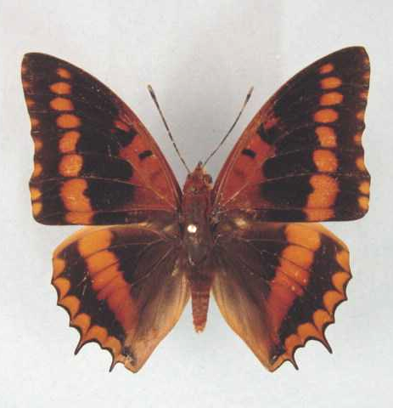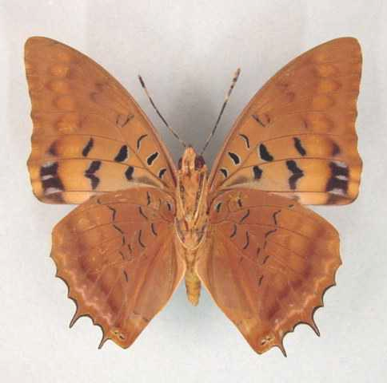

Charaxes lucida intermedius. Male. Left – upperside; right – underside. Wingspan: 63mm. Ebogo, Cameroon, 800m, 03.15N 11.15E. 28.iii.1995. (Curle Trust Collection - 91).

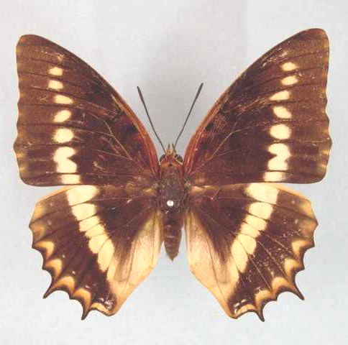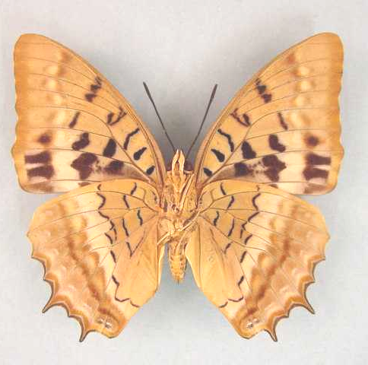

Charaxes lucretius intermedius. Female. Left – upperside; right – underside. Wingspan: 72mm. Bangui, C. A. R. 8.viii.1980. P.R. Godart. (Curle Trust Collection - 92).

Type locality: Central African Republic: “Bangui”. Holotype (female) in the Natural History Museum, London.
Distribution: Nigeria (south-east and Cross River loop), Cameroon, Gabon, Congo, Central African Republic, Democratic Republic of Congo, Zambia.
Specific localities:
Nigeria – Kagoro Forest (Larsen, 2005a: 321).
Cameroon – Korup (Larsen, 2005a).
Zambia – Ikelenge (Heath, et al., 2002).

caliginosa Le Cerf, 1923 (as f. indiv. of Charaxes lucretius). Bulletin du Muséum National d’Histoire Naturelle. Paris 29: 366 (360-367, 428-429). Gabon: “Tchibanga, Gabon”.

albofascia Le Cerf, 1923 (as female f. of Charaxes cynthia). Bulletin du Muséum National d’Histoire Naturelle. Paris 29: 367 (360-367, 428-429). Cameroon: “Bitje, Ja River”.

Charaxes lucretius maximus van Someren, 1971

Charaxes lucretius maximus van Someren, 1971. Bulletin of the British Museum (Natural History) (Entomology) 26: 197 (181-226).
Type locality: Uganda: “Mawakota, Kamengo”. Holotype (male) in the Natural History Museum, London.
Distribution: Democratic Republic of Congo (Ituri, Kivu), Uganda, Rwanda, Burundi, Kenya (west), Tanzania (north-west).
Specific localities:
Kenya – Kakamega; Kisii (Larsen, 1991).
Tanzania – Ntakatta Forest to Gombe Stream National Park (Kielland, 1990).

babingtoni Stoneham, 1943 (as female f. of Charaxes lucretius). Bulletin of the Stoneham Museum (46): [2] ([2 pp.]). Kenya: “Kakamega Forest, Kenya Colony”.

alberici Dufrane, 1945 (as f. of Charaxes lucretius). Bulletin et Annales de la Société Royale Entomologique de Belgique 81: 106 (90-143). Democratic Republic of Congo: “Kamituga”.

victoriaeincola Storace, 1948 (as f. of Charaxes lucretius). Annali del Museo Civico di Storia Naturale (di Genova) Giacomo Doria 63: 137 (132-141). Uganda: “Entebbe (nell ’angolo di N.W. del Lago Victoria, Uganda)”.

Charaxes lucretius saldanhai Bivar de Sousa, 1983

Charaxes lucretius saldanhai Bivar de Sousa, 1983b. Actas del I Congreso Iberico de Entomologia, Facultad de Biologia, Leon, France, 7-10 June, 1983: 115 (107-119).
Type locality: Angola: “Bessa Monteiro”. Type specimen in the collection of Bivar de Sousa.
Distribution: Angola (north-west).

Charaxes lucretius schofieldi Plantrou, 1989

Charaxes lucretius schofieldi Plantrou, 1989. In: Henning, 1989. The Charaxinae butterflies of Africa 78 (457 pp.). Johannesburg.

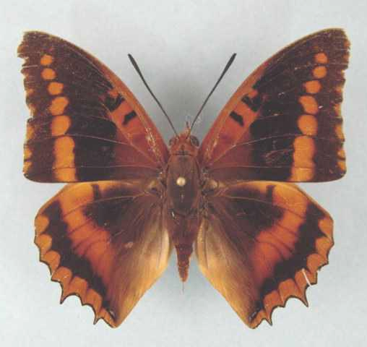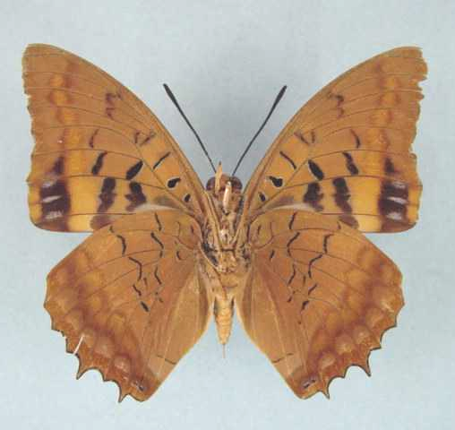

Charaxes lucretius schofieldi. Male. Left – upperside; right – underside. Wingspan: 65mm. N.E. Zambia, Kalungwishi R., Lumangwe Falls. About 1400 m. 26-IV-1972. J.C. Little. (Newport Collection).

Type locality: Zambia: “Zambie, Lumangwe forest, Mporokoso”. Holotype (male) in the Natural History Museum, London.
Distribution: Zambia (north-east).
Specific localities:
Zambia – Lumangwe Forest, Mporokoso; Kabweluma Falls; Musonda Falls (Heath, et al., 2002).

Charaxes lemosi Joicey & Talbot, 1927

Charaxes lemosi Joicey & Talbot, 1927. Entomologist 60: 12 (12-16).
Type locality: Sao Tome and Principe: “St. Principe”.
Distribution: Sao Tome and Principe (Principe Island).
Habitat: Forest.
Early stages: Nothing published.
Larval food: Nothing published.
Note: C. lemosi Joicey and Talbot, 1927 is treated as a subspecies of lucretius (Cramer, 1777) by Van Someren (1971: 198). Henning (1989: 79) treats lemosi as a distinct species on the authority of Plantrou (1983). Plantrou’s paper is, however, an unpublished thesis; thus the taxonomic change is, strictly speaking, not valid.

Charaxes odysseus Staudinger, 1892

Charaxes odysseus Staudinger, 1892. Deutsche Entomologischen Zeitschrift, Iris 5: 260 (260-264).
Type locality: Sao Tome and Principe: “Sao Thomé, (West-Afrika)”.
Distribution: Sao Tome and Principe (Sao Tome Island).
Habitat:
Early stages: Nothing published.
Larval food: Nothing published.

Charaxes lactetinctus Karsch, 1892

Charaxes lactetinctus Karsch, 1892. Entomologische Nachrichten. Berlin 18: 113 (113-117).
Type locality: Togo: “Bismarckburg im Togolande”. Holotype (male) in the Natural History Museum, London.
Distribution: Guinea, Ivory Coast, Ghana, Togo, Nigeria, Cameroon, Congo, Central African Republic, Democratic Republic of Congo, Uganda, Kenya, Ethiopia, Sudan?
Common name: Blue patch charaxes.
Habitat: Savanna, including dry thorn-bush savanna. In West Africa it is associated mainly with Guinea savanna (Larsen, 2005a).
Habits: A scarce species (Larsen, 2005a). Males defend territories aggresively, from perches high up on isolated trees. In territorial disputes males buzz around one another, spiralling upward until they disappear. Males have also been noted hilltopping (Larsen, 2005a). Larsen (2005a) has observed a male at water. Females are mostly found in river valleys, in proximity to the larval foodplants. Unlike most of their congeners they do not appear to be very partial to fermenting fruit (Larsen, 1991).
Early stages:

Jackson, 1932: 173 (ssp. lactetinctus).

Henning, S., 1989: 82 (ssp. lactetinctus).

Larval food:
Syzygium cordatum Hochst. (Myrtaceae) [Van Someren, 1974: 320].
Maesopsis eminii Engl. (Rhamnaceae) [Henning, 1989: 82].

Charaxes lactetinctus lactetinctus Karsch, 1892

Charaxes lactetinctus Karsch, 1892. Entomologische Nachrichten. Berlin 18: 113 (113-117).
Type locality: Togo: “Bismarckburg im Togolande”. Holotype (male) in the Natural History Museum, London.
Distribution: Guinea (west), Ivory Coast (north), Ghana, Togo, Nigeria (north), Cameroon, Congo, Central African Republic, Democratic Republic of Congo (north), Uganda (east, central and north), Kenya (west, north-west).
Specific localities:
Guinea – Fouta Djalon (Larsen, 2005a); Park National du Haut Niger (Larsen, 2005a); Nimba (Larsen, 2005a).
Ghana – Kogyae (Larsen, 2005a); many localities in the Volta Region (Larsen, 2005a).
Togo – Bismarckburg (TL).
Nigeria – Vom (Owen, 1977); Obudu town (Larsen, 2005a); Kaduna (R. St Leger teste Larsen, 2005a).
Kenya – Kakamega; Webuye; Kitale; Broderick Falls; Mt Elgon district; Turkana district (Larsen, 1991).

jacksonianus van Someren, 1936 (as f. of Charaxes lactetinctus). Journal of the East Africa and Uganda Natural History Society 12: 174 (147-199). Kenya; Uganda.

busogus van Someren, 1972 (as ssp. of Charaxes lactetinctus). Bulletin of the British Museum (Natural History) (Entomology) 27: 234 (215-264). Kenya: “Busoga district, Broderik Falls Scarp”.

Charaxes lactetinctus ungemachi Le Cerf, 1927

Charaxes lactetinctus ungemachi Le Cerf, 1927. Encyclopédie Entomologique (B.3. Lepidoptera) 2: 144 (144).
Type locality: Ethiopia: “Youbdo (Birir), Abyssinie”. Holotype (male) in the Museum national d’Histoire naturelle, Paris.
Distribution: Ethiopia (south-west), Sudan? (adjoining areas).

brunneus Carpenter, 1935 (as f. of Charaxes lactetinctus ungemachi). Transactions of the Royal Entomological Society of London 83: 359 (313-447). Ethiopia: “Haeto R. 7° 48', 35° 27'”.

JASIUS GROUP

Charaxes jasius (Linnaeus, 1767)

Papilio jasius Linnaeus, 1767. Systema Naturae 1 (2), 12th edition: Errata (Addenda [36]): 749 (533-1328 pp.). Holmiae.
Type locality: “Barbaria” [Lectotype designated by Honey and Scoble, 2001: 338.]
Distribution: Senegal, Gambia, Guinea-Bissau, Guinea, Mali, Sierra Leone, Liberia, Ivory Coast, Burkina Faso, Ghana, Togo, Benin, Nigeria, Niger, Cameroon, Gabon, Congo, Angola, Central African Republic, Democratic Republic of Congo, Sudan, Uganda, Ethiopia, Somalia, Kenya, Tanzania, Malawi, Zambia, Mozambique, Zimbabwe, Botswana, Namibia, South Africa, Swaziland.
The nominate subspecies is in southern Europe and North Africa.
Common name: Foxy charaxes (for ssp. saturnus); koppie charaxes (for ssp. saturnus); cream-bordered charaxes (for ssp. epijasius).
Habitat: Savanna. Subspecies epijasius occurs mainly in the Guinea and Sudan savannas but also penetrates the Sahel sparingly (Larsen, 2005a). In Tanzania ssp. saturnus occurs from 200 to 2 200 m (Kielland, 1990).
Habits: A common to, at times, even abundant butterfly (Larsen, 2005a). The flight is fast and gliding, with the wings being held almost horizontal. Males defend territories from perches on the twigs of bushes or trees, both on the flats and on hill-tops. Both sexes are readily attracted to fermenting fruit, and to sap exuding from trees (Pringle, et al., 1994) and males come to foul substances, including animal carcasses (Larsen, 2005a).
Flight period: All year.
Early stages:

Van Someren and Rogers, 1928: 140. (ssp. saturnus and ssp. epijasius; as subspecies of C. pelias).

Dickson, 1972: 42 [as Charaxes jasius saturnus] (ssp. saturnus).

Clark, in Van Son, 1979: 152 (Plate 63) [as Charaxes jasius saturnus] (ssp. saturnus).
“The eggs are laid singly on the surface of a leaf, and are 1,65 mm in diameter by 1,5 mm high, with 20-22 ribs on top and part way over the side. Very pale yellow at first, deepening and developing a reddish-brown circlet. The larva hatches after seven days. It is 5 mm long on hatching and of a pale blue-green, with white body spots and light brown extremities, and reaches 9,5 mm before its first moult which takes place after 14 days. In the 2nd instar it is green and is covered with blue moles bearing small whitish spines. There are three larger yellow moles on each side of the segments, bearing longer white spines, and towards the end of the instar a dorsal patch develops on segment 4. The instar lasts nine days and the larvae grow to 14,5 mm. The third instar lasts nine days and the larvae grow to 21,5 mm. The shade of green is darker than in the preceding instar. In the fourth instar other dorsal patches appear on segments 6 and 8. The instar lasts 13 days and the larvae grow to 33 mm. In the final instar some larvae develop faint yellow lateral streaks accentuated by yellow moles. These moles are a very good guide in classifying the species. The lateral ridge is made conspicuous by a close row of yellow moles bearing small spines. This instar lasts some 30 days and the larvae reach a length of 54 mm. The duration of instars given here is for larvae reared during the winter months, and is probably much shorter in summer broods. The pupa is 27 mm and is suspended by cremastral hooks. The body spots are at first white but gradually change to a milky-pink. Emergence takes place after some 27 days.”

Henning, S., 1984. (ssp. saturnus).

Henning, S., 1989: 89 (ssp. epijasius, ssp. saturnus).

Larval food:
Afzelia quanzensis Welw. (Fabaceae) [Van Someren and Rogers, 1928: 140 (ssp. saturnus).].
Annona cherimola (Annonaceae) [Sariot, 2003: 275; Spain].
Annona species (Annonaceae) [Larsen, 1991: 286 (ssp. harrisoni).].
Arbutus unedo Linn. (Ericaceae) [Henning, 1989: 90 (ssp. jasius).].
Bauhinia galpinii N.E. Br. (Fabaceae) [Henning, 1989: 90 (ssp. saturnus).].
Bauhinia petersiana Bolle (Fabaceae) [Henning, S., 1989: 90 (ssp. saturnus).].
Bauhinia species (Fabaceae) [Gifford, 1965: 94 (ssp. saturnus).].
Berlinia species (Fabaceae) [Larsen, 2005a].
Brachystegia edulis Hutchinson and Davy (Fabaceae) [Van Someren, 1974: 319].
Brachystegia species (Fabaceae) [Van Someren and Rogers, 1928: 140 (ssp. saturnus).].
Brachystegia spiciformis Benth. (Fabaceae) [Van Someren, 1974: 319 (ssp. saturnus and ssp. harrisoni).].
Burkea africana Hook (Fabaceae) [Dickson and Kroon, 1978: 59 (ssp. saturnus); Henning, 1989: 90 (ssp. brunnescens).].
Cassia species (Fabaceae) [Nichols, 1995].
Cassine sp. (syn. Elaeodendron sp.) (Celastraceae) [Van Someren, 1974: 319 (ssp. epijasius); Henning, 1989: 90 (ssp. saturnus).].
Catha edulis (Vahl) Forssk. ex Endl. (Celastraceae) [Henning, 1989: 90 (ssp. saturnus).].
Celtis africana Ulmaceae) [Kroon vide Botha & Botha, 2006].
Colophospermum mopane (Kirk ex Benth.) Kirk ex J. Leonard (Fabaceae) [Henning, 1989: 90 (ssp. saturnus).].
Copaifera baumiana Harms (Fabaceae) [Henning, S., 1989: 90 (ssp. saturnus).].
Croton species (Euphorbiaceae) [Dickson and Kroon, 1978: 59 (ssp. saturnus).].
Daniella oliveri (Fabaceae) [Larsen, 2005a].
Guibourtia conjugata (Bolle) J. Leonard (Fabaceae) [Pringle, et al., 1994: 88 (ssp. saturnus).].
Gymnosporia senegalensis (Lam.) Excell. (Celastaceae) [Dickson and Kroon, 1978: 59 (ssp. saturnus); Henning, 1989: 90 (ssp. epijasius and ssp. harrisoni); as sp. of Maytenus].
Gymnosporia spp. (Celastraceae) [Van Someren, 1974: 319].
Hibiscus species (Malvaceae) [Gifford, 1965: 94 (ssp. saturnus); Larsen, 1991: 286 (ssp. epijasius).].
Isoberlina species (Fabaceae) [Larsen, 2005a].
Julbernardia globiflora (Benth.) Troupin (Fabaceae) [Pringle, et al., 1994: 88 (ssp. saturnus).].
Khaya senegalensis (Meliaceae) [Larsen, 2005a].
Laurus nobilis [Stefanescu, 1995; Spain; oviposition only].
Lonchocarpus cyanescens (Schumach. & Thonn.) Benth. (Fabaceae) [Henning, 1989: 90 (ssp. epijasius).].
Lonchocarpus sericeus (Fabaceae) [Larsen, 2005a].
Maytenus spp. (Celastraceae) [Van Someren, 1974: 319].
Osyris lanceolata [Fernandez-Martinez, 2000: 51 (ssp. jasius); Spain].
Pleurostylia africana Loes (Celastraceae) [Henning, 1989: 90 (ssp. epijasius).].
Protea species (Proteaceae) [Gifford, 1965: 94 (ssp. saturnus).].
Prunus persica (Apricot) [Danner, 2001: 401, 474-475 (ssp. jasius); Greece].
Pseudocedrala (Meliaceae) [Larsen, 2005a].
Schotia brachypetela Sond. (Fabaceae) [Platt, 1921 (ssp. saturnus).].
Sorghum roxburghii Stapf. (Poaceae) [Henning, S., 1989: 90 (ssp. epijasius).].
Sorghum spp. (Poaceae) [Van Someren, 1974: 319].
Vaccinium corymbosum L. [Molina, 2000].
Xanthocerces zambesiaca (Bak.) Dumaz-le-Grand (Fabaceae) [Pringle, et al., 1994: 88 (ssp. saturnus).].
Xeroderris stuhlmannii (Taub.) Mendonca and E.P. Sousa (Fabaceae) Pringle, et al., 1994: 88 (ssp. saturnus).].

Charaxes jasius jasius (Linnaeus, 1767)

Papilio jasius Linnaeus, 1767. Systema Naturae 1 (2), 12th edition: Errata (Addenda [36]): 749 (533-1328 pp.). Holmiae.
Type locality: “Barbaria”.
Distribution: Southern Europe, North Africa [i.e. extralimital].
Note: D’Abrera (1980) and Larsen (1991: 286; 2005a) treat jasius as a valid species, confined to the Palaearctic. While these authors may well be correct in doing so, until such time as an in depth study of this species complex has been done, I am maintaining the status quo, i.e. following Ackery et al., 1995.

jason Linnaeus, 1767 (as sp. of Papilio). Systema Naturae 1 (2), 12th edition: 749 (533-1328 pp.). Holmiae. “Barbaria”. [Invalid; junior primary homonym of Papilio jason Linnaeus, 1764 [Papilionidae].]

Charaxes jasius brunnescens Poulton, 1926

Charaxes pelias brunnescens Poulton, 1926. Internationaler Entomologen-Kongress 2: 570 (518-575).
Type locality: [Angola]: “Congo”; Angola.
Distribution: Gabon, Angola (north), Central African Republic, Democratic Republic of Congo (south-west).

brunnescens Rothschild, 1900 in Rothschild and Jordan, 1900 (as ab. of Charaxes pelias saturnus). Novitates Zoologicae 7: 445 (287-524). Angola: “northern Angola”.

Charaxes jasius epijasius Reiche, 1850

Charaxes epijasius Reiche, 1850 in: Ferrets, P.V.A. & Galinier, J.G. [1847-50]. Voyage en Abyssinie dans les provinces du Tigre, du Samen et de l’Ahmarra: 469 (258-471). Paris.
Type locality: Senegal: “Sénégal”.
Distribution: Senegal, Gambia, Guinea-Bissau, Guinea, Mali, Sierra Leone, Liberia, Ivory Coast, Burkina Faso, Ghana, Togo, Benin, Nigeria, Niger, Cameroon, Central African Republic, Democratic Republic of Congo (Uele - north), Sudan (south), Uganda (north), Ethiopia (north), Somalia, Kenya (north-west).
Specific localities:
Sierra Leone – Freetown (Owen & Chanter, 1972).
Ghana – Atewa Range (Joly, 2003); Accra Plains (Larsen, 2005a).
Nigeria – Vom (Owen, 1977); Kaduna (R. St Leger teste Larsen, 2005a); Lagos (Larsen, 2005a).
Note: Larsen (1991: 286; 2005a) treats epijasius as a valid species. There is apparently a zone of hybridization between epijasius and saturnus in the Pokot/Turkana districts of Kenya.

maculatus Suffert, 1904 (as ssp. of Charaxes epijasius). Deutsche Entomologische Zeitschrift, Iris 17: 122 (108-123). Guinea: “Insel Konakry (10° n.B., 13° w.L. von Greenwich)”.

murina Le Cerf, 1923 (as f. indiv. of Charaxes epijasius). Bulletin du Muséum National d’Histoire Naturelle. Paris 29: 364 (360-367, 428-429). Mali: “Niger, entre Tombouctou et Say”.

feisthameli Le Cerf, 1923 (as f. indiv. of Charaxes epijasius). Bulletin du Muséum National d’Histoire Naturelle. Paris 29: 364 (360-367, 428-429). Senegal: “Casamance”.

liberiae Le Cerf, 1923 (as ? ssp. of Charaxes pelias). Bulletin du Muséum National d’Histoire Naturelle. Paris 29: 365 (360-367, 428-429). Ivory Coast: “Haute Sassandra, frontière de Libéria”.

aeson Stoneham, 1960 (as f. of Charaxes jasius epijasius). Bulletin of the Stoneham Museum (73): [2] ([3 pp.]). Kenya: “East Surrey Estates, Trans Nzoia, W. Kenya”. [Invalid; junior primary homonym of Charaxes aeson Herrich-Schaffer, 1858 [Charaxinae].]

plutus Stoneham, 1960 (as f. of Charaxes jasius epijasius). Bulletin of the Stoneham Museum (73): [2] ([3 pp.]). Kenya: “East Surrey Estates, W. Kenya”.

alcimede Stoneham, 1960 (as f. of Charaxes jasius epijasius). Bulletin of the Stoneham Museum (73): [2] ([3 pp.]). No locality given.

melas van Someren, 1963 (as var. of Charaxes jasius epijasius). Bulletin of the British Museum (Natural History) (Entomology) 13: 202 (195-242). Uganda: “Uganda from West Nile to Suk and the Mokia plains SE. of Ruwenzori”.

aesonius Stoneham, 1964 in Stoneham, 1951-65 (as replacement name for Charaxes jasius epijasius f. aeson Stoneham). The butterflies of western Kenya with notes on allied forms, etc. 104 (180 pp.). Nairobi.

Charaxes jasius harrisoni Sharpe, 1904

Charaxes harrisoni Sharpe, 1904. Entomologist 37: 133 (131-134).
Type locality: Kenya: “Kamagombo”.
Distribution: Uganda (south-west), Kenya (south-west), Tanzania (north-west).
Specific localities:
Tanzania – North-western parts (Kielland, 1990).
Note: Larsen (1991: 286) treats harrisoni as a valid species. This is a very unstable taxon with variable intermediates (hybrids) showing more or less affinity to either C. j. epijasius or C. j. saturnus. This variation appears to be clinal (Henning, S., 1989: 85).

saturnalis van Someren, 1963 (as f. of Charaxes jasius harrisoni). Bulletin of the British Museum (Natural History) (Entomology) 13: 203 (195-242). Kenya: “South Kavirondo, Suna”.

Charaxes jasius pagenstecheri Poulton, 1926

Charaxes pelias pagenstecheri Poulton, 1926. Internationaler Entomologen-Kongress 2: 570 (518-575).
Type locality: Ethiopia: “S. Abyssinia”.
Distribution: Ethiopia (south), Somalia.

pagenstecheri Schultze, 1913 (as ab. of Charaxes saturnus). Entomologische Rundschau 30: 50 (49-50). Ethiopia: “Awala-See (abyssinien)”.

Charaxes jasius saturnus Butler, 1866

Charaxes jasius saturnus Butler, 1866. Proceedings of the Zoological Society of London 1865: 624 (622-639).

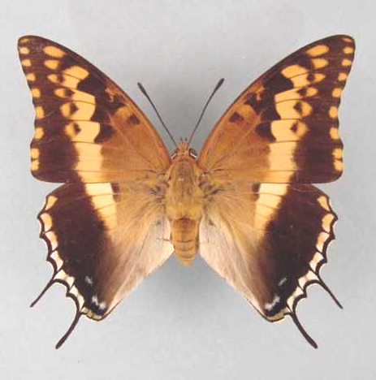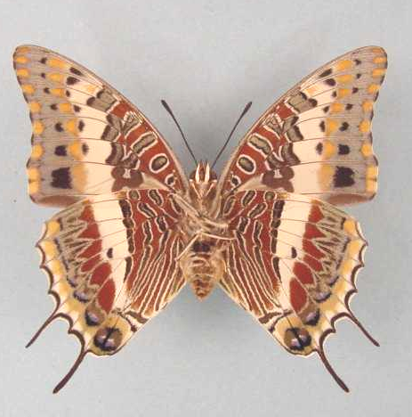

Charaxes jasius saturnus. Female. Left – upperside; right – underside. Wingspan: 78mm. Soutpan, Pretoria Distr. 7.II.1972. Potgieter & Jones. (Transvaal Museum - TM3348).

Type locality: South Africa: “Interior of South Africa”.
Distribution: Kenya (east, north-east), Tanzania, Malawi, Democratic Republic of Congo (central and south), Angola, Zambia, Mozambique, Zimbabwe, Botswana, Namibia (north-east), South Africa (Limpopo Province, Mpumalanga, North West Province, Gauteng, KwaZulu-Natal, Eastern Cape Province), Swaziland.
Specific localities:
Tanzania – Virtually throughout (Kielland, 1990).
Zambia – Kasangezhi; Mwinilunga; Mufulira; Ndola; Lusaka; Victoria Falls; Serenje; Chinzombo; Kasama; Sumbu (Heath, et al., 2002).
Zimbabwe – Victoria Falls (Pennington); Dichwe Farm, near Chinhoyi (Pringle, et al., 1994); Matetsi (Pinhey).
Namibia – Otavi (Kroon); Waterberg Plateau Park (Swart, 2004).
Limpopo Province – Throughout bushveld areas (Swanepoel, 1953); Legalameetse Nature Reserve (“Malta Forest”).
Mpumalanga - Throughout bushveld areas (Swanepoel, 1953); Buffelskloof Nature Reserve (Williams).
North West Province – Throughout bushveld areas (Swanepoel, 1953); Kgaswane Mountain Reserve (Williams); Mountain Sanctuary N.R. (Williams).
Gauteng – Throughout bushveld areas (Swanepoel, 1953); Witwatersrand Botanical Gardens (J. Dobson, unpublished checklist, 2001).
KwaZulu-Natal – Pinetown (Swanepoel, 1953); Empangeni (Swanepoel, 1953); Mtubatuba (Swanepoel, 1953); Durban (Pringle, et al., 1994); Hluhluwe (Pennington).
Eastern Cape Province – East London (Quickleberge).
Swaziland – Mlawula N. R. (www.sntc.org.sz).
Note: Larsen (1991: 286) treats saturnus as a valid species.

flavicinctus Butler, 1895 (as var. of Charaxes castor). Proceedings of the Zoological Society of London 1895: 251 (250-270). Malawi: “Zomba”.

Charaxes pelias (Cramer, 1775)

Papilio pelias Cramer, 1775. Die Uitlandsche Kapellen voorkomende in de drie waerrelddeelen Asia, Africa en America 1: 5 (155 pp.). Amsteldam and Utrecht.
Type locality: South Africa: “Kaap de Goede Hoop”.
Diagnosis: Superficially resembles C. jasius saturnus Butler, from which it differs in the following characters: smaller size; orange-yellow markings of upperside lighter; hindwing discal band broader posteriorly, not triangular, and extending to vein Cu₂; forewing underside with orange markings much reduced, transverse red-brown markings of basal areas and spots of same colour beyond hindwing discal band much darker, and those in anal area obsolete; tails on hindwing much shorter; antenna/wing ration higher; numerous differences in gentitalia, early stages and larval food plants (Van Son, 1979: 153).
Distribution: South Africa (Eastern Cape Province, Western Cape Province, excluding the Cape Peninsula (Van Son, 1979)).
Specific localities:
Eastern Cape Province – Willowmore (Swanepoel, 1953); Hankey (Swanepoel, 1953); Cogman’s Kloof (Swanepoel, 1953); Tradouw Kloof (Swanepoel, 1953); Cockscomb Mountain (Van Son, 1979); Grahamstown district (Buchanan).
Western Cape Province – Montagu (Trimen, 1887); Klapmuts (Swanepoel, 1953); Jonkershoek (Swanepoel, 1953); Franschhoek (Swanepoel, 1953); Paarl (Swanepoel, 1953); Wellington (Swanepoel, 1953); Gouda – Tulbagh Kloof (Swanepoel, 1953); Ceres (Swanepoel, 1953); Worcester (Swanepoel, 1953); Swartberg (Swanepoel, 1953); Cedarberg Range (Van Son, 1979); Olifantsrivier Berge (Van Son, 1979); Piketberg (Van Son, 1979); Roode Zands Berge (Van Son, 1979); Voelvlei Berge (Van Son, 1979); Witzenberg (Van Son, 1979); Mitchell’s Pass (Van Son, 1979); Riebeeck Kasteel Berg (Van Son, 1979); Elandskloofberge (Van Son, 1979); Paardeberg (Van Son, 1979); Limiet Bergen (Van Son, 1979); Slanghoekberge (Van Son, 1979); Du Toit’s Kloof (Van Son, 1979); Hawequas Mountains (Van Son, 1979); Klein Drakensteinberge (Van Son, 1979); Steenbras River Mouth (Van Son, 1979); Du Toitsberge (Van Son, 1979); Orange Grove near De Wet (Van Son, 1979); Hex River Mountains (Van Son, 1979); Keeromsberg (Van Son, 1979); Grootvadersbos (Van Son, 1979); Attaquas Mountains (Van Son, 1979); Roodeberg near Ladismith (Van Son, 1979); Seven Weeks Poort (Van Son, 1979); Matsikamma Mountains, near Vanrhynsdorp (Dickson and Wykeham); above Tulbagh; Bain’s Kloof (Pringle et al., 1994); Kammanassie Mountains (Williams, unpublished).
Common name: Protea charaxes.
Habitat: Fynbos (Cape macchia) in mountainous terrain.
Habits: Males hilltop, gliding around their territories with occasional wing beats. They select perches on the twigs of small trees, particulary proteas (hence their common name) (Pringle et al., 1994).
Flight period: October to March, with a few records for September and April (Pringle et al., 1994).
Early stages:

Dickson, 1949: 109.

Dickson, 1972: 42 [as Charaxes pelias].

Clark, in Van Son, 1979: 153 (Plate 64) [as Charaxes pelias].
“The eggs are laid singly on the surface of a leaf; they are 1,6 mm in diameter by 1,6 mm high, with 21 faint ribs on the top surface. They are watery cream when laid and later darken and develop a purplish-red circlet; they hatch after seven days. The young larva eats its way out near the top of the egg and devours the empty shell. It is 5,5 mm long and grows to 8 mm in six days. The second instar lasts six days and the larva grows to 12,5 mm, in the 3rd instar it grows to 18,5 mm in seven days, and to 27 mm in seven days in the 4th instar. In the final instar the larvae attain a length of 45-50 mm in about 16 days. The larvae rest on the midrib of a leaf and rely on their colouring for protection. They feed at the edge of a leaf and generally eat the leaf completely in one meal. The pupa is suspended from the underside of a leaf or a twig by cremastral hooks entangled in a silken mat. It is 30 mm long. Emergence takes place after 13-17 days.”

Van Son, 1979: 154
“The difference in the life-histories of j. saturnus and pelias can be readily seen from a comparison of the life-history plates of the two species; among other differences, the very numerous setae on the larvae of the first three instars of pelias as against the papillose general surface and the few enlarged setigerous moles in j. saturnus are particularly noteworthy, as are also the details of the structure of the head in all instars.”

Henning, S., 1989: 91 [as Charaxes pelias].

Larval food:
Alternative food-plants (Bauhinia, Schotia and Cercis species) that are not normally used by C. pelias were tried experimentally, but with limited success [Dickson, 1962: 332].
Bauhinia galpinii (Fabaceae) [Kroon, 1999].
Bauhinia species (Fabaceae) [Pinhey, 1965: 86].
Cercis siliquastrum L. (Fabaceae) (exotic) [Henning, S., 1989: 92].
Erythrina species (Fabaceae) [Claassens, in Pringle et al., 1994: 87; oviposition only].
Hypocalyptus sophoroides (Berg.) Baill. (Fabaceae) [? Duke, in Pinhey, 1965: 86].
Osyris compressa (DC.) Berg. (Santalaceae) [? Duke, in Van Son, 1979: 154; as Colpoon compressum].
Osyris lanceolata Hochst. & Steud. (Sanatalaceae) [Henning, S., 1989: 92].
Rafnia amplexicaulis Thunb. (Fabaceae) [Dickson, 1949: 109].
Rafnia triflora Thunb. (Fabaceae) [Dickson, 1949: 109].
Schotia species (Fabaceae) [Pinhey, 1965: 86].

pelopia Hübner, [1819] (as sp. of Eriboea). Verz. bekannt.Schmett. (3): 47.

Charaxes legeri Plantrou, 1978

Charaxes legeri Plantrou, 1978. Bulletin de la Société des Lépidoptèristes Français 1: 190 (187-194).
Type locality: Nigeria: “Kaduna, Nord Nigeria”. Holotype (male) in the Museum national d’Histoire naturelle de Paris.
Distribution: Burkina Faso (south), Nigeria (north), Niger (south).
Specific localities:
Burkina Faso – Bobo-Dioullasso (B. Turlin teste Larsen, 2005a).
Nigeria – Kaduna (TL); near the Kainji Dam (Larsen, 2005a); Zaria (Larsen, 2005a); Bauchi (Larsen, 2005a).
Niger – Maradi (B. Turlin teste Larsen, 2005a).
Common name: St Leger’s charaxes.
Habitat: Woodland savanna at altitudes of 600 to 1 700 m (Henning, 1989).
Habits: According to both St Leger and Boersma the flight is stronger than that of C. jasius epijasius and it is a more ‘nervous’ insect when caught in traps (Larsen, 2005a). Males hilltop on inselbergs, arriving between 09h00 and 09h40 and leaving between 10h10 and 10h50 (C. j. epijasius arrives between 11h25 and 13h30 and departs at about 15h00) (S. Norman teste Henning, 1989).
Early stages:

Henning, S., 1989: 94.

Larval food:
Sorghum roxburghii Stapf (Poaceae) [Henning, S., 1989: 94; in captivity].
Annona species (Annonaceae) [Henning, 1989: 94; in captivity].
Note: D’Abrera (1980) and Henning (1989) suggested that C. legeri might be a hybrid between C. jasius epijasius and C. castor. Larsen (2005a), however, gives a cogent argument for considering C. legeri to be a distinct species. See also St Leger, 1984.

Charaxes hansali Felder, 1867

Charaxes hansali Felder, 1867 in Felder and Felder, [1865-7]. Reise der Österreichischen Fregatte Novara 446 (549 pp.). Wien.
Type locality: Ethiopia: “Africa septentrionali-orientalis: Bogos”.
Diagnosis: Similar to C. castor but upperside band paler, marginal spots larger, smaller in size (Kielland, 1990).
Distribution: Tanzania, Rwanda, Kenya, Uganda, Sudan, Ethiopia, Somalia, Saudi Arabia, Yemen, Oman.
Common name: Cream-banded charaxes.
Habitat: Arid savanna.
Early stages:

Van Someren, 1936: 30 (ssp. baringana).

Henning, S., 1989: 96 (ssp. baringana).

Larval food:
Salvadora persica L. (Salvadoraceae) [Van Someren, 1974: 319].
Osyris lanceolata Hochst. & Steud. (Santalaceae) [Henning, S., 1989: 97].
Colpoon compressum Berg. (Santalaceae) [Henning, S., 1989: 97].
Dobera glabra (Forsk.) A. DC. (Salvadoraceae) [Henning, S., 1989: 97].

Charaxes hansali hansali Felder, 1867

Charaxes hansali Felder, 1867 in Felder and Felder, [1865-7]. Reise der Österreichischen Fregatte Novara 446 (549 pp.). Wien.
Type locality: Ethiopia: “Africa septentrionali-orientalis: Bogos”.
Distribution: Ethiopia (north, east, south-east), Somalia (north – Wagga Mountains).

minor Storace, 1948 (as ab. of Charaxes achaemenes). Annali del Museo Civico di Storia Naturale (di Genova) Giacomo Doria 63: 135 (132-141). Ethiopia: “Scioa, Abissinia”.

Charaxes hansali arabica Riley, 1931

Charaxes hansali arabica Riley, 1931. Entomologist 64: 279 (279-280).
Type locality: Oman: “Hamerar Road; Fuzul; Sahalnaut; Sa’arin; Ain, Qara Mts.; Khiyunt; Gurthurnut”.
Distribution: Oman.

Charaxes hansali baringana Rothschild, 1905
Charaxes hansali baringana Rothschild, 1905. Novitates Zoologicae 12: 78 (78-79).
Type locality: Kenya: “Lake Baringo”.
Distribution: Tanzania (southern shores of Lake Victoria), Rwanda (east), Kenya, Uganda (north), Sudan (south), Ethiopia (south).
Specific localities:
Tanzania – Mlamba Forest in North Pare Mountains; Kilimanjaro; Mto wa Mbu, below Ngorongoro; Usambara Region; Mwanza (Kielland, 1990).

Charaxes hansali kulalae van Someren, 1975

Replacement name for Charaxes hansali kulalensis van Someren, 1971. Bulletin of the British Museum (Natural History) (Entomology) 32: 108 (65-136).
Type locality: Kenya: “Northern Frontier Province, Mt. Kulal, south east of Lake Rudolf”. Holotype (male) in the Natural History Museum, London.
Distribution: Kenya (Mt Kulal), Ethiopia (south – Nighelli).

kulalensis van Someren, 1971 (as ssp. of Charaxes hansalii [sic]). Bulletin of the British Museum (Natural History) (Entomology) 26: 192 (181-226). Kenya: “Northern Frontier Province, Mt. Kulal, south east of Lake Rudolf”. [Invalid; junior primary homonym of Charaxes acuminatus kulalensis van Someren [Charaxinae].]

Charaxes hansali yemeni Turlin, 1998

Charaxes hansali yemeni Turlin, 1998. Lambillionea 98 (2) (Tome I): 184 (181-189).
Type locality: Yemen: “Wadi Sharas, 1400 m. X-1992 (S. Collins).” In M.N.H.N., Paris.
Distribution: Yemen.

Charaxes castor (Cramer, 1775)

Papilio castor Cramer, 1775. Die Uitlandsche Kapellen voorkomende in de drie waerrelddeelen Asia, Africa en America 1: 152 (155 pp.). Amsteldam and Utrecht.

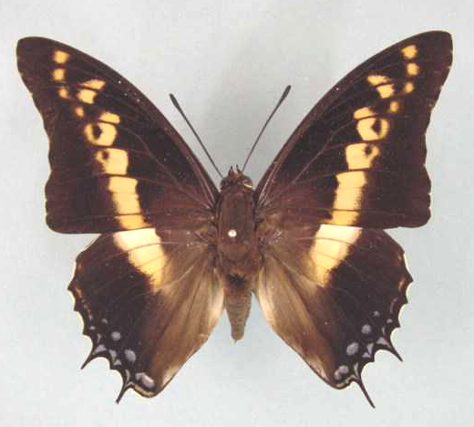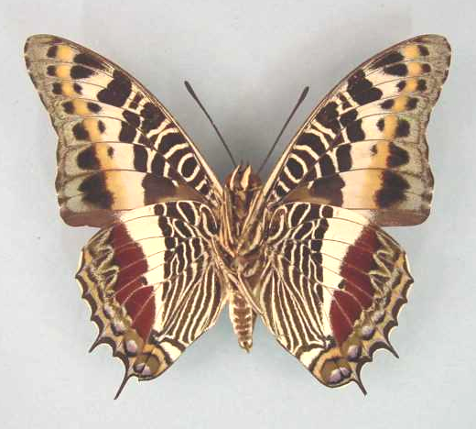

Charaxes castor castor. Male. Left – upperside; right – underside. Wingspan: 85mm. Bangui, R. C. A. 81.07.07. R.P. Godart. (Curle Trust Collection - 93).

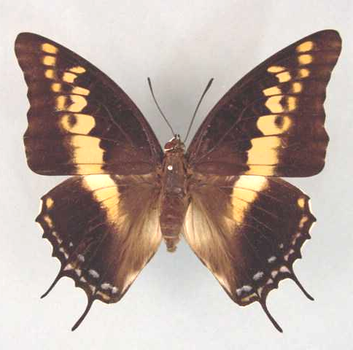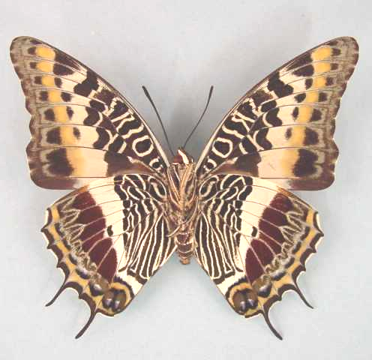

Charaxes castor castor. Female. Left – upperside; right – underside. Wingspan: 92mm. Bangui, R. C. A. Rec. July ‘94. (Curle Trust Collection - 95).

Type locality: No locality given.
Distribution: Senegal, Gambia (H. Boersma), Guinea-Bissau, Guinea, Burkina Faso, Sierra Leone, Liberia, Ivory Coast, Ghana, Togo, Benin (Fermon et al., 2001), Nigeria, Cameroon, Equatorial Guinea, Gabon, Congo, Angola, Central African Republic, Democratic Republic of Congo, Uganda, Ethiopia, Kenya, Tanzania, Malawi, Zambia, Mozambique, Zimbabwe, Botswana (east) (Kielland, 1990), South Africa, Swaziland, Comoro Islands.
Common name: Giant charaxes.
Habitat: Forest and savanna, including Guinea savanna in West Africa (Larsen, 2005a). In Tanzania ssp. flavifsciatus occurs at altitudes from 800 to 2 000 m (Kielland, 1990).
Habits: A relatively common species. The flight is very powerful, males often swooping up and down while circling in a forest clearing (Larsen, 2005a). Males hilltop in the morning, from about 08:00 to 10:00 and are very wary. Both sexes are attracted to fermenting fruit (Pringle et al., 1994).
Flight period: All year.
Early stages:

Van Someren & Van Someren, 1926: 338 (ssp. castor).

Van Someren & Rogers, 1928: 144 (ssp. castor).
“The egg of castor is spherical, 2 mm in diameter, pearly-yellow in colour and slightly cupped and fluted on the top; it is laid singly on the leaves of the food-plants. A brown ring appears round the depression as the germ develops, and the whole egg turns a dark brown, then black just before the larva emerges. The larva emerges in from eight to ten days and at once devours the egg shell. It is at first olive-yellow, very finely papillated, and carries on the anal segment two blunt fleshy spines with ochreous papillae. The head is black with short tubercles on the upper quadrant. It is a voracious feeder and is easily reared. It assumes a greener tint with each successive moult, and the dorsal spots appear at the third instar, whilst the degree of papillation is continually increased also. The adult larva is a most conspicuous object, as it is about 9 cm long, with a grass-green body covered with coarse irrorations or papillae. The tip of each papilla is light yellow in colour, giving to the larva a speckled appearance and also showing off the papillae as a series of vertical bands. The body-line is formed by a series of cream-coloured papillae, forming a spiracular line extending from the second segment to the tail. Most larvae have two dorsal spots, although some only possess one. They are placed on segments 6 and 8, and each forms a conspicuous black oval, set nearer to the front of a smooth green oval area having its long axis parallel with that of the body. The number of these spots bears no relation to sex or any other characteristic, so far as has been observed. The head of the adult larva has the form of a hexagonal plate with its two lower sides elongated. The disc which bears fine dark green papillae, is divided by a vertical central groove, expanding into a smooth green area above the mouth-parts. Two stout side horns arise as the prolongation of the angle between the two lateral sides of the hexagon, and thus are set outwards, but afterwards curve slightly inwards, especially at the tips. Each horn is 6 mm long, very serrated and coloured dark maroon on the inner aspect. From the upper angles of the plate arise two similar finely serrated horns, with their tips a deep maroon or red colour, slightly curving inwards (length 5 mm). A yellow face-line starts from the tips of the lateral horns and runs downwards along the outer aspect of the face to the mouthparts; it is bordered along the outer and lower edge by a conspicuous black line which starts from the base of the lateral horns and reaches the mouth. This larva is one of the most striking in the group. The pupa is large and opaque light green in colour; it is almost immaculate when the larval skin has just been shed, but on the second day certain characteristic white patches appear on the wing-scuta and also on the dorsum of the thorax. The whole transformation from egg to imago can be completed in six weeks, as the larva is a most voracious feeder and growth is extremely rapid.”

Van Someren & Rogers, 1929 (ssp. flavifasciatus) (J. E. Afr. Nat. Hist. Soc. 33-34 (1928): 171-222).

Van Someren & Rogers, 1931 (ssp. flavifasciatus) (J. E. Afr. Nat. Hist. Soc. 38-39 (1930); 18-33).

Henning, S., 1989: 100 (ssp. flavifasciatus).

Larval food:
Afzelia africana Sm. ex Pers. (Fabaceae) [Blandin, et al., 1975 (Ivory Coast); Henning, S., 1989: 100].
Afzelia quanzensis Welw. (Fabaceae) [Van Someren and Rogers, 1928: 144].
Bauhinia species (Fabaceae) [Henning, S., 1989: 100].
Brachystegia species (Fabaceae) [Henning, S., 1989: 100].
Bridelia micrantha (Hochst.) Baill. (Euphorbiaceae) [Dickson and Kroon, 1978: 59].
Cassia fistula L. (Fabaceae) (exotic) [Dickson and Kroon, 1978: 59].
Cassia podocarpa Guill. ex Perr. (Fabaceae) [Henning, S., 1989: 100].
Cassine species (syn. Elaeodendron species) (Celastaceae) [Van Someren, 1974: 319].
Chaetachme aristata Planch (Ulmaceae) [Henning, S., 1989: 100].
Copaifera species (Fabaceae) [Kielland, 1990: 98].
Croton species (Euphorbiaceae) [Kielland, 1990: 98].
Entada species (Fabaceae) [Henning, S., 1989: 101].
Erythrina senegalensis (Fabaceae) [Owen & Owen, 1973 (Sierra Leone)].
Gmeliana arborea Roxb. (Verbenaceae) (exotic) [Henning, S., 1989: 101].
Gymnosporia senegalensis (Lam.) Excell (Celastraceae) [Van Someren and Rogers, 1928: 144; as sp. of Maytenus].
Gymnosporia species (Celastraceae) [Larsen, 2005a].
Hibiscus species (Malvaceae) [Kielland, 1990:98].
Iris species (Iridaceae) [Larsen, 2005a].
Pleurostylia africana Loes. (Celastaceae) [Van Someren and Rogers, 1928: 144].
Schotia brachypetela Sond. (Fabaceae) [Williams, in Pringle, et al., 1994: 88; in captivity (ssp. flavifasciatus)].
Sorghum roxburghii Stapf. (Poaceae) [Van Someren and Rogers, 1928: 144].
Tragia benthami Bak. (syn. cordifolia Benth.) (Euphorbiaceae) [Van Someren and Rogers, 1928: 144].
Trema orientalis (L.) Blume (Ulmaceae) [Paré, in Pringle, et al., 1994: 88 (ssp. flavifasciatus)].

Charaxes castor castor (Cramer, 1775)

Papilio castor Cramer, 1775. Die Uitlandsche Kapellen voorkomende in de drie waerrelddeelen Asia, Africa en America 1: 152 (155 pp.). Amsteldam and Utrecht.

Charaxes castor castor. Male. Left – upperside; right – underside. Wingspan: 85mm. Bangui, R. C. A. 81.07.07. R.P. Godart. (Curle Trust Collection - 93).

Charaxes castor castor. Female. Left – upperside; right – underside. Wingspan: 92mm. Bangui, R. C. A. Rec. July ‘94. (Curle Trust Collection - 95).

Type locality: No locality given.
Distribution: Senegal, Gambia, Guinea-Bissau, Guinea, Burkina Faso, Sierra Leone, Liberia, Ivory Coast, Ghana, Togo, Benin (Fermon et al., 2001), Nigeria (south and Cross River loop), Cameroon, Equatorial Guinea (Bioko), Gabon, Congo, Angola (north), Central African Republic, Democratic Republic of Congo, Uganda, Ethiopia (south-west), Kenya (west), Tanzania (north-west), Zambia (Copperbelt and north).
Specific localities:
Senegal – Basse Casamance (Owen & Chanter, 1972).
Sierra Leone – Freetown (Larsen, 2005a).
Ivory Coast – Bossematie (H. Fermon teste Larsen, 2005a).
Ghana – Atewa Range (Joly, 2003).
Benin – Noyau Central, Lama Forest (Fermon, et al., 2001).
Nigeria – Vom (Owen, 1977); Warri (H. Boersma teste Larsen, 2005a); Kaduna (R. St Leger teste Larsen, 2005a).
Cameroon – Korup (Larsen, 2005a).
Zambia – Ikelenge; Mufulira; Ndola; Mpongwe; Musonda Falls; Sumbu; Kalambo Falls (Heath et al., 2002).

godarti Aurivillius, 1899 in Aurivillius, 1898-9 (as var. et ab. of Charaxes castor). Kungliga Svenska Vetenskapakademiens Handlingar 31 (5): 232 (1-561). Nigeria: “Calabar”.

aginga Stoneham, 1931 (as f. of Charaxes castor). Bulletin of the Stoneham Museum (6): [1] ([1 p.]). Kenya: “East Surrey Estates, about 12 miles east of Kitale, Kenya Colony”.

severus Biederman, 1935 (as f. indiv. of Charaxes castor godarti). Bulletin de la Société Entomologique de France 40: 209 (209-212). Cameroon: “Cameroun, Bipindi”.

flavimarginalis Stoneham, 1936 (as f. of Charaxes castor). Bulletin of the Stoneham Museum (29): [2] ([3 pp.]). Kenya: “East Surrey Coffee Estates”.

Charaxes castor arthuri van Someren, 1971

Charaxes castor arthuri van Someren, 1971. Bulletin of the British Museum (Natural History) (Entomology) 26: 188 (181-226).
Type locality: Tanzania: “Pemba Island”. Holotype (male) in the Natural History Museum, London.
Diagnosis: Forewing discal spots in spaces 2 to 4 small and pale compared to the nominate subspecies (Kielland, 1990).
Distribution: Tanzania (island of Pemba).
Specific localities:
Tanzania – Ngezi Forest, Pemba Island (Kielland, 1990).

Charaxes castor comoranus Rothschild, 1903

Charaxes castor comoranus Rothschild, 1903. Novitates Zoologicae 10: 310 (309-312).
Type locality: Comoro Islands: “Great Comoro I.”.
Distribution: Comoro Islands (Grand Comore).

Charaxes castor flavifasciatus Butler, 1895

Charaxes castor var. flavifasciatus Butler, 1895. Proceedings of the Zoological Society of London 1895: 251 (250-270).
Type locality: Malawi: “Zomba”.
Diagnosis: Smaller than the nominate subspecies, and the median band in the female paler (Kielland, 1990).
Distribution: Kenya (east), Tanzania (north and east), Malawi, Mozambique, Zimbabwe (east), South Africa (Limpopo Province, Mpumalanga, KwaZulu-Natal), Swaziland.
Specific localities:
Limpopo Province – Letaba – Isoavina (Swanepoel, 1953); Tzaneen – Loretta (Swanepoel, 1953); Mokeetsi (Swanepoel, 1953).
Mpumalanga – Eureka Mine, Barberton (C.F. Palmer, in Trimen & Bowker, 1889: 408); Sabi River Bungalows (Swanepoel, 1953).
KwaZulu-Natal – Durban (Millar; two records); Muden (Cookson; single record); St Lucia Bay(Swanepoel, 1953); False Bay (Swanepoel, 1953).
Swaziland – Mlawula N. R. (www.sntc.org.sz).

orientalis Lanz, 1896 (as var. of Charaxes castor). Deutsche Entomologische Zeitschrift, Iris 9: 140 (113-147). Malawi: “Parumbira, Hochplateau”.

reimeri Rothschild, 1900 in Rothschild and Jordan, 1900 (as f. of Charaxes castor flavifasciatus). Novitates Zoologicae 7: 439 (287-524). Tanzania: “Dar-es-Salaam”.

dyscrita van Son, 1979 (as ab. of Charaxes castor flavifasciatus). Transvaal Museum Memoires No. 22: 155 (286 pp.). Mozambique: “Zimbiti (= Mzimbiti)”.

Charaxes octavus Minig, 1972

Charaxes octavus Minig, 1972 [May]. Bulletin de la Société Entomologique de France 76: 269 (269-270).
Type locality: Central African Republic: “Sikia, à 25 km à l’est de Bangui (République centralafricaine)”.
Distribution: Central African Republic. Known from a single specimen from the type locality only. According to Roger White (pers. comm., 2003) there may be additional specimens in the collections of Bernard Turlin and Steve Collins. Probably a hybrid of brutus and lucida (syn. lucretius) (B. Turlin, cited by Ackery, et al., 1995: 453).
Habitat: Forest.
Early stages: Nothing published.
Larval food: Nothing published.

patergodarti Neidhoefer, 1972 [Dec.] (as sp. of Charaxes). Occasional papers. Milwaukee Public Museum (3): 5 (9 pp.). Central African Republic: “Bangui, Republic of Central Africa”.

Charaxes brutus (Cramer, 1779)

Papilio brutus Cramer, 1779 in Cramer, [1779-80]. Die Uitlandsche Kapellen voorkomende in de drie waerrelddeelen Asia, Africa en America 3: 82 (176 pp.) Amsteldam & Utrecht.
Type locality: South Africa: “Kaap de Goede Hoop” [patria falsa].
Distribution: Senegal, Guinea-Bissau, Guinea, Sierra Leone, Liberia, Ivory Coast, Ghana, Togo, Nigeria, Cameroon, Equatorial Guinea, Central African Republic, Gabon, Congo, Angola, Democratic Republic of Congo, Uganda, Sudan, Kenya, Rwanda, Burundi, Tanzania, Malawi, Zambia, Mozambique, Zimbabwe, Botswana, Namibia, South Africa, Swaziland.
Common name: White-barred charaxes.
Habitat: Forest, including degraded forest, and dense savanna. In Tanzania ssp. alcyone is found at altitudes from sea-level to 2 600 m; ssp. natalensis from 500 to 1 900 m (Kielland, 1990).
Habits: A fairly common forest charaxes. The species is a fast, powerful flier, frequently sailing over the tops of trees. Fermenting fruit and tree-sap attract them strongly. J. Joannou once saw numbers feeding from the flowers of Spathodea (Pringle, et al., 1994). J. Greyling noted that the species invaded the towns of Pietersburg and Potgietersrus when specimens of their larval hosts were planted on the pavements (Pringle, et al., 1994). This also appears to have happened in Pretoria (F. O’Brien, pers. comm., 2002).
Flight period: All year.
Early stages:

Trimen & Bowker, 1887, Vol. 1: 337 [as Charaxes Brutus (Cramer); Natal (ssp. natalensis)].
“Larva. Bright yellow-green (covered with minute yellow granules); second and last segments of a much duller green than the others. On each side of back a row of cuneiform yellowish marks, broad anteriorly, and deflected upward and posteriorly, narrowing to a point before hind-edge of the segment. On seventh segment a yellow-circular dorsal marking with a brown centre. Head light-green; the frontal horns short and tipped with cobalt-blue, - the two outer horns shorter than the two middle ones; mandibles light-blue tipped with black. (W.D. Gooch, M.S. description and outline drawing of Natalian larva, 1874.). Captain H.C. Harford, who also observed the larva in Natal, saw the ova deposited on the leaves of the Seringa (Melia azedarach), and noted that they were at first pale-yellow, but became in a few hours reddish-brown. From an egg that was watched on a leaf out of doors the larva was hatched on the eighth day after its deposit. It was brownish-green, with the head and horns brown, and the caudal processes very long and curved inward. After the first moult, it was dark olive-green, with a slight indication of a pale spot on the back of the seventh segment; the head being of a darker brown, but the horns lighter at the tip; while the anal processes were light ashy-grey. After the second moult, it became dark-green minutely irrorated with white, and showed the whitish spot on the seventh segment much more distinctly; the head was larger in proportion to the body, and presented an ochreous line running along the sides and along outer edge of the horns. After the third moult, it remained of the same dark-green, but the white dorsal spot was circled with light-blue. (This larva does not appear to have been described by Captain Harford in its final stage.). Pupa. Bright-green; spiracles reddish-brown ringed with white, diminishing in size towards last segment; projections of head tipped with white; some confluent white spots on wing-covers. Head rather acutely bifid; thorax very convex; wings forming slight lateral projections; abdomen making a great angle at the segment in a line with apex of wing-covers, the last segment prolonged into a pedicel bearing four tubercles. (H.C. Harford, MS. notes on Natalian pupa, 1869).”

Monteiro, 1891: 220.

Van Someren & Van Someren, 1926: 339 [as Charaxes brutus alcyone?].

Van Someren & Rogers, 1928: 149 [as Charaxes brutus alcyone?].

Clark, in Van Son, 1979: 158 (Plate 65) [as Charaxes brutus natalensis].
“Eggs are laid singly on the surface of a leaf, 1,7 mm in diameter by 1,6 mm high, with 23-25 ribs just visible, with seven to nine moles each, marking the junction of very faint cross ribs; these moles fade away down the sides and towards the micropyle. The young larva eats its way out of the shell, near the top after some nine days and may or may not eat the empty shell. It is 4,5 mm and grows to 10 mm in nine days. In some larvae a colour patch develops on segment 6 towards the end of this instar. The second instar lasts some six days, and the larvae grow to 15 mm; they grow to 23 mm in six days in the 3rd instar and to 34,5 mm in some 10 days in the 4th instar. The final instar lasts another 10 days and the larvae reach a length of 52 mm; the larvae rest on the surface of the leaf along the midrib. They may be found on exposed leaves as well as on more concealed ones. They feed on the edge. The pupae are suspended only by cremastral hooks from the underside of a leaf or from a twig. The junction of the leaf to the twig is generally secured with silk. The pupae are 26 mm long, and the imago emerges after 20-25 days.” Van Son notes: “There is a discrepency in the pupal period as given by van Someren and Rogers (nine days) and Clark (20-25 days), which is probably due to the difference in temperature conditions in their respective breeding experiments. It is well known that the pupal period of some species of Charaxes may be very much protracted by unfavourable conditions.”

Carcasson, 1981.

Henning, S., 1989: 104 (ssp. natalensis).

Larval food:
Allophylus species (Sapindaceae) [Henning, S., 1989: 105; East Africa].
Bersama species (Melianthaceae) [Van Someren, 1974: 319].
Blighia unijugata Bak. (Sapindaceae) [Henning, S., 1989: 105; as Blighia unifugata].
Ekebergia benguelensis Welw. ex f. DC. (Meliaceae) [Pringle, et al., 1994: 88].
Ekebergia capensis Sparrm. (syn. meyeri Presl.; syn. Ruepeliana (Fresen) A. Rich) (Meliaceae) [Platt, 1921: 103].
Entandrophragma delevoyi De Wild (Meliaceae) [Henning, S., 1989: 105].
Flueggea virosa Blume (Euphorbiaceae) [Van Someren, 1974: 319; as Fluggia microcarpa Blume].
Grewia forbesii Harv. ex Mast. (Tiliaceae) [Henning, S., 1989: 105].
Grewia species (Tiliaceae) [Van Someren and Rogers, 1928: 150].
Khaya nyasica Stapf. ex E.G. Baker f. (Meliaceae) [Henning, S., 1989: 105].
Lepidotrichilia volkensii (Guerke) Leroy (Meliaceae) [Van Someren, 1974: 319; as Melia volkensii Guerke].
Melia azedarach L. (Meliaceae) (exotic) [Harford, in Trimen & Bowker, 1887, Vol. 1: 337 (ssp. natalensis)].
Phialodiscus zambezicus (Sapindaceae) [Kielland, 1990: 97].
Securinega virosa (Roxb. ex Willd.) Pax and K. Hoffm. (Euphorbiaceae) [Henning, S., 1989: 105].
Trichilia dregeana Sond. (Meliaceae) [Migdoll, 1987: ; KwaZulu-Natal (ssp. natalensis)].
Trichilia emetica Vahl. (Meliaceae) [Platt, 1921: 103].
Trichilia roka (Meliaceae) [Dening, in Heath, et al., 2002: 73; Lusaka, Zambia].
Turraea floribunda Hochst. (Meliaceae) [Platt, 1921: 103].
Turraea nilotica Kotschy & Peyr (Meliaceae) [Henning, S., 1989: 105].

Charaxes brutus brutus (Cramer, 1779)

Papilio brutus Cramer, 1779 in Cramer, [1779-80]. Die Uitlandsche Kapellen voorkomende in de drie waerrelddeelen Asia, Africa en America 3: 82 (176 pp.) Amsteldam & Utrecht.
Type locality: South Africa: “Kaap de Goede Hoop”. [patria falsa]
Distribution: Senegal, Guinea-Bissau, Guinea, Sierra Leone, Liberia, Ivory Coast, Ghana, Togo, Nigeria (west).
Specific localities:
Senegal – Basse Casamance (Larsen, 2005a).
Sierra Leone – Freetown (Owen & Chanter, 1972).
Ivory Coast – Bossematie (H. Fermon teste Larsen, 2005a).
Ghana – Atewa Range (Joly, 2003).
Nigeria – Warri (H. Boersma teste Larsen, 2005a); Kaduna (R. St Leger teste Larsen, 2005a).
Cameroon – Korup (Larsen, 2005a).
Note: The populations from the Kagoro Forest, just south of the Jos Plateau (Larsen), as well as the populations on the Obudu Plateau (Boersma, St Leger) are transitional to the narrow-banded subspecies angustus Rothschild (Larsen, 2005a).

cajus Herbst, 1790 (as sp. of Papilio). Natursystem aller bekannten in- und ausländischen Insekten. Der Schmetterlinge 4: 65 (208 pp.). Berlin. South Africa: “Vorgeburge der guten Zofnung”. [False locality?]

Charaxes brutus alcyone Stoneham, 1943

Charaxes brutus alcyone Stoneham, 1943. Bulletin of the Stoneham Museum (46): [2] ([2 pp.]).
Type locality: Kenya: “Dida, Kenya Coast”.
Diagnosis: Very similar to ssp. natalensis (Kielland, 1990).
Distribution: Kenya (east of Rift Valley), Tanzania (north and east).

nigribasalis Sevastopulo, 1973 (as f. of Charaxes brutus alcyone). Entomologists Record and Journal of Variation 85 (7-8): 197.

Charaxes brutus angustus Rothschild, 1900

Charaxes brutus angustus Rothschild, 1900 in Rothschild and Jordan, 1900. Novitates Zoologicae 7: 432 (287-524).

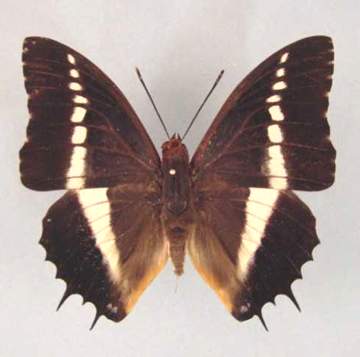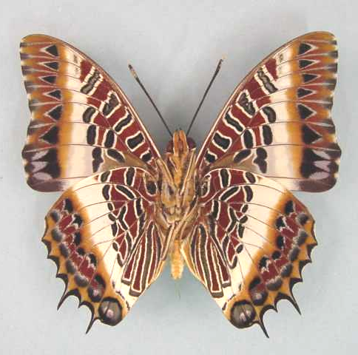

Charaxes brutus angustus. Male. Left – upperside; right – underside. Wingspan: 73mm. Male. Ebogo, Cameroon, 800m, 03.15N 11.15E. 4.iv.1995. A.I. & M.A. Curle. (Curle Trust Collection - 96).

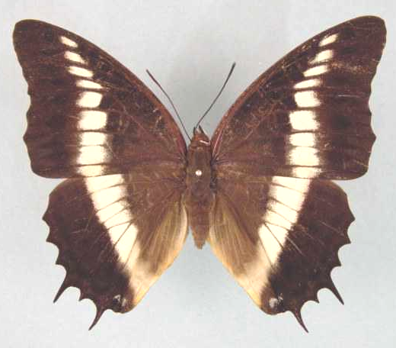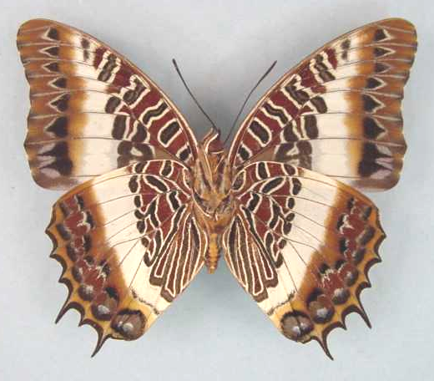

Charaxes brutus angustus. Female. Left – upperside; right – underside. Wingspan: 84mm. Bangui, R. C. A. 83.04.21. R.P. Godart. (Curle Trust Collection - 98).

Type locality: Democratic Republic of Congo: “Upoto”.
Diagnosis: The white bands on the upperside are narrower than in the other subspecies (Kielland, 1990).
Distribution: Nigeria (east), Cameroon, Equatorial Guinea (Bioko), Central African Republic, Gabon, Congo, Angola (north), Democratic Republic of Congo, Uganda (west), Sudan (south), Kenya (west), Tanzania (north-west), Zambia.
Specific localities:
Tanzania – Minziro Forest (Congdon and Collins, 1998).
Zambia – Ikelenge; Nkamba Bay; Kalambo Falls, near Lake Tanganyika (Heath, et al., 2002).

fractifascia Le Cerf, 1923 (as f. (? indiv.) of Charaxes brutus angustus). Bulletin du Muséum National d’Histoire Naturelle. Paris 29: 365 (360-367, 428-429). Gabon: “vallée de la N’Goumé”.

nigrescens Le Moult, 1933 (as ab. of Charaxes brutus angustus). Novitates Entomologicae 3: 17 (16-18). Congo: “Etoumbi (Congo français)”.

Charaxes brutus natalensis Staudinger, 1885

Charaxes brutus var. natalensis Staudinger, 1885 in Staudinger and Schatz, 1884-8. Exotischer Schmetterlinge 1: 169 (333 pp.). Bayern.

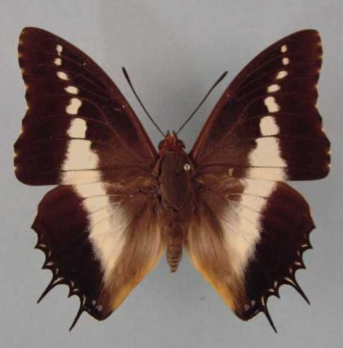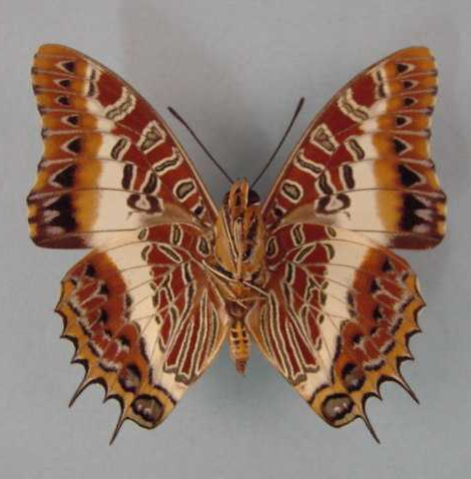

Charaxes brutus natalensis. Male. Left – upperside; right – underside. Wingspan: 65mm. Mnt. Selinda, S. Rhod. XII-1935. G. van Son. (Transvaal Museum - TM3360).

Type locality: South Africa: “Natal”.
Distribution: Tanzania (south and west), Malawi, Zambia, Angola (south-east), Mozambique, Zimbabwe, Botswana (north), Namibia (north), South Africa (Limpopo Province, Mpumalanga, Gauteng, KwaZulu-Natal, Eastern Cape Province), Swaziland.
Specific localities:
Zambia – Mufulira; Mpongwe; Kabwe; Lusaka; Kafue; Victoria Falls; Luangwa; Samfya; Mbala; Makutu Mountains; Mafinga Mountains (Heath, et al., 2002).
Limpopo Province – Legalameetse Nature Reserve (“Malta Forest”) (Swanepoel, 1953); Matlapetsi River (Swanepoel, 1953); Tubex (Swanepoel, 1953); Woodbush (Swanepoel, 1953); Munnik (Swanepoel, 1953); Sibasa (Swanepoel, 1953); Entabeni Forest (Swanepoel, 1953); Louis Trichardt (Swanepoel, 1953); Waterpoort (Swanepoel, 1953); Saltpan (Swanepoel, 1953).
Mpumalanga – Barberton (Swanepoel, 1953); Nelspruit (Swanepoel, 1953); Graskop (Swanepoel, 1953); Marieps Kop (Swanepoel, 1953); Buffelskloof Nature Reserve (Williams).
Gauteng – Pretoria (Williams and O’Brien – from about 2000 both fresh adults and early stages were more frequently found).
KwaZulu-Natal – Oribi Gorge (Swanepoel, 1953); Umkomaas (Swanepoel, 1953); Durban (Swanepoel, 1953); Pietermaritzburg (Swanepoel, 1953); Eshowe (Swanepoel, 1953); St Lucia Bay (Swanepoel, 1953); False Bay (Swanepoel, 1953); Candover (Swanepoel, 1953).
Eastern Cape Province – Bashee River (Swanepoel, 1953); Port St Johns (Swanepoel, 1953); Van Staden’s Pass (Pringle, et al., 1994).
Swaziland – Mlawula N. R. (www.sntc.org.sz).

Charaxes brutus roberti Turlin, 1987

Charaxes brutus roberti Turlin, 1987. Bulletin de la Société Scientifique Naturelle (53): 20 (19-25).
Type locality: Tanzania: “Ngezi Forest, nord-ouest Pemba Island”. Holotype (female) in the Muséum national d’Histoire naturelle, Paris.
Diagnosis: Darker than ssp. alcyone; hindwing with a small submarginal ochre spot in space 7 (Kielland, 1990).
Distribution: Tanzania (Pemba Island).
Specific localities:
Tanzania – Ngezi Forest, Pemba Island (Kielland, 1990).

Charaxes junius Oberthür, 1880

Charaxes junius Oberthür, 1880. Annali del Museo Civico di Storia Naturale (di Genova) Giacomo Doria 15: 166 (129-186).
Type locality: Ethiopia: “Scioa”.
Distribution: Ethiopia, Sudan.
Habitat: Forest and woodland savanna.
Early stages: Nothing published.
Larval food: Nothing published.
Note: C. junius Oberthür, 1880 is treated as a subspecies of brutus (Cramer, 1779) by Van Someren (1970: 218). Henning (1989: 105) treats junius as a distinct species on the authority of Plantrou (1983). Plantrou’s paper is, however, an unpublished thesis; thus the taxonomic change is, strictly speaking, not valid.

Charaxes junius junius Oberthür, 1880

Charaxes junius Oberthür, 1880. Annali del Museo Civico di Storia Naturale (di Genova) Giacomo Doria 15: 166 (129-186).
Type locality: Ethiopia: “Scioa”.
Distribution: Ethiopia (west and south-west).
Specific localities:
Ethiopia – Shoa country; Sciotalit; Feleklek (Henning, S., 1989).
Note: C. junius Oberthür, 1880 is treated as a subspecies of brutus (Cramer, 1779) by Van Someren (1970: 218). Henning (1989: 105) treats junius as a distinct species on the authority of Plantrou (1983). Plantrou’s paper is, however, an unpublished thesis; thus the taxonomic change is, strictly speaking, not valid.

ragazzii Storace, 1948 (as f. of Charaxes brutus). Annali del Museo Civico di Storia Naturale (di Genova) Giacomo Doria 63: 132 (132-141). Ethiopia: “Abissinia, Scioa”.

Charaxes junius somalicus Rothschild, 1900

Charaxes brutus somalicus Rothschild, 1900 in Rothschild and Jordan, 1900. Novitates Zoologicae 7: 432 (287-524).
Type locality: Ethiopia: “Harrar Highlands, Somaliland”. Holotype (male) in the Natural History Museum, London.
Distribution: Ethiopia (south), Sudan (south-east).
Specific localities:
Ethiopia – Adola; Youbodo (Henning, 1989).
Note: C. junius somalicus Rothschild, 1900 is treated as a subspecies of brutus (Cramer, 1779) by Van Someren (1970: 218). Henning (1989: 105) treats somalicus as a subspecies of junias on the authority of Plantrou (1983). Plantrou’s paper is, however, an unpublished thesis; thus the taxonomic change is, strictly speaking, not valid.

Charaxes antiquus Joicey & Talbot, 1926

Charaxes brutus antiquus Joicey & Talbot, 1926. Entomologist 59: 222 (220-226).
Type locality: Sao Tome and Principe: “Sao Thomé”.
Distribution: Sao Tome and Principe (island of Sao Tome).
Habitat: Forest and woodland (Henning, 1989).
Early stages: Nothing published.
Larval food: Nothing published.
Note: C. antiquus Joicey and Talbot, 1926 is treated as a subspecies of brutus (Cramer, 1779) by Van Someren (1970: 220). Henning (1989: 106) treats anitquus as a distinct species on the authority of Plantrou (1983). Plantrou’s paper is, however, an unpublished thesis; thus the taxonomic change is, strictly speaking, not valid.

Charaxes andara Ward, 1873

Charaxes andara Ward, 1873. Entomologist’s Monthly Magazine 9: 209 (209-210).
Type locality: Madagascar.
Distribution: Madagascar (east and south).
Habitat: Forest.
Early stages: Nothing published.
Larval food: Nothing published.

Charaxes ansorgei Rothschild, 1897

Charaxes ansorgei Rothschild, 1897. Novitates Zoologicae 4: 181 (179-184).
Type locality: Uganda: “Patsho, Nandi Country, Uganda Protectorate”.
Diagnosis: Similar to C. pollux but male with a white band on the hindwing upperside (Kielland, 1990).
Distribution: Sudan, Democratic Republic of Congo, Uganda, Rwanda, Burundi, Kenya, Tanzania, Malawi, Zambia.
Habitat: Montane forest, at altitudes of 2 000 to 3 000 m (Henning, 1989). In Tanzania ssp. kungwensis is found at altitudes from 2 000 to 2 300 m; ssp. ufipa from 2 000 to 2 200 m; ssp. levicki from 1 700 to 2 200 m; ssp. simoni from 1 750 to 2 140 m; ssp. rydoni from 1 000 to 2 200 m (Kielland, 1990).
Early stages:

Van Someren and Van Someren, 1926: 340 (ssp. ansorgei).

Henning, S., 1989: 112 (ssp. ruandana; ex Impenetrable Forest, Uganda).

Thiry and Vingerhoedt, 1991a.

Larval food:
Bersama abyssinica abyssinica Fresen. (Melianthaceae) [Van Someren, 1974: 319].
Bersama paullinoides Verdcourt (Melianthaceae) [Van Someren, 1974: 319].
Bersama abyssinica englerana (Gürke) F. White (Melianthaceae) [Henning, S., 1989: 113].

Charaxes ansorgei ansorgei Rothschild, 1897

Charaxes ansorgei Rothschild, 1897. Novitates Zoologicae 4: 181 (179-184).
Type locality: Uganda: “Patsho, Nandi Country, Uganda Protectorate”. Holotype (male) in the Natural History Museum, London.
Distribution: Uganda (slopes of Mt Elgon), Kenya (highlands west of the Rift Valley).
Specific localities:
Kenya: - Patsho (TL); Mt Elgon; Kitale; Turbo; Nandi Forest; Lumbwa; Kericho; Mau; Elgeyo; Cherangani (Henning, 1989).

Charaxes ansorgei jacksoni Poulton, 1933

Charaxes ansorgei jacksoni Poulton, 1933. Stylops 2: 13 (12-16).
Type locality: Kenya: “Kikuyu Escarpt., nr. Uplands, Uganda Rly”. Holotype (male) in the University Museum, Oxford.
Distribution: Kenya (highlands east of the Rift Valley).
Specific localities:
Kenya: - Aberdare Mountains; Uplands (upper Kikuyu country); Kirita Forest; upper Meru Forest; Njombeni Range. In the latter two localities specimens differ slightly from topotypical material (Henning, 1989).

Charaxes ansorgei kilimanjarica van Someren, 1967

Charaxes ansorgei kilimanjarica van Someren, 1967. Bulletin of the British Museum (Natural History) (Entomology) 18: 309 (277-316).
Type locality: Tanzania: “Western Foot hills, ... Kilimanjaro”. Holotype (male) in the Natural History Museum, London.
Diagnosis: Forewing discal band in female yellow-orange (Kielland, 1990).
Distribution: Tanzania. Known only from the type locality (on the western slopes of Mt Kilimanjaro, at Wasendo).

Charaxes ansorgei kinyeti Plantrou, 1989

Charaxes ansorgei kinyeti Plantrou, 1989. In: Henning, 1989. The Charaxinae butterflies of Africa 108 (457 pp.). Johannesburg.
Type locality: Sudan: “Sud Soudan, Gilo, Mts Imatong”. Holotype (male) in the Natural History Museum, London.
Distribution: Sudan (south - Imatong, Kinyeti and Didinga Mountains).

Charaxes ansorgei kungwensis van Someren, 1967

Charaxes ansorgei kungwensis van Someren, 1967. Bulletin of the British Museum (Natural History) (Entomology) 18: 306 (277-316).
Type locality: Tanzania: “East shore, Lake Tanganyika, in Mahali forest on the Kungwe Peninsula”. Holotype (male) in the Natural History Museum, London.
Diagnosis: Hindwing band in male white; hindwing submarginal orange spots greatly reduced; forewing median band in female white or only slightly tinged with yellow (Kielland, 1990).
Distribution: Tanzania (eastern shores of Lake Tanganyika).
Specific localities:
Tanzania – Mahale Mountains, Kigoma District (Kielland, 1990).

Charaxes ansorgei levicki Poulton, 1933

Charaxes ansorgei levicki Poulton, 1933. Stylops 2: 15 (12-16).

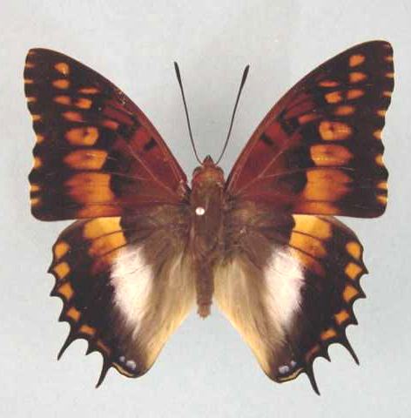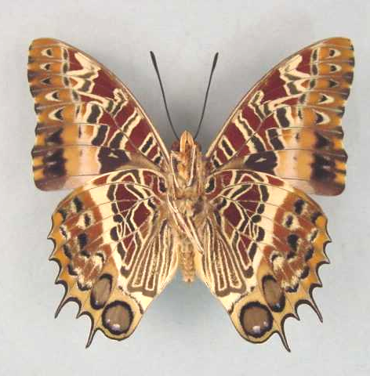

Charaxes ansorgei levicki. Male. Left – upperside; right – underside. Wingspan: 63mm. Mufindi, Tanzania. 15.I.1994. (Curle Trust Collection - 99).

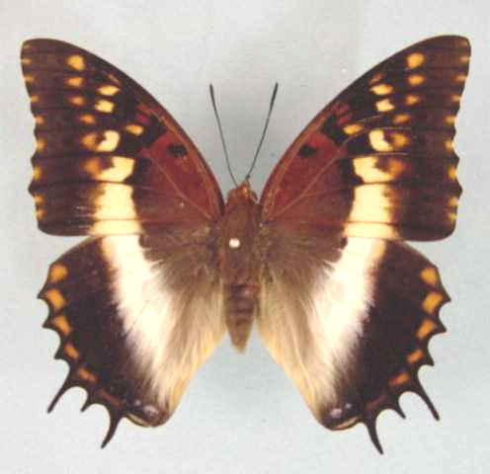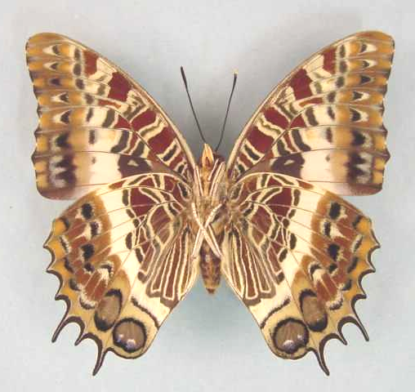

Charaxes ansorgei levicki. Female. Left – upperside; right – underside. Wingspan: 74mm. Mufindi, Tanzania. 15.I.1994. (Curle Trust Collection - 101).

Type locality: “Lake Nyasa, E. Africa”. Holotype (male) in the Natural History Museum, London.
Diagnosis: Forewing apex in both sexes rounded (as in ssp. simoni); hindwing band in male orange and white; forewing band in female pale yellow or whitish (Kielland, 1990).
Distribution: Tanzania (southern highlands), Malawi, Zambia.
Specific localities:
Tanzania – Porto; Rungwe; Manow; Njombe; Iringa (Henning, 1989); Uzungwa Range; Mwanihana Forest; Mufindi; Image Mountain; Kitesa Forest west of Songea; Mount Mangalisa; Chugu Mountain; Nguru Mountains (Kielland, 1990).
Malawi – Nyika Plateau; Misuku Hills (Roger White, pers. comm., 2003).
Zambia – Nyika (Heath, et al., 2002).

Charaxes ansorgei loita Plantrou, 1982

Charaxes ansorgei loita Plantrou, 1982. Miscellanea Entomologica 49: 112 (101-115).
Type locality: Kenya: “Mt Loita, Sud Kenya”. Holotype (male) in the Natural History Museum, London.
Diagnosis: Hindwing band in male pure white (Kielland, 1990).
Distribution: Kenya (south), Tanzania (north).
Specific localities:
Kenya – Loita Hills, east of Lake Magadi.
Tanzania – Loliondo (Kielland, 1990).

Charaxes ansorgei ruandana Talbot, 1932

Charaxes ansorgei ruandana Talbot, 1932. Bulletin of the Hill Museum, Witley 4: 289 (288-289).
Type locality: Rwanda: “E. Congo: Kabira Forest, Ruanda, 12 miles north of Usambara”. Holotype (female) in the Natural History Museum, London.
Distribution: Uganda (south-west), Rwanda, Burundi, Democratic Republic of Congo (Kivu, Ituri).
Specific localities:
Uganda: - Mafugu; Kanaba Gap; Ruhiza; Nawamba Valley (Henning, 1989).

Charaxes ansorgei rydoni van Someren, 1967

Charaxes ansorgei rydoni van Someren, 1967. Bulletin of the British Museum (Natural History) (Entomology) 18: 309 (277-316).
Type locality: Tanzania: “Usambara Range, Magamba Forest, nr. Lusheto [Lushoto]”. Holotype (male) in the Natural History Museum, London.
Diagnosis: Wing margins more dentate than in other subspecies; hindwing tails long and slender (Kielland, 1990).
Distribution: Tanzania (north-east)
Specific localities:
Tanzania - Usambara Mountains (Kielland, 1990).

Charaxes ansorgei simoni Turlin, 1987

Charaxes ansorgei simoni Turlin, 1987. Bulletin de la Société Scientifique Naturelle (53): 19 (19-25).
Type locality: Tanzania: “Mont Bondwa, Uluguru Mts, Est Tanzania”. Holotype (male) in the Natural History Museum, London.
Diagnosis: Hindwing submarginal orange spots large in both sexes; tails thick; forewing band in female white (Kielland, 1990).
Distribution: Tanzania (north-east)
Specific localities:
Tanzania – Uluguru Mountains.

Charaxes ansorgei ufipa Kielland, 1978

Charaxes ansorgei ufipa Kielland, 1978. Tijdschrift voor Entomologie 121: 174 (147-237).
Type locality: Tanzania: “Ufipa, Mbuzi Mt., 2000 m”. Holotype (male) in the National Museum, Nairobi, Kenya.
Diagnosis: Median band of hindwing in male white; forewing band in both sexes narrower and basal area much darker than in ssp. kungwensis (Kielland, 1990).
Distribution: Tanzania (west).
Specific localities:
Tanzania – Bizi Forest, Ufipa District; Mbuzi Mountain, Ufipa District (Kielland, 1990).

Charaxes phoebus Butler, 1866

Charaxes phoebus Butler, 1866. Proceedings of the Zoological Society of London 1865: 625 (622-639).
Type locality: Ethiopia: “Abyssinia”.
Distribution: Ethiopia (north-west, central, west, south).
Habitat: Montane forest and woodland (Henning, 1989).
Early stages:

Henning, S., 1989: 114.

Larval food:
Bersama abyssinica Fresen. (Melianthaceae) [Van Someren, 1974: 319].

Charaxes pollux (Cramer, 1775)

Papilio pollux Cramer, 1775. Die Uitlandsche Kapellen voorkomende in de drie waerrelddeelen Asia, Africa en America 1: 61 (155 pp.). Amsteldam and Utrecht.

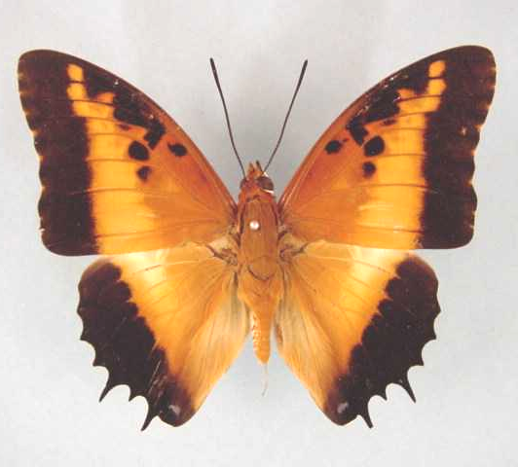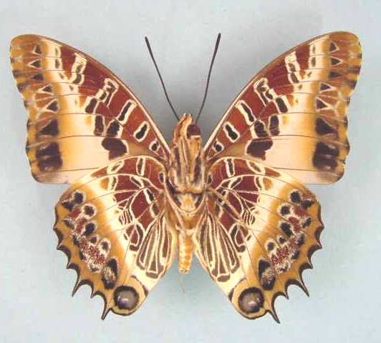

Charaxes pollux pollux. Male. Left – upperside; right – underside. Wingspan: 76mm. Bangui, R. C. A. 80.11.12. R.P. Godart. (Curle Trust Collection - 102).

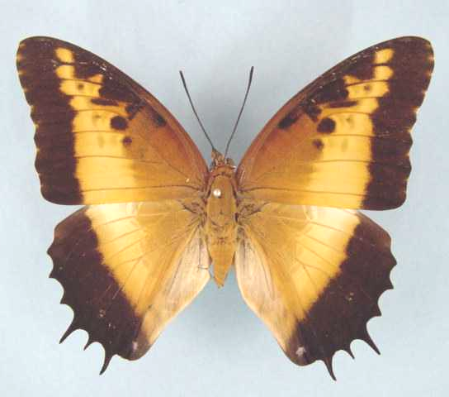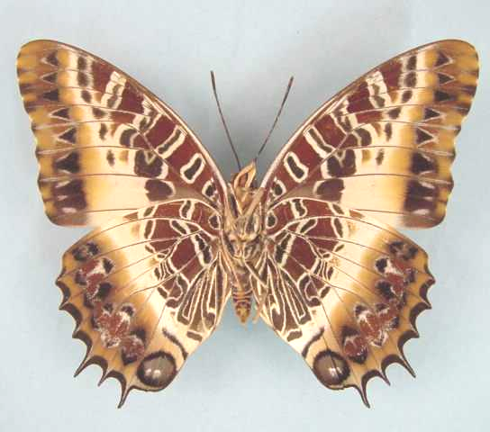

Charaxes pollux pollux. Female. Left – upperside; right – underside. Wingspan: 84mm. Bangui, R. C. A. 82.02.20. R.P. Godart. (Curle Trust Collection - 104).

Type locality: “Cote de Guinée”.
Distribution: Guinea, Sierra Leone, Liberia, Ivory Coast, Ghana, Nigeria, Cameroon, Equatorial Guinea, Central African Republic, Gabon, Angola, Congo, Democratic Republic of Congo, Zambia, Rwanda, Burundi, Sudan, Uganda, Kenya, Tanzania, Malawi, Mozambique, Zimbabwe.
Common name: Black-bordered charaxes.
Habitat: Forest, gallery forest and heavy woodland (Henning, 1989). In Tanzania the nominate subspecies occurs at altitudes of 300 to 2 000 m, ssp. maua from 1 700 to 2 400 m, and ssp. mira from 1 200 to 2 100 m (Kielland, 1990).
Habits: Males often perch high up, with the wings partially open, on trees at the edge of the forest. They seem to be less aggressive than other members of the genus. Both sexes are readily attracted to fermenting fruit (Pringle, et al., 1994) and ‘sucking-trees’ (Larsen, 2005a).
Flight period: Probably on the wing throughout the year (Pringle, et al., 1994).
Early stages:

Van Someren & Van Someren, 1926: 342 (ssp. pollux).

Van Someren & Rogers, 1928: 147 (ssp. pollux).
“The eggs are laid on the young leaves of the food-plants … with great rapidity, so much so that the insect will not even trouble to shift the position of the ovipositor, with the result that very often two or more eggs are piled one on top of another. They are of the usual Charaxes form, a sphere with a saucer-like fluted depression on the top, pearly white in colour and 1 mm in diameter. At an early stage in development, three radiating lines appear on the surface giving the egg a marbled appearance. When the egg is mature it turns dark brown to black. The young larva hatches in from seven to ten days and at once eats the egg-shell, then after a while commences on the young shoots and descending as it grows, consumes the more mature leaves. Very shortly after emerging it spins a pad of silk on some sheltered leaf and returns to this spot every morning after its nightly feed. The shelter is changed from time to time as the larva grows. The larva is at first uniform pale olive with a black head, the colour then changes with each successive moult to a tranlucent green which is almost smooth and immaculate until after the third moult, when one or two dorsal spots appear on the sixth and eighth segments respectively. The adult larva is about 6 cm in length, has a bright green almost smooth-skinned body, the papillation being very fine, with one or two circular rusty-red spots on a white ground, enclosed by a fine brown line. In some larvae the rusty-red tint later changes to a bright blood-red. When only one spot appears it is invariably on segment 6, the second, if present, being on segment 8. There is no definite body-line and the spiracles are obscure, the under surface is greyish-white. When at rest the larva lies along the mid-rib of the prepared leaf, with its head and tail raised. As a rule one finds only a single larva to each leaf. The head is characteristic of the species, being in front view somewhat quadrate in outline and having two pairs of very spiny horns, a central, straight pair arising on either side of the mid-line, the lateral pair arising from just below the upper angles and curving slightly backwards and inwards. There are two short sharp-pointed spines between the central pair and one on either side of the lateral horns. The general colour of the head is a uniform bluish-green. No facial line is present but the lateral tubercles and the spines on the horns are strongly developed. The larval stage lasts 18 days. The pupa is of the usual Charaxes shape, smooth and with a light green colour on the thorax and wing-cases becoming more bluish-white towards the dorsum of the abdominal segments. There is only a slight concavity between the thorax and the abdomen on the dorsum; practically no projection on the shoulders of the wing-scutae, but the head is bifid. There are white patches on each wing-case, while the abdominal spiracles are represented by a row of six reddish-brown spots. The pupal period extends to ten days as a rule but is often longer.”

Pinhey, 1949: 63 (ssp. gazanus).

Clark, in Van Son, 1979: 160 (Plate 66) (ssp. gazanus).
From the incomplete account by Clark “it follows that the egg is 1,4 mm in diameter by 1,3 mm high, and has traces of 20 short ribs on top of the depression; from the paintings of the 2nd to the final instar it is evident that they are very similar to the respective instars of the nominate subspecies. The pupa, instead of having white patches on the wing-cases, has pinkish ones, but it is probable that the colour is subject to variation.”

Henning, S., 1989: 119 (ssp. maua; ex Mt Kilimanjaro, Tanzania).

Larval food:
Sorindeia species (Anacardiaceae) [Van Someren and Rogers, 1928: 147].
Bersama abyssinica Fresen. (Melianthaceae) [Van Someren and Rogers, 1928: 147; Blandin, et al., 1975 (Ivory Coast)].
Deinbollia kilimandsharica Taub. (Sapindaceae) [Van Someren, 1974: 319].
Deinbollia borbonica Scheff. (Sapindaceae) [Van Someren, 1974: 319].
Fluggia microcarpa Blume (Euphorbiaceae) [Van Someren, 1974: 319].
Securinega virosa (Roxb. ex Willd.) Pax and K. Hoffm. (Euphorbiaceae) [Dickson and Kroon, 1978: 60].
Fluggia virosa (Euphorbiaceae) [Kielland, 1990: 108].

Charaxes pollux pollux (Cramer, 1775)

Papilio pollux Cramer, 1775. Die Uitlandsche Kapellen voorkomende in de drie waerrelddeelen Asia, Africa en America 1: 61 (155 pp.). Amsteldam and Utrecht.

Charaxes pollux pollux. Male. Left – upperside; right – underside. Wingspan: 76mm. Bangui, R. C. A. 80.11.12. R.P. Godart. (Curle Trust Collection - 102).

Charaxes pollux pollux. Female. Left – upperside; right – underside. Wingspan: 84mm. Bangui, R. C. A. 82.02.20. R.P. Godart. (Curle Trust Collection - 104).

Type locality: “Cote de Guinée”.
Diagnosis: Hindwing marginal black border without orange submarginal markings (Kielland, 1990).
Distribution: Guinea, Sierra Leone, Liberia, Ivory Coast, Ghana, Nigeria (south and Cross River loop), Cameroon, Central African Republic, Gabon, Angola (north), Congo, Democratic Republic of Congo (Shaba), Zambia (north and north-west), Rwanda, Burundi, Sudan (south), Uganda, Kenya (west, central), Tanzania (west).
Specific localities:
Sierra Leone – Freetown (Owen & Chanter, 1972).
Ivory Coast – near Abidjan (H. Warren-Gash teste Larsen, 2005a); Bossematie (H. Fermon teste Larsen, 2005a).
Ghana – Atewa Range (Larsen, 2005a).
Cameroon – Korup (Larsen, 2005a).
Nigeria – Vom (Owen, 1977); Jos Plateau (St Leger, 1984); Obudu Plateau (St Leger, 1984); Kagoro Forest – strays (Larsen, 2005a); Mambilla Plateau (R. Warren teste Larsen, 2005a).
Tanzania – From Mpanda to the Ugandan border (Kielland, 1990). Populations in the south and east, north to the Ulugurus, and Nguu and Nguru Mountains, are transitional to geminus but, on the whole, closer to the nominate subspecies (Kielland, 1990).
Zambia – Ikelenge; Kasangezhi; Mwinilunga; 100 km south of Mwinilunga; Mufulira; Ndola; Mpongwe; Mswebe, Mumbwa; Samfya; Nchelenge; Lumangwe Falls; Nkamba Lodge; Mbala; Kalambo Falls (Heath, et al., 2002).

camulus Drury, 1782 (as sp. of Papilio). Illustrations of Natural History 3: index et 41 (76 pp.). London. Sierra Leone: “Sierra Leon”.

subalbescens Hall, 1930 (as ab. of Charaxes pollux). Entomologist 63: 279 (278-279). Sierra Leone: “Sierra Leon”.

bungense Stoneham, 1932 (as ssp. of Charaxes pollux). Bulletin of the Stoneham Museum (9): [2] ([2 pp.]). Kenya: “Malawa Forest, Kabras, Kenya Colony”.

ongeus Stoneham, 1932 (as ab. of Charaxes pollux). Bulletin of the Stoneham Museum (9): [2] ([2 pp.]). Kenya: “East Surrey Coffee Estates, Trans-Nzoia, Kenya Colony”.

Charaxes pollux annamariae Turlin, 1998

Charaxes pollux annamariae Turlin, 1998. Lambillionea 98 (2) (Tome I): 182 (181-189).
Type locality: Equatorial Guinea: “île de Bioko, (Fernando Poo) Pico Malabo, 11 X 80 (H. Cornet).” In M.N.H.N., Paris.
Distribution: Equatorial Guinea (Bioko Island).

Charaxes pollux gazanus van Someren, 1967

Charaxes pollux gazanus van Someren, 1967. Bulletin of the British Museum (Natural History) (Entomology) 18: 314 (277-316).

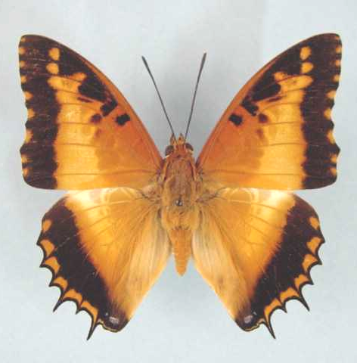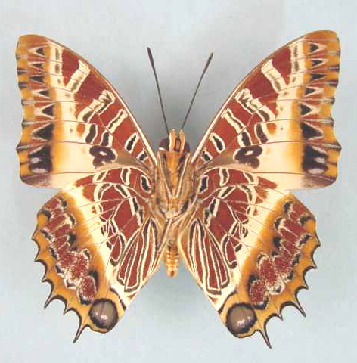

Charaxes pollux gazanus. Male. Left – upperside; right – underside. Wingspan: 63mm. Burma Valley, Zimbabwe. 21.5.86. I. Bampton. (Curle Trust Collection - 105).

Type locality: Mozambique: “S. Mozambique, Amatongas”. Holotype (male) in the Transvaal Museum, Pretoria, South Africa.
Distribution: Mozambique (west - between Zambezi and Limpopo Rivers), Zimbabwe (east).
Specific localities:
Mozambique – Dondo Forest; Amatongas; Maronga Forest; Buzi River, below Espungabera (Pringle, et al., 1994).
Zimbabwe Mount Selinda; Mutare (Pringle, et al., 1994).

Charaxes pollux geminus Rothschild, 1900

Charaxes pollux geminus Rothschild, 1900 in Rothschild and Jordan, 1900. Novitates Zoologicae 7: 427 (287-524).
Type locality: Zambia: “Nyassaland, Lauderdale”.
Diagnosis: Characterized, on the hindwing upperside margin, by the prominent orange markings (Kielland, 1990).
Distribution: Malawi, Zambia (east of the Luangwa Valley), Tanzania (south and east) [Kielland (1990) avers that true geminus does not occur in Tanzania – see remarks under the nominate subspecies], Kenya (south-east) [Kielland (1990) implies that populations from south-east Kenya belong to ssp. mira].
Specific localities:
Zambia – near Chipata; near Lundazi; Nyika (Heath, et al., 2002).

zinjense Stoneham, 1932 (as ssp. of Charaxes pollux). Bulletin of the Stoneham Museum (9): [2] ([2 pp.]). Kenya: “Mambrui”.

Charaxes pollux maua van Someren, 1967

Charaxes pollux maua van Someren, 1967. Bulletin of the British Museum (Natural History) (Entomology) 18: 316 (277-316).
Type locality: Tanzania: “western foothills, Mt. Kilimanjaro, Maua”. Holotype (male) in the Natural History Museum, London.
Diagnosis: Characterized by the darker brown basal area on the upperside of the wings, slightly narrower orange median bands, and submarginal orange markings in the hindwing black border (Kielland, 1990). In the populations from Mbulu and Mount Kwaraha the median bands are rather narrow and the basal area darker; specimens from Mount Meru are paler than those from Mount Kilimanjaro (Kielland, 1990).
Distribution: Tanzania (north)
Specific localities:
Tanzania – Mount Kilimanjaro; Mount Meru; Mount Oldeani; Ngorongoro Crater; Mbulu Forests; Mount Kwaraha (Kielland, 1990).

Charaxes pollux mira Ackery, 1995

Charaxes pollux mira Ackery, 1995: 455.
Type locality: Tanzania: “Amani, Mts Usambara, 1000 m”. Holotype (male) in the Muséum national d’Histoire naturelle, Paris.
Diagnosis: Characterized by the following: large size; long tails; very wide orange median band on upperside of wings; prominent submarginal orange markings on both fore and hindwings; basal areas on upperside of both wings paler than in ssp. maua.
Distribution: Tanzania (north-east)
Specific localities:
Tanzania – Usambara Mountains (Kielland, 1990). Populations on the North and South Pare Mountains and Teita Hills (Kenya) are very similar, and are regarded as being consubspecific with ssp. mira by Kielland (1990).

mirabilis Turlin, 1989 in Henning, 1989 [before Oct.] (as ssp. of Charaxes pollux). The Charaxinae butterflies of Africa 116, 117 (457 pp.). Johannesburg. Tanzania: “Amani, Mts Usambara, 1000 m”. [Invalid; junior primary homonym of Charaxes bernardus mirabilis Hanafusa, 1989 [March] [Charaxinae, extralimital].]]

Charaxes pollux piersoni Collins, 1990

Charaxes pollux piersoni Collins, 1990 in Kielland, 1990. Butterflies of Tanzania 338 (363 pp.). Melbourne.
Type locality: Tanzania: “Jozani F. Zanzibar 8/87. M. Pierson”. Types in the Tervuren Museum, Belgium.
Original description:
“This is a small race confined to the Island of Zanzibar. The forewing length of the male is 35 mm. The general pattern is like the typical pollux pollux; the margin on the recto surface being entirely black, the brown markings of the basal area extend further towards the margins as in the races p. miribalus and p. geminus. The most characteristic feature is a large well developed blue spot of the anal angle at least twice as large as in any other race. The female has the same basic pattern as the male and the blue spot in the anal angle of the marginal black band is even more developed (6 mm). The underside is of the typical pollux pattern.
Distribution: Tanzania (Zanzibar Island).
Specific localities:
Tanzania – Jozani Forest, Zanzibar Island (TL).

Charaxes dowsetti Henning, 1989

Charaxes dowsetti Henning, 1989. The Charaxinae butterflies of Africa 119 (457 pp.). Johannesburg.
Type locality: Malawi: “10 km N of Chilinda, Nyika National Park”. Holotype (male) in the Natural History Museum, London.
Distribution: Malawi (Nyika Plateau).
Habitat: Montane forest, at altitudes above 2 200 m (Henning, 1989).
Early stages:

Henning, S., 1989: 121.

Larval food:
Agauria salicifolia (Comm. ex Lam.) Hook. f. ex Oliv. (Ericaceae) [Henning, S., 1989: 121].

Charaxes druceanus Butler, 1869

Charaxes druceanus Butler, 1869. Cistula Entomologica 1: 4 (1-16).
Type locality: [South Africa]: “Old Calabar”. [False locality.]. Holotype (male) in the Natural History Museum, London.
Distribution: Congo, Angola, Democratic Republic of Congo, Sudan, Uganda, Rwanda, Burundi, Kenya, Tanzania, Malawi, Zambia, Mozambique, Zimbabwe, South Africa, Swaziland.
Misattributed to Guinea by Fleury (1926). According to Larsen (2005a) also misattributed to Nigeria and Cameroon.
Common name: Silver-barred charaxes.
Habitat: Montane forest. The nominate subspecies is also found in coastal forest. In Tanzania ssp. proximans occurs at altitudes from 1 200 to 2 000 m (but as low as 600 m); ssp. praestans from 900 to 2 000 m; ssp. setentrionalis from 1 800 to 2 200 m; ssp. teita from 1 700 to 2 600 m (Kielland, 1990).
Habits: Males establish territories and perch on the tops of high trees. Males occasionally mud-puddle and both sexes are readily attracted to fermenting fruit. Pennington saw a number of specimens feeding from the flowers of Syzygium cordatum near the Havelock Mine in Swaziland (Pringle, et al., 1994).
Flight period: All year (ssp. entabeni; ssp. stevensoni; ssp. proximans; ssp. solitaria?); September to May (nominate subspecies and ssp. moerens) (Pringle, et al., 1994).
Early stages:

Van Someren & Van Someren, 1926: 343 (ssp. proximans).

Van Someren & Rogers, 1929: 4 (ssp. proximans).
“This [sub]species lays its eggs on the undersurfaces of the leaves of a creeping shrub. They are spherical and glossy, with a slight concavity on top. Fine radial lines pass from the edge of the depression, converging towards the centre, where they become obsolescent. When first laid, the egg is yellow, but in twenty-four hours the upper part becomes streaked with pinkish lines; still later the upper third of the egg is overspread with pinkish-brown. The larva emerges in about eight days and straight away devours the egg shell. The newly hatched larva is pale apricot in colour, 4 mm long and tapering slightly towards the posterior end. The head is pale-brown with darker markings and a rugose surface. Two pairs of horns are present, one at the highest point on each side of the head and the other about one-third down. The former pair diverging at an angle of about ninety degrees and strongly curved backwards, are almost as long as the height of the head, while the latter are about half as long as the other pair and curve upwards and slightly backwards. There are two minute spinous processes between each upper and side horn. A pair of brown, white-tipped, blunt processes, directed upwards in a slight curve and diverging nearly at a right angle, is present on the anal segment. The length at the end of the first stage is 9 mm and the general colour greenish with a brown spot on segment 6. At the first moult the larva becomes grass-green, with paler green dots, each bearing a minute short hair. The upper half of the head is dark purplish-brown, the lower pink-brown. The horns are crimson, with paler tips. The anal spines are crimson with pink tubercles. A well-marked spot on segement 6 is in shape somewhat semi-circular, with a straight edge directed forwards, while that on segment 8 is circular and somewhat obscure. Both spots are purply-brown, the front one having a green dot towards the front edge. The length at this stage is 12 mm. The head is first cast and then the skin gradually shed. Growth in the third stage is rapid, but the colour hardly changes except that the head is now green with a purply suffusion at the upper half. The dorsal spots on segments 6 and 8 become well defined and more purply, with a dotted outline of blue at the circumference. This general colouration is maintained throughout the final stage; but the larva is 45 mm long when ready to pupate. The pupa is pale green, 30 mm long, and rather broad, 15 mm at the angle of the wing scutae. It resembles that of Ch. pollux but is rather more bluish and the white marbling on the wing cases is more pronounced. The spiracular spots are red with a central longitudinal dark line and with a brown outline. The angle of the dorsum of the thorax is white and from this, wavy whitish lines run to the bluntly bifurcated head-shield. The cremaster is orange and consists of a long pedicle with on either side a well-pronounced bilobed process and anterior to each pair is a further bilobed projection on segment 2. The pupal stage lasts three weeks as a rule, but some carry over for a much longer period.”

Clark, in Van Son, 1979: 161 (Plate 67) (ssp. druceanus; as cinadon).
“Eggs are laid singly on the surface of a leaf. They are 1,8 to 2 mm in diameter by 1,75-1,8 mm high, with some 24 ribs made up of some eight to ten very faint rib-braced moles. They are at first very pale watery yellow and later develop a thin brownish circlet. The eggs hatch after some eight days. The young larva eats its way out near the top of the egg and generally eats the shell; it is 6 mm and grows to 10 mm in some nine days. It rests on the midrib of a leaf and feeds on the edge of the leaf. In the second instar the larva grows to 15 mm in 10 days and in the 3rd to 21 mm in 13 days. The 4th instar takes some 15 days and the larva grows to 29 mm. In the final instar the larva grows to 46 mm in 35 days. The times given are for end of the season eggs, but in the spring and summer the times are much shorter. The pupa is suspended by cremastral hooks only, from a leaf or twig, and is 23 mm long. Emergence takes place after 20-25 days.”

Clark, in Van Son, 1979: 161 (Plate 68) (ssp. moerans).
“The late Mr Clark was of the opinion that the present race [moerans] is specifically distinct from nominate druceanus on account of differences in the structural details of the head of the larva, the cremaster of the pupa and the slightly different position of the larger moles on the side of the larval segments. However, neither van Someren, nor the present author, share this view, as Clark’s plates are based on the characters of single larvae only and therefore do not show the amount of possible individual variation which in most species is very considerable. The egg is 1,9 mm in diameter by 1,75 mm high, with 24-25 ribs over the edge of the flat top and part way down the sides. The size and duration of the larval instars are the same as in druceanus cinadon [= druceanus druceanus], and the food-plant is also the same. The very close relation of the antenna/wing ratio (0,01 difference in the male, and no difference in the female) in cinadon [= druceanus] and moerans confirms that they are conspecific.”

Henning, S., 1989: 130 (ssp. moerans; Mariepskop, Mapumalanga).

Henning, S., 1989: 131 (ssp. proximans; Dedza, Malawi).

Vingerhoedt, 1997 (ssp. obscura; Burundi).

Larval food:
Syzygium cordatum Hochst. (Myrtaceae) [Millar, J., and Haygarth, in Platt, 1921: 103] (ssp. druceanus; as cinadon).
Syzygium cordatum Hochst. (Myrtaceae) [Van Someren, 1936: 178] (ssp. proximans).
Syzygium guineense (Willd.) DC. (Myrtaceae) [Van Someren, 1963: 228] (ssp. proximans).
Syzygium mambwaensis Greenway (Myrtaceae) [Van Someren, 1963: 228] (ssp. proximans).
Bersama abyssinica Fresen. (Melianthaceae) [Van Someren, 1963: 228] (ssp. proximans).
Protea arborea Houtt. (syn. grandiflora Thunb.) (Proteaceae) [Gifford, 1965: 95] (ssp. proximans).
Syzygium cordatum Hochst. (Myrtaceae) [Clark, in Van Son, 1979: 162] (ssp. moerans).
Syzygium gerrardii (Harv. ex Hook. f.) Burtt Davy (Myrtaceae) [Henning, S., 1989: 130; Mariepskop, Mpumalanga] (ssp. moerans).
Eugenia species (Myrtaceae) [Henning, S., 1989: 131] (ssp. proximans).
Schefflera goetzenii Harms (Araliaceae) [Henning, S., 1989: 131] (ssp. proximans).

Charaxes druceanus druceanus Butler, 1869

Charaxes druceanus Butler, 1869. Cistula Entomologica 1: 4 (1-16).
Type locality: [South Africa]: “Old Calabar”. [False locality.]. Holotype (male) in the Natural History Museum, London.
Distribution: South Africa (KwaZulu-Natal).
Specific localities:
KwaZulu-Natal – Pinetown (Swanepoel, 1953); Eshowe (Swanepoel, 1953); Pietermaritzburg (Swanepoel, 1953); Balgowan (Swanepoel, 1953); Ngoye Forest; Kranskop; Karkloof (Swanepoel, 1953); Kloof; Umdoni Park; Burman’s Bush, Durban; Cowie’s Hill; Balcomb’s Hill (Pringle, et al., 1994).

cinadon Hewitson, 1870 (as sp. of Charaxes). Entomologist’s Monthly Magazine 6: 177 (177-178). South Africa: “Natal”. [Given in Ackery, et al., 1995: 440 as a synonym of C. druceanus druceanus Butler but treated as a good subspecies by Pringle, et al., 1994: 89. Apparently the type locality of “Old Calabar” (Nigeria) given by Butler when he described Charaxes druceanus was not correct and the material on which his description was based actually came from KwaZulu-Natal, South Africa.]

Charaxes druceanus brazza Turlin, 1987

Charaxes druceanus brazza Turlin, 1987. Bulletin de la Société Scientifique Naturelle (53): 23 (19-25).
Type locality: Congo: “Kinkala, 150 km à l’ouest de Brazzaville, R.P. du Congo”. Holotype (male) in the Muséum national d’Histoire naturelle, Paris.
Distribution: Congo (Kinkala, Bela).

Charaxes druceanus entabeni van Someren, 1963

Charaxes druceanus entabeni van Someren, 1963. Bulletin of the British Museum (Natural History) (Entomology) 13: 233 (195-242).
Type locality: South Africa: “Northern Transvaal, Zoutpansberg, Entabeni”. Holotype (male) in the Transvaal Museum, Pretoria, South Africa.
Diagnosis: Subspecies entabeni is lighter than ssp. moerens, with a lighter forewing discal band in the male and a darker one in the female; there is also a well developed dark spot in the middle of the cell, which is normally absent in moerens (Pringle, et al., 1994).
Distribution: South Africa (Limpopo Province - Zoutpansberg).
Specific localities:
Limpopo Province – Entabeni Forest (Pringle, et al., 1994).

Charaxes druceanus katamayu Plantrou, 1982

Charaxes druceanus katamayu Plantrou, 1982. Miscellanea Entomologica 49: 108 (101-115).
Type locality: Kenya: “la région de Nairobi et du Mt Kenya Uplands, Katamayu, Njambeni, Mts Aberdare”. Holotype (male) in the Natural History Museum, London.
Distribution: Kenya (south - east of the Rift Valley, around Nairobi).
Specific localities:
Kenya: - Nairobi; Mt Kenya uplands; Katamayu; Njambeni; Aberdare Mountains.

Charaxes druceanus moerens Jordan, 1936

Charaxes druceanus moerens Jordan, 1936. Novitates Zoologicae 39: 333 (330-333).
Type locality: South Africa: “Transvaal: Marieps Mt., Drakensberg district, 24° 35' S., 30° 50' E”.
Diagnosis: Subspecies moerens is much darker than the nominate subspecies and the discal bands are narrow due to the enlargement of the black markings on the upperside. The discal bands of the female are much lighter than those in other southern African subspecies (Pringle, et al., 1994).
Distribution: South Africa (Limpopo Province, Mpumalanga), Swaziland.
Specific localities:
Limpopo Province – Legalameetse Nature Reserve (“Malta Forest”) (Swanepoel, 1953); Woodbush (Swanepoel, 1953).
Mpumalanga – Mariepskop (TL); Barberton (Swanepoel, 1953); Graskop (Swanepoel, 1953).
Swaziland – Havelock Mine (Pennington).

Charaxes druceanus obscura Rebel, 1914

Charaxes druceanus var. obscura Rebel, 1914. Annalen des (K.K.) Naturhistorischen Museums. Wien 28: 253 (219-294).
Type locality: Uganda: “Nordwestufer des Tanganyika-Sees”. Holotype (male) in the Vienna Museum.
Distribution: Uganda (west), Democratic Republic of Congo (Kivu), Rwanda (west), Burundi (west).

kivuanus Jordan, 1925 (as ssp. of Charaxes druceanus). Novitates Zoologicae 32: 288 (288-289). Rwanda: “Rugege forest, east of south-end of Lake Kivu”.

cryanae Le Cerf, 1932 (as ssp. of Charaxes druceanus). Bulletin du Muséum National d’Histoire Naturelle. Paris (2) 4: 406 (405-406). Democratic Republic of Congo: “Congo belge oriental, Kitembo, lac Kivu”.

nyungwe Turlin, 1980 (as f. of Charaxes druceanus obscura). Bulletin de la Société Scientifique Naturelle (25): 15 (13-22). Rwanda: “[Nyungwe forest]”.

Charaxes druceanus praestans Turlin, 1989

Charaxes druceanus praestans Turlin, 1989. In: Henning, 1989. The Charaxinae butterflies of Africa 127 (457 pp.). Johannesburg.
Type locality: Tanzania: “Lusotho, Monts Usambara”. Holotype (male) in the Muséum national d’Histoire naturelle de Paris.
Distribution: Tanzania (north-east).
Specific localities:
Tanzania – Usambara Mountains; South Pare Mountains; ?Mount Lossoganeu (Kielland, 1990).

Charaxes druceanus proximans Joicey & Talbot, 1922

Charaxes druceanus proximans Joicey & Talbot, 1922. Bulletin of the Hill Museum, Witley 1: 338 (335-338).
Type locality: Malawi: “Nyasaland”.
Diagnosis: In ssp. proximans the discal bands on the upperside are even wider than in stevensoni and the ground colour is bright orange-chestnut. In the male the blue spots in the anal angle of the hindwing upperside are well developed (Pringle, et al., 1994).
Distribution: Democratic Republic of Congo (Lualaba, Shaba), Angola (east), Rwanda (east), Burundi (east), Tanzania (south and west), Malawi, Zambia, Zimbabwe (north-west).
Specific localities:
Tanzania – Masakulu Forest, Tukuyu; Ngara District; Songea; Kitesa Forest; Uzungwa Range; Rubeho Mountains; Ukaguru Mountains; Nguru Mountains; Nguu Mountains; Uluguru Mountains (Kielland, 1990).
Zambia – Ikelenge; Kasangezhi; Mwinilunga; Chingola; Mufulira; Kitwe; Ndola; Mkushi; Lusaka; Chipata; Shiwa Ngandu; Kasama; Nyika (Heath, et al., 2002).

Charaxes druceanus septentrionalis Lathy, 1925

Charaxes druceanus septentrionalis Lathy, 1925. Encyclopédie Entomologique (B.3. Lepidoptera) 1: 93 (93-97).
Type locality: Kenya: “Kenya Colony, Afrique oriental britannique”. Holotype (male) in the collection of Madame Fournier, Paris.
Diagnosis: Underside darker than in proximans with narrower bands on both wings; hindwing band wider than in praestans (Kielland, 1990).
Distribution: Uganda (east), Kenya (west), Tanzania (north).
Specific localities:
Tanzania – Marang Forest; Hasama Forest (Kielland, 1990).

alicea Stoneham, 1931 (as sp. of Charaxes). Bulletin of the Stoneham Museum (5): [2] ([2 pp.]). Kenya: “East Surrey Estates, about 12 miles east of Kitale, Kenya Colony”.

lugari van Someren, 1939 (as f. of Charaxes druceanus proximans). Journal of the East Africa and Uganda Natural History Society 14: 179 (172-180). Kenya: “Lugari”.

Charaxes druceanus solitaria Henning & Henning, 1992

Charaxes druceanus solitaria Henning & Henning, 1992. Metamorphosis 3 (3): 118 (115-120).
Type locality: South Africa: “South Africa, Blouberg, Northern Transvaal, 10-13.x.1985.” Described from one male and five females. Holotype in the Transvaal Museum, Pretoria.
Diagnosis: In ssp. solitaria the marginal silvery area on the underside of the hindwing is greatly enlarged (Pringle, et al., 1994).
Distribution: South Africa (Limpopo Province - north-east and north-west slopes of the Blouberg). Known only from the type locality.

Charaxes druceanus stevensoni van Someren, 1963

Charaxes druceanus stevensoni van Someren, 1963. Bulletin of the British Museum (Natural History) (Entomology) 13: 233 (195-242).

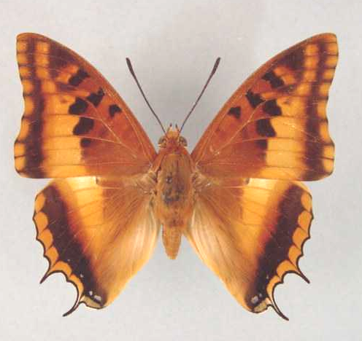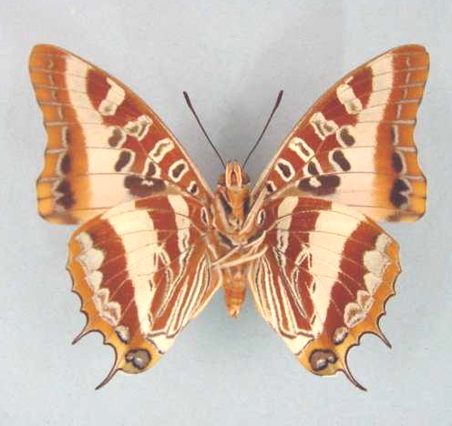

Charaxes druceanus stevensoni. Male. Left – upperside; right – underside. Wingspan: 65mm. Laurenceville, Vumba, S. R. 2:9:57. H. Cookson. (Transvaal Museum - TM3370).

Type locality: Zimbabwe: “Vumba Mts. (Eastern side of S. Rhodesia)”. Holotype (male) in the Natural History Museum, London.
Diagnosis: Subspecies stevensoni is similar to the nominate subspecies but the ground colour on the upperside is lighter and the discal bands are broader and lighter. The dark spot in the middle of the cell is weakly developed, while the silver bands on the underside are wider (Pringle, et al., 1994).
Distribution: Mozambique (west), Zimbabwe (east).
Specific localities:
Zimbabwe – Vumba Mountains (TL); Hwedza; Harare; Mazowe; Dichwe; Rusape; Penhalonga; Mutare; Butler North; Chimanimani; Mount Selinda (Pringle, et al., 1994).

Charaxes druceanus teita van Someren, 1939

Charaxes druceanus teita van Someren, 1939. Journal of the East Africa and Uganda Natural History Society 14: 177 (172-180).
Type locality: Kenya: “Teita Hills”. Holotype (male) in the Natural History Museum, London.
Diagnosis: Female with a paler median band than in ssp. septentrionalis (Kielland, 1990).
Distribution: Kenya (south-east), Tanzania (north - Arusha-Moshi district).
Specific localities:
Kenya – Teita Hills, Chawia Forest; Wandanyi Forest; Wesu Forest; Mbololo Forest (Henning, 1989).
Tanzania – Mount Kilimanjaro; North Pare Mountains; Mount Longido (Kielland, 1990).

Charaxes druceanus vivianae Plantrou, 1982

Charaxes druceanus vivianae Plantrou, 1982. Miscellanea Entomologica 49: 107 (101-115).
Type locality: Sudan: “Silo, Mts Imatong, Sud Soudan, 7200 ft”. Holotype (male) in the Natural History Museum, London.
Distribution: Sudan (south - Imatong Mountains).

Charaxes druceanus williamsi Plantrou, 1982

Charaxes druceanus williamsi Plantrou, 1982. Miscellanea Entomologica 49: 109 (101-115).
Type locality: Kenya: “Mt Kasigau, 5000 ft, sud-est Kenya”. Holotype (male) in the Natural History Museum, London.
Distribution: Kenya (south-east - Mount Kasigau).

Charaxes tectonis Jordan, 1937

Charaxes druceanus tectonis Jordan, 1937. Novitates Zoologicae 40: 323 (323-325).
Charaxes tectonis Jordan, 1937. Darge, 1983: 75.
Charaxes druceanus tectonis Jordan, 1937. Henning, S., 1989: 123.
Charaxes tectonis Jordan, 1937. Larsen, 2005a: 312.
Type locality: Cameroon: “Msungli, Cameroon, Bamenda Division”. Holotype (male) in the Natural History Museum, London.
Distribution: Nigeria, Cameroon.
Common name: Mountain silver-barred charaxes.
Habitat: Submontane and montane forest (Larsen, 2005a).
Habits: This is an uncommon species. According to H. Boersma (teste Larsen, 2005a) they come to traps baited with fermented fruit but after feeding rest for a short time and then escape.
Early stages: Nothing published.
Larval food: Nothing published.

Charaxes tectonis tectonis Jordan, 1937

Charaxes druceanus tectonis Jordan, 1937. Novitates Zoologicae 40: 323 (323-325).
Charaxes tectonis Jordan, 1937. Darge, 1983: 75.
Charaxes druceanus tectonis Jordan, 1937. Henning, S., 1989: 123.
Charaxes tectonis Jordan, 1937. Larsen, 2005a: 312.
Type locality: Cameroon: “Msungli, Cameroon, Bamenda Division”. Holotype (male) in the Natural History Museum, London.
Distribution: Nigeria (east), Cameroon (west - Bamenda Forest, Mt Oku).
Specific localities:
Nigeria – Obudu Plateau (Larsen, 2005a).
Cameroon – Msungli (TL); Bamenda Forest; Mount Oku.

Charaxes tectonis nebularum Darge, 1977

Charaxes druceanus nebularum Darge, 1977. Bulletin de la Société Entomologique de Mulhouse 1977: 9 (9-12).
Type locality: Cameroon: “Massif de Manengouba, versant Nord-Est, (altitude: 2,120 mètres)”. Holotype (male) in the collection of Ph. Darge.
Distribution: Cameroon (Manengouba massif).
Note: Larsen (2005a: 312) avers that nebularum may not be conspecific with tectonis.

Charaxes phraortes Doubleday, 1847

Charaxes phraortes Doubleday, 1847. Proceedings of the Zoological Society of London 1847: 60 (58-61).
Type locality: Madagascar.
Distribution: Madagascar (north-east ).
Specific localities:
Madagascar: - Maroantsetra (Henning, 1989); La Mandraka (Henning, 1989; unconfirmed according to Lees et al., 2003); Montangne d’Ambre (Lees et al., 2003); Nosy Berafia (Lees et al., 2003; unconfirmed).
Habitat: Wet coastal forest.
Early stages: Nothing published.
Larval food: Nothing published.

Charaxes andranodorus Mabille, 1884

Charaxes andranodorus Mabille, 1884. Annales de la Société Entomologique de Belgique 28: 184 (184-191).
Type locality: Madagascar.
Distribution: Madagascar.
Habitat: The nominate subspecies is found at altitudes between 800 and 1 400 m in wet evergreen forest. Subspecies andrefana is found is scattered remnants of rainforest in western Madagascar (Henning, 1989).
Early stages:

Henning, S., 1989: 134 (ssp. andranodorus).

Larval food:
Annona senegalensis Pers. (Annonaceae) [Henning, S., 1989: 135 (ssp. andranodorus); in captivity].

Charaxes andranodorus andranodorus Mabille, 1884

Charaxes andranodorus Mabille, 1884. Annales de la Société Entomologique de Belgique 28: 184 (184-191).
Type locality: Madagascar.
Distribution: Madagascar (east).

zoippus Mabille, 1884 (as sp. of Charaxes). Annales de la Société Entomologique de Belgique 28: 185 (184-191). Madagascar.

Charaxes andranodorus andrefana Viette, 1975

Charaxes andranodorus andrefana Viette, 1975. Bulletin de la Société Entomologique de France 80: 112 (112).
Type locality: Madagascar: “Madagascar Ouest, district d’Antsalova, Andobo, forêt de l’Antsingy [Bemaraha]”. Holotype (male) in the Muséum national d’Histoire naturelle, Paris.
Distribution: Madagascar (west).
Note: Considered to be possibly threatened by habitat degradation by Jenkins (1987) (teste Lees et al., 2003) and placed as a red data species on the IUCN list, but subsequently (1996) justifiably removed from listing (Lees et al., 2003). It is reasonably common in the northeast of Madagascar (Kremen et al., 2001).

Charaxes eudoxus (Drury, 1782)

Papilio castor var. eudoxus Drury, 1782. Illustrations of Natural History 3: index et 44 (76 pp.). London.
Type locality: Sierra Leone: “Sierra Leon”.
Distribution: Guinea, Sierra Leone, Liberia, Ivory Coast, Ghana, Nigeria, Cameroon, Equatorial Guinea, Gabon, Congo, Angola, Democratic Republic of Congo, Central African Republic, Sudan, Uganda, Rwanda, Burundi, Kenya, Tanzania, Cameroon, Zambia.
Common name: Eudoxus charaxes.
Habitat: Forest, including gallery and riverine forest. In West Africa it penetrates Guinea savanna along riverine forest (Larsen, 2005a). In Tanzania ssp. mechowi occurs in lowland to submontane forest at altitudes from 800 to 1 600 m and ssp. raffaellae from 1 300 to 1 400 m (Kielland, 1990).
Habits: Apparently it is becoming increasingly scarce in West Africa, possibly because one of its main foodplants, Garcinia, a favoured ‘chewing stick’, is under increasing pressure from utilization (Larsen, 2005a).
Early stages:

Van Someren, 1936: 183 (ssp. cabacus; ssp. amaurus).

Henning, S., 1989: 141 (ssp. cabacus).

Larval food:
Schefflera species (Araliaceae) [Van Someren, 1974: 320].
Syzygium spp. (Myrtaceae) [Van Someren, 1974: 320].
Syzygium cordatum Hochst. (Myrtaceae) [Henning, S., 1989: 141].
Syzygium guineense (Willd.) DC. (Myrtaceae) [Henning, S., 1989: 141].
Garcinia species (Guttiferae) [Henning, S., 1989: 141].

Charaxes eudoxus eudoxus (Drury, 1782)

Papilio castor var. eudoxus Drury, 1782. Illustrations of Natural History 3: index et 44 (76 pp.). London.
Type locality: Sierra Leone: “Sierra Leon”.
Distribution: Guinea, Sierra Leone, Liberia, Ivory Coast, Ghana, Nigeria (west).
Specific localities:
Guinea – Conakry (Larsen, 2005a).
Ivory Coast – Tai National Park (Blandin et al, 1975); Cocody, Abidjan (H. Warren-Gash teste Larsen, 2005a).
Ghana – Kissi, near Cape Coast (Larsen, 2005a).
Nigeria – Warri (H. Boersma teste Larsen, 2005a); Obudu Plateau (Larsen, 2005a).

druceanoides Nicat, 2002a (as f. of Charaxes eudoxus eudoxus). Lambillionea 102 (2): 155 (155-158). Ivory Coast.

Charaxes eudoxus amaurus Poulton, 1929

Charaxes eudoxus amaurus Poulton, 1929 in Eltringham, et al., 1929. Transactions of the Entomological Society of London 77: 478 (475-504).
Type locality: Kenya: “W. of Kitale on the E. slopes of Mt. Elgon, Kenya Colony”. Holotype (male) in the University Museum, Oxford.
Distribution: Kenya (west).

nzoia van Someren, 1970 (as f. of Charaxes eudoxus amaurus). Bulletin of the British Museum (Natural History) (Entomology) 25: 246 (197-250). Kenya: “N.W. Kenya: Kitale”.

Charaxes eudoxus biokoensis Canu, 1989

Charaxes eudoxus biokoensis Canu, 1989. In: Henning, 1989. The Charaxinae butterflies of Africa 136 (457 pp.). Johannesburg.
Type locality: Equatorial Guinea: “Bioko”. Holotype (male) in the collection of Dr. J.G. Canu.
Distribution: Equatorial Guinea (Bioko Island).

Charaxes eudoxus boersmana Plantrou, 1980

Charaxes eudoxus boersmana Plantrou, 1980. Sciences Naturelles (26): 12 (11-13).
Type locality: Nigeria: “Forêt de Kagoro, Nord Nigéria”. Holotype (male) in the Muséum national d’Histoire naturelle de Paris.
Distribution: Nigeria (north- central).
Specific localities:
Nigeria – Kagoro Forest (Larsen, 2005a). Known only from the type localitiy.

Charaxes eudoxus cabacus Jordan, 1925

Charaxes eudoxus cabacus Jordan, 1925. Novitates Zoologicae 32: 288 (288-289).
Type locality: Uganda: “Kampala, Entebbe”.
Distribution: Uganda (north-west shores of Lake Victoria).

Charaxes eudoxus goubandana Nicat, 2002

Charaxes eudoxus goubandana Nicat, 2002a. Lambillionea 102 (2): 158 (155-158).
Type locality: Guinea.
Distribution: Guinea.
Specific localities:
Guinea – Fouta Djalon (Larsen, 2005a); Labe (Larsen, 2005a); Parc National du Haut Niger (Larsen, 2005a).

Charaxes eudoxus imatongensis Plantrou, 1982

Charaxes eudoxus imatongensis Plantrou, 1982. Miscellanea Entomologica 49: 105 (101-115).
Type locality: Sudan: “Silo [Gilo], Mt Imatong, Sud Soudan”. Holotype (male) in the Natural History Museum, London.
Distribution: Sudan (south - Imatong Mountains).

Charaxes eudoxus katerae Carpenter, 1937

Charaxes eudoxus katerae Carpenter, 1937. Transactions of the Royal Entomological Society of London 86: 91 (85-98).
Type locality: Uganda: “Katera, ... , in the Malabigambo forest on the Buddu (west) coast of Lake Victoria”. Holotype (male) in the Natural History Museum, London.
Distribution: Uganda (south - western shores of Lake Victoria), Tanzania (north-west).
Specific localities:
Uganda – Matera Forest; Malabigambo Forest; Katera Forest (Henning, 1989).
Tanzania – Minziro Forest (Congdon and Collins, 1998).

Charaxes eudoxus lequeuxi Plantrou, 1982

Charaxes eudoxus lequeuxi Plantrou, 1982. Miscellanea Entomologica 49: 101 (101-115).
Type locality: Rwanda: “Forêt de Nyungwe, 2500 m”. Holotype (male) in the Muséum national d’Histoire naturelle de Paris.
Distribution: Rwanda, Burundi.

Charaxes eudoxus mechowi Rothschild, 1900

Charaxes eudoxus mechowi Rothschild, 1900 in Rothschild and Jordan, 1900. Novitates Zoologicae 7: 419 (287-524).

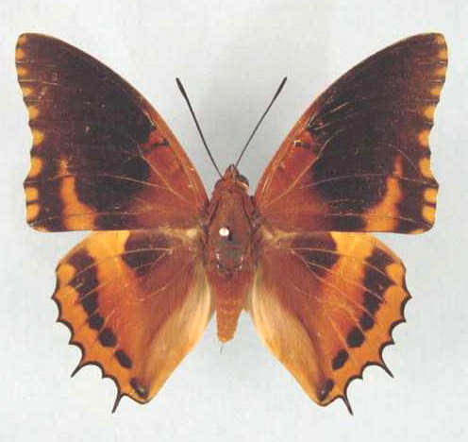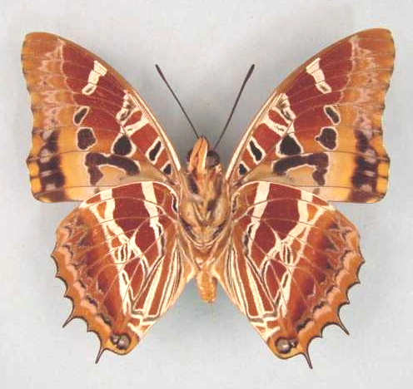

Charaxes eudoxus mechowi. Male. Left – upperside; right – underside. Wingspan: 70mm. Bangui, C. A. R. 8.viii.1980. (Curle Trust Collection - 108).

Type locality: Angola: “Northern Angola”. Holotype (male) in the Oberthür collection.
Distribution: Nigeria (east), Sudan (south-west), Uganda (south-west - Kigezi district), Tanzania (west - Kigoma), Cameroon, Gabon, Congo, Angola (north), Zambia (extreme north-west), Democratic Republic of Congo, Central African Republic.
Specific localities:
Cameroon – Korup (Larsen, 2005a).
Tanzania – North-west Mpanda to Kigoma (Kielland, 1990).
Zambia – Lisombu River; Kasangezhi (Heath, et al., 2002).

blachieri Oberthür, 1912 (as sp. of Charaxes). Études de Lépidoptérologie Comparée 6: 311 (311). Democratic Republic of Congo: “Quango-Strom”.

theresae Le Cerf, 1932 (as ssp. of Charaxes eudoxus). Bulletin du Muséum National d’Histoire Naturelle. Paris (2) 4: 405 (405-406). Democratic Republic of Congo: “Congo belge oriental, Kitembo, lac Kivu”.

Charaxes eudoxus mitchelli Plantrou & Howarth, 1977

Charaxes eudoxus mitchelli Plantrou & Howarth, 1977. Proceedings and Transactions of the British Entomological and Natural History Society 10: 24 (22-25).

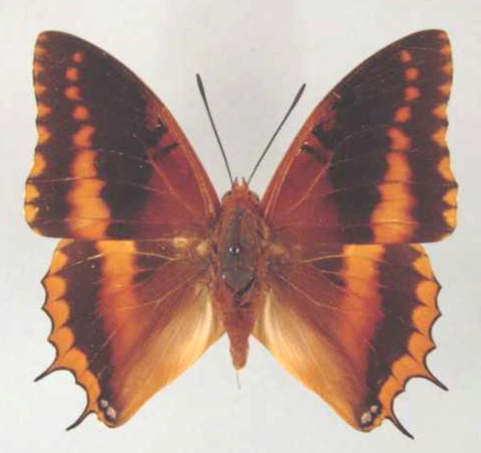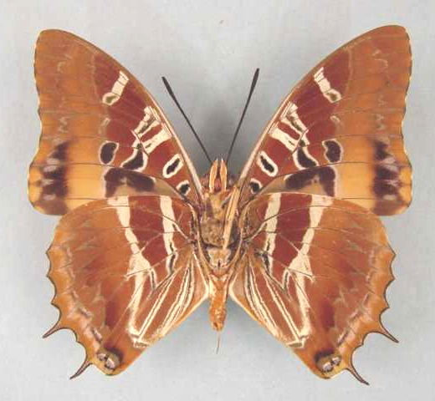

Charaxes eudoxus mitchelli. Male. Left – upperside; right – underside. Wingspan: 60mm. Kashiba, Central Zambia. 5.11.72. M. Mitchell. (Henning collection - H257).

Type locality: Zambia: “Lake Kashiba, Mpongwe”. Holotype (male) in the Natural History Museum, London.
Distribution: Zambia.
Specific localities:
Zambia – Lake Kashiba; near Mpongwe; Ndola Township; Mufulira (Heath, et al., 2002).

Charaxes eudoxus raffaellae Plantrou, 1982

Charaxes eudoxus raffaellae Plantrou, 1982. Miscellanea Entomologica 49: 103 (101-115).
Type locality: Tanzania: “Mumwendo-Rulenge, Nord-ouest Tanzanie”. Holotype (male) in the Muséum national d’Histoire naturelle de Paris.
Distribution: Tanzania (north-west); Burundi? (Kielland, 1990).
Specific localities:
Burundi – Kiofi (Kielland, 1990).
Tanzania – Rulenge in Ngara District; Biharamulo (Kielland, 1990); Kikuru Forest (Congdon and Collins, 1998).

Charaxes eudoxus zambiae van Someren, 1970

Charaxes eudoxus zambiae van Someren, 1970. Bulletin of the British Museum (Natural History) (Entomology) 25: 246 (197-250).

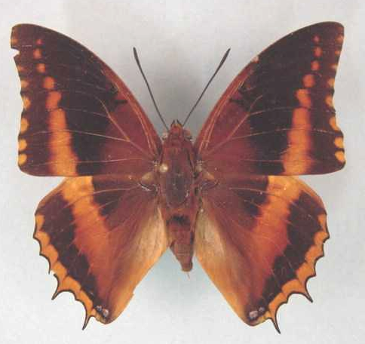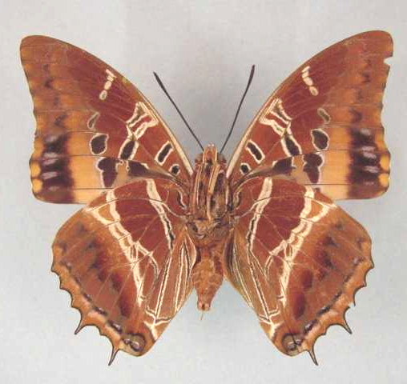

Charaxes eudoxus zambiae. Male. Left – upperside; right – underside. Wingspan: 69mm. Lunzua Falls, Mbala, N.E. Zambia. 4/1970. J.C. Little. (African Butterfly Research Institute, Nairobi).

Type locality: Zambia: “Shiwa Ngandu, [near Danger Hill, east side Upper Loangwe Valley]”. Holotype (male) in the Natural History Museum, London.
Distribution: Zambia (eastern side of upper Luangwa Valley).
Specific localities:
Zambia – Lumangwe Falls; Kasama; Shiwa Ngandu (Heath, et al., 2002).

Charaxes lucyae van Someren, 1975

Charaxes eudoxus lucyae van Someren, 1975. Bulletin of the British Museum (Natural History) (Entomology) 32: 104 (65-136).
Type locality: Tanzania: “Usambara Mts, Magamba Forest, Lushoto”. Holotype (female) in the Natural History Museum, London.
Diagnosis: Very close to C. eudoxus, from which it differs in the more dentate wing margins and longer tails; there are also minor differences in the genitalia (Kielland, 1990).
Distribution: Tanzania.
Habitat: Submontane and montane forest. In Tanzania the three subspecies occur in the following altitudinal ranges: 1 500 to 2 100 m (ssp. luycae), 1 200 to 1 800 m (ssp. mwanihanae and ssp. gabriellae) (Kielland, 1990).
Early stages: Nothing published.
Larval food: Nothing published.

Charaxes lucyae lucyae van Someren, 1975

Charaxes eudoxus lucyae van Someren, 1975. Bulletin of the British Museum (Natural History) (Entomology) 32: 104 (65-136).
Type locality: Tanzania: “Usambara Mts, Magamba Forest, Lushoto”. Holotype (female) in the Natural History Museum, London.
Distribution: Tanzania (north-east).
Specific localities:
Tanzania – Western Usambara Mountains (rare) (Kielland, 1990).

Charaxes lucyae gabriellae Turlin & Chovet, 1987

Charaxes lucyae gabriellae Turlin & Chovet, 1987. Bulletin de la Société Scientifique Naturelle (54): 7 (5-12).
Type locality: Tanzania: “Kwadiboma, Mts Nguu”. Holotype (male) in the Muséum national d’Histoire naturelle, Paris.
Diagnosis: Basal area of forewing upperside darker than in the other two subspecies and the forewing discal band much reduced in the upper half (Kielland, 1990).
Distribution: Tanzania (north-east).
Specific localities:
Tanzania – Nguu Mountains (common at Kwadiboma); Nguru Mountains (uncommon); Kanga Mountains (uncommon) (Kielland, 1990).

Charaxes lucyae mwanihanae Kielland, 1982

Charaxes eudoxus mwanihanae Kielland, 1982. Lambillionea 81: 86 (86-90).
Type locality: Tanzania: “Tanzania, Ifakara, Mwanihana Forest”. Holotype (female) in the Natural History Museum, London.
Diagnosis: Darker than the nominate subspecies and with the rufous band narrower on both wings (Kielland, 1990).
Distribution: Tanzania (east). Known only from the type locality, on a ridge above Sanje Village (very rare) (Kielland, 1990).

Charaxes musakensis Darge, 1973

Charaxes eudoxus musakensis Darge, 1973. Annales de la Faculté du Cameroun 15-16: 29 (25-26).
Type locality: Cameroon: “Musake Hut (= Hutte 1), mont Cameroun, République Unie du Cameroun”. Holotype (male) in the collection of Mr. P. Darge.
Distribution: Cameroon. Known only from the type locality.
Habitat: Montane forest, above 1 300 m altitude (Henning, 1989).
Early stages: Nothing published.
Larval food: Nothing published.

Charaxes richelmanni Röber, 1936

Charaxes richelmanni Röber, 1936. Entomologische Rundschau 53: 578 (575-580).
Type locality: Cameroon: “Kamerun”; “Kongogebiet”.
Distribution: Cameroon, Gabon, Congo, Central African Republic, Democratic Republic of Congo, Tanzania.
Habitat: Lowland evergreen forest (Henning, 1989).
Early stages: Nothing published.
Larval food: Nothing published.

Charaxes richelmanni richelmanni Röber, 1936

Charaxes richelmanni Röber, 1936. Entomologische Rundschau 53: 578 (575-580).
Type locality: Cameroon: “Kamerun”; “Kongogebiet”.
Distribution: Cameroon (south), Gabon, Congo, Central African Republic, Democratic Republic of Congo (Uele, Mongala, Tshopo, Sankuru).

fallax Richelmann, 1913 (as sp. of Charaxes). Internationale Entomologische Zeitschrift 7: 105 (105-106). Cameroon: “Kamerun”; “Kongogebiet”. [Invalid; junior primary homonym of Charaxes fallax Röber, 1894 [Charaxinae], [extralimital].]

Charaxes richelmanni ducarmei Plantrou, 1982

Charaxes richelmanni ducarmei Plantrou, 1982. Miscellanea Entomologica 49: 111 (101-115).
Type locality: Democratic Republic of Congo: “Butuhe, Est du Zaire”. Holotype (male) in the Muséum national d’Histoire naturelle de Paris.
Distribution: Democratic Republic of Congo (Kivu).

Charaxes richelmanni scheveni Ackery, 1995

Charaxes richelmanni scheveni Ackery, 1995: 457.
Type locality: Tanzania: “East Usambara, Amani”.
Distribution: Tanzania.

orientalis Scheven, 1975 (as ?). Annales de la Faculté des Sciences. Université Fédérale du Cameroun (18): 79 (79-82). Tanzania: “East Usambara, Amani”. [Invalid; junior primary homonym of Charaxes castor var. orientalis Lanz, 1896 [Charaxinae] and Charaxes smaragdalis orientalis Joicey and Talbot, 1918 [Charaxinae].]

TIRIDATES GROUP

Charaxes numenes (Hewitson, 1859)

Nymphalis numenes Hewitson, 1859 in Hewitson, 1857-61. Illustrations of new species of exotic butterflies 2: 75 (124 pp.). London.
Type locality: Sierra Leone.
Distribution: Senegal, Guinea-Bissau, Guinea, Sierra Leone, Liberia, Ivory Coast, Ghana, Benin (Fermon et al., 2001), Nigeria, Equatorial Guinea, Cameroon, Gabon, Congo, Angola, Democratic Republic of Congo, Zambia, Central African Republic, Sudan, Ethiopia, Uganda, Kenya, Tanzania.
Common name: Lesser blue charaxes.
Habitat: Evergreen lowland forest (Henning, 1989). In West Africa it extends into degraded forest and along riverine forest into the Guinea savanna (Larsen, 2005a). In Tanzania it is found at altitudes between 800 and 1 500 m (Kielland, 1990).
Habits: A fairly common butterfly but not nearly as common as C. tiridates, at least in West Africa (Larsen, 2005a).
Early stages:

Van Someren and Van Someren, 1926: 344 (ssp. aequatorialis).

Henning, S., 1989: 148 (ssp. aequatorilis).

Larval food:
Hugonia platysepela Welw. ex Oliv. (Linaceae) [Van Someren, 1974: 320].
Grewia mollis Juss. (Tiliaceae) [Van Someren, 1974: 320].
Grewia forbesi Harv. ex Mast. (Tiliaceae) [Van Someren, 1974: 320].
Deinbollia fulvotomentella Bak. f. (Sapindaceae) [Van Someren, 1974: 320].
Erythrina abyssinica Lam. ex DC. (Fabaceae) [Van Someren, 1974: 320].
Erythrina excelsa Bak. (Fabaceae) [Van Someren, 1974: 320].
Grewia trichocarpa Hochst. ex A. Rich. (Tiliaceae) [Henning, S., 1989: 148].
Allophylus species (Sapindaceae) [Henning, S., 1989: 148].
Blighia unijugata Bak. (Sapindaceae) [Henning, S., 1989: 148].
Phialodiscus unijugatus (Sapindaceae) [Kielland, 1990: 107].

Charaxes numenes numenes (Hewitson, 1859)

Nymphalis numenes Hewitson, 1859 in Hewitson, 1857-61. Illustrations of new species of exotic butterflies 2: 75 (124 pp.). London.
Type locality: Sierra Leone.
Distribution: Senegal, Guinea-Bissau, Guinea, Sierra Leone, Liberia, Ivory Coast, Ghana, Benin (Fermon et al., 2001), Nigeria (west). Intergrades with ssp. aequatorialis in eastern Nigeria (Larsen, 2005a).
Specific localities:
Senegal – Basse Casamance (Larsen, 2005a).
Sierra Leone – Freetown (Owen & Chanter, 1972).
Ivory Coast – Bossematie (H. Fermon teste Larsen, 2005a).
Ghana – Atewa Range (Joly, 2003).
Benin – Noyau Central, Lama Forest (Fermon, et al., 2001).
Nigeria – Warri (H. Boersma teste Larsen, 2005a).

Charaxes numenes aequatorialis van Someren, 1972

Charaxes numenes aequatorialis van Someren, 1972. Bulletin of the British Museum (Natural History) (Entomology) 27: 244 (215-264).

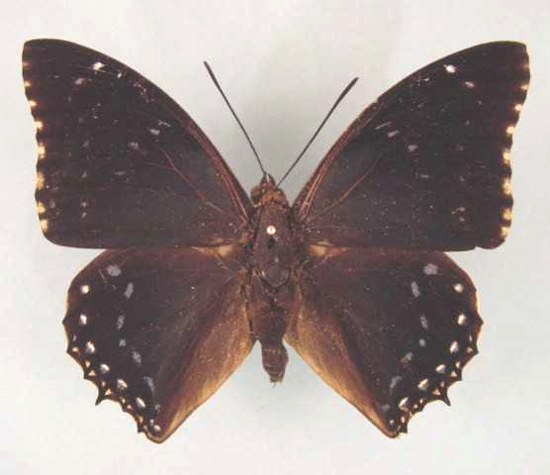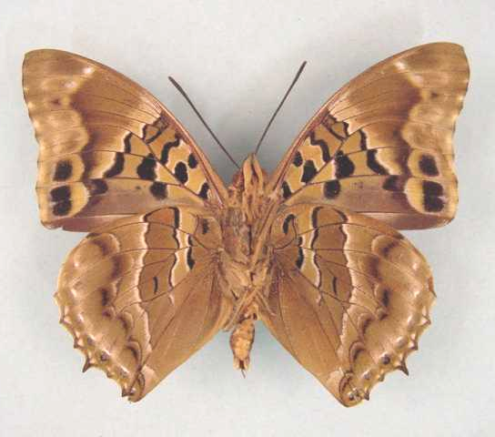

Charaxes numenes aequatorialis. Male. Left – upperside; right – underside. Wingspan: 76mm. Bangui, R. C. A. 80.11.15. R.P. Godart. (Curle Trust Collection - 109).

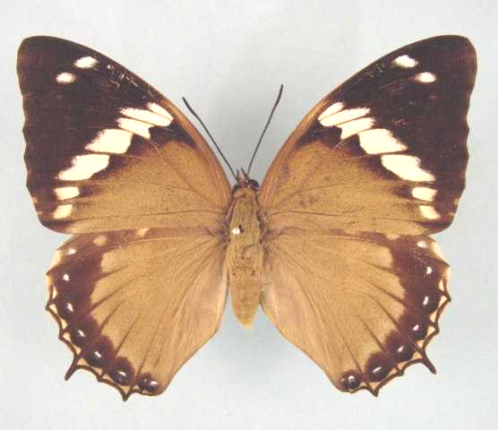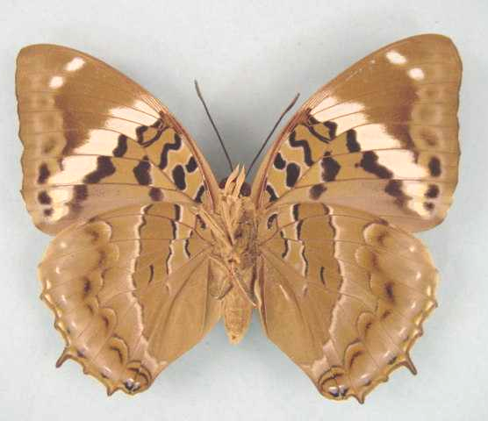

Charaxes numenes aequatorialis. Female. Left – upperside; right – underside. Wingspan: 82mm. Bangui, R. C. A. 81.01.06. R.P. Godart. (Curle Trust Collection - 112).

Type locality: Uganda: “Kayonza, Kigezi”. Holotype (male) in the Natural History Museum, London.
Distribution: Nigeria, Cameroon, Gabon, Congo, Angola (north), Democratic Republic of Congo, Zambia, Central African Republic, Sudan (south), Uganda, Kenya (west), Tanzania (west).
Specific localities:
Nigeria – Kagoro Forest (Larsen, 2005a: 321).
Cameroon – Korup (Lees, 1989).
Tanzania – North-west Mpanda to Gombe, north of Kigoma (Kielland, 1990).
Zambia – Kamapanda; Lisombu; 100 km south of Mwinilunga (Heath, et al., 2002).

obsolescens Stoneham, 1931 (as f. of Charaxes numenes). Bulletin of the Stoneham Museum (7): [1] ([1 p.]). Kenya: “Malawa Forest, Kabras, Kenya Colony”.

laticatena Le Cerf, 1932 (as ssp. of Charaxes numenes). Bulletin du Muséum National d’Histoire Naturelle. Paris (2) 4: 405 (405-406). Democratic Republic of Congo: “Congo belge oriental, Kadjudju, lac Kivu”.

albimaculatus van Someren, 1972 (as sp. of Charaxes). Bulletin of the British Museum (Natural History) (Entomology) 27: 252 (215-264). Democratic Republic of Congo: “Stanleyville”.

Charaxes numenes malabo Turlin, 1998

Charaxes numenes malabo Turlin, 1998. Lambillionea 98 (2) (Tome I): 183 (181-189).
Type locality: Equatorial Guinea: “Malabo, 4-VII- 1980 (H. Cornet).” In M.N.H.N, Paris.
Distribution: Equatorial Guinea (Bioko Island).

Charaxes numenes neumanni Rothschild, 1902

Charaxes numenes neumanni Rothschild, 1902. Novitates Zoologicae 9: 597 (595-598).
Type locality: Ethiopia: “Wori to Gamitscha, Kaffa”. Holotype (male) in the Natural History Museum, London.
Distribution: Ethiopia (south and west).

Charaxes fuscus Plantrou, 1967

Charaxes fuscus Plantrou, 1967. Bulletin de la Société Entomologique de France 72: 66 (66-68).
Type locality: Central African Republic: “Bangui”. Holotype (male) is in the collection of Mr J. Plantrou.
Distribution: Central African Republic. Known from a single specimen only. Probably a hybrid of cynthia and numenes (B. Turlin, cited by Ackery, et al., 1995: 444).
Habitat: Lowland evergreen forest (Henning, 1989).
Early stages: Nothing published.
Larval food: Nothing published.

Charaxes tiridates (Cramer, 1777)

Papilio tiridates Cramer, 1777. Die Uitlandsche Kapellen voorkomende in de drie waereld-deelen Asia, Africa en America 2: 100 (151 pp.). Amsteldam & Utrecht.
Type locality: “Les Isles de Java and D’Amboine”. [False locality.]
Diagnosis: Similar to C. numenes but lines on underside irregular and lacking the whitish, evenly curved, median line and straight subbasal line of that species; longer tails (Kielland, 1990).
Distribution: Senegal, Guinea, Burkina Faso, Sierra Leone, Liberia, Ivory Coast, Ghana, Togo, Benin, Nigeria, Equatorial Guinea, Cameroon, Gabon, Congo, Democratic Republic of Congo, Central African Republic, Sudan, Ethiopia, Uganda, Rwanda, Burundi, Kenya, Tanzania, Angola, Zambia.
Common name: Common blue charaxes.
Habitat: Lowland evergreen forest (Henning, 1989). Also in dense savanna and in severely degraded forest habitats (Larsen, 2005a). In Tanzania ssp. tiridatinus occurs at altitudes from 800 to 1 500 m (Kielland, 1990).
Habits: A common forest butterfly (Larsen, 2005a). Males defend territories from perches high up and are very partial to excrement and rotting carcasses (Larsen, 2005a). Females are mostly seen while they are searching for host plants on which to oviposit (Larsen, 2005a).
Early stages:

Van Someren and Van Someren, 1926: 345 (ssp. tiridatinus).

Van Someren and Rogers, 1929: 199 (ssp. tiridatinus).

Henning, S., 1989: 151 (ssp. tiridatinus).

Larval food:
Phialodiscus unijugatus Baker (Sapindaceae) [Van Someren, 1974: 320]
Hugonia platysepala Welw. ex Oliv. (Linaceae) [Van Someren, 1974: 320].
Hugonia castaneifolia Engl. (Linaceae) [Van Someren, 1974: 320].
Bombax reflexum Sprague (Bombacaceae) [Van Someren, 1974: 320].
Hibiscus sp. (Malvaceae) [Van Someren, 1974: 320].
Chaetacme aristata Planch. (Ulmaceae) [Van Someren, 1974: 320; Vuattoux and Blandin, 1977 (West Africa)].
Celtis africana Burm. f. (Ulmaceae) [Van Someren, 1974: 320].
Celtis durandi Engl. (Ulmaceae) [Van Someren, 1974: 320].
Grewia tricocarpa Hochst. ex A. Rich. (Tiliaceae) [Van Someren, 1974: 320].
Grewia mollis Juss. (Tiliaceae) [Van Someren, 1974: 320].
Afzelia africana Sm. ex Pers. (Fabaceae) [Vuattoux and Blandin, 1977 (West Africa); Henning, S., 1989: 151].
Flacourtia indica (Burm. f.) Merrill (Flacoutiaceae) [Van Someren, 1974: 320].
Indigofera macrophylla Schumach. (Fabaceae) [Vuattoux and Blandin, 1977 (West Africa); Henning, S., 1989: 151].
Osyris lanceolata Hochst. & Steud. (Santalaceae) [Henning, S., 1989: 151].
Albizia species (Fabaceae) [Henning, S., 1989: 151].
Berlinia species (Fabaceae) [Henning, S., 1989: 151].
Lonchocarpus species (Fabaceae) [Henning, S., 1989: 151].
Blighia unijugata Bak. (Sapindaceae) [Henning, S., 1989: 151].
Grewia forbesi Harv. ex Mast. (Tiliaceae) [Henning, S., 1989: 151].
Hibiscus calyphyllus Cav. (Malvaceae) [Henning, S., 1989: 152].
Bombax buonopozense Beauv. (Bombacaceae) [Henning, S., 1989: 152].
Trema species (Ulmaceae) [Larsen, 2005a].
Cassia species (Fabaceae) [Larsen, 2005a].
Dalbergia species (Fabaceae) [Larsen, 2005a].
Macrolobium species (Fabaceae) [Larsen, 2005a].
Millettia species (Fabaceae) [Larsen, 2005a].
Pterocarpus species (Fabaceae) [Larsen, 2005a].

Charaxes tiridates tiridates (Cramer, 1777)

Papilio tiridates Cramer, 1777. Die Uitlandsche Kapellen voorkomende in de drie waereld-deelen Asia, Africa en America 2: 100 (151 pp.). Amsteldam & Utrecht.
Type locality: “Les Isles de Java and D’Amboine”. [False locality.]
Distribution: Senegal (east), Guinea, Burkina Faso, Sierra Leone, Liberia, Ivory Coast, Ghana, Togo, Benin, Nigeria (west).
Specific localities:
Sierra Leone – Freetown (Owen & Chanter, 1972).
Ivory Coast – Bossematie (H. Fermon teste Larsen, 2005a).
Ghana – Atewa Range (Joly, 2003); Mole N.P. (Larsen, 2005a).
Benin – Noyau Central, Lama Forest (Fermon, et al., 2001).
Nigeria – Vom (Owen, 1977); Warri (H. Boersma teste Larsen, 2005a); Omo Forest (Larsen, 2005a); Kaduna (R. St Leger teste Larsen, 2005a).

marica Fabricius, 1793 (as sp. of Papilio). Entomologia Systematica emendata et aucta 3 (1): 113 (488 pp.). “Africa”.

Charaxes tiridates choveti Turlin, 1998

Charaxes tiridates choveti Turlin, 1998. Lambillionea 98 (2) (Tome I): 182 (181-189).
Type locality: Equatorial Guinea: “Malabo, Ile de Bioko, 12-III-79 (H. Cornet).” In M.N.H.N., Paris.
Distribution: Equatorial Guinea (Bioko Island).

Charaxes tiridates marginatus Rothschild & Jordan, 1903

Charaxes tiridates marginatus Rothschild & Jordan, 1903. Novitates Zoologicae 10: 539 (491-542).
Type locality: Ethiopia: “Scheko”. Holotype (male) in the Hope Department, Oxford.
Distribution: Ethiopia (west and south-west).

Charaxes tiridates tiridatinus Röber, 1936

Charaxes tiridatinus Röber, 1936. Entomologische Rundschau 53: 577 (575-580).

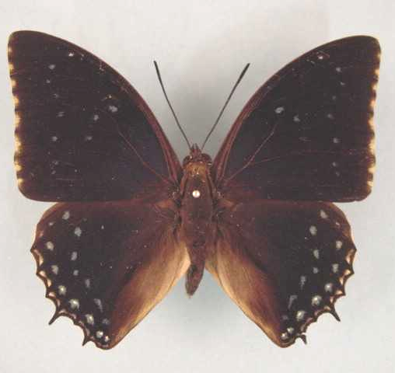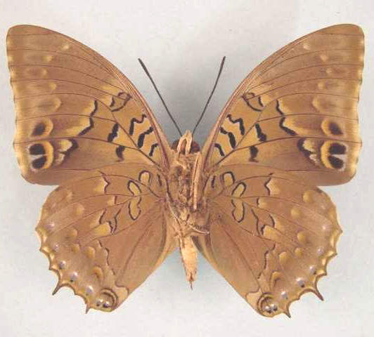

Charaxes tiridates tiridatinus. Male. Left – upperside; right – underside. Wingspan: 78mm. Bangui, C. A. R. 79.08.16. R.P. Godart. (Curle Trust Collection - 113).

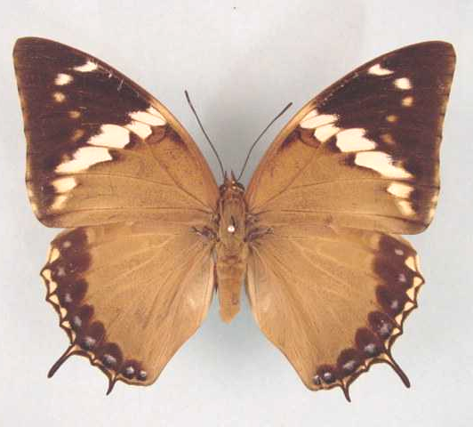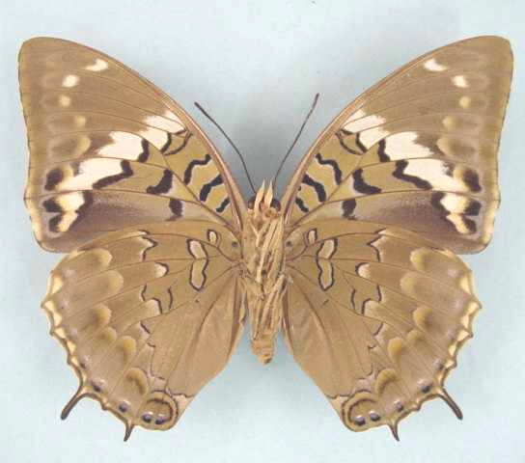

Charaxes tiridates tiridatinus. Female. Left – upperside; right – underside. Wingspan: 95mm. Bangui, C. A. R. 79.09.28. R.P. Godart. (Curle Trust Collection - 115).

Type locality: Uganda.
Distribution: Nigeria (Cross River loop), Cameroon, Gabon, Congo, Democratic Republic of Congo (west, south), Central African Republic, Sudan, Uganda, Rwanda, Burundi, Kenya (west), Tanzania (north-west), Angola, Zambia (north).
Specific localities:
Cameroon – Korup (Larsen, 2005a).
Tanzania – Western Mpanda District to Geita and the Ugandan border (Kielland, 1990).
Zambia – Lisombu; Lake Mweru; Lumangwe Falls; Sumbu; Lunzua Falls; Mbala (Heath, et al., 2002).

tristis Schultze, 1914 (as ab. male of Charaxes tiridates). Entomologische Rundschau 31: 82 (82-83). Cameroon: “Bascho”.

angusticaudatus Röber, 1936 (as sp. of Charaxes). Entomologische Rundschau 53: 578 (575-580). Cameroon: “Süd-Kamerun”.

purpurina Rousseau-Decelle, 1938 (as f. indiv. of Charaxes tiridates). Bulletin de la Société Entomologique de France 43: 162 (161-168). Congo: “Etoumbi (Congo francais)”.

alberici Dufrane, 1945 (as f. of Charaxes lucretius). Bulletin et Annales de la Société Royale Entomologique de Belgique 81: 106 (90-143). Democratic Republic of Congo: “Kamituga”.

conjuncta Storace, 1948 (as ab. of Charaxes tiridates). Annali del Museo Civico di Storia Naturale (di Genova) Giacomo Doria 63: 138 (132-141). Uganda: “Bufumira (Is. Sesse, Uganda)”.

subcaerulea Storace, 1948 (as ab. of Charaxes tiridates). Annali del Museo Civico di Storia Naturale (di Genova) Giacomo Doria 63: 138 (132-141). Congo: “Etoumbi (Congo Francese)”.

hysginus Darge, 1978 (as sp. of Charaxes). Bulletin de la Société Entomologique de France 83: 65 (65-67). Cameroon: “Ngon, forêt ripuaire du Soo, 640 m”.

Charaxes bipunctatus Rothschild, 1894

Charaxes bipunctatus Rothschild, 1894. Novitates Zoologicae 1: 536 (535-540).
Type locality: Ghana?: “West Africa, probably Gold Coast”. Holotype (male) in the Natural History Museum, London.
Diagnosis: Differs from C. tiridates and C. numenes in that there are only two hindwing postdiscal spots (in spaces 5 and 6) and the continuous yellowish distal margin (Kielland, 1990).
Distribution: Ivory Coast, Ghana, Nigeria, Cameroon, Gabon, Congo, Democratic Republic of Congo, Central African Republic, Uganda, Sudan, Kenya, Tanzania.
Common name: Two-spot blue charaxes.
Habitat: Lowland evergreen forest in good condition (Larsen, 2005a). In Tanzania ssp. ugandensis is found in submontane forest at altitudes from 1 200 to 1 500 m (Kielland, 1990).
Habits: A local and uncommon butterfly with habits similar to those of C. tiridates (Larsen, 2005a). A male was taken at light at 20:00 in Bia National Park (Larsen, 2005a).
Early stages: Nothing published.
Larval food:
Blighia unijugata Bak. (Sapindaceae) [Van Someren, 1974: 320; as Phialodiscus unijugatus].

Charaxes bipunctatus bipunctatus Rothschild, 1894

Charaxes bipunctatus Rothschild, 1894. Novitates Zoologicae 1: 536 (535-540).
Type locality: Ghana?: “West Africa, probably Gold Coast”. Holotype (male) in the Natural History Museum, London.
Distribution: Ivory Coast, Ghana, Nigeria (west).
Specific localities:
Ivory Coast – Bossematie (H. Fermon teste Larsen, 2005a).
Ghana – Atewa Range (Joly, 2003); Bia N.P. (Larsen, 2005a).
Nigeria – Omo Forest (C.R. Clarke teste Larsen, 2005a).

johnstoni Rousseau-Decelle, 1956 (as ssp. of Charaxes bipunctatus). Bulletin de la Société Entomologique de France 61: 91 (91-92). Ghana: “Gold Coast, Amentia”.

Charaxes bipunctatus ugandensis van Someren, 1972

Charaxes bipunctatus ugandensis van Someren, 1972. Bulletin of the British Museum (Natural History) (Entomology) 27: 248 (215-264).
Type locality: Uganda: “Toro For.”. Holotype (male) in the Natural History Museum, London.
Distribution: Cameroon, Gabon, Congo, Democratic Republic of Congo (north - Mongala, Uele, Ituri, Kivu), Central African Republic, Uganda (west), Kenya (west), Sudan (south), Tanzania (north-west).
Specific localities:
Tanzania – Ntakatta Forest; upper part of Lugungwizi River (Kielland, 1990).

Charaxes mixtus Rothschild, 1894

Charaxes mixtus Rothschild, 1894. Novitates Zoologicae 1: 536 (535-540).
Type locality: Democratic Republic of Congo: “Lukolele (N. Congo)”. Holotype (male) in the Natural History Museum, London.
Distribution: Cameroon, Central African Republic, Gabon, Congo, Democratic Republic of Congo, Tanzania.
Habitat: Lowland forest. In Tanzania ssp. tanzanicus occurs at an altitude of about 900 m (Kielland, 1990).
Habits: Both sexes are attracted to fermenting bananas (Kielland, 1990).
Early stages: Nothing published.
Larval food: Nothing published.

Charaxes mixtus mixtus Rothschild, 1894

Charaxes mixtus Rothschild, 1894. Novitates Zoologicae 1: 536 (535-540).
Type locality: Democratic Republic of Congo: “Lukolele (N. Congo)”. Holotype (male) in the Natural History Museum, London.
Distribution: Cameroon, Central African Republic (south-west), Gabon, Congo, Democratic Republic of Congo (Uele, Kasai, Lualaba, Sankuru).

bubastis van Schultze, 1916 (as sp. of Charaxes). Archiv für Biontologie 4: 110 (83-129). Cameroon: “Bipindi”.

Charaxes mixtus tanzanicus Kielland, 1988

Charaxes mixtus tanzanicus Kielland, 1988. Lambillionea 88: 35 (33-36).
Type locality: Tanzania: “Kigoma, Kasye Forest, 900 m”.
Diagnosis: In males the blue markings of the hind wing upperside are larger than in the nominate subspecies; postdiscal spots often with blue rays pointing towards base. In females the basal half of the wings have a stronger blue sheen than in the nominate subspecies (Kielland, 1990).
Distribution: Tanzania (north-west).
Specific localities:
Tanzania – Kakindu (Poulton, 1926); Kasye Forest; Mihumu Forest (Kielland, 1990).

Charaxes murphyi Collins, 1989

Charaxes murphyi Collins, 1989. In: Henning, 1989. The Charaxinae butterflies of Africa 154 (457 pp.). Johannesburg.

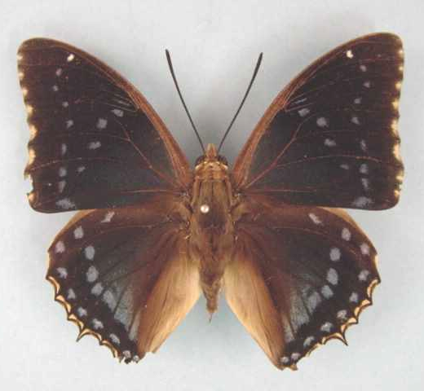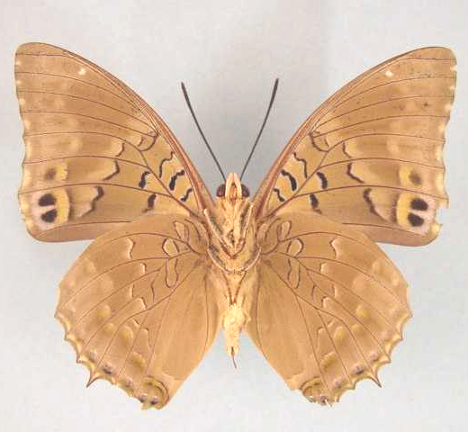

Charaxes murphyi. Male. Left – upperside; right – underside. Wingspan: 80mm. South Mutundu River, Mufulira, Zambia, 4100'. 31-VII-1983. M.A. Newport. (Henning collection - H258).

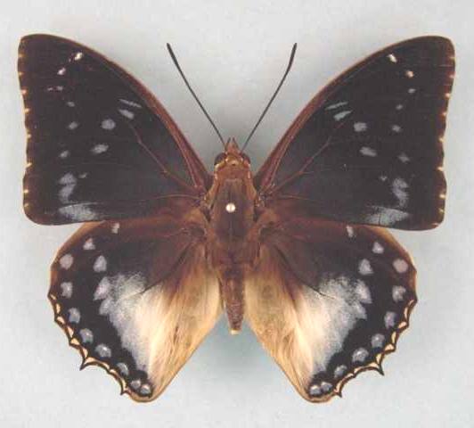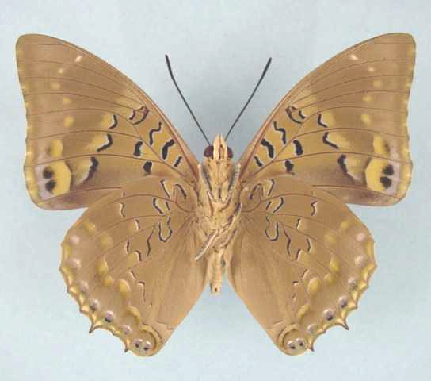

Charaxes murphyi. Male. Left – upperside; right – underside. Wingspan: 81mm. South Mutundu River, Mufulira, Copperbelt Prov., Zambia. 1250 m. 25-IV-1982. M.A. Newport. (Newport collection).

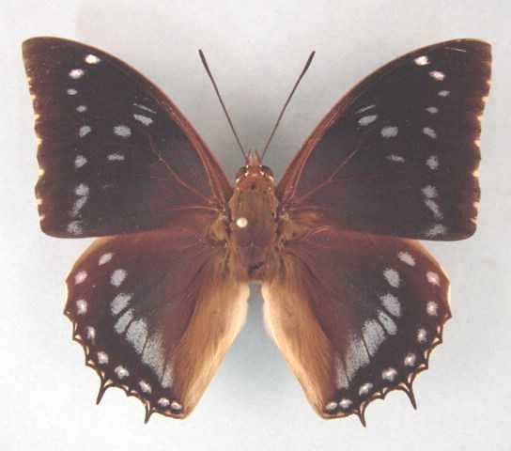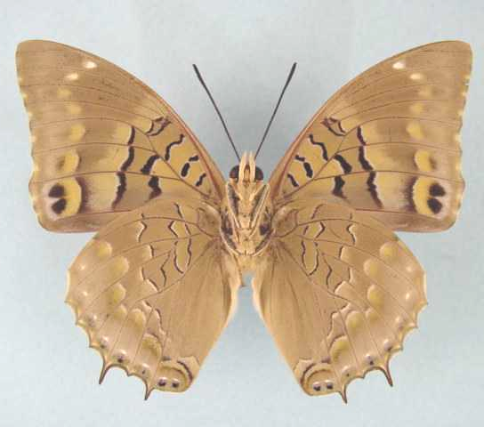

Charaxes murphyi. Male (f. tiridatoides). Left – upperside; right – underside. Wingspan: 81mm. Zambia, Copperbelt Prov., South Mutundu River nr Mufulira. 1250 m. 5.V.1993. A. Kapulile. (Newport Collection).

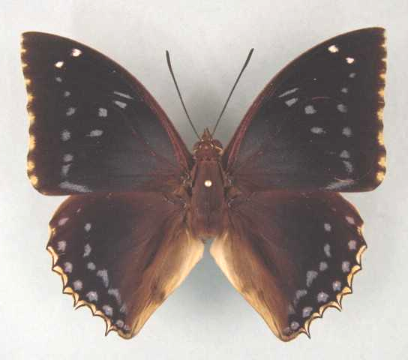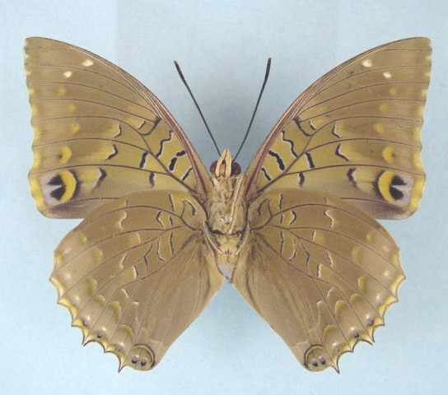

Charaxes murphyi. Male. Left – upperside; right – underside. Wingspan: 83mm. South Mutundu River, Mufulira, Copperbelt Prov., Zambia. 1250 m. 15.IV.1983. M.A. Newport. (Newport Collection).

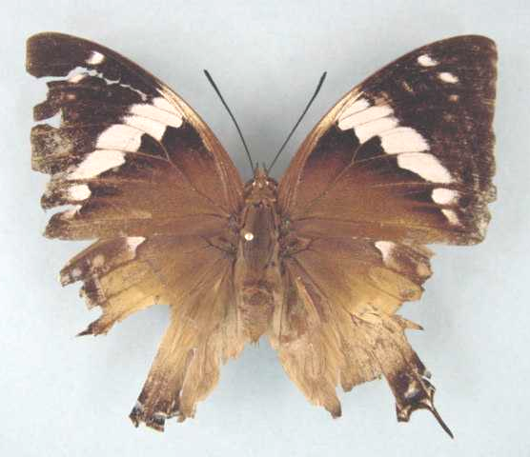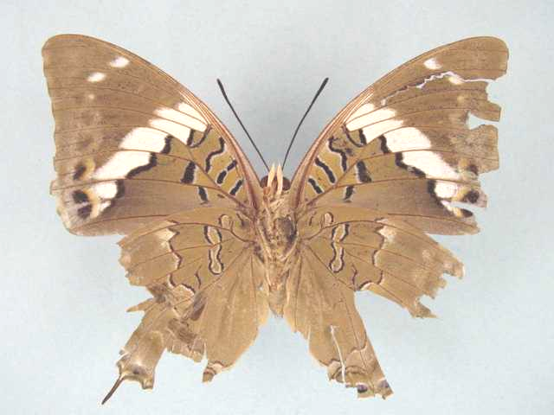

Charaxes murphyi. Female (f. tiridatoides). Left – upperside; right – underside. Wingspan: 89mm. South Mutundu River, Mufulira, Copperbelt Prov., Zambia. 1250 m. 24.IV.1991. A. Kapulile. (Newport Collection).

Type locality: Zambia: “South Mutundu Stream, Mufulira, 1400 metres”. Holotype (male) in the Natural History Museum, London.
Distribution: Zambia (north), Democratic Republic of Congo (south-east).
Specific localities:
Zambia – ‘Forest Trial Burning Plots’, just north of Ndola (R. Murphy); South Mutundu River near Mufulira; Luinda River (a tributary of the Luapula River) (Heath, et al., 2002).
Democratic Republic of Congo – Kibomboma, near Kasumbalesa (Heath, et al., 2002).
Habitat: Riverine forest.
Early stages: Nothing published.
Larval food: Nothing published.

tiridatoides Bouyer, 1990 (as f. of Charaxes murphyi). Lambillionea 90 (1): 20 (19-24). Democratic Republic of Congo: “Kibomboma, au sud-est du Zaire”.

cithaeronoides Bouyer, 1990 (as f. of Charaxes murphyi). Lambillionea 90 (1): 20 (19-24). Democratic Republic of Congo: “Kibomboma, au sud-est du Zaire”.

garnieri Bouyer, 1990 (as f. of Charaxes murphyi). Lambillionea 90 (1): 21 (19-24). Democratic Republic of Congo: “Kibomboma, au sud-est du Zaire”.

Charaxes barnsi Joicey & Talbot, 1927

Charaxes barnsi Joicey & Talbot, 1927. Entomologist 60: 14 (12-16).
Charaxes barnesi Joicey & Talbot, 1927. Henning, S. 1989: 156 [misspelling]
Type locality: Sao Tome and Principe: “St. Principe”. Holotype (male) in the Natural History Museum, London.
Distribution: Sao Tome and Principe (island of Principe).
Habitat: The island of Principe, up to 1 000 m altitude.
Early stages: Nothing published.
Larval food: Nothing published.

Charaxes monteiri Staudinger, 1886

Charaxes monteiri Staudinger, 1886 in Staudinger & Schatz, 1884-8. Exotischer Schmetterlinge 1: 170 (333 pp.). Bayern.
Charaxes montieri Staudinger, 1886. Henning, 1989: 156 [misspelling]
Type locality: Sao Tome and Principe: “Insel St. Thomas (Westafrika)”.
Distribution: Sao Tome and Principe (Sao Tome Island).
Habitat:
Early stages: Nothing published.
Larval food: Nothing published.

Charaxes overlaeti Schouteden, 1934

Charaxes overlaeti Schouteden, 1934. Revue de Zoologie et de Botanique Africaine 26: 123 (122-124).
Type locality: Democratic Republic of Congo: “Kafakumba”. Holotype (male) in the Musée du Congo Belge, Tervuren, Belgium.
Distribution: Democratic Republic of Congo, Kenya. Known only from the holotype and a similar specimen captured in Kenya.
Habitat: Nothing published.
Early stages: Nothing published.
Larval food: Nothing published.
Note: S. Collins believes that C. overlaeti may be a hybrid between C. bohemani and C. ameliae (Henning, 1989: 158).

Charaxes bohemani Felder & Felder, 1859

Charaxes bohemani Felder & Felder, 1859. Wiener Entomologische Monatschrift 3: 321 (321-328).

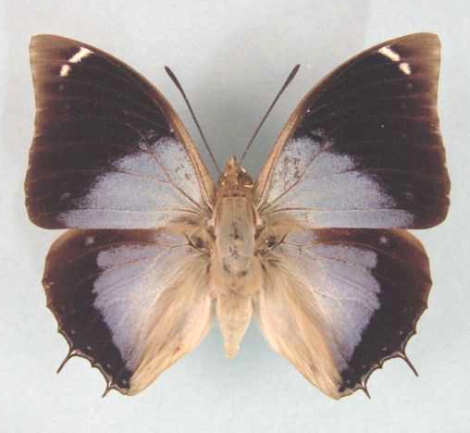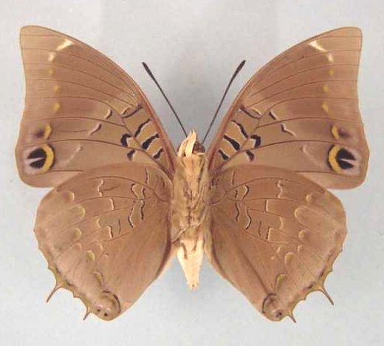

Charaxes bohemani. Male. Left – upperside; right – underside. Wingspan: 69mm. Lundi, S. Rh. 1-5.IX.1953. Dr. G. van Son. (Transvaal Museum - TM3392).

Type locality: Botswana: “innerafrikanischen See’s Ngami (20 ° s. Br.)”. There are two male syntypes in the Natural History Museum, London and one male in the Stockholm Museum.
Distribution: Congo, Democratic Republic of Congo (south, north and west), Rwanda, Kenya (coast), Tanzania, Malawi, Zambia, Angola, Mozambique, Zimbabwe, Botswana (norht), Namibia (north, east), South Africa (Limpopo Province - north-east), Swaziland (north).
Specific localities:
Tanzania – Troughout but rare in the northernmost areas (Kielland, 1990).
Zambia – Ikelenge; Kasangezhi; Mwinilunga; Mufulira; Kitwe; Ndola; Luanshya; Mumbwa; Chisamba; Mkushi River; Musonda Falls; Kasama; Sumbu; Lunzua Falls; Makutu Mountains (Heath, et al., 2002).
Limpopo Province – Gravelotte (Swanepoel, 1953); Sedula (Swanepoel, 1953); Mokeetsi (Swanepoel, 1953); Sibasa (Swanepoel, 1953); Abel Erasmus Pass – Manoutsa (Williams); 20 km south of Ofcolaco (Swanepoel, 1953).
Namibia – Waterberg Plateau Park (Swart, 2004).
Common name: Large blue charaxes; Divebomber charaxes.
Habitat: Dry deciduous woodland savanna, especially Brachystegia woodland. Also forest fringes (Henning, 1989). In Tanzania at altitudes from near sea-level to 2 000 m (Kielland, 1990).
Habits: Males hilltop, usually during a three hour period in midmorning, selecting perches high up in a tree. They are fast-flighted and wary. Both sexes are fond of fermenting fruit (Pringle, et al., 1994).
Flight period: All year but commonest in spring and late summer (Pringle, et al., 1994).
Early stages:

Van Someren and Rogers, 1929: 24.
“This species lays its eggs on the upper surface of the old leaves of Afzelia quanzensis (Leguminosae). They are large, measuring 2 x 2,5 mm, pale yellow in colour, slightly flattened on top and faintly fluted in this area. In twelve hours, the eggs turn red-brown, then black, just before the larva hatches. The young larva eats the remains of the eggshell before feeding on the leaves. Its colour is at first olive, with black head and whitish tail. The first moult takes place in three days. The larva is now an olive-brown, with a white bifid tail and greenish head. The full-fed larva is 45 mm long, of an ochreous-olive colour, each segment with lateral-dorsal lines of yellowish running obliquely forward. There are also two vertical rows of greenish spots along the fore part of each segment. Segment 6 is ornamented with a circular dark green mark, most heavily lined laterally and enclosing an olive fore area. The spiracular line is slightly indicated by a broken series of yellowish dots. The underside of the body is light greenish-ochreous. The general appearance of the body is therefore ‘dead-leaf’ like. The head is almost rectangular, pale fawn with a slight olive tinge and with a marginal ochreous line, forming a triangle above the black mouth parts. The horns are very short, almost as in Ch. numenes Hewitson. The outer ones (2 mm long) are directed up and slightly out and then incline inwards; the upper pair is equally short and is almost vertical. The whole surface, including the horns is coarsely papillated. The pupa is very large, measuring 31 x 15 mm. It is pale apple-green with a bluish tinge on the margin of the wing scutae. The spiracular spots are ill-defined, but the whole pupa is decorated with bluish-white; the abdomen carries seven oblique horse-shoe lines, most marked dorsally; the wing-cases are traversed by a broad line subapically and by a more diffuse one along the marginal ridge. The antennal line is white while the thorax carries a white oval. The cremaster is composed of a short stalk bounded by lateral ovoid lobes with rugose surfaces, and in front of these are two other semi-quadrate lobes, all ochreous in colour. The pupal stage lasts from 10 to 18 days.”

Henning, S., 1989: 158.

Larval food:
Afzelia quanzensis Welw. (Fabaceae) [Van Someren, 1974: 320].
Baphia bequaerti De Wild (Fabaceae) [Henning, S., 1989: 159].
Baphia capparidifolia Bak. (Fabaceae) [Henning, S., 1989: 159].
Berlinia craibiana Bak. f. (Fabaceae) [Henning, S., 1989: 159].
Brachystegia spicifomis Benth. (Fabaceae) [Henning, S., 1989: 159].
Dalbergia nitidula Welw. ex Bak. (Fabaceae) [Henning, S., 1989: 159].
Erythrina species (Fabaceae) [Heath, et al., 2002: 75].
Isoberlinia angolensis (Benth.) Hoyle & Brenan (Fabaceae) [Henning, S., 1989: 159].
Julbernadia globiflora (Benth.) Troup. (Fabaceae) [Henning, S., 1989: 159].
Philenoptera violacea (Fabaceae) [Henning, S., 1989: 159; as Lonchocarpus carpassa].
Schotia brachypetela (Fabaceae) [Williams in Pringle et al., 1994: 91].
Xeroderris stuhlmanni Mendonca & E.P. Sousa (Fabaceae) [Henning, S., 1989: 159].

Charaxes smaragdalis Butler, 1866

Charaxes smaragdalis Butler, 1866. Proceedings of the Zoological Society of London 1865: 630 (622-639).
Type locality: “Congo”.
Distribution: Guinea, Sierra Leone, Liberia, Ivory Coast, Ghana, Nigeria, Cameroon, Gabon, Congo, Central African Republic, Democratic Republic of Congo, Sudan, Uganda, Angola, Kenya, Tanzania.
Common name: Emerald blue charaxes.
Habitat: Lowland rainforest in the west, gallery forest in the south, and patches of lowland and montane forest in the east of its range (Henning, 1989). In Tanzania ssp. kigoma is found at altitudes from 800 to 1 500 m; ssp. homonymus at altitudes up to 2 000 m; ssp. kagera from 1 200 to 1 400 m (Kielland, 1990).
Habits: A scarce butterfly with habits similar to those of C. tiridates (Larsen, 2005a).
Early stages: Nothing published.
Larval food:
Drypetes gerrardii (Euphorbiaceae) [Congdon and Collins, 1998: 55; ssp. kagera; oviposition].
Grewia species (Tiliaceae) [Williams, vide Congdon and Collins, 1998: 55; requires verification].

Charaxes smaragdalis smaragdalis Butler, 1866

Charaxes smaragdalis Butler, 1866. Proceedings of the Zoological Society of London 1865: 630 (622-639).
Type locality: “Congo”.
Distribution: Nigeria (south and Cross River loop), Cameroon, Gabon, Congo, Central African Republic, Democratic Republic of Congo (north).

princeps Butler, 1896 (as sp. of Charaxes). Journal of the Linnean Society of London 25: 378 (348-404). Cameroon: “Victoria, Cameroons”.

beni van Someren, 1964 (as f. of Charaxes smaragdalis smaragdalis). Bulletin of the British Museum (Natural History) (Entomology) 15: 212 (181-235). Democratic Republic of Congo: “Beni, N.E. Congo, Beni, Irumu”.

pseudobohemani Plantrou, 1979 (as male f. of Charaxes smaragdalis leopoldi). Lambillionea 79: 42 (34-45). Congo: “Brazzaville (R.P. Congo)”.

Charaxes smaragdalis allardi Bouyer & Vingerhoedt, 1997

Charaxes smaragdalis allardi Bouyer & Vingerhoedt, 1997. Entomologia Africana 2 (2): 36.
Type locality: Democratic Republic of Congo: Shaba, Luena.
Distribution: Democratic Republic of Congo.

Charaxes smaragdalis butleri Rothschild, 1900

Charaxes smaragdalis butleri Rothschild, 1900 in Rothschild and Jordan, 1900. Novitates Zoologicae 7: 385 (287-524).
Type locality: Sierra Leone.
Distribution: Guinea, Sierra Leone, Liberia, Ivory Coast, Ghana.
Specific localities:
Guinea – Nimbas (Larsen, 2005a).
Sierra Leone – Freetown (Owen & Chanter, 1972).
Ivory Coast – Abidjan area (Larsen, 2005a); Mopri (Larsen, 2005a); Tai National Park (Larsen, 2005a).
Ghana – Atewa Range (Joly, 2003); Ankasa (Larsen, 2005a).

Charaxes smaragdalis caerulea Jackson, 1951

Charaxes smaragdalis caerulea Jackson, 1951. Proceedings of the Royal Entomological Society of London (B) 20: 99 (91-105).
Type locality: Uganda: “Ankole, Kalinzu Forest”.
Distribution: Uganda (south-west - Ankole and Kigezi), Democratic Republic of Congo (Kivu, Maniema).

caerulea Carpenter and Jackson, 1950 (as female f. of Charaxes smaragdalis). Proceedings of the Royal Entomological Society of London (B) 19: 97 (97-108). Uganda: “Ankole, Kalinzu Forest”.

Charaxes smaragdalis elgonae van Someren, 1964

Charaxes smaragdalis elgonae van Someren, 1964. Bulletin of the British Museum (Natural History) (Entomology) 15: 215 (181-235).
Type locality: Uganda: “Mbale District at Bufumbo Forest, W. Mt. Elgon”.
Distribution: Uganda (east - western slopes of Mt Elgon), Kenya (west - Kakamega).
Note: Van Someren (1964: 216) treats the populations in north-west Kenya (Kaimosi; Kakamega; Kabras; Nandi Escarpment) as a cline between ssp. elgonae and homonymus.

Charaxes smaragdalis gobyae Plantrou, 1989

Charaxes smaragdalis gobyae Plantrou, 1989. In: Henning, 1989. The Charaxinae butterflies of Africa 165 (457 pp.). Johannesburg.
Type locality: Sudan: “Sud Soudan, Nagichot, Mts Didinga, 1700 m”. Holotype (male) in the Natural History Museum, London.
Distribution: Sudan (south).

Charaxes smaragdalis homonymus Bryk, 1939

Charaxes smaragdalis homonymus Bryk, 1939 in Stichel, 1939. In: Bryk, F., Lepidopterorum Catalogus 30 (91): 444 (375-542.). s’Gravenhage.
Type locality: Kenya: “Kericho; Rau, Nandi”.
Distribution: Kenya (south-west), Tanzania (north).
Specific localities:
Kenya – Kericho-Sotik area; Chepalungu; Mara (Henning, 1989).
Tanzania – Mara River (Kielland, 1990).

orientalis Joicey and Talbot, 1918 (as ssp. of Charaxes smaragdalis). Proceedings of the Zoological Society of London 1917: 272 (271-272). Kenya: “Kericho; Rau, Nandi”. [Invalid; junior primary homonym of Charaxes castor var. orientalis Lanz, 1896 [Charaxinae].]

Charaxes smaragdalis kagera van Someren, 1964

Charaxes smaragdalis kagera van Someren, 1964. Bulletin of the British Museum (Natural History) (Entomology) 15: 218 (181-235).
Type locality: Tanzania: “Kakindu Hill, north bank of Kagera River, near the Uganda border”.
Diagnosis: In males the hind wing discal blue area wider than in ssp. homonymus. In females the forewing basal area is strongly scaled with violet, and lighter than in ssp. homonymus (Kielland, 1990).
Distribution: Tanzania (north-west).
Specific localities:
Tanzania – Kere Hill, Minziro Forest (common); Rumanyika Game Reserve (rare) (Congdon and Collins, 1998).

Charaxes smaragdalis kigoma van Someren, 1964

Charaxes smaragdalis kigoma van Someren, 1964. Bulletin of the British Museum (Natural History) (Entomology) 15: 219 (181-235).
Type locality: Tanzania: “Tanganyika, Mukuvu forest south of Kigoma, north-east shores of Lake Tanganyika”.
Diagnosis: Forewing postdiscal blue spots small to absent; median blue spots from space 2 to costa separate (Kielland, 1990).
Distribution: Tanzania (north-west).
Specific localities:
Tanzania – Ntakatta Forest (north-west Mpanda); Kigoma to Gombe (Kielland, 1990).

Charaxes smaragdalis leopoldi Ghesquiére, 1933

Charaxes smaragdalis f. reg. leopoldi Ghesquiére, 1933. Lambillionea 33: 4 (3-6).
Type locality: Democratic Republic of Congo: “Komi (Ter. Lodja)”. Holotype (male) was in the collection of Mr G. Rousseau-Decelle.
Distribution: Angola (north), Congo (east), Democratic Republic of Congo (central and south).

schoutedeni Ghesquière, 1933 (as f. reg. of Charaxes smaragdalis). Lambillionea 33: 5 (3-6). Democratic Republic of Congo: “N.E. Congo, Beni, Irumu”.

Charaxes smaragdalis metu van Someren, 1964

Charaxes smaragdalis metu van Someren, 1964. Bulletin of the British Museum (Natural History) (Entomology) 15: 219 (181-235).
Type locality: Uganda: “West Nile District, N.W. Madi, Forest of Metu Hills”.
Distribution: Uganda (north-west - West Nile district).

Charaxes smaragdalis toro van Someren, 1964

Charaxes smaragdalis toro van Someren, 1964. Bulletin of the British Museum (Natural History) (Entomology) 15: 214 (181-235).
Type locality: Uganda: “Toro district, Kibale Forest”.
Distribution: Uganda (west - Toro and Ruwenzori areas).
Specific localities:
Uganda – Forests of Toro; Kibale; Mpanga; Utwara; Buboma (Henning, 1989).

Charaxes xiphares (Stoll, 1781)

Papilio xiphares Stoll, 1781 in Stoll, [1780-2]. Die Uitlandsche Kapellen voorkomende in de drie waerrelddeelen Asia, Africa en America 4 [part]: 171 (29-252). Amsteldam & Utrecht.
Type locality: South Africa: “Cap de bonne Espérance”.
Diagnosis: Similar to C. cithaeron but the male of C. xiphares has less white scaling on the hind wing upperside (Kielland, 1990).
Distribution: Cameroon?, Democratic Republic of Congo, Uganda, Rwanda, Burundi, Kenya, Tanzania, Malawi, Zambia, Zimbabwe, South Africa, Swaziland.
Common name: Forest-king charaxes.
Habitat: Temperate and montane forest. In Tanzania the various subspecies occur in the following altitudinal ranges: ssp. brevicaudatus 800 to 2 300 m; ssp. nguru 1 200 to 2 000 m; ssp. sitebi 1 600 to 2 000 m; ssp. maudei 1 000 to 2 000 m; ssp. kiellandi 1 900 to 2 400 m; ssp. walwandi 1 900 to 2 600 m (Kielland, 1990).
Habits: Males defend territories from perches on twigs of trees, high up, on forest edges and in forest clearings. Females are most often seen flying rapidly along forest margins and along forest roads. Both sexes come to fermenting fruit and also feed from sap oozing from wounds in trees.
Flight period: All year but the southern subspecies, in South Africa, are very scarce from June to September (Henning, 1989).
Early stages:

Fountaine, 1911: 53 (C. xiphares penningtoni; as C. xiphares; Dargle, KwaZulu-Natal, South Africa).
“These larvae were certainly very like their close ally C. cithaeron, the dorsal marks being practically the same, but the green was quite different, being much brighter with more yellow in it, and none of the whitish touches introduced as in cithaeron larvae.” Although she stated that both food-plant species were found to grow more profusely at the coast than in the high mountain forests, she found it very difficult to rear the larvae at the coast, and most of her larvae either died, or produced much undersized specimens. This observation provides an explanation of the reason why in the Cape Province xiphares occurs in the coastal area as well as in the higher forests, but further north, where the temperatures at the coast become too high, it can only survive at higher altitudes.

Clark, in Van Son, 1979: 170 (Plate 69) (ssp. thyestes).
“The eggs are laid singly on the under- or upperside of a leaf. They are 1,8 mm in diameter by 1,6 mm high, with 20-22 undeveloped ribs with transverse ribbing; in some eggs this is very faint, but in others it is distinct and extends over the flattened top and develops into a faint netting pattern. The eggs are at first pale watery yellow but develop two thin reddish circlets, the upper one broken and admits a branch from the lower. The larva hatches after eight to ten days. It eats its way out near the top and the first meal is on the discarded shell. It is 5 mm long and grows to 8,5-9,5 mm in seven to twelve days. The second instar takes nine to twelve days and the larva grows to 13-14,5 mm. The third instar takes nine to fourteen days, at the end of which the larva is 20-23 mm long. The fourth instar takes 11-17 days and the larva grows to 28-31 mm. In the final instar the larva reaches a length of 50-54 mm in 14-78 days, depending on the time of the year and the climate. The dorsal patch on segment 8 is not always present. The larva rests on a midrib of a leaf on a silken mat from which it crawls away to feed, but to which it returns after each meal. The pupa is suspended by cremastral hooksfrom the underside of a leaf or twig, it is 26 mm long. The imago emerges after 12-33 days depending on the prevailing climatic conditions. There are least three broods a year.”

Henning, S., 1989: 178 (ssp. kenwayi; ssp. woodi).

Larval food:
Chaetachme aristata Planch. (Ulmaceae) [Bampton and the Hennings, in Dickson and Kroon, 1978: 61 (subspecies not noted); Henning, S., 1989: 179 (ssp. kenwayi)].
Craibia brevicaudata (Vatke) S.T. Dunn (Fabaceae) [Henning, S., 1989: 179 (ssp. woodi); Kielland, 1990: 111 (ssp. nguru).].
Craibia species (Fabaceae) [Congdon, vide Kielland, 1990: 111 (ssp. brevicaudatus and ssp. sitebi)].
Cryptocarya acuminata Merrill (Lauraceae) [Fountaine, 1911: 54 (ssp. penningtoni)].
Cryptocarya woodii Engl. (Lauraceae) [Fountaine, 1911: 54 (ssp. penningtoni); Henning, S., 1989: 179 (ssp. thyestes)].
Drypetes gerrardii Hutch. (Euphorbiaceae) [Dickson and Kroon, 1978: 61 (subspecies not noted); Henning, S., 1989: 179 (ssp. kenwayi)].
Rhamnus prinoides L'Herit. (Rhamnaceae) [Henning, S., 1989: 178 (ssp. kenwayi)].
Scutia myrtina (Burm. f.) Kurz (syn. commersoni Brongn.) (Rhamnaceae) [Van Son, 1979: 171 (ssp. thyestes); Henning, S., 1989: 179 (ssp. kenwayi); Kielland, 1990: 111 (ssp. maudei and ? ssp. walwandi); Edge, 1995: 83 (ssp. xiphares and ssp. occidentalis)].

Charaxes xiphares xiphares (Stoll, 1781)

Papilio xiphares Stoll, 1781 in Stoll, [1780-2]. Die Uitlandsche Kapellen voorkomende in de drie waerrelddeelen Asia, Africa en America 4 [part]: 171 (29-252). Amsteldam & Utrecht.
Type locality: South Africa: “Cap de bonne Espérance”.
Diagnosis: In females of this subspecies the inner tail is strongly curved outwards (Pringle, et al., 1994).
Distribution: South Africa (Eastern Cape Province, Western Cape Province).
Specific localities:
Eastern Cape Province – Van Staden’s Pass (Pringle, et al., 1994).
Western Cape Province – Knysna (Swanepoel, 1953); Plettenberg Bay (Swanepoel, 1953); George.

Charaxes xiphares bavenda van Son, 1935

Charaxes xiphares bavenda van Son, 1935. Annals of the Transvaal Museum 15: 486 (485-489).
Type locality: South Africa: “Entabeni, Zoutpansberg Dist., Transvaal”. Holotype (male) in the Transvaal Museum, Pretoria, South Africa.
Diagnosis: The male, on the upperside of the hindwing, shows a marked incursion of white into the discal patch and comparatively broad marginal lunules. In the forewing upperside of females the discal spots in areas 4, 5 and 6 are also well developed. The nominate female form has white forewing spots and an ochreous hindwing discal patch; form ochreomacula has distinctly ochreous forewing spots; form cyanescens has white forewing spots but the discal patch on the hindwing is white, suffused, to a variable extent, with deep lavender (Pringle, et al., 1994).
Distribution: South Africa (Limpopo Province - Zoutpansberg).
Specific localities:
Limpopo Province: Entabeni Forest (Pringle, et al., 1994); Louis Trichardt – Hanglip (Williams).

ochremacula van Son, 1935 (as female f. of Charaxes xiphares bavenda). Annals of the Transvaal Museum 15: 489 (485-489). South Africa: “Entabeni, Zoutpansberg Dist., Transvaal”.

cyanescens van Son, 1935 (as female f. of Charaxes xiphares bavenda). Annals of the Transvaal Museum 15: 489 (485-489). South Africa: “Entabeni, Zoutpansberg Dist., Transvaal”.

Charaxes xiphares bergeri Plantrou, 1975

Charaxes xiphares bergeri Plantrou, 1975. Lambillionea 75: 105 (102-105).
Type locality: Democratic Republic of Congo: “Kafakumba, Katanga Zaire”. Holotype (male) in the collection of Mr Plantrou.
Distribution: Democratic Republic of Congo. Known only from the type locality.

Charaxes xiphares brevicaudatus Schultze, 1914

Charaxes cithaeron var. brevicaudatus Schultze, 1914. Archiv für Naturgeschichte 79 (A.8): 3 (3).
Type locality: Tanzania: “Iringa (Deutsch Ostafrika)”. Holotype (female) in the Berlin Museum.
Diagnosis: Characterized, as the subspecific name implies, by very short tails (Kielland, 1990).
Distribution: Tanzania (south).
Specific localities:
Tanzania – Manow; Songea; Mbeya; Poroto Mountains; Mount Rungwe; Ifakaso; Bondwa Mountain; Uluguru Mountains (Henning, 1989); Livingstone Mountains; Kitesa Forest Reserve; Uzungwa Range; Mufindi; Mwanihana; Image Mountain; Rubeho Mountains (Kielland, 1990).

Charaxes xiphares burgessi van Son, 1953

Charaxes xiphares burgessi van Son, 1953. Annals of the Transvaal Museum 22: 229 (219-230).
Type locality: Uganda: “Ruhiza Forest, Kigesi, Uganda”. Holotype (male) in the Transvaal Museum, Pretoria, South Africa.
Distribution: Democratic Republic of Congo (Kivu), Uganda (south-west), Rwanda, Burundi.

Charaxes xiphares desmondi van Someren, 1939

Charaxes desmondi van Someren, 1939. Journal of the East Africa and Uganda Natural History Society 14: 176 (172-180).
Type locality: Kenya: “The Teita Hills, Wandanyi-Mbololo Forests”. Holotype (male) in the Natural History Museum, London.
Distribution: Kenya (south-east - Teita Hills).

Charaxes xiphares draconis Jordan, 1936

Charaxes xiphares draconis Jordan, 1936. Novitates Zoologicae 39: 331 (330-333).
Type locality: South Africa: “Transvaal, Marieps Mt., south of Olifants R., 24° 35' S., 30° 50' E”.
Diagnosis: Characterized by the short, blunt tails on the hindwing. In females the upperside hindwing discal patch is enlarged as are the forewing postdiscal spots. A second female form (candida) has the hindwing discal patch white, with a slight violet sheen on its margins (Pringle, et al., 1994).
Distribution: South Africa (Mpumalanga), Swaziland.
Specific localities:
Mpumalanga – Barberton (Swanepoel, 1953); Graskop (Swanepoel, 1953); Marieps Kop (Swanepoel, 1953); Sabie (Williams); Buffelskloof Nature Reserve (Williams).
Swaziland – Havelock Mine (Hennings).

candida van Son, 1953 (as female f. of Charaxes xiphares draconis). Annals of the Transvaal Museum 22: 226 (219-230). South Africa: “Mariepskop”.

Charaxes xiphares kenwayi Poulton, 1929

Charaxes xiphares kenwayi Poulton, 1929 in Eltringham, et al, 1929. Transactions of the Entomological Society of London 77: 482 (475-504).
Type locality: South Africa: “Haenertzburg, Zoutpansberg district”.
Diagnosis: Characterized by its small size, and the enlarged blue markings on the upperside in males. The nominate female form has a white discal patch, whereas the predominate female form (lutea) has an ochreous patch (Pringle, et al., 1994).
Distribution: South Africa (Limpopo Province - north-east).
Specific localities:
Limpopo Province – Legalameetse Nature Reserve (“Malta Forest”) (Swanepoel, 1953); Woodbush (Swanepoel, 1953).

lutea van Son, 1953 (as female f. of Charaxes xiphares kenwayi). Annals of the Transvaal Museum 22: 227 (219-230). South Africa: “Woodbush, Pietersburg district, Transvaal”.

Charaxes xiphares kiellandi Plantrou, 1976

Charaxes xiphares kiellandi Plantrou, 1976. Proceedings and Transactions of the British Entomological and Natural History Society 9: 95 (94-96).
Type locality: Tanzania: “Mt. Oldeani”. Holotype (male) in the Natural History Museum, London.
Distribution: Tanzania (north).
Specific localities:
Tanzania – Hasama Forest in Mbulu; Mount Oldeani (Kielland, 1990); Mount Mamaisara (Henning, 1989).

Charaxes xiphares kilimensis van Someren, 1972

Charaxes xiphares kilimensis van Someren, 1972. Bulletin of the British Museum (Natural History) (Entomology) 27: 260 (215-264).
Type locality: Tanzania: “Lower slopes of Mt. Kilimanjaro at Maua Estate”. Holotype (male) in the Natural History Museum, London.
Distribution: Tanzania (north)
Specific localities:
Tanzania - west Kilimanjaro Mountain (Kielland, 1990).

Charaxes xiphares kulal van Someren, 1962

Charaxes kulal van Someren, 1962. Proceedings of the Royal Entomological Society of London (B) 31: 45 (44-46).
Type locality: Kenya: “Mt. Kulal, S.E. Lake Rudolf, Northern Frontier Province”. Holotype (male) in the Natural History Museum, London.
Distribution: Kenya (north - Mt Kulal).

Charaxes xiphares ludovici Rousseau-Decelle, 1933

Charaxes xiphares ludovici Rousseau-Decelle, 1933. Bulletin de la Société Entomologique de France 38: 271 (269-273).

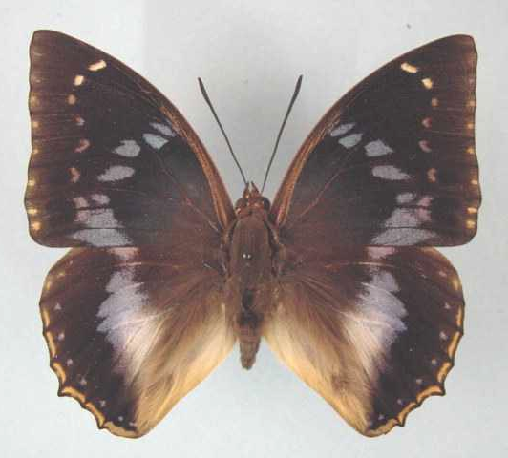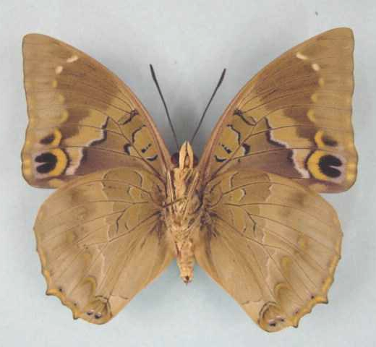

Charaxes xiphares ludovici. Male. Left – upperside; right – underside. Wingspan: 74mm. Uzumara Forest, Malawi. 17.9.78. I. Bampton. (Henning collection - H259).

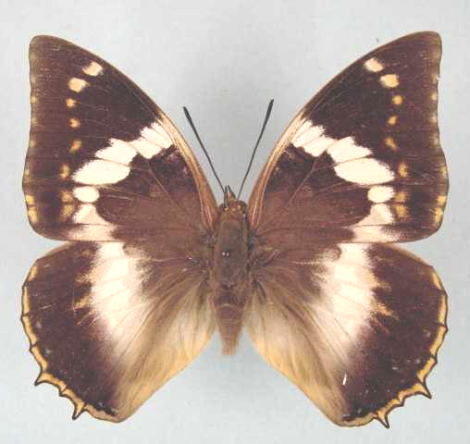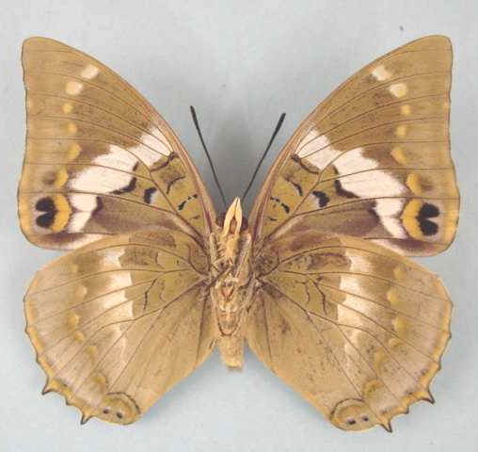

Charaxes xiphares ludovici. Female. Left – upperside; right – underside. Wingspan: 76mm. Uzumara Forest, Malawi. 17.9.78. I. Bampton. (Henning collection - H259A).

Type locality: “Nyassasee, Afrique orientale”.
Distribution: Malawi (north), Zambia (north-east).
Specific localities:
Malawi – Chitipa; Mugesse; Misuku Hills; Mt Ulsumara; north of Mt Viphya; Nyika Plateau.
Zambia – Makutu Mountains; Mafinga Mountains; Nyika (Heath, et al., 2002).
Note: Henning, S. (1989: 172) thinks that the populations representing ssp. ludovici Rousseau-Decelle, 1933 in central and northern Malawi, and Zambia may be indistinguishable from those of ssp. brevicaudatus Schultze, 1914 in south and south-west Tanzania.

Charaxes xiphares maudei Joicey & Talbot, 1918

Charaxes maudei Joicey & Talbot, 1918. Proceedings of the Zoological Society of London 1917: 271 (271-272).
Type locality: Tanzania: “German East Africa (British occupation), Lindi”. Holotype (female) in the Natural History Museum, London.
Diagnosis: Characterized by long tails in both sexes and wide hind wing band (Kielland, 1990).
Distribution: Tanzania (north-east).
Specific localities:
Tanzania – Usambara Mountains; North Pare Mountains (Kielland, 1990); Rondo Plateau? (Henning, 1989).

Charaxes xiphares nguru Collins, 1989

Charaxes xiphares nguru Collins, 1989 in Henning, 1989. The Charaxinae butterflies of Africa 174 (457 pp.). Johannesburg.
Type locality: Tanzania: “Maskati, Nguru Mountain, Morogoro District”. Holotype (male) in the Natural History Museum, London.
Distribution: Tanzania (east).
Specific localities:
Tanzania – Nguru Mountains; Kanga Mountains (Kielland, 1990).

Charaxes xiphares occidentalis Pringle, 1995

Charaxes xiphares occidentalis Pringle, 1995. Metamorphosis 6 (4): 177 (176-179).
Type locality: South Africa: “Grootvadersbosch, Swellendam 1-6 November, 1940 (Transvaal Museum).” Described from 12 males and 10 females. Holotype in the Transvaal Museum, Pretoria.
Diagnosis: In males of occidentalis the blue discal area on the hindwing upperside is smaller than in the nominate subspecies and the marginal lunules on the hindwing are shorter and thicker. In females the yellow discal area on the hindwing upperside is narrower and lighter than in the nominate subspecies (Pringle, et al., 1994).
Distribution: South Africa (Western Cape Province).
Specific localities:
Western Cape Province – Grootvadersbosch (TL).

occidentalis van Son, 1953 (as f. of Charaxes xiphares xiphares). Annals of the Transvaal Museum 22: 223 (219-230). South Africa: “Grootvadersbosch, Swellendam district”.

Charaxes xiphares penningtoni van Son, 1953

Charaxes xiphares penningtoni van Son, 1953. Annals of the Transvaal Museum 22: 225 (219-230).
Type locality: South Africa: “Champagne Castle, Natal”. Holotype (male) in the Transvaal Museum, Pretoria, South Africa.
Diagnosis: In the male the forewing discal spot in area 4 is longer than in either ssp. thyestes or ssp. draconis. In the female the underside is heavily marked with white. A second female form (luminosa) has the discal area on the hindwing upperside white with a lavender-blue sheen (Pringle, et al., 1994).
Distribution: South Africa (KwaZulu-Natal).
Specific localities:
KwaZulu-Natal – Kokstad – Ngele forest (Swanepoel, 1953); Pietermaritzburg (Swanepoel, 1953); Karkloof (Swanepoel, 1953); Balgowan (Swanepoel, 1953); Eshowe (Swanepoel, 1953).

luminosa van Son, 1953 (as female f. of Charaxes xiphares penningtoni). Annals of the Transvaal Museum 22: 226 (219-230). South Africa: “Balgowan”.

Charaxes xiphares sitebi Plantrou, 1981

Charaxes xiphares sitebi Plantrou, 1981. Bulletin de la Société Entomologique de France 86: 160 (159-166).
Type locality: Tanzania: “Mont Sitebi (Mpanda)”. Holotype (male) in the Muséum national d’Histoire naturelle de Paris.
Distribution: Tanzania (north-west).
Specific localities:
Tanzania – Mount Sitebi; Mount Ihassa; Katuma (Henning, 1989).

Charaxes xiphares staudei Henning & Henning, 1992

Charaxes xiphares staudei Henning & Henning, 1992. Metamorphosis 3 (3): 116 (115-120).
Type locality: South Africa: “South Africa, Blouberg, Northern Transvaal, 10-13.x.1985, W. & H. Staude.” Described from 26 males and 20 females. Holotype in the Transvaal Museum, Pretoria.
Diagnosis: The spots in the centre of the forewing upperside are larger and more elongated, and the markings on the hindwing underside are indistinct. There is an interesting female form which has a blue upperside hindwing discal patch (Pringle, et al., 1994).
Distribution: South Africa (Limpopo Province - north-east and north-west slopes of the Blouberg). Known only from the type locality.

arikae Henning and Henning, 1992 (as f. of Charaxes xiphares staudei). Metamorphosis 3 (3): 117 (115-120). South Africa: Blouberg, Northern Transvaal.

louisae Henning and Henning, 1992 (as f. of Charaxes xiphares staudei). Metamorphosis 3 (3): 117 (115-120). South Africa: Blouberg, Northern Transvaal.

Charaxes xiphares thyestes (Stoll, 1790)

Papilio thyestes Stoll, 1790 in Stoll, [1787-90]. Die Uitlandsche Kapellen voorkomende in de drie waerrelddeelen Asia Africa en America [Supplement]: 144 ([184 pp.]). Amsterdam.
Type locality: South Africa: “Pais des Caffres”.
Diagnosis: In the male the costal spots on the upperside of the hindwing are blue, tinged with white; the double black spots on the forewing underside are, for the greater part, fused. In females the light yellow discal area on the hindwing upperside is larger than in the nominate subspecies (Pringle, et al., 1994).
Distribution: South Africa (Eastern Cape Province).
Specific localities:
Eastern Cape Province – Suurberg; Somerset East (Swanepoel, 1953); Katberg (Swanepoel, 1953); Hogsback (Swanepoel, 1953); Stutterheim (Swanepoel, 1953); Tsomo River (Swanepoel, 1953); Bashee River (Swanepoel, 1953); Pirie Forest; Port St Johns (Pringle, et al., 1994).

reducta Rothschild, 1929 in Eltringham, et al, 1929 (as ssp. of Charaxes xiphares). Transactions of the Entomological Society of London 77: 481 (475-504). South Africa: “W. Pondoland”.

elatias Jordan, 1936 (as ssp. of Charaxes xiphares). Novitates Zoologicae 39: 331 (330-333). South Africa: “West Pondoland, Natal, Zululand-St. John’s district”.

Charaxes xiphares upembana Plantrou, 1976

Charaxes xiphares upembana Plantrou, 1976. Lambillionea 76: 65 (64-66).
Type locality: Democratic Republic of Congo: “Kadule N, Katanga central-Zaire”. Holotype (male) in the Royal Museum of Central Africa, Tervuren, Belgium. Female first figured by Bouyer, 2007.
Distribution: Democratic Republic of Congo. Known only from the type locality.

Charaxes xiphares vumbui van Son, 1936

Charaxes xiphares vumbui van Son, 1936. Proceedings of the Royal Entomological Society of London (B) 5: 201 (201-207).
Type locality: Zimbabwe: “Elephant Forest, Vumba Mountains, Umtali district, S. Rhodesia”. Holotype (male) in the Natural History Museum, London.
Diagnosis: Larger than the other southern African subspecies. Male characterized by a violet tinge to the blue markings on the upperside of the wings; very large blue discal area, heavily marked with white, on the hindwing upperside. In females the discal area on the hindwing upperside is heavily irrorated with violet scales along its inner and outer margins. The only named female form resembles C. cithaeron. According to Pinhey there is an unnamed female form from Chirinda, which has yellow bands. In both sexes the hindwing tails are very short (Pringle, et al., 1994).
Distribution: Zimbabwe (eastern border).
Specific localities:
Zimbabwe – Mount Selinda (Chirinda Forest); Vumba Mountains (Pringle, et al., 1994).

Charaxes xiphares walwandi Collins, 1989

Charaxes xiphares walwandi Collins, 1989. In: Henning, 1989. The Charaxinae butterflies of Africa 174 (457 pp.). Johannesburg.
Type locality: Kenya: “Ol Donyo Orok Mountain, near Namanga”. Holotype (male) in the Natural History Museum, London.
Distribution: Kenya, Tanzania.
Specific localities:
Tanzania – Mount Longido (Kielland, 1990).

namukanae Collins, 1989 in Henning, 1989 (as female f. of Charaxes xiphares walwandi). The Charaxinae butterflies of Africa 175 (457 pp.). Johannesburg. Kenya: “Ol Donyo Orok Mountain, near Namanga”.

Charaxes xiphares wernickei Joicey & Talbot, 1927

Charaxes xiphares wernickei Joicey & Talbot, 1927. Encyclopédie Entomologique (B.3. Lepidoptera) 2: 14 (1-14).
Type locality: Cameroon: “South Cameroons”.
Distribution: Cameroon. Known only from the holotype (female). Type locality suspect; status doubtful (Henning, S., 1989: 178).

Charaxes xiphares woodi van Someren, 1964

Charaxes xiphares woodi van Someren, 1964. Bulletin of the British Museum (Natural History) (Entomology) 15: 195 (181-235).
Type locality: Malawi: “Nyasaland: Cholo”. Holotype (male) in the Natural History Museum, London.
Distribution: Malawi (south).

Charaxes nandina Rothschild & Jordan, 1901

Charaxes nandina Rothschild & Jordan, 1901. Novitates Zoologicae 8: 403 (401-407).
Type locality: Kenya: “Escarpment, British E. Africa”.
Distribution: Kenya (central highlands, east of the Rift Valley).
Specific localities:
Kenya – Nairobi; Ngong; Upper Kikuyu; Katamayo; southern Aberdares; Meru; Mt Kenya (Henning, !989).
Habitat: Montane forest.
Early stages:

Henning, 1989: 181.

Larval food:
Drypetes gerrardii Hutch. (Euphorbiaceae) [Van Someren, 1974: 320].
Craibia brownii S.T. Dunn (Fabaceae) [Van Someren, 1974: 320].
Hippocratea africana (Willd.) Loes. (Celastraceae) [Henning, S., 1989: 181].

Charaxes cithaeron Felder & Felder, 1859

Charaxes cithaeron Felder & Felder, 1859. Wiener Entomologische Monatschrift 3: 398 (390-405).
Type locality: South Africa: “Port Natal”.
Diagnosis: Similar to C. xiphares but with a much wider forewing white band in the female (Kielland, 1990). Also similar to C. violetta, which has straight white lines on the underside (irregular in C. cithaeron) (Kielland, 1990). Kielland (1990) discusses the great variability both within and between the various described subspecies and implies that the species is not divisible into definable subspecies.
Distribution: Kenya, Tanzania, Malawi, Zambia, Mozambique, Zimbabwe, South Africa, Swaziland (Duke, et al., 1999).
Common name: Blue-spotted charaxes.
Habitat: Low altitude forest and riverine forest. In Tanzania it occurs mostly at altitudes from sea-level to 800 m but, occasionally, it is found as high up as 1 700 m (Kielland, 1990).
Habits: Both sexes readily come to fermenting fruit. Males are often seen flying rapidly around the tops of the tallest forest trees; females fly lower down, along the edges of the forest, occasionally settling on the leaves, branches or trunks of trees (Pringle, et al., 1994).
Flight period: All year (Pringle, et al., 1994).
Early stages:

Trimen & Bowker, 1887: 345 [mistaken for those of Charaxes ethalion ethalion].

Van Someren and Rogers, 1929: 14 (ssp. nairobicus and ssp. kennethi).

Dickson, 1972: 43 (ssp. cithaeron).

Clark, in Van Son, 1979: 175 (Plate 70) (ssp. cithaeron).
“Eggs are laid singly on the surface of a leaf. They are pale watery yellow, changing to almost white with streaked brown markings edged with very pale salmon, and there may be streaks of salmon as well. The eggs are 1,8 to 2 mm in diameter. They have some 19 distinct ribs partway over the flat crown and down the side, and these have some 10 moles each and are cross-braced. The larva hatches after 15-16 days. It is 5,5 mm on hatching, very pale brown, but turns to green as soon as it feeds and later develops white blotches on segments 6 and 8, the former being much larger than the latter. The instar lasts seven to ten days and the larva grows to 10 mm. It grows to 15 mm in the 2nd instar in seven days and to 21,5 mm in the 3rd instar also in seven days. It takes 12 days to reach 31-32 mm in the 4th instar, and in the final instar it attains a length of 56-58 mm in 27 days. Like most Charaxes the larva spins a silken mat in a sheltered place and crawls away to feed on the edge of a leaf, but always returns to its mat, finding its way by a spun trail. The pupa is suspended by cremastral hooks from a leaf or twig, it is 28 mm long. The imago emerges after some 25 days.”

Henning, S., 1989: 185 (ssp. joanae; Chisamba, Zambia).

Larval food:
Acacia species (Fabaceae) [Van Someren, 1964: 225].
Afzelia quanzensis Welw. (Fabaceae) [Van Someren and Rogers, 1929: 17].
Albizia adianthifolia (Schumach.) W.F. Wight (Fabaceae) [Platt, 1921: 103].
Baphia racemosa (Hochst.) Bak. (Fabaceae) [Platt, 1921: 103].
Celtis africana Burm. f. (Ulmaceae) [Platt (1921) cited by Pringle, et al., 1994: 92].
Celtis zenkeri Engl. (syn. soyauxii Engl.) (Ulmaceae) [Platt, 1921: 103].
Chaetacme aristata Planch. (Ulmaceae) [Platt, 1921: 103].
Cola laurifolia Mast. (Sterculiaceae) [Van Someren, 1974: 320].
Cola natalensis Oliv. (Sterculiaceae) [Henning, S., 1989: 186].
Craibia brevicaudata Harms and Dunn (Fabaceae) [Henning, S., 1989: 186].
Craibia brownii S.T. Dunn (Fabaceae) [Van Someren, 1974: 320].
Dalbergia lactea Vatke (Fabaceae) [Henning, S., 1989: 186].
Deinbollia kilimandsharica Taub. (Sapindaceae) [Henning, S., 1989: 186; as Dienbollia kilimandsharica].
Grewia species (Tiliaceae) [Van Someren, 1964: 225].
Gymnosporia senegalensis (Lam.) Excell (Celastraceae) [Bampton and the Hennings, in Dickson and Kroon, 1978: 61; as sp. of Maytenus].
Gymnosporia species (Celastraceae) [Van Someren, 1964: 225].
Hippocratea africana (Willd.) Loes. (Celastraceae) [Henning, S., 1989: 186].
Hippocratea obtusifolia (Hippocrataceae) [Van Someren, 1974: 320].
Hippocratea species (Hippocrataceae) [Van Someren, 1964: 225].
Hugonia orientalis Engl. (syn. busseana Engl.) (Linaceae) [Henning, S., 1989: 186 (ssp. joanae)].
Leptoderris species (Fabaceae) [Henning, S., 1989: 186].
Philenoptera sutherlandii Harv. (Fabaceae) [Henning, S., 1989: 186; as sp. of Millettia].
Schotia latifolia Jacq (Fabaceae) Williams, in Dickson and Kroon, 1978: 61; Note: This is erroneous. A tree in the Botanical Gardens, Durban, on which larvae of C. cithaeron cithaeron were found was incorrectly labelled. The tree was, in fact, Afzelia quanzensis. The statement in Pringle, et al., 1994: 92, should therefore be ignored as it is a misquotation.].
Trema orientalis (L.) Blume (syn. bracteolata Blume) (Ulmaceae) [Platt, 1921: 103].

Charaxes cithaeron cithaeron Felder & Felder, 1859

Charaxes cithaeron Felder & Felder, 1859. Wiener Entomologische Monatschrift 3: 398 (390-405).
Type locality: South Africa: “Port Natal”.
Distribution: Tanzania, Mozambique, Zimbabwe (east), South Africa (Limpopo Province, Mpumalanga, KwaZulu-Natal, Eastern Cape Province), Swaziland (Duke, et al., 1999).
Specific localities:
Mozambique – Beira (Pringle, et al., 1994).
Zimbabwe – Mutare; Mount Selinda (Pringle, et al., 1994); Harare (Pinhey).
Limpopo Province – Mpaphuli N.R.
Mpumalanga – ‘Butterfly Farm’, 5 km S of Malelane (O. Garvie, May 2007).
KwaZulu-Natal – Durban (TL); Oribi Gorge (Swanepoel, 1953); Scottburgh (Swanepoel, 1953); Eshowe (Swanepoel, 1953); St Lucia Bay (Swanepoel, 1953); Ngoye Forest (Williams).
Eastern Cape Province – Port St Johns (Swanepoel, 1953); East London (Pringle, et al., 1994).

whitei van Someren, 1975 (as female ab. of Charaxes cithaeron cithaeron). Bulletin of the British Museum (Natural History) (Entomology) 32: 105 (65-136). South Africa: “Natal, Eshowe”.

Charaxes cithaeron joanae van Someren, 1964

Charaxes cithaeron joanae van Someren, 1964. Bulletin of the British Museum (Natural History) (Entomology) 15: 227 (181-235).

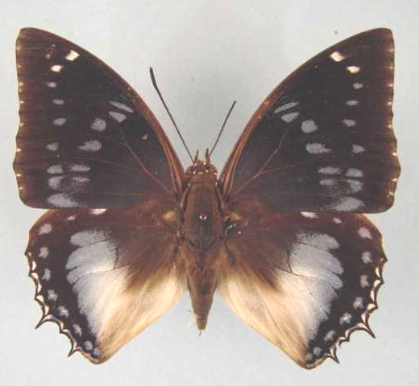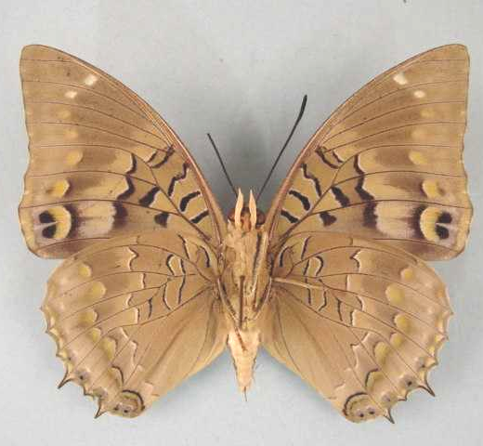

Charaxes cithaeron joanae. Male. Left – upperside; right – underside. Wingspan: 74mm. Lake Kashiba, Zambia. 14.5.74. I. Bampton. (Henning collection - H260).

Type locality: Zambia: “Mumbwa, west of Lusaka”. Holotype (male) in the Natural History Museum, London.
Diagnosis: Males differ from those of the nominate subspecies in that the spots on the upperside are larger and they have a larger discal patch on the hindwing. Females have a wider and more solid forewing discal band, larger subapical white spots, and a larger discal patch on the hindwing (Pringle, et al., 1994).
Distribution: Tanzania? (Tukuyu District), Zambia, Zimbabwe (north).
Specific localities:
Zambia – Mumbwa; Mswebe on the Kafue River; Chisamba; Mpongwe; Mufulira; Luangwa Valley (Heath, et al., 2002).
Zimbabwe – Mana Pools, at the confluence of the Sape and Zambezi Rivers (Hancock).

Charaxes cithaeron kennethi Poulton, 1926

Charaxes cithaeron kennethi Poulton, 1926. Internationaler Entomologen-Kongress 2: 539 (518-575).
Type locality: Kenya: “Ndzovuni, Kenya Colony”.
Distribution: Kenya (coast), Tanzania (east).
Specific localities:
Tanzania – East coast; Sadani Forest; Nguu Mountains; Marang Forest, Mbulu Mountains; Nguru Mountains; Ukaguru Mountains; Uzungwa Rift (Kielland, 1990).

Charaxes cithaeron nairobicus van Son, 1953

Charaxes cithaeron nairobicus van Son, 1953. Annals of the Transvaal Museum 22: 220 (219-230).
Type locality: Kenya: “Nairobi, Kenya”. Holotype (male) in the Transvaal Museum, Pretoria, South Africa.
Distribution: Kenya (central highlands east of the Rift Valley).

Charaxes cithaeron nyasae van Someren, 1964

Charaxes cithaeron nyasae van Someren, 1964. Bulletin of the British Museum (Natural History) (Entomology) 15: 229 (181-235).
Type locality: Malawi: “Nyasaland, W. shore Lake Nyasa at Nkata Bay”. Holotype (male) in the Natural History Museum, London.
Distribution: Malawi.

Charaxes violetta Grose-Smith, 1885

Charaxes violetta Grose-Smith, 1885. Entomologist’s Monthly Magazine 21: 247 (247-248).
Type locality: Mozambique: “Delagoa Bay”.
Diagnosis: Closely resembles C. cithaeron, from which it is easily distinguished by the bands on the underside of both wings and the straight, white median line (Kielland, 1990; Pringle, et al., 1994).
Distribution: Kenya, Tanzania, Malawi, Zimbabwe, Mozambique, South Africa.
Common name: Violet-spotted charaxes.
Habitat: Forest. In Tanzania ssp. melloni is found at altitudes from 300 to 1 700 m; ssp. maritima from sea-level to 850 m (Kielland, 1990).
Habits: Both sexes are attracted to fermenting fruit and sap exuding from wounds in trees. The flight is vigorous. Males establish territories on the crowns of forest trees, which they defend for most of the day (Pringle, et al., 1994).
Flight period: All year (Pringle, et al., 1994).
Early stages:

Junod, 1899: 209 [Bull. Soc. neuchatel Sci. Nat. 27: 176-251 (ssp. violetta)].

Van Someren & Rogers, 1929: 11 (ssp. maritima).
“Ch. violetta lays its eggs on the upper or underside of the leaves of ‘Mizuru’ [= Deinbollia kilimandscharica Taub.] a common tree in the forests at the coast. The eggs are at first creamy-white, but in twenty-four hours they begin to turn brown at the top. They are spherical with a slight flattening at the top, this area rather coarsely fluted with radiating lines from the central point. Within a day the top becomes concave and the rays stand out more prominently. At the coast these eggs hatch in six days, but in Nairobi they carry over ten days. The newly emerged larva is olive, with a black head carrying two pairs of short brown horns decorated with black knobs. The anal end has a bifid tail also brown in colour. The larva first eats the egg shell and then feeds at the edge of the leaf. The first moult takes place on the fourth day. The body colour turns into a dull green but the head remains brown except for two greenish patches on either side above the mouth-parts. No dorsal spot is present; these appear at the second moult when the larva becomes grass-green; if only one spot is present, it is on segment 6, but usually there are two, the second being on segment 8. These dorsal spots are white with a narrow brown outline; the anterior one is somewhat heart-shaped with the apex flattened, and with a small lobe between the two lateral ones. The second spot is a simple shield with a white line separating the two colours. The head is now green with an ochreous margin. There are two pairs of long tapering horns, with internal to each, a short spine. The horns are pinkish with white tips, and covered with short tubercles. The outer pair projects outwards very considerably and then curves up at the tips; the central pair projects up and slightly outwards, then curves inwards. This stage lasts about a week. In the final stage the larva is 45-50 mm long, bright grass-green in colour covered with a very fine yellow irroration, with the spiracular line well defined as small contiguous pale yellow spots. The dorsal spots are of the same shape as before, but the outline is now a series of bright blue spots on a darker blue ground, enclosing a purply-buff or brick-red area. The head is now much squarer while the horns are not so long in comparison with the facial disc. The lateral pair is less divergent, while the central pair is almost vertical, curving in very slightly at the tips. All the horns are pinkish-violet or purply; the marginal line is yellowish and passes over the black mouth-parts. The posterior-lateral aspect of the facial disc is srongly pectinate as are also the bases of the horns. The pupa is rather long and slender, pale green in colour, with slight bluish-white marbling on the dorsum and wing-cases. The spiracles are pinkish ovals and carry a small dark dot at the lower end. The wing-scutae have two parallel black lines at the angles and these are characteristic. There may be a further black spot midway along the antennae sheaths and two small ones on either side of the thoracic ridge.”

Henning, S., 1989: 188 (ssp. melloni).

Larval food:
Deinbollia kilimandsharica Taub. (Sapindaceae) [Van Someren and Rogers, 1929: 11 (ssp. maritima)].
Afzelia quanzensis Welw. (Fabaceae) [Van Someren, 1974: 319].
Brachystegia spiciformis Benth. (syn. edulis Hutch. and Burrt Davy) (Fabaceae) [Van Someren, 1974: 319].
Deinbollia oblongifolia (E. Mey. ex Arn.) Radlk. (Sapindaceae) [Henning, S., 1989: 189].
Deinbollia nyasica Excell (Sapindaceae) [Henning, S., 1989: 189].
Blighia unijugata Bak. (Sapindaceae) [Henning, S., 1989: 189 (ssp. melloni)].
Paullinia pinnata L. (fam?) [Mullin, in Pringle, et al., 1994: 91].

Charaxes violetta violetta Grose-Smith, 1885

Charaxes violetta Grose-Smith, 1885. Entomologist’s Monthly Magazine 21: 247 (247-248).
Type locality: Mozambique: “Delagoa Bay”. Holotype (male) in the Natural History Museum, London.
Distribution: Mozambique (south), South Africa (KwaZulu-Natal).
Specific localities:
Mozambique – Maputo (TL).
KwaZulu-Natal – Dukuduku Forest (P. Stobbia; single male).

Charaxes violetta maritima van Someren, 1966

Charaxes violetta maritima van Someren, 1966. Bulletin of the British Museum (Natural History) (Entomology) 18: 52 (45-101).
Type locality: Kenya: “Rabai Hills”. Holotype (male) in the Natural History Museum, London.
Diagnosis: Smaller than ssp. melloni (Kielland, 1990). Kielland (1990) doubts that ssp. maritima and ssp. melloni are subspecifically distinct.
Distribution: Kenya (coast), Tanzania (north-east - coast).

Charaxes violetta melloni Fox, 1963

Charaxes violetta melloni Fox, 1963. Annals of the Carnegie Museum 36: 222 (213-224).
Type locality: Tanzania: “Nguru Mountains, north-eastern Tanganyika”. Holotype (male) in the Carnegie Museum, London.
Diagnosis: Distinguished from the nominate subspecies by the broader discal markings on the upperside of the wings in both sexes (Pringle, et al., 1994).
Distribution: Mozambique, Zimbabwe (east), Malawi, Tanzania (east, except coastal areas).
Specific localities:
Tanzania – Mount Meru; Mount Kilimanjaro; Tukuyu (Kielland, 1990).
Mozambique – Dondo Forest; Amatongas (Pringle, et al., 1994).
Zimbabwe – Mutare; Vumba Mountains; Mount Selinda; Pungwe Bridge in the Honde Valley (Pringle, et al., 1994); Bikita (Mullin).

Charaxes violetta meru van Someren, 1966

Charaxes violetta meru van Someren, 1966. Bulletin of the British Museum (Natural History) (Entomology) 18: 53 (45-101).
Type locality: Kenya: “Meru, N.E. of Mt. Kenya”. Holotype (male) in the Natural History Museum, London.
Distribution: Kenya (north-eastern slopes of Mt Kenya, Njombeni Hills).

Charaxes imperialis Butler, 1874

Charaxes imperialis Butler, 1874. Transactions of the Entomological Society of London 1874: 531 (531-533).
Type locality: Ghana: “Whydah on the Gold Coast”. Holotype (male) in the Natural History Museum, London.
Distribution: Guinea-Bissau (ABRI), Guinea, Sierra Leone, Liberia, Ivory Coast, Ghana, Benin (Fermon et al., 2001), Nigeria, Cameroon, Equatorial Guinea, Congo, Central African Republic, Democratic Republic of Congo, Rwanda, Uganda, Tanzania, Zambia.
Common name: Imperial blue charaxes.
Habitat: Lowland to submontane forest (Kielland, 1990). In West Africa it occurs also in drier forests bordering the Guinea savanna (Larsen, 2005a). In Tanzania ssp. lisomboensis occurs at altitudes from 800 to 1 500 m (Kielland, 1990).
Habits: Localized but occasionally numerous (Larsen, 2005a).
Early stages: Nothing published.
Larval food:
(Probably) Sapindaceae [Rydon, according to Kielland (1990: 104)].

Charaxes imperialis imperialis Butler, 1874

Charaxes imperialis Butler, 1874. Transactions of the Entomological Society of London 1874: 531 (531-533).
Type locality: Ghana: “Whydah on the Gold Coast”. Holotype (male) in the Natural History Museum, London.
Distribution: Guinea-Bissau (ABRI), Guinea, Sierra Leone, Liberia, Ivory Coast, Ghana, Benin (Fermon et al., 2001).
Specific localities:
Sierra Leone – Freetown (Owen & Chanter, 1972).
Ivory Coast – Bossematie (H. Fermon & the Plowes family teste Larsen, 2005a).
Ghana – Atewa Range (Joly, 2003).
Benin – Noyau Central, Lama Forest (Fermon, et al., 2001).

Charaxes imperialis albipuncta Joicey & Talbot, 1920

Charaxes imperialis albipuncta Joicey & Talbot, 1920: 68. [Get ref. - not in Ackery, et al., 1995]
Type locality: Cameroon: “Bitje, Ja River, Cameroons”. Holotype (male) in the Natural History Museum, London.
Distribution: Nigeria (south and Cross River loop), Cameroon, Central African Republic, Democratic Republic of Congo (north).
Specific localities:
Nigeria – Warri (H. Boersma teste Larsen, 2005a); Kagoro (Larsen, 2005a).
Cameroon – Korup (Larsen, 2005a).

Charaxes imperialis dargei Collins, 1989

Charaxes imperialis dargei Collins, 1989. In: Henning, 1989. The Charaxinae butterflies of Africa 190 (457 pp.). Johannesburg.
Type locality: Congo: “Southern Congo, Foulakari River”. Holotype (male) in the Natural History Museum, London.
Distribution: Congo (south).

Charaxes imperialis graziellae Turlin, 1989

Charaxes imperialis graziellae Turlin, 1989. In: Henning, 1989. The Charaxinae butterflies of Africa 195 (457 pp.). Johannesburg.
Type locality: Tanzania: “Mumwendo”. Holotype (male) in the Muséum national d’Histoire naturelle de Paris.
Distribution: Tanzania (north-west - Mumwendo Forest).
Specific localities:
Tanzania – Mumwendo Forest, Ngara District (Turlin, 1989).

Charaxes imperialis lisomboensis van Someren, 1975

Charaxes imperialis lisomboensis van Someren, 1975. Bulletin of the British Museum (Natural History) (Entomology) 32: 109 (65-136).

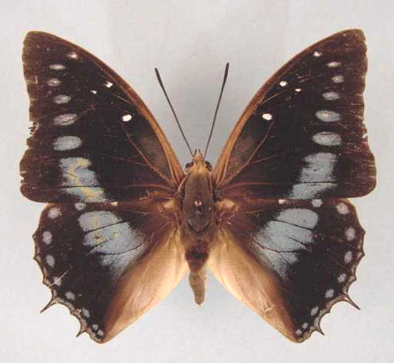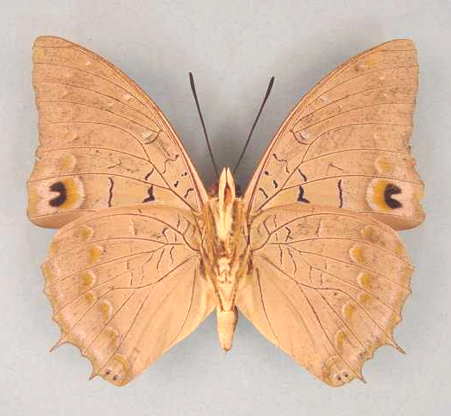

Charaxes imperialis lisomboensis. Male. Left – upperside; right – underside. Wingspan: 71mm. Lisombo River, 4500 ft., W. Zambia. 26.5.74. I. Bampton. (Henning collection - H261).

Type locality: Zambia: “Mwinilunga, Lisombo River”. Holotype (male) in the Natural History Museum, London.
Distribution: Zambia (extreme north-east), Tanzania (Kigoma).
Specific localities:
Tanzania – Northern Mpanda District to the Ugandan border (Kielland, 1990).
Zambia – Lisombu River; Ikelenge; Lumangwe Falls; Mbala (Heath, et al., 2002).

Charaxes imperialis nathaliae Canu, 1989

Charaxes imperialis nathaliae Canu, 1989. In: Henning, 1989. The Charaxinae butterflies of Africa 190 (457 pp.). Johannesburg.
Type locality: Equatorial Guinea: “Bioko”. Holotype (male) in the collection of Dr. J.G. Canu.
Distribution: Equatorial Guinea (Bioko Island).

Charaxes imperialis pauliani Rousseau-Decelle, 1933

Charaxes imperialis pauliani Rousseau-Decelle, 1933. Bulletin de la Société Entomologique de France 38: 269 (269-273).
Type locality: Democratic Republic of Congo: “Kafakumba-Katanga, Congo belge”. Types in the collection of Mr J. Plantrou.
Distribution: Democratic Republic of Congo (south - Lualaba).

Charaxes imperialis ugandicus van Someren, 1972

Charaxes imperialis ugandicus van Someren, 1972. Bulletin of the British Museum (Natural History) (Entomology) 27: 225 (215-264).
Type locality: Uganda: “Katera Forest, Masaka District, west shore of Lake Victoria”. Holotype (male) in the Natural History Museum, London.
Distribution: Uganda, Democratic Republic of Congo (north Kivu).

caerulipunctatus van Someren, 1972 (as female f. of Charaxes imperialis ugandicus). Bulletin of the British Museum (Natural History) (Entomology) 27: 227 (215-264). Uganda: “Bwamba Valley”.

Charaxes imperialis werneri Turlin, 1989

Charaxes imperialis werneri Turlin, 1989. In: Henning, 1989. The Charaxinae butterflies of Africa 193 (457 pp.). Johannesburg.
Type locality: Rwanda: “Rangiri, Forêt Nyungwe”. Holotype (male) in the Werner collection.
Distribution: Rwanda (Nyungwe Forest).

Charaxes ameliae Doumet, 1861

Charaxes ameliae Doumet, 1861. Revue et Magasin de Zoologie Pure et Appliqué (2) 13: 171 (171-178).
Type locality: Gabon.
Distribution: Guinea, Sierra Leone, Liberia, Ivory Coast, Ghana, Togo, Nigeria, Cameroon, Gabon, Congo, Central African Republic, Democratic Republic of Congo, Uganda, Kenya, Zambia, Tanzania, Malawi.
Common name: Blue-spotted charaxes (Larsen, 2005a) [C. cithaeron has the same common name!].
Habitat: Forest and Brachystegia woodland. In Tanzania ssp. amelina occurs from 800 to 1 600 m (occasionally to 2 000 m) (Kielland, 1990).
Early stages:

Henning, G., 1977: 222 (ssp. amelina).

Henning, S., 1989: 198 (ssp. amelina).

Larval food:

Brachystegia spiciformis Benth. (Fabaceae) [Henning, 1989: 199].

Julbernardia globiflora (Benth.) Troup. (Fabaceae) [Henning, 1989: 199].

Albizia adianthifolia (Schumach) W.F. Wight (Fabaceae) [Henning, S., 1989: 199].
Baikiaea insignis (Fabaceae) [Congdon and Collins, 1998: 52].

Charaxes ameliae ameliae Doumet, 1861

Charaxes ameliae Doumet, 1861. Revue et Magasin de Zoologie Pure et Appliqué (2) 13: 171 (171-178).
Type locality: Gabon.
Distribution: Nigeria (Cross River loop), Cameroon, Gabon, Congo, Central African Republic, Democratic Republic of Congo.
Specific localities:
Cameroon – Korup (Larsen, 2005a).

regius Aurivillius, 1889 (as sp. of Charaxes). Entomologisk Tidskrift 10: 191 (191-192). Cameroon: “Camerun”.

Charaxes ameliae amelina Joicey & Talbot, 1925

Charaxes ameliae amelina Joicey & Talbot, 1925. Annals and Magazine of Natural History (9) 16: 644 (633-653).

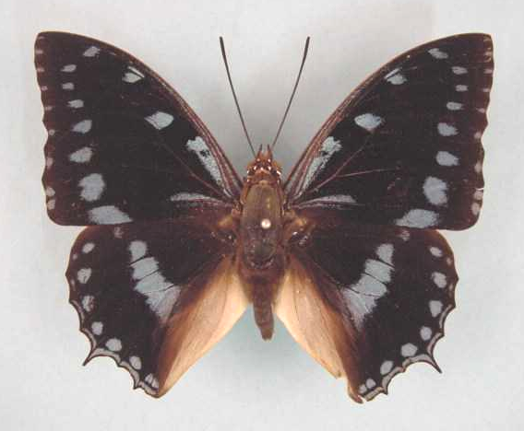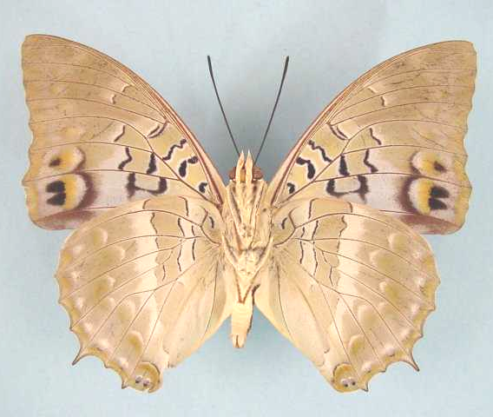

Charaxes ameliae amelina. Male. Left – upperside; right – underside. Wingspan: 85mm. Kitwe, Zambia. 1964.08.23. A.I. Curle. (Curle Trust Collection - 116).

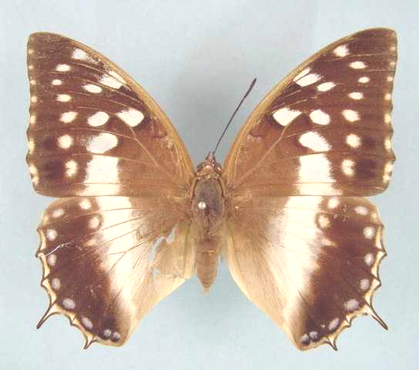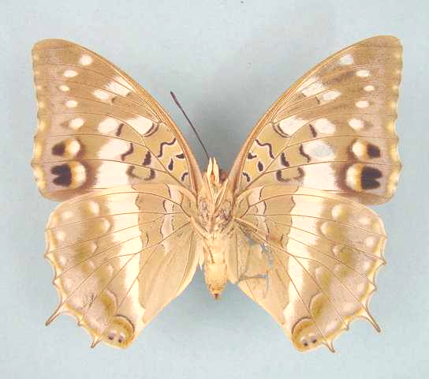

Charaxes ameliae amelina. Female. Left – upperside; right – underside. Wingspan: 78mm. Kitwe, Zambia. 64.09.03. A.I. Curle. (Curle Trust Collection - 118).

Type locality: Malawi: “Nyassaland”.
Distribution: Tanzania (Kigoma), Malawi, Zambia (north). Also the Democratic Republic of Congo (Shaba) (Henning, 1989).
Specific localities:
Tanzania – North-west Mpanda District; Gombe, north of Kigoma (Kielland, 1990).
Zambia – Ikelenge; Kasangezhi; Mwinilunga Town; 100 km south of Mwinilunga; 50 km east of Mwinilunga; Chingola; Mufulira; Ndola; Musonda Falls; Kalungwishi River; Lumangwe Falls; Lunzua Falls; Kalmbo Falls (Heath, et al., 2002).

Charaxes ameliae doumeti Henning, 1989

Charaxes ameliae doumeti Henning, 1989. The Charaxinae butterflies of Africa 197 (457 pp.). Johannesburg.
Type locality: Type locality and holotype not designated. Distribution given as: “Sierra Leone, Liberia, Guinea, Ivory Coast, Ghana, and western Nigeria”.
Distribution: Guinea, Sierra Leone, Liberia, Ivory Coast, Ghana, Togo, Nigeria (west).
Specific localities:
Sierra Leone – Freetown (Owen & Chanter, 1972).
Ivory Coast – Banco Forest, Abidjan (H. Warren-Gash teste Larsen, 2005a); Bossematie (H. Fermon teste Larsen, 2005a).
Ghana – Atewa Range (Joly, 2003).
Nigeria – Warri (H. Boersma teste Larsen, 2005a).

Charaxes ameliae victoriae van Someren, 1972

Charaxes ameliae victoriae van Someren, 1972. Bulletin of the British Museum (Natural History) (Entomology) 27: 231 (215-264).
Type locality: Uganda: “Katera Forest, west shore of Lake Victoria”. Holotype (male) in the Natural History Museum, London.
Diagnosis: Differs from ssp. amelina in that the forewing upperside in the female has creamy spotting (pure white in amelina) (Congdon and Collins, 1998). Populations from Biharamulo (e.g. Nyakanazi) are transitional, with both white and creamy spotted females (Bjornstad, vide Congdon and Collins, 1998: 52).
Distribution: Uganda, Kenya (west), Tanzania (north-west).
Specific localities:
Tanzania – Minziro Forest (very common); Munene Forest (very common) (Congdon & Collins, 1998).

Charaxes pythodoris Hewitson, 1873

Charaxes pythodoris Hewitson, 1873. Entomologist’s Monthly Magazine 10: 57 (57-58).

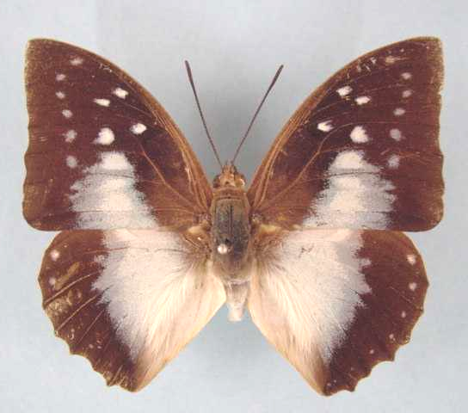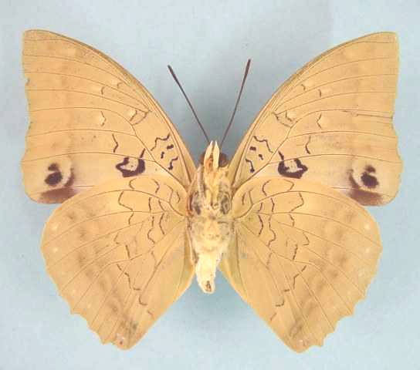

Charaxes pythodoris pythodoris. Male. Left – upperside; right – underside. Wingspan: 69mm. Mufulira, Zambia. 65.05.01. A.I. Curle. (Curle Trust Collection - 119).

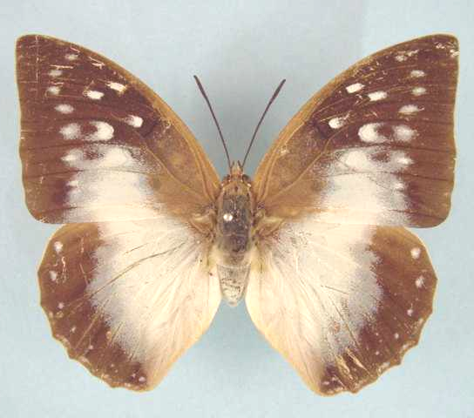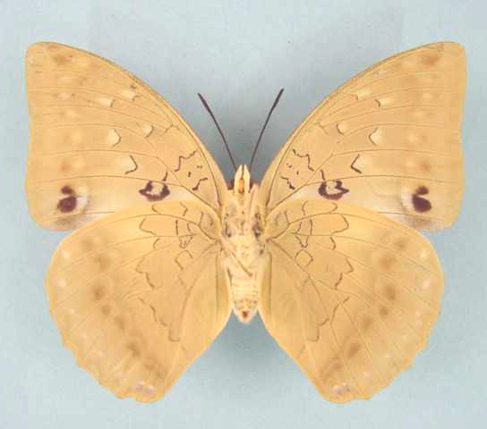

Charaxes pythodoris pythodoris. Female. Left – upperside; right – underside. Wingspan: 77mm. Mufulira, Zambia. 65.05.01. A.I. Curle. (Curle Trust Collection - 120).

Type locality: Angola: “the mountainous district of Angola”. Holotype (male) in the Natural History Museum, London.
Distribution: Sierra Leone, Ivory Coast, Ghana, Nigeria, Cameroon, Gabon, Congo, Central African Republic, Angola, Democratic Republic of Congo, Ethiopia, Uganda, Kenya, Tanzania, Malawi, Zambia.
Common name: Powder-blue charaxes.
Habitat: Drier forests (Larsen, 2005a), riparian forest, heavy savanna, and light arid savanna (ssp. pallida), where forest-crowned hills or thickets occur (Henning, 1989). In Tanzania the nominate subspecies is found at altitudes from 800 to 2 000 m (Kielland, 1990).
Habits: Rare and localized in West Africa (Larsen, 2005a). Males are attracted to otter and bird droppings, and both sexes occasionally feed from fermenting bananas (Kielland, 1990).
Early stages:

Evans, 1935 (ssp. pythodoris).

Henning, S., 1982: 76, 79 (ssp. ventersi and sumbuensis).

Henning, S., 1989: 203 (ssp. ventersi).

Henning, S., 1989: 204 (ssp. sumbuensis).

Larval food:
Craibia brownii Dunn (Fabaceae) [Van Someren, 1974: 319].
Craibia laurentii Willd. (Fabaceae) [Van Someren, 1974: 319].
Craibia brevicaudata (Vatke) S.T. Dunn (Fabaceae) [Van Someren, 1974: 319; Henning, 1989: 204 (ssp. ventersi, ssp. sumbuensis) and Kielland, 1990: 109 (ssp. nesaea)].
Craibia affinis (De Wild) De Wild. (Fabaceae) [Henning, 1989: 204 (ssp. pythodoris).

Charaxes pythodoris pythodoris Hewitson, 1873

Charaxes pythodoris Hewitson, 1873. Entomologist’s Monthly Magazine 10: 57 (57-58).

Charaxes pythodoris pythodoris. Male. Left – upperside; right – underside. Wingspan: 69mm. Mufulira, Zambia. 65.05.01. A.I. Curle. (Curle Trust Collection - 119).

Charaxes pythodoris pythodoris. Female. Left – upperside; right – underside. Wingspan: 77mm. Mufulira, Zambia. 65.05.01. A.I. Curle. (Curle Trust Collection - 120).

Type locality: Angola: “the mountainous district of Angola”. Holotype (male) in the Natural History Museum, London.
Distribution: Angola, Zambia (north-west), Democratic Republic of Congo (Uele, Lomami, Equateur), Ethiopia (south), Uganda, Kenya (west), Tanzania (north-west).
Specific localities:
Tanzania – Mpanda and Kigoma Districts to Geita (Kielland, 1990).
Zambia – Ikelenge; South Mutundu River, Mufulira (Heath, et al., 2002).

Charaxes pythodoris davidi Plantrou, 1973

Charaxes pythodorus [sic] davidi Plantrou, 1973. Bulletin de la Société Entomologique de France 78: 269 (268-276).
Type locality: Ivory Coast: “Côte d’Ivoire nord-est, environs de Kakpin, sud de la réserve de Bouna”. Holotype (male) in the Muséum national d’Histoire naturelle de Paris.
Distribution: Sierra Leone, Ivory Coast, Ghana.
Specific localities:
Ivory Coast – near Kakpin (TL).

Charaxes pythodoris knoopae Plantrou, 1982

Charaxes pythodoris knoopae Plantrou, 1982. Miscellanea Entomologica 49: 113 (101-115).
Type locality: Nigeria: “Irin Ijesha, Ouest Nigéria”. Holotype (male) in the Muséum national d’Histoire naturelle de Paris.
Distribution: Nigeria (west).
Note: Larsen (2005a) feels that this may not be a distinct subspecies, averring that the populations in Nigeria might more properly be regarded as intermediate between the western spp. davidi and the eastern ssp. occidens.

Charaxes pythodoris nesaea Grose-Smith, 1889

Charaxes nesaea Grose-Smith, 1889. Annals and Magazine of Natural History (6) 3: 132 (121-137).
Type locality: Kenya: “in the neighbourhood of Mombasa, East Coast of Africa”.
Diagnosis: Smaller than the nominate subspecies and hind wing bluish area extends closer to outer margin of wing (Kielland, 1990).
Distribution: Kenya (coast), Tanzania (north-east).
Specific localities:
Tanzania – Sadani to Amani in East Usambara Mountains; South Pare Mountains (Kielland, 1990).

Charaxes pythodoris occidens van Someren, 1963

Charaxes pythodorus [sic] occidens van Someren, 1963. Bulletin of the British Museum (Natural History) (Entomology) 13: 223 (195-242).
Type locality: Congo: “French Congo: Ouesso, Mambili”. Holotype (male) in the Natural History Museum, London.
Distribution: Nigeria, Cameroon, Gabon, Congo, Central African Republic.
Specific localities:
Nigeria – Bridge over the Ogun River in the Olokemeji Forest (Larsen, 2005a); Kagoro (Larsen, 2005a); Omo (Larsen, 2005a); Gashaka-Gumpti (Larsen, 2005a).

Charaxes pythodoris pallida van Someren, 1963

Charaxes pythodoris pallida van Someren, 1963. Bulletin of the British Museum (Natural History) (Entomology) 13: 224 (195-242).
Type locality: Tanzania: “Singida”. Holotype (female) in the Hope Department, Oxford.
Diagnosis: Generally paler than the other subspecies (Kielland, 1990).
Distribution: Tanzania (central).
Specific localities:
Tanzania – Itigi towards Tabora (Kielland, 1990).

pallida Carpenter, 1934 (as f. of Charaxes pythodoris). Proceedings of the Royal Entomological Society of London 9: 12 (12-14). Tanzania: “Kazi-Kazi station on the central Railway in Tanganyika Territory”.

geraldi Stoneham, 1964 in Stoneham, 1951-65 (as [unnecessary] replacement name for Charaxes pythodoris f. pallida Carpenter). The butterflies of western Kenya with notes on allied forms, etc. 114 (180 pp.). Nairobi.

Charaxes pythodoris sumbuensis Henning, 1982

Charaxes pythodoris sumbuensis Henning, 1982. Miscellanea Entomologica 49: 79 (75-82).

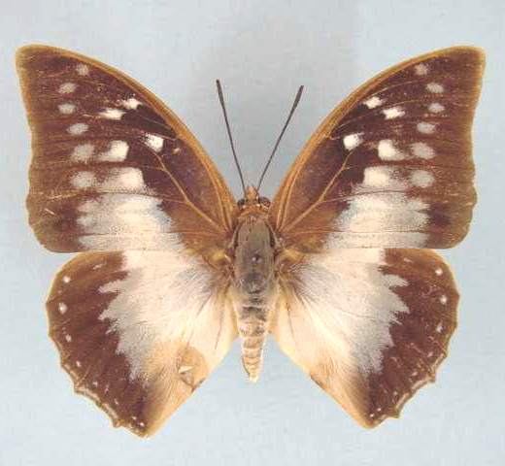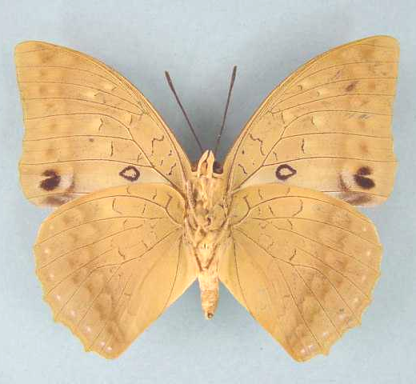

Charaxes pythodoris sumbuensis. Male. Left – upperside; right – underside. Wingspan: 60mm. Paratype. Keso Falls, Lifubu River, Zambia. 8.7.78. I. Bampton. (Henning collection - H262).

Type locality: Zambia: “Sumbu, 800 m”. Holotype (male) in the Natural History Museum, London.
Distribution: Zambia (southern end of Lake Tanganyika).
Specific localities:
Zambia – Lake Mweru; Lufubu River; Sumbu; Itigi thicket, near Sumbu (Dening); Kalombo Falls (Heath, et al., 2002).

Charaxes pythodoris ventersi Henning, 1982

Charaxes pythodoris ventersi Henning, 1982. Miscellanea Entomologica 49: 76 (75-82).
Type locality: Malawi: “Zomba Mountain Foothills, 1000 m”.
Distribution: Malawi (gorges and valleys down the sides of the Zomba Plateau). Holotype (male) in the Natural History Museum, London.

HADRIANUS GROUP

Charaxes hadrianus Ward, 1871

Charaxes hadrianus Ward, 1871. Entomologist’s Monthly Magazine 8: 120 (34-36, 58-60, 81-82, 118-122).
Type locality: Cameroon: “Camaroons”.
Distribution: Guinea, Sierra Leone, Liberia, Ivory Coast, Ghana (south-west), Nigeria (east and Cross River loop), Cameroon, Gabon, Congo, Central African Republic, Democratic Republic of Congo, Uganda (west).
Specific localities:
Guinea – Djeke (Larsen, 2005a).
Ghana – Akasa National Park (Larsen, 2005a); Cape Three Points (Larsen, 2005a); Mpasaso (Joly, 2003)..
Nigeria – Warri (Larsen, 2005a).
Common name: Hadrian’s white charaxes.
Habitat: Wet primary forest (Larsen, 2005a).
Habits: This is a very rare charaxes, especially in West Africa (Larsen, 2005a). Specimens are known to come to fruit-baited traps, albeit apparently reluctantly (Larsen, 2005a). Schultze (1916) states that freshly captured males emit a smell of violets.
Early stages:

Henning, S., 1989: 206.

Larval food:
Ouratea reticulata (P. Beauv.) Engler (Ochnaceae) [Henning, S., 1989: 206].
Ochna species (Ochnaceae) [Henning, S., 1989: 206].

dux Staudinger, 1886 in Staudinger and Schatz, 1884-8 (as sp. of Charaxes). Exotischer Schmetterlinge 1: 170 (333 pp.). Bayern. Gabon: “Gabun”.

gabonica Crowley, 1890 (as sp. of Charaxes). Transactions of the Entomological Society of London 1890: 553 (551-556). Gabon: “Gaboon”.

orientalis Mollet, 1975 (as ssp. of Charaxes hadrianus). Bulletin de la Société de Entomologique de France 80: 32 (32-38). Uganda: “Ouest de l’Ouganda, versant Est du Ruwenzori, vallée de Bwamba, 2000 m”. [Invalid.] [Synonymized with C. hadrianus hadrianus Ward, 1871 by Henning, S. (1989: 205)].

molleti Koçak, 1996 (as replacement name for Charaxes hadrianus orientalis Mollet, 1975, nec Charaxes castor orientalis Lanz, 1896). Centre for Entomological Studies Miscellaneous Papers 27-28: 12 (10-16)).]. [Unesserary replacement name].

Charaxes lecerfi Lathy, 1925

Charaxes hadrianus lecerfi Lathy, 1925. Encyclopédie Entomologique (B.3. Lepidoptera) 1: 94 (93-97).
Type locality: Nigeria: “Warri, Nigeria”. Holotype (male) in the Muséum national d’Histoire naturelle de Paris. Larsen (2005a) believes that the type locality may be in error.
Distribution: ?Nigeria (south), Cameroon, Central African Republic, Democratic Republic of Congo (R. White, pers. comm., 2003).
The only specimen known from Nigeria (a female from Warri) is most probably a melanic aberration of C. hadrianus (Larsen, 2005a). The species is therefore most probably absent from Nigeria.
Common name: Le Cerf’s white charaxes.
Habitat: Evergreen forest.
Habits: Like C. hadrianus this is a local and rare species that does not readily visit traps baited with fermenting fruit (Larsen, 2005a).
Early stages: Nothing published.
Larval food: Nothing published.

janmoullei Berger, 1975 (as sp. of Charaxes). Lambillionea 75: 94 (92-95). Central African Republic: “Rép. Centrafricaine, Bangui”.

NOBILIS GROUP

Charaxes nobilis Druce, 1873

Charaxes nobilis Druce, 1873. Entomologist’s Monthly Magazine 10: 13 (13-14).
Type locality: Nigeria: “Old Calabar”. The holotype (male) is in the Natural History Museum, London.
Distribution: Guinea, Ivory Coast, Ghana, Nigeria, Cameroon, Gabon, Congo, Central African Republic, Democratic Republic of Congo, Uganda.
Common name: Noble white charaxes.
Habitat: Lowland evergreen forest.
Habits: A very scarce butterfly (Larsen, 2005a). The single male seen by Larsen (2005a) flew in wide circles for about 10 minutes, just beneath the forest canopy. Schultze (1916) states that live males emit an odour of perfumed hair-pomade.
Early stages: Nothing published.
Larval food: Nothing published.

Charaxes nobilis nobilis Druce, 1873

Charaxes nobilis Druce, 1873. Entomologist’s Monthly Magazine 10: 13 (13-14).
Type locality: Nigeria: “Old Calabar”. Holotype (male) is in the Natural History Museum, London.
Distribution: Nigeria (south and east), Cameroon, Gabon, Congo, Central African Republic, Democratic Republic of Congo (Kivu, Ubangi, Mongala, Tshuapa, Sankuru), Uganda.
Specific localities:
Nigeria – Old Calabar (TL); Ikom (Larsen, 2005a); Oban Hills (Larsen, 2005a).
Cameroon – Korup (Lees, 1989).

agabo Distant, 1880 (as sp. of Charaxes). Proceedings of the Zoological Society of London 1879: 708 (703-709). Nigeria: “Calabar district”.

homerus Staudinger, 1891 (as sp. of Charaxes). Deutsche Entomologische Zeitschrift, Iris 4: 132 (61-157). Cameroon: “Barombi-Station im Hinterlande von Kamerun”.

Charaxes nobilis claudei le Moult, 1933

Charaxes nobilis claudei le Moult, 1933. Novitates Entomologicae 3: 17 (16-18).
Type locality: Guinea: “Kérouané, Guinée Française”.
Distribution: Guinea (north-west), Ivory Coast, Ghana, Nigeria (south-west).
Specific localities:
Guinea – Kerouane (TL); Nimbas (Larsen, 2005a).
Ivory Coast – Atewa Range (Joly, 2003); Abidjan (Larsen, 2005a); Azagny (Larsen, 2005a).
Ghana – Atewa Range (Larsen, 2005a).
Nigeria – Sapoba (Larsen, 2005a); Omo (Larsen, 2005a); Okomu (Larsen, 2005a).

Charaxes nobilis rosaemariae Rousseau-Decelle, 1934

Charaxes nobilis rosaemariae Rousseau-Decelle, 1934. Bulletin de la Société Entomologique de France 39: 233 (228-236).
Type locality: Democratic Republic of Congo: “Kafakumba-Katanga, Congo belge”.
Distribution: Democratic Republic of Congo (Lualaba, Shaba).

Charaxes superbus Schultze, 1909

Charaxes superbus Schultze, 1909. Societas Entomologica 23: 172 (172-173).
Type locality: Cameroon: “Bipindi (Camerun)”.
Distribution: Nigeria (Cross River loop), Cameroon, Gabon (R. White, pers. comm., 2003), Congo (north-west), Central African Republic.
Specific localities:
Nigeria – Oban Hills (Knoop teste Larsen, 2005a).
Cameroon – Bipindi (TL).
Common name: Superb white charaxes.
Habitat: Evergreen forest (Henning, 1989).
Habits: Generally an extremely rare charaxes (Larsen, 2005a), but on occasion it may be locally common in parts of Cameroon (T. Bouyer teste Larsen, 2005a). Possibly it remains in the forest canopy most of the time (Henning, 1989).
Early stages: Nothing published.
Larval food: Nothing published.

Charaxes lydiae Holland, 1917

Charaxes lydiae Holland, 1917. Annales of the Carnegie Museum 11: 16 (14-18).
Type locality: Cameroon: “Lolodorf”. Holotype (female) is in the Carnegie Museum, Pittsburg, U.S.A.
Distribution: Cameroon (type locality and Yaounde district), Gabon (R. White, pers. comm., 2003), Congo (Kelle).
Habitat: Primary forest.
Habits: Described in some detail by Darge (1973).
Early stages: Nothing published.
Larval food: Nothing published.

ACRAEOIDES GROUP

Charaxes acraeoides Druce, 1908

Charaxes acraeoides Druce, 1908. Annals and Magazine of Natural History (8) 2: 449? (499).
Type locality: Cameroon: “Cameroons, Bitje, Ja River”.
Distribution: Cameroon, Gabon, Congo, Central African Republic, Democratic Republic of Congo (Kasai).
Habitat: Evergreen forest.
Early stages: Nothing published.
Larval food: Nothing published.

Charaxes fournierae Le Moult, 1930

Charaxes fournierae Le Moult, 1930. Bulletin de la Société Entomologique de France 1930: 171 (171-173).
Type locality: Congo: “Moyen Congo Français”.
Distribution: Guinea (Haydon Warren-Gash, pers. comm., 2002), Ivory Coast (Nicat, 2002b), Ghana, Cameroon, Gabon (Roger White, pers. comm., 2003), Congo, Central African Republic, Democratic Republic of Congo (Roger White, pers. comm., 2003), Rwanda, Uganda.
Common name: Euphaedra charaxes.
Habitat: Lowland evergreen forest.
Habits: A rare species that seldom enters fruit-baited traps (Larsen, 2005a). The flight is extremely fast and powerful (Larsen, 2005a). The nominate subspecies resembles Euphaedra adonina and E. justicia, while ssp. jolybouyeri is closest to E. sarcoptera. All three of these euphaedras fly high up on occasion (Larsen, 2005a). It is puzzling that a non-aposematic charaxes should apparently mimic species of non-aposematic Euphaedra (Larsen, 2005a).
Early stages: Nothing published.
Larval food: Nothing published.

Charaxes fournierae fournierae Le Moult, 1930

Charaxes fournierae Le Moult, 1930. Bulletin de la Société Entomologique de France 1930: 171 (171-173).
Type locality: Congo: “Moyen Congo Français”. Type in the Muséum national d’Histoire naturelle de Paris.
Distribution: Cameroon, Gabon (Roger White, pers. comm., 2003), Congo, Central African Republic, Democratic Republic of Congo (west) (Roger White, pers. comm., 2003).

Charaxes fournierae jolybouyeri Vingerhoedt, 1998

Charaxes fournierae jolybouyeri Vingerhoedt, 1998. Entomologia Africana 3 (Supplement): 4.
Type locality: Ghana: South-western Ghana. Female first described by Nicat, 2002 (Entomologia Africana 7 (Supplement): 1 (1-4).

Distribution: Guinea (Warren-Gash, pers. comm., 2002), Ivory Coast (Nicat, 2002b), Ghana.
Specific localities:
Guinea – Nimbas: near Nzerekore on the northern Guinea/Liberia border (H. Warren-Gash teste Larsen, 2005a).
Ghana – Atewa Range (Joly, 2003).

Charaxes fournierae kigeziensis Howarth, 1969

Charaxes fournierae kigeziensis Howarth, 1969. Proceedings of the Royal Entomological Society of London (B) 38: 152 (141-156).
Type locality: Uganda: “Kigezi, Kayenza Forest”. Holotype (male) in the Natural History Museum, London.
Distribution: Uganda (south-west - south-west Kigezi).

Charaxes fournierae vandenberghei Collins, 1982

Charaxes fournierae vandenberghei Collins, 1982. Miscellanea Entomologica 49: 99 (99-100).
Type locality: Rwanda: “Nyungwe Forest”. Holotype (male) in the Tervuren Museum, Belgium.
Distribution: Rwanda (west - Nyungwe Forest).

ZINGHA GROUP

Charaxes zingha (Stoll, 1780)

Papilio zingha Stoll, 1780 in Stoll, [1780-2]. Die Uitlandsche Kapellen voorkomende in de drie waerrelddeelen Asia, Africa en America 4 [part]: 53 (29-252). Amsteldam & Utrecht.
Type locality: “op de Kust van Afrika [on the coast of Africa]”.
Distribution: Senegal, Guinea, Sierra Leone, Liberia, Ivory Coast, Ghana, Nigeria (south and Cross River loop), Cameroon, Congo, Angola, Central African Republic, Democratic Republic of Congo (north), Uganda, Tanzania (west).
Specific localities:
Senegal – Basse Casamance (Underwood teste Larsen, 2005a).
Guinea – Parc National Haut du Niger (Larsen, 2005a).
Sierra Leone – Freetown (Owen & Chanter, 1972).
Ivory Coast – Bossematie (H. Fermon teste Larsen, 2005a).
Ghana – Atewa Range (Joly, 2003); Cape Coast (Larsen, 2005a).
Nigeria – Warri (H. Boersma teste Larsen, 2005a).
Cameroon – Korup (Lees, 1989).
Tanzania – Kasye Forest; Mihumu Forest (Kielland, 1990).
Common name: Shining red charaxes.
Habitat: Lowland evergreen forest and, to a lesser extent gallery forest and coastal scrubland (Larsen, 2005a). In Tanzania it is found at altitudes of 800 to 900 m (Kielland, 1990).
Habits: A widespread and fairly common species (Larsen, 2005a). Specimens are found in the more open, sunny parts of the forest and on forest margins. The flight is slower than most other species of Charaxes (Kielland, 1990) and both sexes are more retiring (Larsen, 2005a). They usually settle, head downwards, under large leaves (Larsen, 2005a). Decaying animal matter does not attract males (Henning, 1989) but both sexes come to fermenting fruit (Larsen, 2005a). Larsen (2005a) notes that they will even come to fresh paw-paw placed on forest paths.
Early stages:

Van Someren, 1935: 50.

Henning, 1989. [larval head capsule].

Larval food:
Hugonia platsepala Welw. ex Oliv. (Linaceae) [Van Someren, 1974: 321].
Hugonia castaneifolia Engl. (Linaceae) [Van Someren, 1974: 321].

berenice Drury, 1782 (as sp. of Papilio). Illustrations of Natural History 3: index et 13 (76 pp.). London. Sierra Leone: “Sierra Leon”.

ETESIPE GROUP

Charaxes etesipe (Godart, 1824)

Nymphalis etesipe Godart, 1824 in Latreille and Godart, [1819], [1824]. Encyclopédie Méthodique. Histoire Naturelle [Zoologie] 9 Entomologie: 355 (1-328 [1819], 329-828 [1824]). Paris.
Type locality: Sierra Leone: “Sierra Leon”.
Diagnosis: Related to C. penricei and C. cacuthis (Kielland, 1990). Kielland (1990) treats tavetensis as a species distinct from etesipe and regards pemba and shaba as subspecies of the former.
Distribution: Senegal, Guinea, Sierra Leone, Liberia, Ivory Coast, Ghana, Togo, Nigeria, Cameroon, Gabon, Congo, Angola, Central African Republic, Democratic Republic of Congo, Uganda, Sudan, Rwanda, Tanzania, Ethiopia, Kenya, Somalia, Democratic Republic of Congo, Angola, Mozambique, Malawi, Zimbabwe, Swaziland (Duke, et al., 1999), South Africa.
Common name: Scarce forest charaxes; blue-spotted charaxes (Larsen, 2005a).
Habitat: A wide range, from wet forest, to riparian forest and moist savanna woodland, including Guinea savanna in West Africa (Larsen, 2005a). In Tanzania ssp. etesipe is found at altitudes from 900 to 1 600 m; ssp. tavetensis from sea-level to 1 500 m (Kielland, 1990).
Habits: Males fly up and down river beds in search of animal and bird droppings (Kielland, 1990). Larsen (2005a) found many specimens on dog excrement (Larsen, 2005a). Both sexes come to fermented fruit (Larsen, 2005a). When disturbed in forest, males fly off and settle head-down on a tree trunk, where they are well camouflaged (Larsen, 2005a).
Flight period: Presumably flies all year (Pringle, et al., 1994).
Early stages:

Van Someren and Van Someren, 1926: 347 (ssp. etesipe).

Van Someren and Rogers, 1929: 221 (ssp. tavetensis).
Apparently the eggs of tavetensis are indistinguishable from those of etesipe but in the former are laid on Fabaceae (Afzelia, Entada) and in the latter are laid on Euphorbiaceae. The larvae of tavetensis show a marked difference from those of etesipe: the body colour is similar, but the dorsal spot on segments 6 and 8 are brick-red surrounded by a grey line, outwardly edged with a series of minute black dots (instead of a grey three-pointed crescent or a figure of quadrilateral shape outlined with small blue-black dots). The head shield differs in the longer and more tapering central horns which are black on the front surfaces at the tips, while the lateral horns are black along the upper edge, and there is a yellow facial line; in etesipe the general colour is green, with the tips of the horns blue, and there is no facial line.

Henning, S., 1989: 222 (ssp. etesipe, tavetensis, and gordoni).

Larval food:
Afzelia africana Sm. ex Pers. (Fabaceae) [Blandin, et al., 1975 (Ivory Coast); Henning, S., 1989: 222 (ssp. etesipe)].
Afzelia quanzensis Welw. (Fabaceae) [Van Someren and Rogers, 1929: 53 (ssp. etesipe and ssp. tavetensis)].
Ceiba pentandra (L.) Gaertn. (Bombaceae) [Blandin et al., 1975 (Ivory Coast); Henning, S., 1989: 222 (ssp. etesipe)].
Croton megalocarpus Hutch. (Euphorbiaceae) [Van Someren, 1974: 319 (ssp. etesipe)].
Dalbergia microcarpa Taub and Baker (Fabaceae) [Van Someren, 1974: 319].
Dalbergia microphylla Chiov. (Fabaceae) [Henning, S., 1989: 222 (ssp. etesipe)].
Dalbergia nitidula (Fabaceae) [Woodhall, 2005a].
Entada abyssinica Steud. ex A. Rich. (Fabaceae) [Van Someren, 1974: 319; Dickson and Kroon, 1978: 62 (ssp. etesipe and ssp. tavetensis)].
Entada pursaetha DC. (syn. gigas auct.) (Fabaceae) [Van Someren, 1966: 63 (ssp. etesipe and ssp. tavetensis)].
Entada rheedii Spreng (Fabaceae) [Henning, 1989].
Entada scandens (L.) Bentham (Fabaceae) [Van Someren, 1974: 319].
Erythroxylum manni (Erythroxylaceae) [Larsen, 2005a].
Maesopsis eminii (Rhamnaceae) [Fontaine, 1988 (Democratic Republic of Congo)].
Margiritaria discoidea (Baill.) (Euphorbiaceae) [M Haywood, ref?].
Phyllanthus guineensis Pax. (Euphorbiaceae) [Van Someren, 1974: 319 (ssp. etesipe)].
Phyllanthus sepialis Muell. Arg. (syn. meruensis Pax) (Euphorbiaceae) [Van Someren, 1974: 319 (ssp. etesipe)].
Ricinis communis L. (Euphorbiaceae) (exotic) [Gifford, 1965: 98 (ssp. etesipe)].
Securidaca longepedunculata Fresen. (Polygalaceae) [Henning, S., 1989: 222 (ssp. tavetensis)].
Securinega sp. (Euphorbiaceae) [Larsen, 2005a].
Securinega species (Euphorbiaceae) [Larsen, 2005a].
Senna species (syn Cassia) (Fabaceae) [Henning, S., 1989: 222 (ssp. etesipe)].
Tragia benthamii Pax. (Euphorbiaceae) [Van Someren, 1974: 319 (ssp. etesipe)].

Charaxes etesipe etesipe (Godart, 1824)

Nymphalis etesipe Godart, 1824 in Latreille and Godart, [1819], [1824]. Encyclopédie Méthodique. Histoire Naturelle [Zoologie] 9 Entomologie: 355 (1-328 [1819], 329-828 [1824]). Paris.
Type locality: Sierra Leone: “Sierra Leon”.
Distribution: Senegal, Guinea, Sierra Leone, Liberia, Ivory Coast, Ghana, Togo, Nigeria (south and Cross River loop), Cameroon, Gabon, Congo, Angola (north-west), Central African Republic, Democratic Republic of Congo, Uganda, Sudan (south), Rwanda, Kenya (north-west), Tanzania (north-west).
Specific localities:
Senegal – Basse Casamance (Larsen, 2005a).
Sierra Leone – Freetown (Owen & Chanter, 1972).
Ivory Coast – Cocody, Abidjan (Larsen, 2005a); Bossematie (H. Fermon teste Larsen, 2005a).
Ghana – Atewa Range (Joly, 2003); Kogyae (Larsen, 2005a).
Nigeria – Vom (Owen, 1977); Warri (H. Boersma teste Larsen, 2005a); Kaduna (R. St Leger teste Larsen, 2005a); Oban Hills (Larsen, 2005a).
Cameroon – Korup (Larsen, 2005a).
Tanzania – Ntakatta Forest; Kigoma District; Ngara District (Kielland, 1990).

etheta Godart, 1824 in Latreille and Godart, [1819], [1824] (as sp. of Nymphalis). Encyclopédie Méthodique. Histoire Naturelle [Zoologie] 9 Entomologie: 356 (1-328 [1819], 329-828 [1824]). Paris. “De la côte occidental d’Afrique”.

castoroides Poulton, 1926 (as female f. of Charaxes etesipe etesipe). Internationaler Entomologen-Kongress 2: 549 (518-575). Uganda: “Jinja”.

caeruleotincta Carpenter, 1945 (as female f. of Charaxes etesipe). Proceedings of the Royal Entomological Society of London (B) 14: 84 (81-88). Uganda: “Entebbe”.

Charaxes etesipe abyssinicus Rothschild, 1900

Charaxes etesipe abyssinicus Rothschild, 1900 in Rothschild and Jordan, 1900. Novitates Zoologicae 7: 458 (287-524).
Type locality: Ethiopia: “Abyssinia: Sciotalit, Sxioa (Shoa)”.
Distribution: Ethiopia (highlands west of the Rift Valley).

Charaxes etesipe gordoni van Someren, 1936

Charaxes etesipe gordoni van Someren, 1936. Journal of the East Africa and Uganda Natural History Society 12: 198 (147-199).
Type locality: Kenya: “Meru forest (lower)”. Holotype (male) in the Natural History Museum, London.
Distribution: Kenya (north-east slopes of Mt Kenya, and Njombeni Hills).
Note: Larsen (2005a) states that the ssp. tavetensis, gordoni and pemba may constitute a species distinct from C. etesipe.

Charaxes etesipe hercules Turlin & Lequeux, 2002

Charaxes etesipe hercules Turlin & Lequeux, 2002. Lambillionea 102 (1) (Tome I): 73 (69-76).
Type locality: Uganda: Buvuma Island, Lake Victoria.
Distribution: Uganda.

Charaxes etesipe patrizii Storace, 1949

Charaxes etesipe patrizii Storace, 1949. Annali del Museo Civico di Storia Naturale (di Genova) Giacomo Doria 64: 21 (12-29).
Type locality: Somalia: “ola Uagér (Oltregiuba)”.
Distribution: Somalia. Known only from a single male from the type locality.

Charaxes etesipe pemba van Someren, 1966

Charaxes etesipe pemba van Someren, 1966. Bulletin of the British Museum (Natural History) (Entomology) 18: 64 (45-101).
Type locality: Tanzania: “Pemba Island, north east of Zanzibar”. Holotype (male) in the Natural History Museum, London.
Diagnosis: Compared to other subspecies it is large (Kielland, 1990).
Distribution: Tanzania (Pemba Island only).
Specific localities:
Tanzania – Ngezi Forest Reserve (Kielland, 1990).
Note: Larsen (2005a) states that the ssp. tavetensis, gordoni and pemba may constitute a species distinct from C. etesipe.

Charaxes etesipe shaba Berger, 1981

Charaxes etesipe shaba Berger, 1981. Les Papillons du Zaire 118 (543 pp.). Bruxelles.
Type locality: Democratic Republic of Congo: “Lualaba: Kafakumba”. Holotype (male) in Musée Royal de l’Afrique centrale, Belgium.
Distribution: Democratic Republic of Congo (Lualaba), Tanzania (north-west).
Specific localities:
Tanzania – Sitebi and Kampisa Forests in Mpanda; Lubalizi and Kasye Forests in Kigoma (Kielland, 1990).

Charaxes etesipe tavetensis Rothschild, 1894

Charaxes tavetensis Rothschild, 1894. Novitates Zoologicae 1: 535 (535-540).
Type locality: Tanzania: “Taveta (East Africa)”.
Diagnosis: Hind wing blue band wider than in the other subspecies; female with pale spots in spaces 2 and 3 of the forewing conjoined (in the other subspecies the spots are usually separate) (Kielland, 1990).
Distribution: Kenya (coast), Tanzania (coast), Mozambique, Malawi, Zimbabwe (east), Swaziland (Duke, et al., 1999), South Africa (Limpopo Province, KwaZulu-Natal - extreme north).
Specific localities:
Tanzania – Outskirts of Dar es Salaam; Masagati Forest; Mount Meru; Mount Kilimanjaro; Usambaras; Rondo Plateau, near Lindi; Nguru Mountains; Uzungwa Rift; Kitonga Gorge (Kielland, 1990).
Mozambique – Dondo Forest; Amatongas (Pringle, et al., 1994); Maronga Forest (Kroon and Pennington).
Swaziland – Mlawula N. R. (www.sntc.org.sz).
Limpopo Province – Kremetartkop, near Tzaneen (Currie); near Thohoyandou (Marais); Mpaphuli N.R..
KwaZulu-Natal – Kosi Bay (the Pringles); Sodwana Bay; Emanguzi Forest (Pringle, et al., 1994).
Note: Larsen (2005a) states that the ssp. tavetensis, gordoni and pemba may constitute a species distinct from C. etesipe.

Charaxes penricei Rothschild, 1900

Charaxes penricei Rothschild, 1900 in Rothschild and Jordan, 1900. Novitates Zoologicae 7: 460 (287-524).

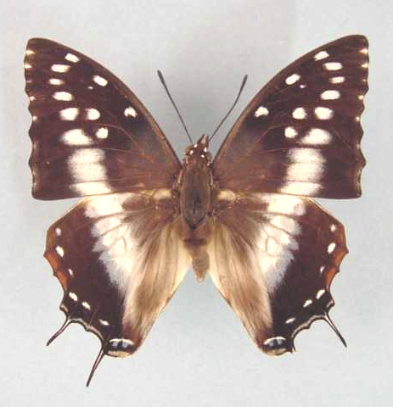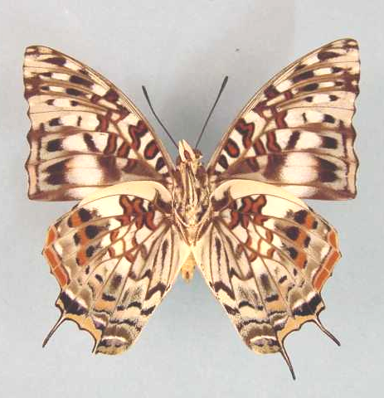

Charaxes penricei penricei. Male. Left – upperside; right – underside. Wingspan: 61mm. Paratype. Mumbwa, N. Rhodesia. 20.1.43. Wedekind. (Transvaal Museum - TM3414).

Type locality: Angola: “Quebe R., Angola”.
Diagnosis: Similar to C. etesipe but upperside median band further from the wing margins (Kielland, 1990).
Distribution: Congo, Angola, Democratic Republic of Congo, Zambia, Tanzania, Malawi, Zimbabwe.
Common name: Scarce savanna charaxes.
Habitat: Savanna, especially Brachystegia woodland. In Tanzania the nominate subspecies occurs at altitudes from 700 to 1 100 m and ssp. tanganyikae from 1 000 to 1 200 m (Kielland, 1990).
Habits: Both sexes feed from fermenting fruit (Pringle, et al., 1994). Specimens are also attracted to animal droppings (Kielland, 1990).
Flight period: October to April, but may fly all year in some localities (Pringle, et al., 1994).
Early stages:

Henning, G., 1977: 223 (ssp. penricei).
“Ova: Usual Charaxes shape, creamy-white when first laid, turning brownish and finally becoming uniform dark brown resembling a parasitized egg. The ova are laid on the underside of the leaves of the foodplant. Final instar larva: Headshield green with shortish horns; lateral facial margin pale green; dorso-medial spines green. Body deep olive with a brownish, longitudinal, oval or diamond-shaped mark on segment 6; in some specimens the dorsal mark is absent. Lateral ridge pale green, anal processes short and square. Pupa: A very beautiful pupa, emerald-green with broad creamy-yellow bands laterally and dorsally across the abdomen, and variable bands and patches across the wing-cases and dorsally on the thorax.”

Henning, S., 1989: 224 (ssp. penricei).

Larval food:
Entada spp. (Fabaceae) [Van Someren, 1974: 319 (ssp. penricei)].
Securidaca longepedunculata Fresen. (Polygalaceae) [Henning, G., 1977: 223 (ssp. penricei)].

Charaxes penricei penricei Rothschild, 1900

Charaxes penricei Rothschild, 1900 in Rothschild and Jordan, 1900. Novitates Zoologicae 7: 460 (287-524).

Charaxes penricei penricei. Male. Left – upperside; right – underside. Wingspan: 61mm. Paratype. Mumbwa, N. Rhodesia. 20.1.43. Wedekind. (Transvaal Museum - TM3414).

Type locality: Angola: “Quebe R., Angola”.
Distribution: Angola (east), Democratic Republic of Congo (Lomami, Lualaba), Zambia, Tanzania (south), Malawi, Zimbabwe (east).
Specific localities:
Tanzania – From Songea to Kitonga Gorge in Iringa District (Kielland, 1990).
Zambia – Ikelenge; Kasangezhi; Kabompo River; Mumbwa; Lusaka; Mufulira; Ndola; Kasama; Mbala (Heath, et al., 2002).
Zimbabwe – Rutenga (Pringle, et al., 1994); Bindura (Lannin); Dichwe, near Chinhoyi (Reed); Nyanga North; Mutare (R. Plowes).

peculiaris Lathy, 1906 (as sp. of Charaxes). Entomologist 39: 125 (125). Zambia: “Kavama, North-eastern Rhodesia”.

flavus Lathy, 1925 (as female ab. of Charaxes penricei). Encyclopédie Entomologique (B.3. Lepidoptera) 1: 95 (93-97). Malawi: “Chintiche, Nyassaland”.

paraperpullus White, 1978 (as ab. of Charaxes penricei penricei). Entomologist’s Record and Journal of Variation 90: 57 (57). Zimbabwe: “Christon Bank, Nr Salisbury”.

Charaxes penricei dealbata van Someren, 1966

Charaxes penricei dealbata van Someren, 1966. Bulletin of the British Museum (Natural History) (Entomology) 18: 66 (45-101).
Type locality: Angola: “Pungo Andongo”.
Distribution: Congo, Angola (north-west), Democratic Republic of Congo (west).

dealbata Joicey and Talbot, 1922 (as f. of Charaxes penricei). Bulletin of the Hill Museum, Witley 1: 338 (335-338). Angola: “Kibokolo do Zombo, Portuguese Congo, Pungo Ndongo, Angola”.

Charaxes penricei tanganyikae van Someren, 1966

Charaxes penricei tanganyikae van Someren, 1966. Bulletin of the British Museum (Natural History) (Entomology) 18: 67 (45-101).
Type locality: Tanzania: “Kigoma. East side of Lake Tanganyika”.
Diagnosis: The male differs from that of the nominate subspecies in the more greenish-blue of the upperside band (Kielland, 1990).
Distribution: Tanzania (west).
Specific localities:
Tanzania – Mpanda; Biharamulo; Geita; Mwanza (Kielland, 1990).

caerulescens van Someren, 1969 (as female f. of Charaxes penricei tanganyikae). Bulletin of the British Museum (Natural History) (Entomology) 23: 80 (75-166). Tanzania: “Kigoma district, Mihumo”.

Charaxes cacuthis Hewitson, 1863

Charaxes cacuthis Hewitson, 1863 in Hewitson, 1862-6. Illustrations of new species of exotic butterflies 3: 63 (124 pp.). London.
Type locality: Madagascar. Holotype (male) in the Muséum national d’Histoire naturelle, Paris.
Distribution: Madagascar (north, east, south-west).
Habitat: Lowland and coastal forest.
Early stages:

Henning, S., 1989: 225.

Larval food:
Annona senegalensis Pers. (Annonaceae) [Henning, S., 1989: 226 (in captivity)].

antanala Lucas, 1872 (as sp. of Charaxes). Annales des Sciences Naturelles (5) 15 (No. 22): 1 (4 pp.). Madagascar.

Charaxes paradoxa Lathy, 1925

Charaxes etesipe paradoxa Lathy, 1925. Encyclopédie Entomologique (B.3. Lepidoptera) 1: 94 (93-97).
Type locality: Comoro Islands: “Grande Comore”.
Distribution: Comoro Islands (Grand Comore).
Habitat: Forest.
Early stages: Nothing published.
Larval food:
Phyllanthus sp. (Euphorbiaceae) [Henning, 1989: 226].

Charaxes achaemenes Felder & Felder, 1867

Charaxes achaemenes Felder & Felder, 1867 in Felder & Felder, 1865-7. Reise der Österreichischen Fregatte Novara 446 (549 pp.). Wien.

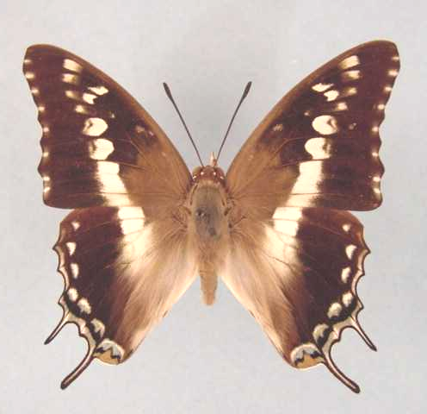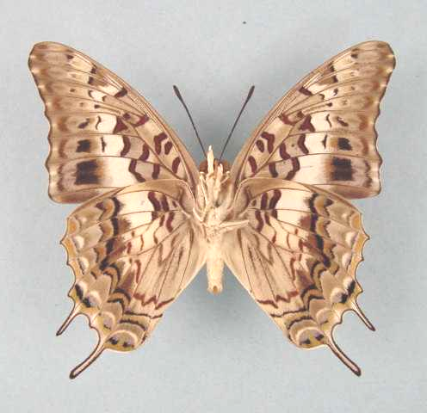

Charaxes achaemenes achaemenes. Male. Left – upperside; right – underside. Wingspan: 61mm. Amatongas, P. E. A. 8.6.59. H. Cookson. (Transvaal Museum - TM3422).

Type locality: South Africa: “Port Natal”; “Zambesi”.
Diagnosis: Female similar to both sexes of C. jasius and to the female of C. guderiana.
Distribution: Senegal, Gambia, Guinea, Ivory Coast, Ghana, Togo, Nigeria, Cameroon, Central African Republic, Sudan, Uganda, Ethiopia, Kenya, Tanzania, Democratic Republic of Congo, Angola, Malawi, Zambia, Mozambique, Zimbabwe, Botswana, Namibia, South Africa, Swaziland.
Common name: Bushveld charaxes; Bush charaxes.
Habitat: Savanna and deciduous woodland. In West Africa it occurs in Guinea and Sudan savanna and is unable to colonize degraded forest habitat (Larsen, 2005a). In Tanzania at altitudes up to 2 000 m (Kielland, 1990).
Habits: A common species of charaxes. Males regularly hilltop and both sexes are attracted by fermenting fruit (Pringle, et al., 1994). Males also regularly mud-puddle (Kielland, 1990). In West Africa males have been noted perching on top of acacia trees, from which they perform rapid, circling flights (Larsen, 2005a).
Flight period: All year.
Early stages:

Henning, G., 1977: 223 (ssp. achaemenes; Saltpan and Malta Forest, both Limpopo Province).
“Ova: Usual Charaxes shape, yellowish with a brown ring if fertile. They are laid singly on the upperside of the leaves of the foodplant. Final instar larva: Headshield green with pale green horns, usually tipped with pinkish-brown; the lateral horns may be completely pinkish-brown; the marginal facial line is yellowish with two pale green medial lines down the face; The dorso-medial spines are small and yellowish. The body is green with very variable dorsal markings. The usual form is the well marked one, but specimens have been found with no markings at all; the well marked form has on segment 6 two large silvery-white to pink patches with a medial small patch, all of which are edged with purplish-black; there are usually two or three smaller patches on segment 8 but seldom any on segment 10. The area between the patches on each segment is yellowish; there are two faint yellow lateral lines on each segment with two small yellow dorso-somitic spots. The anal processes are longish, tipped with purplish-black, and the lateral ridge is yellowish. Pupa: Green, marked with broad yellow bands laterally and dorsally across the abdomen and variable spots or patches dorsally on the thorax.”

Clark, in Van Son, 1979: 188 (Plate 73) (ssp. achaemenes).
“The eggs are laid generally on the upper side of a leaf. They are at first yellowish, changing to greenish-yellow with a reddish-brown circlet of varying width. They vary slightly in size, but average about 1,7 mm in diameter by 1,6 mm high and have 20-25 small ribs over part of the flattened crown and part way down the side. These are faintly cross-braced and have nine to twelve moles each. The egg hatches after seven days. The young larva is pale green with brown extremities and a brown-blotched head. It is 5 mm long at hatching and grows to 10 mm in 14 days. The illustrations show the development for each instar. The 2nd instar lasts 18 days and grows to 14 mm, the 3rd instar lasts 14 days, growing to 20 mm, the 4th to 28,5 mm in 17 days, and the final to 46 mm in 34 days. The above instar durations were recorded in May-August in Port Elizabeth, but are probably much shorter in the warmer regions. The pupa is suspended by cremastral hooks from the underside of a leaf or twig. The imago emerges after some 20 days.”

Henning, S., 1989: 230 (ssp. achaemenes).

Larval food:
Bauhinia species (Fabaceae) [Clark, in Van Son, 1979: 188].
Brachystegia appendiculata Benth. (Fabaceae) [Van Someren, 1974: 319].
Brachystegia oliveri Taub. (Fabaceae) [Van Someren, 1974: 319].
Brachystegia randii Bak. f. (Fabaceae) [Van Someren, 1974: 319].
Brachystegia spiciformis Benth. (Fabaceae) [Van Someren, 1974: 319].
Dalbergia boehmii Taub. (Fabaceae) [Henning, G., 1977: 223].
Dalbergia lactea Vatke (Fabaceae) [Pringle, et al., 1994: 94].
Dalbergia nitidula Welw. ex Bak. (Fabaceae) [Henning, S., 1989: 231].
Diospyros mespiliformis Hochst. ex DC. (Ebenaceae) [Joannou, in Pringle, et al., 1994: 94].
Piliostigma thonningii (Schumach.) Milne-Redh. (Fabaceae) [Duke, in Dickson and Kroon, 1978: 188].
Pterocarpus angolensis DC. (Fabaceae) [Henning, G., 1977: 223 (ssp. achaemenes)].
Pterocarpus erinaceus Poir (Fabaceae) [Blandin, et al., 1975 (Ivory Coast); Henning, S., 1989: 231].
Pterocarpus lucens Guill. and Perr. (Fabaceae) [Pringle, et al., 1994: 94].
Pterocarpus rotundifolius (Sond.) Druce (Fabaceae) [Gifford, 1965: 98].
Xanthocercis zambesiaca (Bak.) Dumaz-le-Grand (Fabaceae) [Henning, G., 1977: 223].

Charaxes achaemenes achaemenes Felder & Felder, 1867

Charaxes achaemenes Felder & Felder, 1867 in Felder and Felder, 1865-7. Reise der Österreichischen Fregatte Novara 446 (549 pp.). Wien.

Charaxes achaemenes achaemenes. Male. Left – upperside; right – underside. Wingspan: 61mm. Amatongas, P. E. A. 8.6.59. H. Cookson. (Transvaal Museum - TM3422).

Type locality: South Africa: “Port Natal”; “Zambesi”.
Distribution: Kenya (east), Tanzania, Democratic Republic of Congo (south-east), Angola (south-east), Malawi, Zambia, Mozambique, Zimbabwe, Botswana, Namibia, South Africa (Limpopo Province, Mpumalanga, North West Province, Gauteng, KwaZulu-Natal - north), Swaziland.
Specific localities:
Zambia – Kalene Hill; Lisombu; Matonchi; Kasangezhi; Mwinilunga; Chingola; Mufulira; Ndola; Chisamba; Lusaka; Chirundu; Kundalila Falls; Lumangwe Falls; Sumbu; Kapwesh Forest Reserve, Kawambwa (Heath, et al., 2002).
Zimbabwe – Mutare (Pinhey).
Botswana – Kabulabula; Chobe River (Pinhey).
Limpopo Province – Throughout bushveld areas (Swanepoel, 1953); Legalameetse Nature Reserve (“Malta Forest”).
Mpumalanga – Throughout bushveld areas (Swanepoel, 1953); Buffelskloof Nature Reserve (Williams).
North West Province – Throughout bushveld areas (Swanepoel, 1953).
KwaZulu-Natal – Durban (Swanepoel, 1953); Elandshoek (Swanepoel, 1953).
Swaziland – Usutu (Swanepoel, 1953); Mlawula N. R. (www.sntc.org.sz).

fasciatus Suffert, 1904 (as ssp. of Charaxes achaemenes). Deutsche Entomologische Zeitschrift, Iris 17: 123 (108-123). Tanzania: “Mhonda”.

glaucomaculata Cordeiro, 1990 (as ab. of Charaxes achaemenes achaemenes). Journal of the East African Natural History Society and National Museum 80 No. 196: 33 (25-41). Tanzania: “Ndala Research Camp, Lake Manyara National Park, Arusha Region, 960m, 9.ix.1987, N. J. Cordeiro.” Specimen deposited in the BM, London.

Charaxes achaemenes atlantica van Someren, 1970

Charaxes achaemenes atlantica van Someren, 1970. Bulletin of the British Museum (Natural History) (Entomology) 25: 211 (197-250).
Type locality: Senegal.
Distribution: Senegal, Gambia, Guinea, Ivory Coast, Ghana, Togo.
Specific localities:
Sierra Leone – Freetown (Owen & Chanter, 1972).
Ghana – Atewa Range (Joly, 2003).

Charaxes achaemenes monticola van Someren, 1970

Charaxes achaemenes monticola van Someren, 1970. Bulletin of the British Museum (Natural History) (Entomology) 25: 209 (197-250).
Type locality: Sudan: “S. Sudan (Maia)”; Nigeria: “N. Nigeria, high plateau”.
Distribution: Nigeria (north), Cameroon (north), Central African Republic, Uganda, Democratic Republic of Congo (Ituri), Ethiopia (west), Sudan, Kenya (west of Rift Valley).
Specific localities:
Nigeria – Vom (Owen, 1977); Kaduna (R. St Leger teste Larsen, 2005a).

monticola Joicey and Talbot, 1925 (as female form of Charaxes achaemenes). Annals and Magazine of Natural History (9) 16: 645 (633-653). Sudan: “S. Sudan (Maia)”; Nigeria: “N. Nigeria, high plateau”.

jocaste Butler, 1869 (as sp. of Charaxes). Transactions of the Entomological Society of London 1869: 274 (273-276). No locality given. [Rejected as an unavailable name - see Opinion 922, 1970.]

minor Storace, 1948 (as ab. of Charaxes achaemenes). Annali del Museo Civico di Storia Naturale (di Genova) Giacomo Doria 63: 135 (132-141). Ethiopia: “Scioa, Abissinia”.

erythraea Storace, 1948 (as f. of Charaxes achaemenes). Annali del Museo Civico di Storia Naturale (di Genova) Giacomo Doria 63: 136 (132-141). Ethiopia: “Dorfù (Eritraea, presso Asmara)”.

JAHLUSA GROUP

Charaxes jahlusa (Trimen, 1862)

Nymphalis jahlusa Trimen, 1862. Rhopalocera Africae Australis Part 1. Papilionidae, Pieridae, Danaidae, Acraeidae, and Nymphalidae 177 (190 pp.). Cape Town.
Type locality: South Africa: “Interior of South Africa”.
Distribution: Sudan, Ethiopia, Somalia, Uganda, Rwanda, Kenya, Angola, Democratic Republic of Congo, Tanzania, Malawi, Zambia, Mozambique, Zimbabwe, Botswana, South Africa, Swaziland (Duke, et al., 1999).
Common name: Pearl-spotted charaxes.
Habitat: Savanna. In Tanzania it does not seem to be found in savanna habitats, being found instead in forest, on forest margins and in dry evergreen forest (Kielland, 1990). In Tanzania ssp. argynnides is found from sea-level to 1 200 m; ssp. kenyensis from sea-level to 1 500m, and ssp. kigomaensis from 800 to 1 500 m (Kielland, 1990).
Habits: Males of the nominate subspecies select specific trees around which they fly vigorously. Males of ssp. rex are avid hilltoppers (Pringle, et al., 1994).
Flight period: All year (ssp. rex; ssp. argynnides). The nominate subspecies flies from October to March (Pringle, et al., 1994).
Early stages:

Taylor & Cresswell, 1940: 179 (ssp. jahlusa) (J. Ent. Soc. Sth. Afr. 3).

Henning, G., 1977: 222 (ssp. rex; Saltpan (Limpopo Province) and Rashoop (North West).

Henning, S., 1978: 213 (ssp. rex) (Ent. Rec. J. Var. 90: 211).
“Egg: Oval, about 1 mm in diameter, with a fluted depression on the top. It is green when first laid and develops a brown ring within 48 hours if fertile. Takes 6-14 days to hatch. Eggs are laid singly on the upper surface of the leaves of the foodplant. At eclosion the larva eats the entire egg shell. 1st instar larva: At eclosion the larva is about 3,5 mm long. Body dull olive-green, without markings, anal processes long and brown. Headshield blackish-brown, diameter 0,9 mm; dorsal horns 0,5 mm long, lateral horns 0,2 mm. Length attained is about 5,5 mm. Duration of instar normally one to two weeks. 2nd instar larva: Body green, finely spotted with cream. It has fine creamy-yellow oblique lateral lines running from the head to the penultimate segment. Each segment, except the last, has two small creamy yellow dorsal spots. Anal processes are long and pointed and are reddish-brown. Headshield diameter 1,5-1,7 mm, pale brown becoming slightly green in the ventral half in some specimens. Faint black line around lower margin and ventral side of lateral horns which are 0,4 mm long. Dorsal horns are 1,0 mm long. Length attained is about 8,5 mm. Duration of instar is normally two to three weeks. 3rd instar larva: Body green, markings as in the second instar, but if the larva is going to develop a yellow somite bar on the sixth segment, the first signs will now be apparent. Anal processes are yellowish-white. Headshield, diameter about 2,3 mm, green, rimmed around lower margin and ventral side of lateral horns with yellow. Horns have a varying amount of brown on them and are straighter than those of previous instars. The dorsal horns are approximately 1,2 mm long, while the lateral horns are about 0,6 mm. Length attained by the larva is 12 mm. Duration of instar normally two to three weeks. 4th instar larva: Body colouring and markings as in the third instar but some specimens have a well developed yellow somite bar. Headshield also similar, although generally the horns appear to have less brown on them. Diameter of headshield is about 3,3 mm, dorsal horns 2 mm, lateral horns 1 mm. Length attained by the larva approximately 20 mm. Duration of instar normally two to three weeks. 5th instar larva: Body short and stocky, green with fine creamy-yellow oblique lateral lines and two dorso-somitic yellowish-white spots running from the head to the penultimate segment. The body usually has a thin yellowish dorsal somite bar on the sixth segment. Lateral ridge yellow and anal processes short and square. The headshield is green, marginally bordered with yellowish-green and the diameter is about 4,9 mm; horns short, the dorsal horns being only 2 mm long while the lateral horns are 1,0 mm, usually tipped with reddish-brown. Length attained by the larva about 34 mm. Duration of instar normally two to three weeks. Pupa: Pale geeen with creamy-white lines in a leaf-like pattern and fine creamy-white striations. It is more rounded than the usual Charaxes pupa. The spiracles are creamy-yellow. Length of pupa is usually about 17,5 mm. The pupal stage lasts about three weeks.”

Clark, in Van Son, 1979 (Plate 72) (ssp. jahlusa; Uitenhage, Eastern Cape).
“The eggs are laid singly on the surface of a leaf. They are 1,4 mm in diameter by 1,1 mm high, with some 30-36 faint troughs radiating from the micropyle. White when laid, they turn to a creamy colour and develop a brownish patch on the micropyle and a thin circlet near the top. They hatch after nine to ten days. The young larva is 3,5 mm long on hatching and grows to 6 mm in eight days before moulting. The second instar lasts seven days and the larva grows to 8 mm. It grows to 12-13,5 mm in seven days in the third instar, and to 18,5-20 mm in nine days in the fourth instar. The final instar lasts 15 days and the final length of the larva is 30-31 mm. The larva rests on a silken mat spun on a leaf and crawls away to feed on the edge of a leaf, but returns to its mat to rest. When ready to pupate, a suitable site is chosen such as the underside of a leaf or a twig, and as a precaution in the former case, the leaf stalk is sewn solidly on to the twig it is on; a mat is spun, and the larva fastens its anal claspers in this and hangs down, but doubles its head up later almost to the anal claspers till pupation. The pupa is 17 mm long and is suspended by cremastral hooks fastened in the silken mat. The pupal stage lasts 14 days.”

Henning, S., 1989: 237 (ssp. rex; ssp. kenyensis).

Larval food:
(Suspected to be) Pappea capensis Eckl. and Zeyh. (Sapindaceae) [Mrs Barber, in Trimen & Bowker, 1889: 407 (ssp. jahlusa)].
Pappea capensis Eckl. and Zeyh. (Sapindaceae) [Taylor and Cresswell, 1946: 45 (ssp. jahlusa); Henning, G., 1977: 222 (ssp. rex); Henning, S., 1989: 238 (ssp. argynnides)].
Acacia species (Fabaceae) [Van Someren, 1974: 319 (ssp. argynnides)].
Dalbergia melanoxylon Guill. and Perr. (Fabaceae) [Henning, G., 1977: 222 (ssp. argynnides); Kenya].
Lecaniodiscus fraxinifolius Bak. (Sapindaceae) [Paré, in Pringle, et al., 1994: 93 (ssp. argynnides)].
Haplocoelum foliosum (Hiern) Bullock (Sapindaceae) [Henning, S., 1989: 238 (ssp. kenyensis and ssp. argynnides)].
Grewia species (Tiliaceae) [Kielland, 1990: 104].
Note: Clark, in Van Son, 1979: 180 gives Pappea fulva Conrath as a food-plant for C. j. jahlusa. This is a junior synonym of Pappea capensis].

Charaxes jahlusa jahlusa (Trimen, 1862)

Nymphalis jahlusa Trimen, 1862. Rhopalocera Africae Australis Part 1. Papilionidae, Pieridae, Danaidae, Acraeidae, and Nymphalidae 177 (190 pp.). Cape Town.
Type locality: South Africa: “Interior of South Africa”. Holotype (male) in the Natural History Museum, London.
Distribution: South Africa (Eastern Cape Province, Western Cape Province).
Eastern Cape Province – Hankey (Swanepoel, 1953); Uitenhage (Swanepoel, 1953); Alicedale (Swanepoel, 1953); Grahamstown (Swanepoel, 1953); Commadagga (Swanepoel, 1953); Hamburg (Swanepoel, 1953); Somerset East (Swanepoel, 1953); Graaff-Reinet (Swanepoel, 1953); Queenstown (Swanepoel, 1953); Butterworth (Swanepoel, 1953); East London (Swanepoel, 1953); Bashee River (Swanepoel, 1953); Umtata (Swanepoel, 1953).
Western Cape Province – Ladismith (Swanepoel, 1953); Calitzdorp (Swanepoel, 1953); Oudsthoorn (Swanepoel, 1953); Montagu (Clark; requires confirmation).

Charaxes jahlusa argynnides Westwood, 1864

Charaxes argynnides Westwood, 1864. Proceedings of the Entomological Society of London 1864: 10 (10).

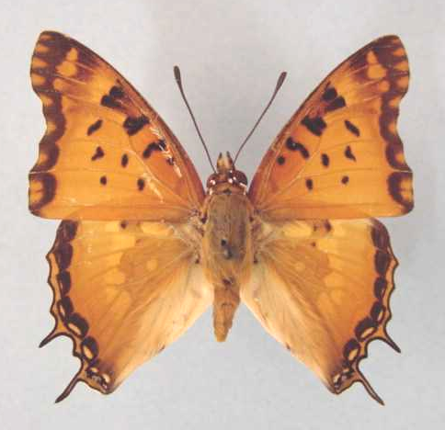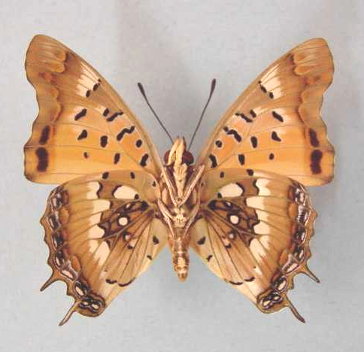

Charaxes jahlusa argynnides. Male. Left – upperside; right – underside. Wingspan: 44mm. 10 m. turn off, Melsetter, S. Rhodesia. 26.2.59. H. Cookson. (Transvaal Museum - TM3444).

Type locality: “Zambesi, Africae”.
Diagnosis: Subspecies argynnides is characterized by the much reduced silvery markings on the underside and by its brown ground colour (Pringle, et al., 1994).
Distribution: Angola (south), Democratic Republic of Congo (Lomami, Lualaba, Shaba, Tanganika), Tanzania (south), Malawi, Zambia, Mozambique, Zimbabwe (north and east), Botswana (north), South Africa (KwaZulu-Natal), Swaziland (Duke, et al., 1999).
Specific localities:
Tanzania – Coastal areas to Dendene Forest and Pugu Hills; Mikumi National Park; Kimboza Forest; Nguru Mountains (Kielland, 1990).
Zambia – Kamapanda; Chingola; Mufulira; Kitwe; Ndola; Mumbwa; Chisamba; Lusaka; Kafue; Chirundu; Katondwe; Samfya; Nkambo Lodge (Heath, et al., 2002).
KwaZulu-Natal – Ixopo (Swanepoel, 1953); Durban (Swanepoel, 1953); Empangeni (Swanepoel, 1953); Hluhluwe (Swanepoel, 1953); Estcourt (Swanepoel, 1953).

Charaxes jahlusa ganalensis Carpenter, 1937

Charaxes jahlusa ganalensis Carpenter, 1937. Proceedings of the Royal Entomological Society of London (B) 6: 64 (64).
Type locality: Ethiopia: “Salakle, Ganale river”.
Distribution: Sudan (south), Ethiopia (south-west), Uganda (north), Kenya (west).

Charaxes jahlusa kenyensis Joicey & Talbot, 1925

Charaxes jahlusa kenyensis Joicey & Talbot, 1925. Annals and Magazine of Natural History (9) 16: 646 (633-653).
Type locality: Kenya: “Mombasa; Teita”.
Diagnosis: Compared to ssp. argynnides the submarginal band in the male is paler, with more prominent submarginal lunules (Kielland, 1990).
Distribution: Kenya (east and north-east), Tanzania (north-east).
Specimens from north-west Kenya and eastern Uganda are transitional to ssp. ganalensis Carpenter (Ackery, et al., 1995: 447).
Specific localities:
Tanzania – Ukerewe Island in Lake Victoria; Pare Mountains; Usamabara Mountains; Pemba Island (Kielland, 1990).

pallene van Someren, 1974 (as f. of Charaxes jahlusa kenyensis). Bulletin of the British Museum (Natural History) (Entomology) 29: 421 (415-487). Kenya: “Kibwezi (Kibezi)”.

Charaxes jahlusa kigomaensis van Someren, 1975

Charaxes jahlusa kigomaensis van Someren, 1975. Bulletin of the British Museum (Natural History) (Entomology) 32: 108 (65-136).
Type locality: Tanzania: “Kigoma, Mukuyu”. Holotype (male) in the Natural History Museum, London.
Diagnosis: A large subspecies. In females the wing border is usually heavy and dark (Kielland, 1990).
Distribution: Tanzania (north-west - eastern shores of Lake Tanganyika).
Specific localities:
Tanzania – Ntakatta Forest; Kasye Forest (common); Gombe Stream National Park (Kielland, 1990).

kigoma van Someren, 1974 (as ssp. of Charaxes jahlusa). Bulletin of the British Museum (Natural History) (Entomology) 29: 423 (415-487). Tanzania: “Kigoma, Mukuyu”. [Invalid; junior primary homonym of Charaxes smaragdalis kigoma van Someren, 1964 [Charaxinae].]

Charaxes jahlusa mafiae Turlin & Lequeux, 1992

Charaxes jahlusa mafiae Turlin & Lequeux, 1992. Lambillionea 92 (4): 314 (311-321).
Type locality: Tanzania: “Morora forest, île Mafia, Tanzania 1-1991.” In M.N.H.N., Paris.
Diagnosis: Male differs from other subspecies, on forewing upperside, in the solid black colouring of the apical area (Congdon and Collins, 1998).
Distribution: Tanzania (Mafia Island).
Specific localities:
Tanzania – Mrora Forest (Congdon & Collins, 1998).

Charaxes jahlusa rex Henning, 1978

Charaxes jahlusa rex Henning, 1978. Entomologist’s Record and Journal of Variation 90: 211 (211-215).
Type locality: South Africa: “Saltpan, Vivo, Transvaal”. Holotype (male) in the Transvaal Mueum, Pretoria, South Africa.
Diagnosis: Subspecies rex is characterized by the less well developed black markings on the upperside of the wings and the absence of the silvery subapical costal mark on the forewing upperside. In addition, the basal area of the hindwing underside is darker than in the nominate subspecies and more orange than in ssp. argynnides (Pringle, et al., 1994).
Distribution: Zimbabwe (south), Botswana (south-east), South Africa (Limpopo Province, Mpumalanga, North West Province, Gauteng).
Specific localities:
Limpopo Province – Throughout bushveld areas (Swanepoel, 1953).
Mpumalanga – Throughout bushveld areas (Swanepoel, 1953); Buffelskloof Nature Reserve (Williams).
North West Province – Throughout bushveld areas (Swanepoel, 1953); Kgaswane Mountain Reserve (Williams).
Gauteng – Throughout bushveld areas (Swanepoel, 1953); Witwatersrand Botanical Gardens (J. Dobson, unpublished checklist, 2001); Buffelsdrif Conservancy (Williams).

Charaxes jahlusa rwandensis Plantrou, 1976

Charaxes jahlusa rwandensis Plantrou, 1976. Bulletin de la Société des Lépidoptèristes Français 1: 61 (60-63).
Type locality: Rwanda: “Karama Bugesera”. Holotype (male) in the Muséum, national d’Histoire naturelle de Paris.
Distribution: Rwanda (west), Tanzania (north-west).
Specific localities:
Tanzania – Kitengule Ranch, Ngara District; Rubondo Island (Congdon and Collins, 1998). The population on Rubondo Island appears to be intermediate between ssp. kigomaensis and ssp. kenyensis, and is presently unnamed (Congdon and Collins, 1998).

EUPALE GROUP

Charaxes eupale (Drury, 1782)

Papilio eupale Drury, 1782. Illustrations of Natural History 3: index et 7 (76 pp.). London.
Type locality: Sierra Leone: “Sierra Leon”.
Dignosis: Similar to C. dilutus but apical green patch darker and hind wing with a dark green margin (Kielland, 1990).
Distribution: Senegal, Guinea, Sierra Leone, Liberia, Ivory Coast, Ghana, Togo, Nigeria, Cameroon, Gabon Congo, Central African Republic, Angola, Zambia, Democratic Republic of Congo, Uganda, Sudan, Rwanda, Kenya, Tanzania, Malawi.
Common name: Common green charaxes.
Habitat: Lowland evergreen forest, tolerating a fair degree of degradation (Larsen, 2005a).
Habits: The most common forest charaxes (Larsen, 2005a). Males are sometimes encountered patrolling, with extreme rapidity, up and down forest paths, over distances of about 100 metres (Larsen, 2005a). Larsen (2005a) believes that this may be a mate-locating behaviour.
Flight period: There may be some degree of seasonality (Larsen, 2005a).
Early stages:

Van Someren and Rogers, 1929: 210 (ssp. latimargo).

Henning, S., 1989: 240.

Larval food:
Scutia myrtina (Burm.) f. Kurz (Rhamnaceae) [Van Someren, 1974: 321].
Albizia gummifera (J.F. Gmel.) C.A. Smith (Fabaceae) [Van Someren, 1974: 321].
Albizia zygia (DC.) Macbride (Fabaceae) [Van Someren, 1974: 321].
Albizia adianthifolia (Schumach) W.F. Wight (Fabaceae) [Vuattoux and Blandin, 1977; Ivory Coast; Henning, S., 1989: 240].
Cathormion species (Fabaceae) [Larsen, 2005a].
Note: Congdon & Bampton (unpublished 2003) suggest that eupale and dilutus may be conspecific but do not make any formal taxonomic changes.

Charaxes eupale eupale (Drury, 1782)

Papilio eupale Drury, 1782. Illustrations of Natural History 3: index et 7 (76 pp.). London.
Type locality: Sierra Leone: “Sierra Leon”.
Distribution: Senegal, Guinea, Sierra Leone, Liberia, Ivory Coast, Ghana, Togo, Nigeria (south and Cross River loop).
Specific localities:
Senegal – Basse Casamance (Larsen, 2005a).
Sierra Leone – Freetown (Owen & Chanter, 1972).
Liberia – Freetown (Larsen, 2005a).
Ivory Coast – Bossematie (H. Fermon teste Larsen, 2005a).
Ghana – Atewa Range (Joly, 2003).
Nigeria – Warri (H. Boersma teste Larsen, 2005a).

amasia Fabricius, 1793 (as sp. of Papilio). Entomologia Systematica emendata et aucta 3 (1): 136 (488 pp.). “Surunami”. [False locality.]

Charaxes eupale latimargo Joicey & Talbot, 1921

Charaxes eupale latimargo Joicey & Talbot, 1921. Bulletin of the Hill Museum, Witley 1: 74 (40-166).
Type locality: Democratic Republic of Congo: “North bank of Ituri River, half-way between Avakubi and Penghe”.
Distribution: Nigeria (extreme south-east), Cameroon, Gabon, Congo, Central African Republic, Angola (north), Democratic Republic of Congo, Sudan (south), Uganda, Rwanda, Kenya (west), Tanzania (north-west).
Specific localities:
Nigeria – Kagoro Forest (St Leger, 1984).
Cameroon – Korup (Larsen, 2005a).
Kenya – Nairobi (Larsen, 2005a).
Tanzania – Bukoba; Ngara (Kielland, 1990); Rumanyika Game Reserve (common); Kere Hill, Minziro Forest (rare); Loliondo; Rubondo Island in Lake Victoria (common) (Congdon and Collins, 1998).

schultzei Röber, 1936 (as sp. of Charaxes). Entomologische Rundschau 53: 575 (575-580). Cameroon: “Süd-Kamerun (Lolodorf”; Democratic Republic of Congo: “Belg. Kongo (Kikwit)”.

citrinella Rousseau-Decelle, 1938 (as f. indiv. of Charaxes eupale). Bulletin de la Société Entomologique de France 43: 165 (161-168). Democratic Republic of Congo: “Kassai, (Congo belge)”.

inornata Storace, 1948 (as f. of Charaxes eupale). Annali del Museo Civico di Storia Naturale (di Genova) Giacomo Doria 63: 141 (132-141). Uganda: “Entebbe”.

Charaxes eupale veneris White & Grant, 1989

Charaxes dilutus veneris White & Grant, 1989. Lambillionea 89: 35 (35-39).
Charaxes eupale veneris White & Grant, 1989. Heath et al., 2002: vii, 76 comb. nov.

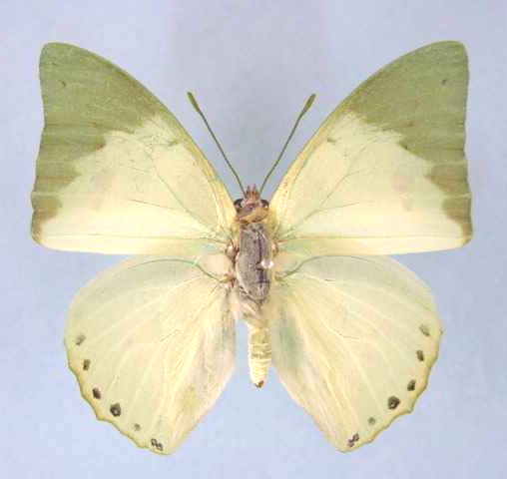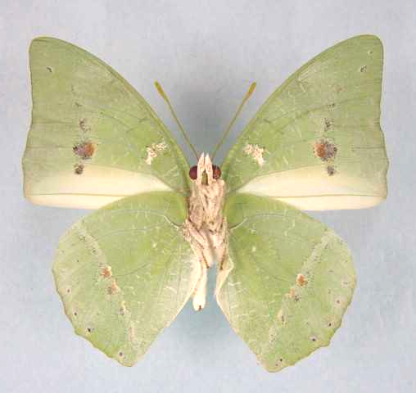

Charaxes eupale veneris. Male. Left – upperside; right – underside. Wingspan: 48mm. 18 km W. of Solwezi, Zambia. 13.X.2000. A.J. Gardiner. (Gardiner Collection).

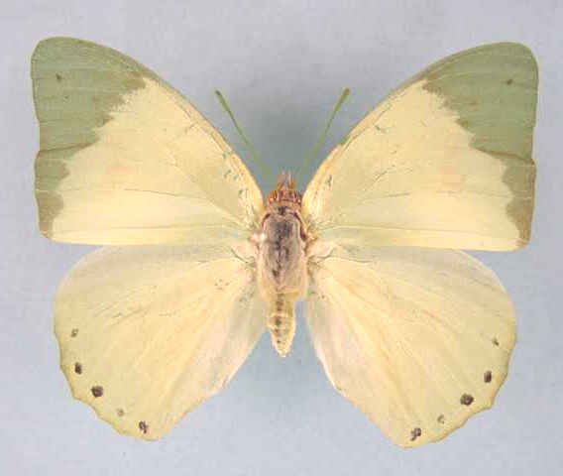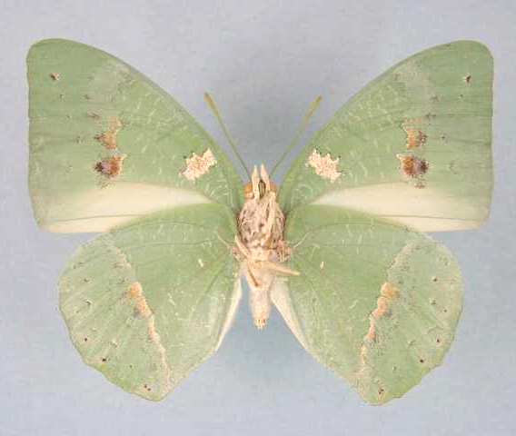

Charaxes eupale veneris. Female. Left – upperside; right – underside. Wingspan: 62mm. Zambia, Copperbelt Prov., Mufulira, 220 Kombe Ave. 1250 m. 1.VII.1978. M.A. Newport. (Newport Collection).

Type locality: Malawi: “Nyamkhowa Mountain, Nyika plateau, 1500 m”.
Distribution: Malawi (north of the Shire River), Tanzania, Zambia (north).
Specific localities:
Zambia – Lisombu; Ikelenge; Kasangezhi; Mwinilunga; Chingola; Mufulira; Ndola; Nchelenge; Lumangwe Falls; Lunzua Falls; Mbala; Kalambo Falls (Heath, et al., 2002).
Note: Congdon & Bampton (unpublished 2003) do not believe that Zambian material is referable to eupale.

Charaxes subornatus Schultze, 1916

Charaxes subornatus Schultze, 1916. Archiv für Biontologie 4: 123 (83-129).
Type locality: Cameroon: “Barombi Station (Kamerun); Babungo (Kameruner Grashochland)”; Togo: “Bismarkburg und Misahöhe (Togo)”.
Distribution: Ivory Coast, Ghana, Togo, Nigeria, Cameroon, Central African Republic, Congo, Gabon, Democratic Republic of Congo, Uganda, Kenya.
Common name: Ornate green charaxes.
Habitat: Evergreen forest.
Habits: In West Africa it is generally scarcer than C. eupale but, at times, may be numerous (Larsen, 2005a).
Early stages: Nothing published.
Larval food:
Albizi brownei Oliv. (Fabaceae) [Van Someren, 1974: 321].
Albizia gummifera (J.F. Gmel.) C.A. Smith (Fabaceae) [Van Someren, 1974: 321; requires confirmation according to Larsen, 2005a].
Albizia zygia (DC.) J.F. Macbride (Fabaceae) [Henning, S., 1989: 242; requires confirmation according to Larsen, 2005a].

Charaxes subornatus subornatus Schultze, 1916

Charaxes subornatus Schultze, 1916. Archiv für Biontologie 4: 123 (83-129).
Type locality: Cameroon: “Barombi Station (Kamerun); Babungo (Kameruner Grashochland)”; Togo: “Bismarkburg und Misahöhe (Togo)”.
Distribution: Nigeria (east), Cameroon, Gabon, Congo, Central African Republic, Democratic Republic of Congo (north and west).
Specific localities:
Nigeria – Kagoro Forest (Larsen, 2005a).

Charaxes subornatus couilloudi Plantrou, 1976

Charaxes subornatus couilloudi Plantrou, 1976. Bulletin de la Société Entomologique de France 81: 126 (126-132).
Type locality: Ivory Coast: “Bouaké, Côte d’Ivoire”. Holotype (male) in the Muséum national d’Histoire naturelle de Paris.
Distribution: Ivory Coast, Ghana, Togo, Nigeria (west ).
Specific localities:
Ivory Coast – Bouake (TL); Tai National Park (Larsen, 2005a).
Ghana – Atewa Range (Joly, 2003).

Charaxes subornatus minor Joicey & Talbot, 1921

Charaxes subornatus minor Joicey & Talbot, 1921. Bulletin of the Hill Museum, Witley 1: 74 (40-166).
Type locality: Uganda: “Mabira Forest”.
Distribution: Democratic Republic of Congo (Kivu, Ituri), Uganda, Kenya (north-west).

Charaxes dilutus Rothschild, 1898

Charaxes eupalus [sic] dilutus Rothschild, 1898. Novitates Zoologicae 5: 97 (96-102).
Type locality: Malawi: “Zomba, Nyassaland”.
Distribution: Sudan, Uganda, Kenya, Tanzania, Malawi, Democratic Republic of Congo, Zambia (Collins in Kielland, 1990: 338), Angola.
West African records for this species are in error (Larsen, 2005a).
Habitat: Evergreen forest. In Tanzania the nominate ssp. is found at altitudes from 300 to 2 100 m, sometimes in woodland some distance from the nearest forest (Kielland, 1990). Subspecies amanica is found only in the eastern Usambara Mountains at 1 000 to 1 300 m (Collins in Kielland, 1990).
Habits: Apparently not particularly attracted to fermenting bananas but males often seen flying along stream beds in search of otter or bird droppings (Kielland, 1990).
Early stages:

Henning, S., 1989: 244 (ssp. dilutus).

Larval food:
Albizia gummifera (J.F. Gmel.) C.A. Smith (Fabaceae) [Van Someren, 1974: 321].
Albizia adianthifolia (Schumach) W.F. Wight (Fabaceae) [Henning, S., 1989: 244].
Scutia species (Rhamnaceae) [Kielland, 1990: 100].

Charaxes dilutus dilutus Rothschild, 1898

Charaxes eupalus [sic] dilutus Rothschild, 1898. Novitates Zoologicae 5: 97 (96-102).
Type locality: Malawi: “Zomba, Nyassaland”.
Distribution: Malawi (south of the Shire River), Zambia (Collins in Kielland, 1990: 338), Angola (east), Democratic Republic of Congo (Lualaba, Lomami), Tanzania (south and west).
Specific localities:
Tanzania – Mpanda; Kigoma; Tukuyu; Mbeya; Chimala; Rondo Plateau; Kitesa Forest; Njombe; Mufindi; Uzungwa Range; Ukaguru Mountains; Nguru Mountains; Kanga Mountains; Uluguru Mountains; Nguu Mountains (Kielland, 1990).

Charaxes dilutus amanica Collins, 1990

Charaxes dilutus amanica Collins, 1990 in Kielland, 1990. Butterflies of Tanzania 338 (363 pp.). Melbourne.
Type locality: Tanzania: “Amani E. Usambara Mtns, July 1976, S. Collins”. Holotype in the Natural History Museum, London.
Original description:
“Holotype Male. Forewing length 27 mm, same general size and shape as others of the group. The most characteristic feature on the recto surface is that the discal dark green apex and subapical area has a very abrupt turn up to costa. The distance of the dark green area extends 12 mm from the apex along the costa whereas, with all other dilutus the dark green curves to the costa and the distance is some 15 mm. Also showing through from the underside in the dark green apex are 2 submarginal dark spots. The winding submargin has black dots between the last median vein and the 1st cubital vein and two small dots on the anal angle. Allotype Female. Forewing length 32 mm. Characters as in male.”
Distribution: Tanzania (north-east).
Specific localities:
Tanzania – Amani in the eastern Usamabara Mountains (TL) (Henning, 1989).

Charaxes dilutus kasitu White & Grant, 1989

Charaxes dilutus kasitu White & Grant, 1989. Lambillionea 89: 37 (35-39).
Type locality: Malawi: “Swamp forest near Kasitu rock. Dzelanyama range. 1250 m”.
Distribution: Malawi (west-central - Dzelanyama Range).

Charaxes dilutus ngonga van Someren, 1974

Charaxes dilutus ngonga van Someren, 1974. Bulletin of the British Museum (Natural History) (Entomology) 29: 442 (415-487).
Type locality: Kenya: “Ngong”. Holotype (male) in the Natural History Museum, London.
Distribution: Kenya (central), Uganda (south-west - Kigezi), Sudan.
Note: Collins (in Kielland, 1990: 338) states that breeding results have shown that C. dilutus ngonga is actually a synonym of C. eupale latimargo but does not officially revise its status.

miotoni van Someren, 1975 (as [unnecessary] replacement name for Charaxes dilutus ngonga van Someren). Bulletin of the British Museum (Natural History) (Entomology) 32: 109 (65-136).

Charaxes montis Jackson, 1956

Charaxes dilutus montis Jackson, 1956. Journal of the East Africa Natural History Society 23: 67 (63-102).
Type locality: Uganda: “Kigezi District, Mafuga Forest”.
Distribution: Democratic Republic of Congo (Kivu), Uganda (south-west), Rwanda, Burundi (Roger White, pers. comm., 2003).
Habitat: Montane forest.
Early stages:

Henning, S., 1989: 245.

Larval food:
Albizia gummifera (J.F. Gmel.) C.A. Smith (Fabaceae) [Henning, S., 1989: 246].

ETHEOCLES GROUP

ANTICLEA SUBGROUP

Charaxes anticlea (Drury, 1782)

Papilio anticlea Drury, 1782. Illustrations of Natural History 3: index et 36 (76 pp.). London.
Type locality: Sierra Leone.
Distribution: Senegal, Guinea-Bissau, Guinea, Sierra Leone, Liberia, Ivory Coast, Ghana, Togo, Nigeria, Cameroon, Gabon, Congo, Central African Republic, Angola, Democratic Republic of Congo, Uganda, Kenya, Tanzania, Zambia.
Common name: Small flame-bordered charaxes.
Habitat: Forest, including dry forests, somewhat degraded forest and dense riverine vegetation. Occasionally penetrates savanna (Larsen, 2005a). In Tanzania ssp. adusta occurs in lowland and submontane forest at altitudes from 800 to 1 500 m (Kielland, 1990).
Habits: A reasonably common butterfly with a less powerful flight than most of its congenerics (Larsen, 2005a). Both sexes avidly visit both fermenting fruit and ‘sucking-trees’ (Larsen, 2005a). Males feed from both excrement and rotting carcasses (Larsen, 2005a).
Early stages:

Van Someren and Van Someren, 1926: 348 (ssp. adusta).

Larval food:
Acacia poetzi Haum. (Fabaceae) [Van Someren, 1974: 320].
Acacia pennata Willd. (Fabaceae) [Van Someren, 1974: 320].
Mezoneuron benthamianum Baill. (Fabaceae) [Blandin, et al., 1975 (Ivory Coast)].
Acacia goetzei Harms. (Fabaceae) [Henning, S., 1989: 250].
Acacia brevispica Harms. (Fabaceae) [Henning, S., 1989: 250].
Mezoneuron welwitschianum (Fabaceae) [Heath, et al., 2002: 77].
Mezoneuron angolense (Fabaceae) [Heath, et al., 2002: 77].
Note: Populations in the Labe area of the Fouta Djalon in Guinea may be subspecifically distinct (Larsen, 2005a).

Charaxes anticlea anticlea (Drury, 1782)

Papilio anticlea Drury, 1782. Illustrations of Natural History 3: index et 36 (76 pp.). London.
Type locality: Sierra Leone.
Distribution: Senegal, Guinea-Bissau, Guinea, Sierra Leone, Liberia, Ivory Coast, Ghana, Togo, Nigeria (to Enugu in the east).
Specific localities:
Senegal – Basse Casamance(Larsen, 2005a).
Guinea – Labe area in the Fouta Djalon (Larsen, 2005a; may be subspecifically distinct).
Sierra Leone – Freetown (Owen & Chanter, 1972).
Ivory Coast – Bossematie (H. Fermon teste Larsen, 2005a).
Ghana – Atewa Range (Joly, 2003).
Nigeria – Enugu (Larsen, 2005a).
Note: The populations in the Labe area of Guinea may be subspecifically distinct (Larsen, 2005a).

horatius Fabricius, 1793 (as sp. of Papilio). Entomologia Systematica emendata et aucta 3 (1): 64 (488 pp.). No locality given. [?Sierra Leone.]

Charaxes anticlea adusta Rothschild, 1900

Charaxes anticlea adusta Rothschild, 1900 in Rothschild & Jordan, 1900. Novitates Zoologicae 7: 494 (287-524).
Type locality: Uganda: “Kampala”. Holotype (male) in the Tring Museum.
Distribution: Democratic Republic of Congo (Kivu, Ituri), Uganda, Tanzania (west).
Specific localities:
Tanzania – Kigoma District and bordering areas of Mpanda (Kielland, 1990).

horatianus Stoneham, 1936 (as f. of Charaxes anticlea). Bulletin of the Stoneham Museum (29): [3] ([3 pp.]). Uganda: “Katera on the Uganda-Tanganyika border”.

Charaxes anticlea mwera Vingerhoedt & Bouyer, 1996

Charaxes anticlea mwera Vingerhoedt & Bouyer, 1996. Entomologia Africana 1: 10.
Type locality: Democratic Republic of Congo: Shaba, Kibomboma, Luina River and Mwera.
Distribution: Democratic Republic of Congo (Shaba).

Charaxes anticlea proadusta van Someren, 1971

Charaxes anticlea proadusta van Someren, 1971. Bulletin of the British Museum (Natural History) (Entomology) 26: 211 (181-226).

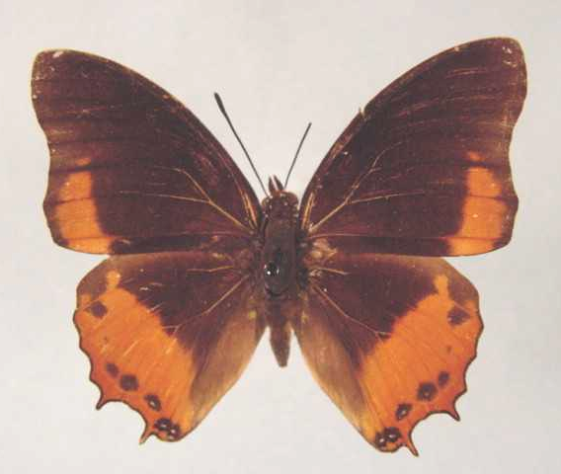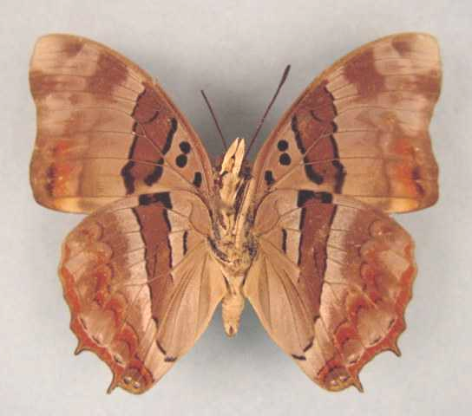

Charaxes anticlea proadusta. Male. Left – upperside; right – underside. Wingspan: 50mm. Bangui, R.C.A., R. Keiser. (Henning collection - H264).

Type locality: Central African Republic: “Bangui”. Holotype (male) in the Natural History Museum, London.
Distribution: Nigeria (Cross River area), Cameroon, Gabon, Congo, Central African Republic (west), Angola (north), Democratic Republic of Congo (west, central, south), Zambia.
Specific localities:
Central African Republic – Bangui (TL).
Zambia – Ikelenge; Luakela River (Heath, et al., 2002: 77).

Charaxes anticlea suna van Someren, 1975

Charaxes anticlea suna van Someren, 1975. Bulletin of the British Museum (Natural History) (Entomology) 32: 108 (65-136).
Type locality: Kenya: “Chepalungu”. Holotype (male) in the Natural History Museum, London.
Distribution: Kenya (south-west).

reducta van Someren, 1971 (as ssp. of Charaxes anticlea). Bulletin of the British Museum (Natural History) (Entomology) 26: 214 (181-226). Kenya: “Chepalunga”. [Invalid; junior primary homonym of Charaxes xiphares reducta Rothschild, 1929 in Eltringham, et al., 1929 [Charaxinae].]

Charaxes baumanni Rogenhofer, 1891

Charaxes baumanni Rogenhofer, 1891. Verhandlungen der Zoologisch-Botanischen Gesellschaft in Wien 42: 564 (571-575).
Type locality: Tanzania: “Pare, montes”.
Distribution: Sudan, Kenya, Democratic Republic of Congo, Uganda, Rwanda, Tanzania, Zambia, Malawi, Mozambique, Zimbabwe.
Common name: Little charaxes.
Habitat: Open forest and woodland. In Tanzania the nominate subspecies occurs at altitudes from 1 400 to 2 100 m; ssp. tenuis from 1 400 to 2 000 m; ssp. whytei from 1 200 to 2 000 m; ssp. granti from near sea-level to 2 000 m (Kielland, 1990).
Habits: Specimens are attracted to fermenting fruit and also feed from animal scats (Congdon and Collins, 1998). Males defend territories from the higher branches of trees on the edges of clearings. The flight is rather slow and gliding when they are patrolling their territory.
Flight period: All year. Subspecies selousi is commoner in spring and in April and May (Pringle, et al., 1994).
Early stages:

Van Someren and Rogers, 1931: 23 (ssp. tenuis).
“The eggs are small and white, 0,75 mm and are laid on the upper or underside of the leaflets. As development proceeds, a brown ring appears just below the somewhat flattened crown and extending to the upper surface, obliterates the slightly fluted marks which decorate this area. The larva emerges in ten days and makes its first meal of the egg-shell; having eaten this it selects a couple of contiguous leaves and covers an area with silk, always retiring to this spot between meals of the young leaves in the vicinity of its “roost”. The larva is at first yellowish with a blackish head and brown tail. At the second moult the colour changes to bright green, a distinct whitish body line appears, and the head is now green with a yellowish marginal line. The dorsal marks on segment 6 and 8 take the form of horse-shoes, are yellowish in colour, and raised above the rest of the surface of the segments. These marks are whitish anteriorly. The underside of the body is pale greenish. The head is remarkable for the length of the horns in proportion to the facial disc. The face is oval in outline, and carries on its upper third four horns and four spines. The latter are crimson or red, while the terminal half of the horns which are slender and straight, is orange-red shading to yellowish at the base. The yellow of the lateral horns is continued round the margin of the facial disc as a border which in turn is accentuated distally by black. The mouth parts are yellow. The pupa is small, and in shape typical of the group. It is pale apple-green in colour, slightly darker on the thorax, somewhat keeled on the marginal aspects of the head, while each abdominal segment is ornamented with three rows of yellowish spots. The imago emerges in ten days, if the weather is warm and humid, but in longer time if cold.”

Clark, in Van Son, 1979 (Plate 74) (ssp. selousi).
“Mr Clark, who has been breeding the species from eggs, but did not complete the plate, stated that the eggs lacked the red or brown stripe common in other South African Charaxes. This statement does not agree with the description given by van Someren and Rogers, and probably indictaes that this character is not stable.”

Henning, S., 1989: 255 (ssp. selousi).

Bampton, in Pringle, et al., 1994: 94 (ssp. whytei).

Larval food:
Acacia brevispica Harms. (syn. pennata Willd.) (Fabaceae) [Van Someren and Rogers, 1931: 23 (ssp. tenuis)].
Acacia species near goetzei Harms. (Fabaceae) [Van Someren and Rogers, 1931: 23 (ssp. tenuis)].
Pterolobium stellatum (Forssk.) Brenan (syn. lacerans R. Br.) (Fabaceae) [Van Someren and Rogers, 1931: 23 (ssp. tenuis); Pringle et al., 1994: 95 (ssp. selousi)].
Acacia seyal Delil (Fabaceae) [Van Someren, 1974: 320 (ssp. tenuis)].
Acacia brevispica Harms. (Fabaceae) [Dickson and Kroon, 1978: 63 (ssp. selousi)].
Caesalpinia decapetala (Roth.) Alston (Fabaceae) (exotic) [Dickson and Kroon, 1978: 63 (ssp. selousi)].

Charaxes baumanni baumanni Rogenhofer, 1891

Charaxes baumanni Rogenhofer, 1891. Verhandlungen der Zoologisch-Botanischen Gesellschaft in Wien 42: 564 (571-575).
Type locality: Tanzania: “Pare, montes”. Holotype (female) in the Vienna Museum, Austria.
Diagnosis: Populations of the nominate subspecies from the Ngurus and Rubehos are intermediate to ssp. granti (Kielland, 1990).
Distribution: Tanzania (north-east), Kenya (south-east).
Specific localities:
Tanzania – North and South Pare Mountains; Lossoganeu Mountain; Nguru Mountains; Rubeho Mountains; Nguu Mountains (Kielland, 1990).

Charaxes baumanni bamptoni van Someren, 1974

Charaxes baumanni bamptoni van Someren, 1974. Bulletin of the British Museum (Natural History) (Entomology) 29: 482 (415-487).
Type locality: Kenya: “Northern Frontier Districts, Mt Kulal”. Holotype (male) in the Natural History Museum, London.
Distribution: Kenya (north - Mt Kulal).

Charaxes baumanni bwamba van Someren, 1971

Charaxes baumanni bwamba van Someren, 1971. Bulletin of the British Museum (Natural History) (Entomology) 26: 221 (181-226).
Type locality: Uganda: “Bwamba Valley”. Holotype (male) in the Natural History Museum, London.
Distribution: Uganda (Bwamba Valley), Democratic Republic of Congo (Kivu).

Charaxes baumanni didingensis van Someren, 1971

Charaxes baumanni didingensis van Someren, 1971. Bulletin of the British Museum (Natural History) (Entomology) 26: 221 (181-226).
Type locality: Sudan: “Didinga Mts”. Holotype (male) in the Hope Department, University Museum, Oxford.
Distribution: Sudan (south - Didinga Mountains), Uganda (north), Kenya (north).

Charaxes baumanni granti Turlin, 1989

Charaxes baumanni granti Turlin, 1989. In: Henning, 1989. The Charaxinae butterflies of Africa 250 (457 pp.). Johannesburg.
Type locality: Tanzania: “Pugu Hills, 100 m”. Holotype (male) in the Muséum national d’Histoire naturelle de Paris.
Diagnosis: Differs from ssp. tenuis and ssp. baumanni in the much wider white band in the female, and the more extended blue area on the hindwing of the male (Kielland, 1990).
Distribution: Tanzania (east).
Specific localities:
Tanzania – Pugu Hills near Dar es Salaam (TL); Uluguru Mountains; Uzungwa Range; Masagati Forest south of Ifakara; Usambara Mountains (Kielland, 1990).
Note: A population in the Usambaras is larger and has longer tails than ssp. granti, and may deserve subspecific status (Kielland, 1990: 96).

Charaxes baumanni interposita van Someren, 1971

Charaxes baumanni interposita van Someren, 1971. Bulletin of the British Museum (Natural History) (Entomology) 26: 220 (181-226).
Type locality: Kenya: “Kitale”.
Distribution: Kenya (west), Uganda (east and central), Tanzania (extreme north-west).
Specific localities:
Tanzania – Rumanyika Game Reserve in Karangwe District (Congdon and Collins, 1998).

Charaxes baumanni nyiro Collins & Larsen, 1991

Charaxes baumanni nyiro Collins & Larsen, 1991 in Larsen, 1991. In: The butterflies of Kenya and their natural history 296, 441 (490 pp.). Oxford.
Type locality: Kenya: “Mount Nyiro”.
Distribution: Kenya (north - Mt Nyiro).

Charaxes baumanni selousi Trimen, 1894

Charaxes selousi Trimen, 1894. Proceedings of the Zoological Society of London 1894: 45 (14-82).

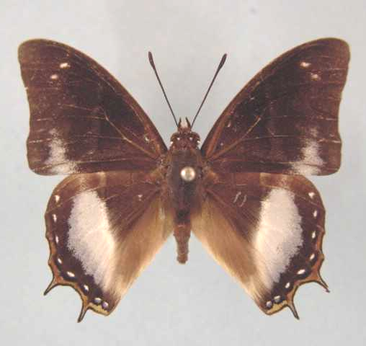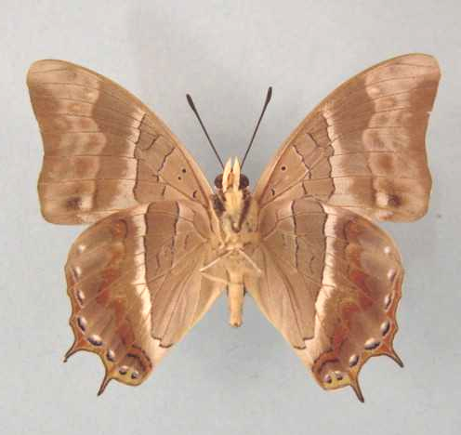

Charaxes baumanni selousi. Male. Left – upperside; right – underside. Wingspan: 45mm. Laurenceville, Vumba, S.R. 8:10:63. D.M. Cookson. (Transvaal Museum - TM3426).

Type locality: Zimbabwe: “Mineni Valley”. Holotype (male) in the South African Museum, Cape Town.
Diagnosis: See ssp. whytei.
Distribution: Zimbabwe (south and east), Zambia (central).
Specific localities:
Zambia – Mpongwe; Mumbwa; Lusaka; Kafue (Heath, et al., 2002).
Zimbabwe – Mineni Valley (Selous; TL); Meikle’s Jungle, Mutare; Rusape; Mazowe (Pringle, et al., 1994); Lomagundi; Bindura; Harare; Matobo Hills (Pinhey); Gweru (White).

Charaxes baumanni tenuis van Someren, 1971

Charaxes baumanni tenuis van Someren, 1971. Bulletin of the British Museum (Natural History) (Entomology) 26: 219 (181-226).
Type locality: Tanzania: “West Kilimanjaro”. Holotype (male) in the Natural History Museum, London.
Diagnosis: Compared to the nominate subspecies the hindwing blue band in the male is narrower; forewing blue spots more distinct; female with narrower white bands (Kielland, 1990). The population from Lolkisale is intermediate to the nominate subspecies (Kielland, 1990).
Distribution: Tanzania (north), Kenya (highlands east of Rift Valley).
Specific localities:
Tanzania – Oldeani-Ngorongoro Range; Mount Meru; Mount Kilimanjaro; Longido; Mbulu Forests; Mount Kwaraha; Lolkisale (Kielland, 1990).

Charaxes baumanni whytei Butler, 1894

Charaxes whytei Butler, 1894. Proceedings of the Zoological Society of London 1893: 649 (643-684).
Type locality: Malawi: “Zomba”. Holotype (male) in the Natural History Museum, London.
Diagnosis: Similar to ssp. selousi but the male in whytei is blue spotted, while the male of selousi is white spotted, to a greater or lesser degree. Females of selousi have larger forewing subapical spots and have slightly greyer undersides (White (1976), cited by Pringle, et al., 1994).
Distribution: Democratic Republic of Congo (Bouyer, 2005), Tanzania (south and west), Zambia (north and east), Malawi, Mozambique.
Specific localities:
Tanzania – Mbuzi Mountain; Chala; Wanzizi in Mpanda; Kampisa in Mpanda; Kigoma; Southern Highlands; Rondo Plateau near Lindi (Kielland, 1990).
Zambia – Kalambo Falls (J. Little) (Heath, et al., 2002).
Mozambique – Dondo Forest; Amatongas; Buzi Valley, below Espungabera; Maronga (Pringle, et al., 1994); Burma Valley (Paré).

Charaxes opinatus Heron, 1909

Charaxes opinatus Heron, 1909. Transactions of the Zoological Society of London 19: 156 (141-178).
Type locality: Uganda: “Mubuku Valley, E. Ruwenzori”. Holotype (male) in the Natural History Museum, London.
Distribution: Uganda (west), Rwanda, Burundi, Democratic Republic of Congo (Kivu).
Habitat: Montane forest.
Early stages:

Henning, S.F., 1989: 256.

Vingerhoedt and Thiry, 1996a [Burundi].

Larval food:
Caesalpinia sp. (Fabaceae) [Henning, S., 1989: 256].

xanthia Turlin, 1998 (as f. of Charaxes opinatus). Lambillionea 98 (2) (Tome I): 189 (181-189). Burundi: “forêt de Teza, 2000m”.

Charaxes thysi Capronnier, 1889

Charaxes thysi Capronnier, 1889. Bulletin de la Société Entomologique de Belgique 1889: 125 (118-127).
Type locality: Democratic Republic of Congo: “Congo”. Holotype (male) in the Institut Royal des Sciences Naturelles de Belgique, Brussels.
Distribution: Cameroon, Gabon, Congo (Kelle), Democratic Republic of Congo (Tshopo, Tshuapa, Equateur, Lulua, Sankuru, Maniema).
Habitat: Forest.
Early stages: Nothing published.
Larval food: Nothing published.
References:
Vingerhoedt, 2006.

Charaxes taverniersi Berger, 1975

Charaxes taverniersi Berger, 1975. Lambillionea 75: 92 (92-95).
Type locality: Democratic Republic of Congo: “Kisangani, km 9 de la route de Mambasa”. Holotype (male) in the Musée royal de l’Afrique Centrale, Tervuren, Bruxelles. Female first described by Bouyer, Prouvost & Collins in 1997 (Entomologia Africana 2 (2): 7).
Distribution: Cameroon (central), Gabon (R. White, pers. comm., 2003); Democratic Republic of Congo.
Specific localities:
Democratic Republic of Congo – Kisangani (TL); Mbandaka (R. White, pers. comm., 2003).
Habitat: Forest.
Early stages: Nothing published.
Larval food: Nothing published.
References:
Vingerhoedt, 2006.

evoei Darge, 1977 (as ssp. of Charaxes taverniersi). Bulletin de l’Institut Fondamental d’Afrique Noire (A) 38: 673 (673-676). Cameroon: “massif du Mont-Kala, 900/1150 m, 20 km W de Yaoundé”. [Given as a subspecies of Charaxes taverniersi Berger by Ackery et al., 1995: 673 but regarded as a synonym of Charaxes taverniersi by Bouyer, Prouvost & Collins, 1997. (Entomologia Africana 2 (2): 6).]

Charaxes hildebrandti (Dewitz, 1879)

Nymphalis hildebrandti Dewitz, 1879. Nova Acta Academiae Caesarea Leopoldino-Carolinae Germanicum Naturae Curiosorum 4 (2): 200 (173-212).
Type locality: Angola: “10° S.B. und zwischendem 17-22° O.C von Greenw.”.
Distribution: Sierra Leone, Ivory Coast, Ghana, Nigeria, Cameroon, Gabon, Congo, Angola, Central African Republic, Democratic Republic of Congo, Uganda, Zambia.
Common name: Hildebrandt’s charaxes.
Habitat: Lowland evergreen forest in good condition (Larsen, 2005a).
Habits: A rare and local species (Larsen, 2005a).
Early stages: Nothing published.
Larval food:
Dyboscia species (Tiliaceae) [Schultze, 1916].

Charaxes hildebrandti hildebrandti (Dewitz, 1879)

Nymphalis hildebrandti Dewitz, 1879. Nova Acta Academiae Caesarea Leopoldino-Carolinae Germanicum Naturae Curiosorum 4 (2): 200 (173-212).
Type locality: Angola: “10° S.B. und zwischendem 17-22° O.C von Greenw.”.
Distribution: Nigeria (Cross River loop), Cameroon, Gabon, Congo, Angola (north), Central African Republic, Democratic Republic of Congo (north and central), Uganda (west).

galba Distant, 1879 (as sp. of Charaxes). Proceedings of the Zoological Society of London 1879: 709 (703-709).

talagugae Holland, 1886 (as sp. of Charaxes). Transactions of the American Entomological Society 13: 331 (325-332). Gabon: “Ogové River, W. Africa”.

michelae Plantrou, 1980 (as female f. of Charaxes hidebrandti hildebrandti). Bulletin de la Société Entomologique de France 85: 174 (173-175). Central African Republic: “Bangui (R.C.A.)”.

Charaxes hildebrandti gillesi Plantrou, 1973

Charaxes hildebrandti gillesi Plantrou, 1973. Bulletin de la Société Entomologique de France 78: 274 (268-276).
Type locality: Ivory Coast: “Côte d’Ivoire, Abidjan, forêt du Banco”. Holotype (male) in the Muséum national d’Histoire naturelle de Paris.
Distribution: Sierra Leone, Ivory Coast, Ghana, Nigeria (west).
Specific localities:
Ivory Coast – Banco Forest (TL).
Ghana – Atewa Range (Joly, 2003); Krokosua (Larsen, 2005a).
Nigeria – Sapoba in the Niger Delta (H. Boersma teste Larsen, 2005a); Okomu Nature Reserve (Larsen, 2005a).

Charaxes hildebrandti katangensis Talbot, 1928

Charaxes hildebrandti katangensis Talbot, 1928. Bulletin of the Hill Museum, Witley 2: 229 (229-231).

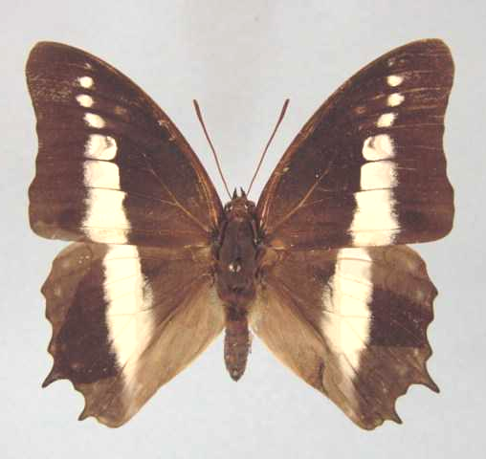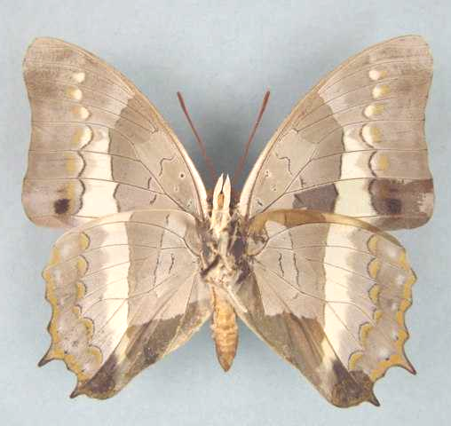

Charaxes hildebrandti katangensis. Male. Left – upperside; right – underside. Wingspan: 51mm. Zilo, Shaba, Zaire. Nov 74. Dr V. Allard. (Henning collection - H265).

Type locality: Democratic Republic of Congo: “Katanga: Kinda”.
Distribution: Democratic Republic of Congo (east and south), Zambia (north-west), Uganda (west -Bwamba Valley).
Specific localities:
Zambia – Kamapanda; Ikelenge (Heath, et al., 2002).

Charaxes blanda Rothschild, 1897

Charaxes blanda Rothschild, 1897. Novitates Zoologicae 4: 507 (507-513).
Type locality: Tanzania: “Mikindani, German East Africa”. Holotype (male) in the Natural History Museum, London. Known only from the male holotype.
Distribution: Kenya, Tanzania.
Habitat: Coastal forest.
Early stages: Nothing published.
Larval food:
Dalbergia species (Fabaceae) [Van Someren, 1970; ssp. kenyae].
Brachystegia spiciformis Benth. (Fabaceae) [Van Someren, 1970; ssp. kenyae].

Charaxes blanda blanda Rothschild, 1897

Charaxes blanda Rothschild, 1897. Novitates Zoologicae 4: 507 (507-513).
Type locality: Tanzania: “Mikindani, German East Africa”. Holotype (male) in the Natural History Museum, London. Known only from the male holotype.
Distribution: Tanzania (south-east).
Specific localities:
Tanzania – Mikindani (TL) (Kielland, 1990).

Charaxes blanda kenyae Poulton, 1926

Charaxes blanda kenyae Poulton, 1926. Internationaler Entomologen-Kongress 2: 551 (518-575).
Type locality: Kenya: “Sokoke Forest at the coast of Kenya Colony, between Takaungu and Malindi, N. of Mombasa”.
Distribution: Kenya (coast north of Mombasa).

ETHEOCLES SUBGROUP

Charaxes virilis van Someren & Jackson, 1952

Charaxes virilis van Someren & Jackson, 1952. Transactions of the Royal Entomological Society of London 103: 283 (257-284).
Type locality: “W. Afr.”. Holotype (male) in the Natural History Museum, London.
Distribution: Guinea, Sierra Leone, Burkina Faso, Ivory Coast, Ghana, Nigeria, Cameroon, Congo, Central African Republic, Democratic Republic of Congo, Uganda.
Common name: Blue demon charaxes.
Habitat: Lowland evergreen forest and forest/savanna mosaic (Larsen, 2005a).
Habits: A widespread but uncommon butterfly (Larsen, 2005a).
Early stages:

Vauttoux and Blandin, 1977 [(Ivory Coast)].

Larval food:
Adenanthera pavonina Linn. (Fabaceae) [Van Someren, 1974: 321].
Griffonia simplicifolia (Vahl ex DC.) Baill. (Fabaceae) [Blandin, et al., 1975 (Ivory Coast); Henning, S., 1989: 276].
Cathormium species (Fabaceae) [Larsen, 2005a].
Dalbergia species (Fabaceae) [Larsen, 2005a].
Entada species (Fabaceae) [Larsen, 2005a].
Tetrapleura species (Fabaceae) [Larsen, 2005a].

Charaxes virilis virilis van Someren & Jackson, 1952

Charaxes virilis van Someren & Jackson, 1952. Transactions of the Royal Entomological Society of London 103: 283 (257-284).
Type locality: “W. Afr.”. Holotype (male) in the Natural History Museum, London.
Distribution: Guinea, Sierra Leone, Burkina Faso (south). Ivory Coast, Ghana, Nigeria (south and Cross River loop), Cameroon, Congo, Central African Republic, Democratic Republic of Congo (central Democratic Republic of Congo to Semliki River and upper Shaba).
Specific localities:
Guinea – Nimba Mountains (Larsen, 2005a).
Ivory Coast – Bossematie (H. Fermon teste Larsen, 2005a).
Ghana – Kyabobo National Park (Larsen, 2005a).
Nigeria – Warri (H. Boersma teste Larsen, 2005a).

virilis Rothschild, 1900 in Rothschild and Jordan, 1900 (as female f. of Charaxes etheocles). Novitates Zoologicae 7: 487 (287-524). “W. Afr.”.

blandini Minig, 1976 (as female f. of Charaxes virilis). Ref.?

blandini Henning, 1989 (as female f. of Charaxes virilis). The Charaxinae butterflies of Africa 275 (457 pp.). Johannesburg. Central African Republic: [“République Centrafricaine, Colline de Bangui”].

Charaxes virilis lenis Henning, 1989

Charaxes virilis lenis Henning, 1989. The Charaxinae butterflies of Africa 257 (457 pp.). Johannesburg.
Type locality: Uganda: “Budongo Forest”. Holotype (male) in the Natural History Museum, London.
Distribution: Uganda.
Specific localities:
Uganda – Budongo Forest (TL); Mabira Forest (Jordan, 1929).

lenis Jordan, 1929: 483 (as male f. of Charaxes etheocles). [Get ref. - not in Ackery et al., 1995] Uganda: “Mulange, Mabira Forest”.

Charaxes chevroti Collins & Larsen, 2005

Charaxes chevroti Collins & Larsen, 2005. In Larsen, 2005a. Butterflies of West Africa: 550.

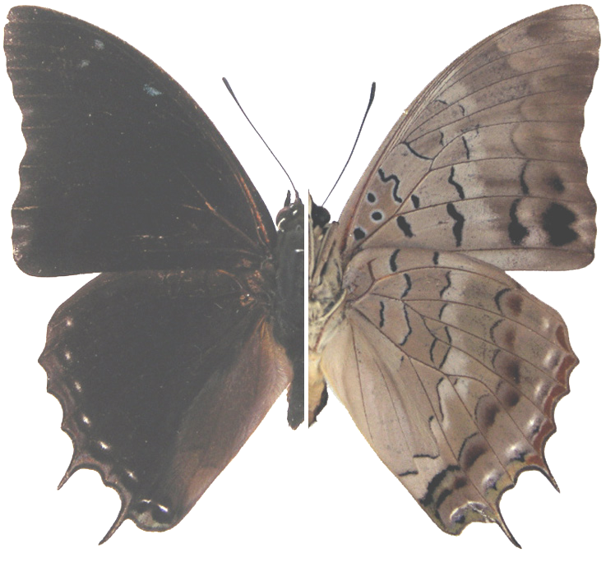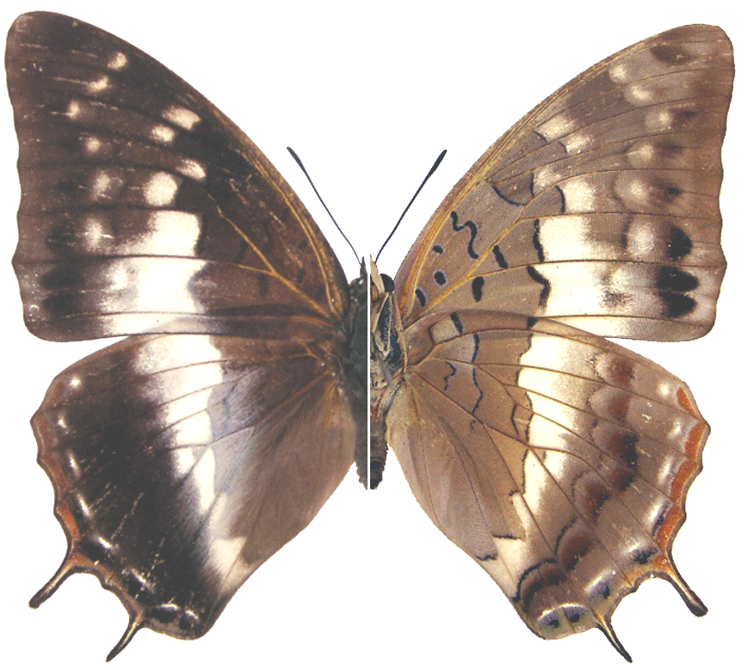

Charaxes chevroti. Left – male (holotype) composite, Nigeria. Right – female (paratype) composite, Nigeria. Photos ex Torben Larsen.

Type locality: Nigeria: “Kafanchan, Kagoro Forest”. Holotype (male) July 1983 (leg. et coll. African Butterfly Research Institute, Nairobi). Paratypes: 25 males and 6 females same locality, various years, some captured by J.H. Boersma and J.-C. Chevrot (coll. African Butterfly Research Institute, Nairobi).
Diagnosis: Male usually slightly larger than C. etheocles Cramer, 1777 and shape of forewing slightly squatter. No metallic sheen on upperside (c.f. C. virilis, C. cedreatus and C. etheocles).
General remarks: Kagoro Forest, the type locality, is an isolated northern relict forest at the base of the Jos Plateau (Collins & Larsen, in Larsen, 2005a). C. chevroti is almost certainly endemic to the Kagoro Forest but, unfortunately, this forest appears to be undergoing anthropogenic destruction (Collins & Larsen, in Larsen, 2005a). Named for Jean-Claude Chevrot who collected extensively in the Kagoro Forest around 1980 (Collins & Larsen, in Larsen, 2005a).
Distribution: Nigeria (north-central).
Specific localities:
Nigeria – Kagoro Forest, Kafanchan (TL). Known only from the type locality (Larsen, 2005a).
Common name: Kagoro demon charaxes.
Habitat: Forest (Collins & Larsen, in Larsen, 2005a).
Habits: Nothing published.
Early stages: Nothing published.
Larval food: Nothing published.

Charaxes catachrous van Someren & Jackson, 1952

Charaxes catachrous van Someren & Jackson, 1952. Transactions of the Royal Entomological Society of London 103: 278 (257-284).

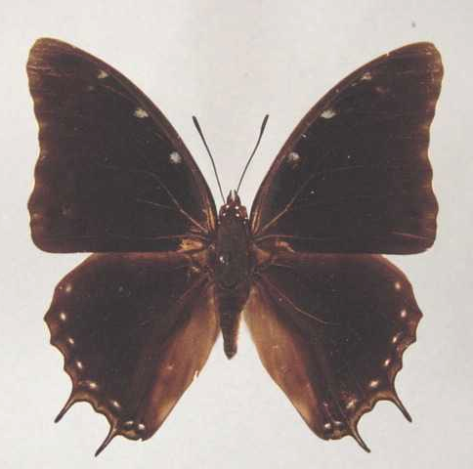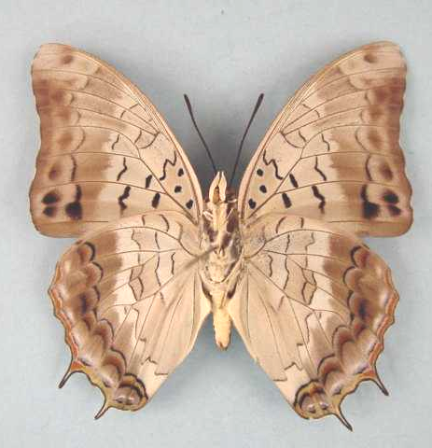

Charaxes catachrous. Male. Left – upperside; right – underside. Wingspan: 56mm. Bangui, RCA. Dec 1969. (Henning collection - H266).

Type locality: Cameroon: “Cameroons”.
Diagnosis: Very similar to C. grahamei on the underside, but a smaller insect (Kielland, 1990).
Distribution: Nigeria (south and Cross River loop), Cameroon, Congo, Central African Republic, Democratic Republic of Congo, Uganda, Tanzania (north-west), Zambia.
Records from west of Nigeria are in error for C. petersi (Larsen, 2005a).
Specific localities:
Nigeria – Okomu Nature Reserve (Larsen, 2005a).
Cameroon – Korup (Larsen, 2005a).
Tanzania – Bukoba Region; Mihumu, south of Kigoma (Kielland, 1990).
Zambia – Lake Kashiba near Mpongwe (Heath, et al., 2002).
Common name: Silvery demon charaxes.
Habitat: Wet riverine or swamp forest (Heath, et al., 2002).
Habits: Apparently much rarer than C. etheocles; in West Africa it is commonest in the Cross River loop (Larsen, 2005a).
Early stages:

Henning, S., 1989: 277 (ex Bampton, from Lake Kashiba, Zambia).

Larval food:
Scutia myrtina (Burm. f.) Kurz (Rhamnaceae) [Henning, S., 1989: 277].

catochrous Staudinger, 1896 (as ab. of Charaxes ephyra). Deutsche Entomologische Zeitschrift, Iris 9: 218 (193-240). Cameroon: “Barombi-Station”.

biinclinata van Someren, 1969 (as ssp. of Charaxes etheocles). Bulletin of the British Museum (Natural History) (Entomology) 23: 102 (75-166). Congo: “Moyen Congo”. [Treated by Henning, S. (1989: 278) as a subspecies of Charaxes etheocles (Cramer, 1777) but according to Larsen (2005a: 320) it was synonymized with catachrous by Van Someren].

Charaxes etheocles (Cramer, 1777)

Papilio etheocles Cramer, 1777. Die Uitlandsche Kapellen voorkomende in de drie waereld-deelen Asia, Africa en America 2: 34 (151 pp.). Amsteldam & Utrecht.
Type locality: “Côte de Guinée, près de Sierra Leona”.
Distribution: Senegal, Guinea, Sierra Leone, Liberia, Ivory Coast, Ghana, Togo, Nigeria, Cameroon, Gabon, Central African Republic, Congo, Angola, Democratic Republic of Congo, Sudan, Ethiopia, Uganda, Kenya, Tanzania, Zambia.
Common name: Demon charaxes.
Habitat: Evergreen forest, also penetrating drier forest and degraded forest (Larsen, 2005a). In Tanzania it is found in forest and riverine vegetation from 1 100 m and above (Kielland, 1990).
Habits: This is the commonest black charaxes of forest in West Africa (Larsen, 2005a). Although often taken in fruit-baited traps it is rarely seen otherwise (Larsen, 2005a). Males are occasionaly seen defending territories from perches high up; their patrol flights are made at great speed (Larsen, 2005a).
Early stages:

Proceedings of the Ent. Soc. Lond. 1918: p. lxxxiii

Van Someren and Van Someren, 1926: 349 (ssp. carpenteri).

Henning, S., 1989: 282 (ssp. evansi).

Larval food:
Scutia myrtina (Burm. f.) Kurz (Rhamnaceae) [Van Someren, 1974: 320].
Celtis durandii Eng. (Ulmaceae) [Van Someren, 1974: 320].
Griffonia simplicifolia Bent. (Fabaceae) [Blandin, et al., 1975 (Ivory Coast); Henning, S., 1989: 282; as Bandeiraea simplicifolia].
Albizia gummifera (J.F. Gmel.) C.A. Smith (Fabaceae) [Henning, S., 1989: 282].
Celtis gomphophylla (Ulmaceae) [Heath, et al., 2002: 77].
Bandeiraea species (Fabaceae) [Larsen, 2005a].
Cathormion species (Fabaceae) [Larsen, 2005a].
Dalbergia species (Fabaceae) [Larsen, 2005a].
Entada species (Fabaceae) [Larsen, 2005a].

Charaxes etheocles etheocles (Cramer, 1777)

Papilio etheocles Cramer, 1777. Die Uitlandsche Kapellen voorkomende in de drie waereld-deelen Asia, Africa en America 2: 34 (151 pp.). Amsteldam & Utrecht.
Type locality: “Côte de Guinée, près de Sierra Leona”.
Distribution: Senegal, Guinea, Sierra Leone, Liberia, Ivory Coast, Ghana, Togo, Nigeria (west and east).
Specific localities:
Senegal – Basse Casamance (Larsen, 2005a; possibly C. plantroui).
Sierra Leone – Freetown (Owen & Chanter, 1972).
Ivory Coast – Bossematie (H. Fermon teste Larsen, 2005a).
Nigeria – Warri (H. Boersma teste Larsen, 2005a); Kaduna (R. St Leger teste Larsen, 2005a).

hollandi Butler, 1893 (as sp. of Charaxes). Annals and Magazine of Natural History (6) 12: 266 (266). Sierra Leone.

Charaxes etheocles carpenteri van Someren & Jackson, 1957

Charaxes etheocles carpenteri van Someren & Jackson, 1957. Annals of the Transvaal Museum 23: 82 (41-58).

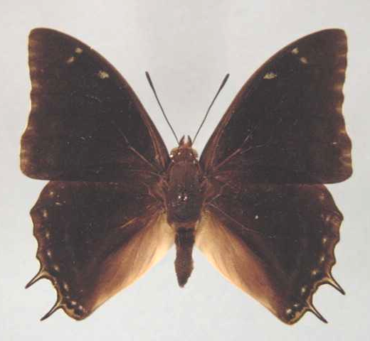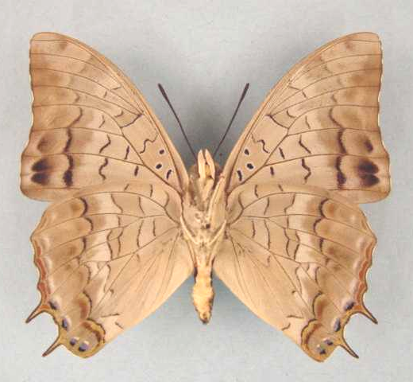

Charaxes etheocles carpenteri. Male. Left – upperside; right – underside. Wingspan: 51mm. Kashiba, Zambia. 17.2.73. I. Bampton. (Henning collection - H267).

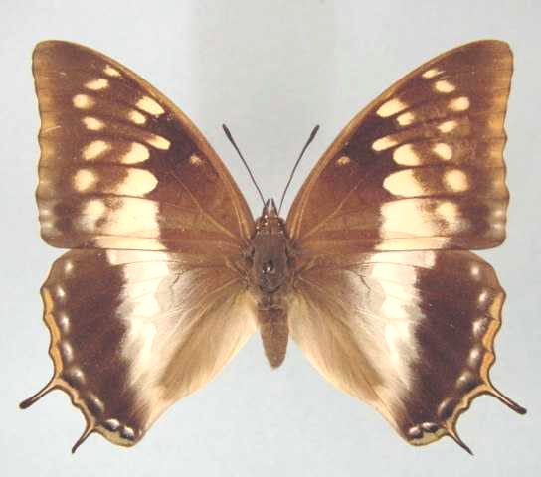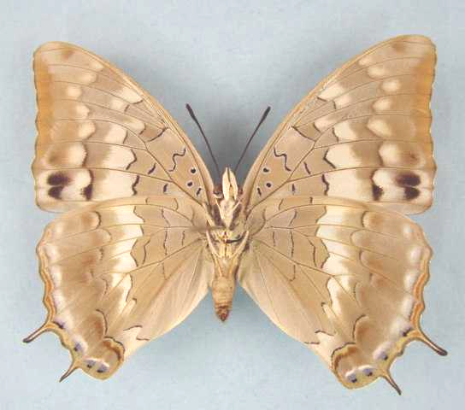

Charaxes etheocles carpenteri. Female. Left – upperside; right – underside. Wingspan: 60mm. Kashiba, Zambia. 23.2.73. I. Bampton. (Henning collection - H267A).

Type locality: Uganda: “Mabera Forest, Kyagive, Mulange”. Holotype (female) in the Natural History Museum, London.
Diagnosis: Besides the two described female forms (carpenteri and pallidimacula) there is a third undescribed female form on Rubondo Island in Lake Victoria (Bjornstad, vide Congdon and Collins, 1998). The female genitalia differ from those of the nominate subspecies and may indicate that carpenteri is specifically distinct (Kielland, 1990: 102). In the Kigoma district of western Tanzania there is a taxon which appears to be intermediate between C. etheocles and C. cedreatis Hewitson (Kielland, 1990: 102).
Distribution: Democratic Republic of Congo (central and east), Sudan (south), Ethiopia (south-west), Uganda, Kenya, Tanzania (north-west), Zambia (north).
Specific localities:
Tanzania – Northern Serengeti; Geita (south-west of Lake Victoria) (Kielland, 1990); Minziro Forest (abundant) (Congdon and Collins, 1998); Rubondo Island (Bjornstad, vide Congdon and Collins, 1998).
Zambia – Kasangezhi; Lisombu River, Ikelenge (Heath, et al., 2002).

carpenteri Poulton, 1919 (as female f. of Charaxes etheocles). Proceedings of the Entomological Society of London 1918: 82 (79-84). Tanzania: “... in the forest near Kakindu, 31° 30' E., 1° 10' S”.

pallidimacula van Someren and Jackson, 1957 (as female f. of Charaxes etheocles carpenteri). Annals of the Transvaal Museum 23: 54 (41-58). Uganda: “Jinja”.

Charaxes etheocles evansi van Someren & Jackson, 1957

Charaxes etheocles evansi van Someren & Jackson, 1957. Annals of the Transvaal Museum 23: 54 (41-58).
Type locality: Kenya: “Kitale”. Holotype (female) in the Natural History Museum, London.
Distribution: Kenya (highlands west of the Rift Valley).
Specific localities:
Kenya – Mt Elgon; Trans Nzoia; Nandi; Lumbwa; Londiani; Mau; Cherangani; Ravine; Tambach (Henning, 1989).

evansi van Someren and Rogers, 1932 (as female f. of Charaxes etheocles). Journal of the East Africa and Uganda Natural History Society 1931 (42, 43): 164 (141-172). No locality given.

conjuncta van Someren and Jackson, 1957 (as female f. of Charaxes etheocles evansi). Annals of the Transvaal Museum 23: 54 (41-58). Kenya: “East Mt. Elgon”.

Charaxes etheocles ochracea van Someren & Jackson, 1957

Charaxes etheocles ochracea van Someren & Jackson, 1957. Annals of the Transvaal Museum 23: 54 (41-58).
Type locality: Gabon: “Gaboon”. Holotype (female) in the Natural History Museum, London.
Distribution: Nigeria (Cross River Loop), Cameroon (south), Gabon, Congo, Central African Republic, Angola?.

violacea Rothschild, 1900 in Rothschild and Jordan, 1900 (as male f. of Charaxes etheocles etheocles). Novitates Zoologicae 7: 485 (287-524). Gabon: “Ogowé R”.

ochracea Rothschild, 1900 in Rothschild and Jordan, 1900 (as female f. of Charaxes etheocles etheocles). Novitates Zoologicae 7: 486 (287-524). “West Africa: Congo”.

regalis Rothschild, 1900 in Rothschild and Jordan, 1900 (as female f. of Charaxes etheocles etheocles). Novitates Zoologicae 7: 486 (287-524). Sierra Leone.

seriata Rothschild, 1900 in Rothschild and Jordan, 1900 (as female f. of Charaxes etheocles etheocles). Novitates Zoologicae 7: 487 (287-524). Ghana: “Gold Coast”; Gabon: “R. Ogowé”; Congo?: “Congo”.

orangina Faravel, 1998 (as female f. of Charaxes etheocles ochracea). Entomologia Africana 3 (Supplement): 12 (10-12). Gabon.

Charaxes plantroui Minig, 1975

Charaxes plantroui Minig, 1975. Bulletin de la Société Entomologique de France 80: 106 (104-111).
Type locality: Ivory Coast: “Cote d’Ivoire, Bouaké”. Holotype (female) in the collection of Dr A. Minig.
Distribution: Guinea (east), Sierra Leone, Ivory Coast (north, central), Ghana, Nigeria.
Specific localities:
Ivory Coast – Bouake (TL).
Nigeria – Kaduna (St Leger, 1984); Bauchi (St Leger, 1984); Ilaro Forest (Larsen, 2005a).
Common name: Pink-washed demon charaxes.
Habitat: Drier forest and dense Guinea savanna (Larsen, 2005a).
Habits: A locally common charaxes (Larsen, 2005a).
Early stages:

Vauttoux and Blandin, 1977 [(Ivory Coast)].

Larval food:
Albizia zygia (DC.) J.F. Macbride (Fabaceae) [Vuattoux and Blandin, 1977 (Ivory Coast)].
Albizia adianthifolia (Schumach) W.F. Wright (Fabaceae) [Vuattoux and Blandin, 1977 (Ivory Coast)].
Afzelia africana Sm. ex Pers. (Fabaceae) [Vuattoux and Blandin, 1977 (Ivory Coast)].
Griffonia (=Bandeiraea) simplicifolia Benth. (Fabaceae) [Vuattoux and Blandin, 1977 (Ivory Coast)].
Andira inermis (Wright) DC. (Fabaceae) [Vuattoux and Blandin, 1977 (Ivory Coast)].
Dalbergia saxatilis Hook. f. (Fabaceae) [Vuattoux and Blandin, 1977 (Ivory Coast)].

simonae Minig, 1975 (as female f. of Charaxes plantroui). Bulletin de la Société Entomologique de France 80: 107 (104-111). Ivory Coast: “Cote d’Ivoire, Bouaké”.

Charaxes angelae Minig, 1975
Charaxes angelae Minig, 1975. Lambillionea 75: 33 (25-35).
Type locality: Ivory Coast: “Côte d’Ivoire: Banco”. Holotype (female) in the collection of Dr A. Minig.
Distribution: ?Sierra Leone, Ivory Coast, Ghana.
Specific localities:
Ivory Coast – Banco Forest, Abidjan (TL).
Ghana – Atewa Range (Larsen, 2005a).
Common name: Angela’s demon charaxes.
Habitat: Evergreen forest.
Habits: Nothing published.
Early stages: Nothing published.
Larval food: Nothing published.
Note: Both S. Collins and T. Larsen believe that this taxon may well be conspecific with C. etheocles (Larsen, 2005a).

Charaxes mccleeryi van Someren, 1972

Charaxes mccleeryi van Someren, 1972. Bulletin of the British Museum (Natural History) (Entomology) 27: 257 (215-264).
Type locality: Tanzania: “Bunduki Hill, Uluguru Mts”. Holotype (male) in the Natural History Museum, London.
Diagnosis: Similar to C. congdoni but larger and with longer tails. Differs from C. usambarae in the less dentate wing margins (Kielland, 1990).
Distribution: Tanzania.
Habitat: Lowland to montane forest at altitudes from 600 to 2 150 m (Kielland, 1990).
Habits: Males are attracted to fermented bananas (Kielland, 1990).
Early stages: Nothing published.
Larval food:
Albizia species (Fabaceae) [Kielland, 1990: 106].

Charaxes mccleeryi mccleeryi van Someren, 1972

Charaxes mccleeryi van Someren, 1972. Bulletin of the British Museum (Natural History) (Entomology) 27: 257 (215-264).
Type locality: Tanzania: “Bunduki Hill, Uluguru Mts”. Holotype (male) in the Natural History Museum, London.
Distribution: Tanzania (north-east).
Specific localities: Uluguru Mountains (Kielland, 1990).

Charaxes mccleeryi iringae Kielland, 1990

Charaxes maccleeryi [sic] iringae Kielland, 1990. Butterflies of Tanzania 106 (363 pp.). Melbourne.
Type locality: Tanzania: “Iringa, Mwanihana Forest, 1200 m. 16-IV-1981, J. Kielland”. Described from two males. Holotype (male) in the Natural History Museum, London.
Description:
“Male. Upperside differs from the nominate race in the h.w. marginal ochreous markings being rplaced by very dark green with a slight deep reddish tinge (the reddish tinge is almost lacking in the paratype); the wavy submarginal line is extremely faint and bluish-green (in ssp. mccleeryi it is more distinct and greenish); tails similar to those of mccleeryi, but the upper one is comparatively shorter; marginal dentations as in mccleeryi; f.w. markings reduced to a few blue scales near costa in spaces 7, 6 and at cell end. Underside similar to other species of the mccleeryi group. Length of f.w. 36.8 & 37.6 mm. Genitalia similar to those of ssp. mccleeryi.”
Diagnosis: Differs from the male of the nominate subspecies in that the upperside hindwing marginal ochreous markings are replaced by green and the wavy submarginal line is faint and bluish green (in the nominate subspecies it is distinct and greenish) (Kielland, 1990). The female is undescribed (Kielland, 1990).
Distribution: Tanzania (central - Iringa District).
Specific localities:
Tanzania – The Iringa side of Mwanihana Forest at 1 200 m (Kielland, 1990).

Charaxes chunguensis White & Grant, 1986

Charaxes chunguensis White & Grant, 1986. Lambillionea 86: 133 (133-136).
Type locality: Tanzania: “Chungu mountain, Rubeho”. Apparently the holotype (male) was stolen (Roger White, pers. comm., 2003).
Diagnosis: Similar to C. congdoni and C. maccleeryi but differs in the darker hindwing margin and shorter signa in the female genitalia (Kielland, 1990).
Distribution: Tanzania.
Specific localities:
Tanzania – Chungu Mountain in Mafwemiru Forest (TL); Mafwemiru Forest, Mangalisa Mountain (Kielland, 1990).
Habitat: Montane forest, at altitudes from 1 700 to 2 200 m (Kielland, 1990).
Habits: Males are known to mud-puddle (Kielland, 1990).
Early stages: Nothing published.
Larval food:
Possibly Albizia species (Fabaceae) [Kielland, 1990: 99].

Charaxes dreuxi Bouche & Minig, 1977

Charaxes dreuxi Bouche & Minig, 1977. Lambillionea 77: 27 (27-29).
Type locality: Ivory Coast: “Côte d’Ivoire, Danané”. Holotype (female) in the collection of Dr A. Minig.
Distribution: Guinea, Ivory Coast.
Specific localities:
Guinea – Nimba Mountains (Larsen, 2005a).
Ivory Coast – Danane (TL); Abengourou (Larsen, 2005a); Banco Forest (Larsen, 2005a); Bossematie (H. Fermon teste Larsen, 2005a).
Common name: Dreux’s demon charaxes.
Habitat: Evergreen forest.
Early stages: Nothing published.
Larval food: Nothing published.

Charaxes petersi van Someren, 1969

Charaxes petersi van Someren, 1969. Bulletin of the British Museum (Natural History) (Entomology) 23: 121 (75-166).
Type locality: Liberia: “Kitoma”. Holotype (male) in the Natural History Museum, London.
Distribution: Guinea, Sierra Leone, Liberia, Ivory Coast, Ghana.
Specific localities:
Guinea – Fouta Djalon (H. Warren-Gash teste Larsen, 2005a).
Sierra Leone – Kambui Hills (Larsen, 2005a); North Gola (Owen & Owen, 1973; as C. catachrous); Tiwai Island (Larsen, 2005a).
Liberia – Kitoma (TL).
Ivory Coast – Bossematie (H. Fermon teste Larsen, 2005a).
Ghana – Konongo (Larsen, 2005a); Tano Ofin (Larsen, 2005a).
Common name: Peters’ demon charaxes.
Habitat: Primary lowland evergreen forest.
Habits: This appears to be a scarce species of Charaxes (Larsen, 2005a).
Early stages: Nothing published.
Larval food: Nothing published.

Charaxes grahamei van Someren, 1969

Charaxes grahamei van Someren, 1969. Bulletin of the British Museum (Natural History) (Entomology) 23: 115 (75-166).
Type locality: Tanzania: “Kigoma District in Mukuyu Forest”. Holotype (male) in the Natural History Museum, London.
Diagnosis: Very similar to C. catachrous, especially on the underside of the wings, but a larger insect (Kielland, 1990).
Distribution: Tanzania (eastern shores of Lake Tanganyika).
Specific localities:
Tanzania – Kasoge Forest; Kasye Forest; Mihumu Forest; Mahale Mountain; Ntakatta Forest; Malagarazi River (Kielland, 1990).
Habitat: Lowland and, more rarely, submontane forest. In Tanzania at altitudes from 800 to 1 500 m (Kielland, 1990).
Habits: Males fly up and down stream beds, often in dense shade, in search of animal droppings and dead crabs
Early stages: Nothing published.
Larval food:
(Probably) Scutia species (Rhamnaceae) [Kielland, 1990: 103].

lacteata van Someren, 1969 (as female f. of Charaxes grahamei). Bulletin of the British Museum (Natural History) (Entomology) 23: 117 (75-166). Tanzania: “Kigoma district in Mukuyu Forest”.

Charaxes bocqueti Minig, 1975

Charaxes bocqueti Minig, 1975. Lambillionea 75: 27 (25-35).
Type locality: Ivory Coast: “Côte d’Ivoire: Abengourou”. Holotype (female) in the collection of Dr A. Minig.
Distribution: Guinea, Sierra Leone, Ivory Coast, Ghana, ?Nigeria, Gabon (R. White, pers. comm., 2003), Central African Republic.
Common name: Bocquet’s demon charaxes.
Habitat: Evergreen forest.
Early stages: Nothing published.
Larval food: Nothing published.

Charaxes bocqueti bocqueti Minig, 1975

Charaxes bocqueti Minig, 1975. Lambillionea 75: 27 (25-35).
Type locality: Ivory Coast: “Côte d’Ivoire: Abengourou”. Holotype (female) in the collection of Dr A. Minig.
Distribution: Guinea, Sierra Leone, Ivory Coast, Ghana.
Specific localities:
Guinea – Nimbas (Larsen, 2005a).
Ivory Coast – Abengourou (TL).

alladinoides Bouche and Minig, 1977 (as female f. of Charaxes bocqueti). Lambillionea 77: 27 (27-29). Ivory Coast: “Côte d’Ivoire, Banco”.

Charaxes bocqueti oubanguiensis Minig, 1975

Charaxes bocqueti oubanguiensis Minig, 1975. Lambillionea 75: 31 (25-35).
Type locality: Central African Republic: “République Centralafricaine, Bangui”. Holotype (female) in the collection of Dr A. Minig.
Distribution: ? Nigeria, Gabon (R. White, pers. comm., 2003), Central African Republic.

Charaxes marieps van Someren & Jackson, 1957

Charaxes marieps van Someren & Jackson, 1957. Annals of the Transvaal Museum 23: 50 (41-58).

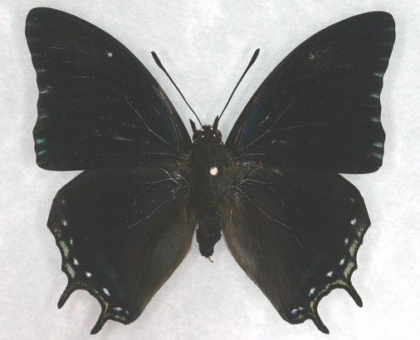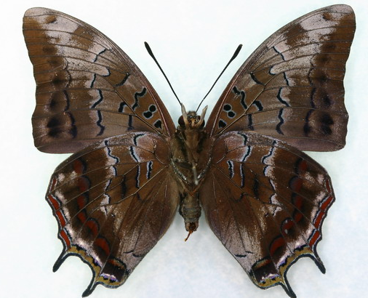

Charaxes marieps male. Left – upperside; right – underside. Images courtesy of Jeremy and Chris Dobson.

Type locality: South Africa: “Transvaal, Mariepskop”. Holotype (male) in the Transvaal Museum, Pretoria, South Africa.
Distribution: South Africa (Mpumalanga).
Specific localities:
Mpumalanga – Mariepskop (Kenway; TL); Graskop (Pringle et al., 1994); Ceylon Forest near Sabie (Hull); Mount Sheba Nature Reserve (Pennington).
Common name: Marieps charaxes.
Habitat: Montane forest.
Habits: Males are usually observed flying around the tops of tall forest trees, where they appear to defend territories from perches. Females fly lower down along the edges of the forest. Males, unlike females, do not readily come to fruit-baited traps (Pringle et al., 1994).
Flight period: October to May; flight period probably more extended (Pringle et al., 1994).
Early stages:

Henning, S., in Van Son, 1979: 193 [as Charaxes marieps; Mariepskop, Mpumalanga].
“Ova: Usual Charaxes shape, bright yellow when first laid but becomes duller and develops the usual reddish-brown ring if fertile. Final instar larva: Headshield green, bordered in ochre-yellow; horns of medium length and dark or purplish-brown in colour; dorsomedial spines black. Body green finely speckled with creamy-white papillae and dorsally on each segment a pair of small spots which are white except for those on segments 6 and 8 which are black with silvery-blue centres; the black marks on segment 6 are occasionally enclosed by a white or creamy-white crescentic line which is often broken in the mid-line. Processes on anal segment short. Length attained by larva is approximately 45 mm. Pupa: Light green with a creamy-yellow line along upper margin of wing-cases and around the eyes. The cremaster and basal tubercles are creamy-yellow.”

Williams & Boomker, 1980: 295 [as Charaxes marieps; Mariepskop, Mpumalanga].
“Egg. Subspherical, top and base flattened, 1.5 mm high, 2 mm diameter. About 30 longitudinal ridges made up of small tubercles, crowded at the top and disappearing towards the base (Fig. 1). Pale yellow when laid, developing a brown ring in upper third after 48 h. Larva hatches after 6-9 days and consumes entire egg shell. First instar. 3-4 mm long; body creamy-yellow turning pale green after the first feeding. Headshield and anal appendages black with rusty-brown edges in some individuals. Headshield diameter 1-1.5 mm; dorsal horns 0.75-0.85 mm, curving inwards and backwards; lateral horns 0.4-0.5 mm, curving slightly upwards (Figs 2, 3 & 8). Frons and clypeus pitted; horns bear numerous setated tubercles (Fig. 2). Body surface densely tuberculated (Fig. 3) and uniformly green. First instar lasts 8-23 days during which a length of 6-7 mm is attained. Second instar. (Figs 4 & 9). Body immaculate green; headshield and anal appendages dark brown. Dorsal horns 1.1-1.3 mm; lateral horns 0.7-0.8 mm, both dark brown with white tips. Frons and clypeus less densely pitted and horns less densely tuberculated than first instar. Body tubercles more widely spaced with white-tipped tubercles at base of anal appendages forming distinct pattern. Length of 10-12 mm is attained in 20-35 days. Third instar. (Figs 5 & 10). Body light green; headshield 2.2-2.8 mm in diameter, brown with variable amount of green invading frons. Dorsal and lateral horns brown to ochre, white-tipped. Body tubercles green but a number of white-tipped tubercles scattered over body in definite pattern. Paired, white-tipped larger tubercles on either side of dorsal vessel. Towards end of instar a pair of purple dots appear dorsally on segment six. Third instar lasts 18-76 days; length attained 14-16 mm. Fourth instar. (Figs 6 & 11). Headshield 3.5-4.2 mm in diameter, green with brown or ochre border. Dorsal horns (2.2-3 mm) and lateral horns (1.5-2 mm) green at base, brown distally and white-tipped. Body tubercles variable in size, larger ones white-tipped. Paired dorsal purple spots on segments six and eight, latter developing towards end of instar. Pleural fold distinct, consisting of white tubercles. Fourth instar lasts a minimum of 23 days; length attained, 22-25 mm. Fifth instar. (Figs 7 & 12). Headshield 5-6 mm in diameter, pale green, bordered by thin yellow or brown line. Dorsal horns 3-3.5 mm; lateral horns 2.5-3 mm, coloration as in fourth instar. Body pale green, numerous white-tipped tubercles, purple spots on segments six and eight distinct, latter often bordered by white patch. In some larvae only one or no spots on segment eight. Pleural fold light yellow. Minimum duration of fifth instar 56 days (winter); length attained 32-42 mm. Prepupa. C-shaped, pale translucent green, lasting 42-50 h. Pupa. (Fig. 13). Pale green; margins of wing cases white or creamy-yellow; spiracles bordered by white. Pupal stage lasts a minimum of 15 days.”

Henning, S., & Henning, G., 1989: 41 [as Charaxes marieps].

Henning, S., 1989: 289 [as Charaxes marieps; Mariepskop, Mpumalanga].

Larval food:
Ochna arborea Burch. ex DC. var. oconnorii (Phill.) Du Toit (Ochnaceae) [Henning, S., in Van Son, 1979: 194].
Ochna arborea Burch. ex DC. var. arborea (Ochnaceae) [Williams & Boomker, 1980: 295].
Ochna arborea Burch. ex DC. var. oconnorii (Phill.) Du Toit (Ochnaceae) [Williams & Boomker, 1980: 295].
Ochna holstii Engl. (Ochnaceae) [Williams & Boomker, 1980: 295].
Ochna natalitia (Meisn.) Walp. (Ochnaceae) [Williams & Boomker, 1980: 295].
Ochna serrulata (Hochst.) Walp. (Ochnaceae) [Williams & Boomker, 1980: 295].

Charaxes karkloof van Someren & Jackson, 1957

Charaxes karkloof van Someren & Jackson, 1957. Annals of the Transvaal Museum 23: 51 (41-58).
Type locality: South Africa: “Karkloof, Natal”. Holotype (male) in the Natural History Museum, London.
Distribution: South Africa.
Common name: Karkloof charaxes.
Habitat: Montane and temperate forest.
Habits: Males can be seen flying around the crowns of forest trees while females are more often observed flying lower down on the edge of the forest. Females appear to be more readily attracted to traps baited with fermented banana than males (Pringle, et al., 1994). Subspecies trimeni: both sexes come to fermenting fruit; males are attracted by blue objects (Rydon, in Pringle, et al., 1994).
Flight period: The nominate subspecies has been recorded from October to May but the flight period is probably more extended (Pringle, et al., 1994). Subspecies capensis has been found from January to April. Subspecies trimeni has been recorded in February, April, May and June.
Early stages:

Van Someren, 1966: 83 (Bull. Br. Mus. Nat. Hist., part III 18: 45-101) (ssp. karkloof).

Van Son, 1979: 195 (ssp. karkloof).
“Egg: Laid singly on the leaves of the food-plant. Of the usual Charaxes shape, pale ochreous in colour, developing a brownish ring at the junction of the slightly fluted flattened top with the sides. Larva: 1st instar pale ochreous with a greenish tinge on hatching changing later to olivaceous-green, head and posterior processes rufous according to Wells and shown in the slides examined by the author, though van Someren mentions the colour of the head as black. There is a pair of small light moles on each segment. Second instar greenish, with fine irrorations, the inner (longer) cephalic horns and posterior processes are whitish-tipped, and the horns are finely tuberculate. Third instar darker green, with the irroration more pronounced, the horns and the much reduced posterior processes are still rufous, the disc of the face is tinged green, a light yellow line appears on each side of the head and also along each side above the claspers; in some specimens, a pair of light yellow spots develops on the dorsum of the sixth segment. Fourth instar: body deep leaf-green, with the surface markedly irrorated, the horns are still rufous, the moles on each segment are a brilliant blue, and there is a ventro-lateral line, the posterior processes are greenish-ochre and very small. Fifth instar: body as in the previous instar, but the horns are now greenish, and the very small posterior processes are of a lemon-yellow colour. Pupa: Mr Wells wrote that he could in no way distinguish the pupa from that of C. e. ethalion Boisduval.”

Henning, S., 1989: 292 (ssp. capensis; Van Stadens Pass, Eastern Cape).

Schlosz, in Pringle, et al., 1994: 97 (ssp. trimeni).

Larval food:
Ochna arborea Burch. ex DC. var. arborea (Ochnaceae) [Wells, in Van Son, 1979: 195 (ssp. karkloof; Edge, 1995: 82 (ssp. trimeni).
Ochna serrulata (Hochst.) Walp. (Ochnaceae) [Henning, S., 1989: 293 (ssp. capensis).
Ochna natalitia (Meisn.) Walp. (Ochnaceae) [Henning, S., 1989: 293 (ssp. capensis); Pringle, et al., 1994: 97 (ssp. trimeni)].

Charaxes karkloof karkloof van Someren & Jackson, 1957

Charaxes karkloof van Someren & Jackson, 1957. Annals of the Transvaal Museum 23: 51 (41-58).
Type locality: South Africa: “Karkloof, Natal”. Holotype (male) in the Natural History Museum, London.
Distribution: South Africa (KwaZulu-Natal, Eastern Cape Province).
Specific localities:
KwaZulu-Natal – Karkloof (H. Millar; TL); Port St Johns; Embotyi Forest (Pringle, et al., 1994); Stutterheim; East London (Quickelberge)

Charaxes karkloof capensis van Someren, 1966

Charaxes karkloof capensis van Someren, 1966. Bulletin of the British Museum (Natural History) (Entomology) 18: 83 (45-101).
Type locality: South Africa: “Cape Province, at Van Staaden’s Pass”. Holotype (male) in the Natural History Museum, London.
Diagnosis: Can be distinguished from the nominate subspecies on the hindwing underside by the more greyish ground-colour, and by the lighter and more clearly defined discal bands (Pringle, et al., 1994).
Distribution: South Africa (Eastern Cape Province).
Specific localities:
Eastern Cape Province – Van Staden’s Pass (Wykeham; TL); near the Van Staden’s River mouth (J. Pringle); Alexandria; Port Alfred (Liversidge); Olifantskop Pass (V. Pringle); near Knysna (Pringle, et al., 1994).

Charaxes karkloof trimeni Rydon, 1994

Charaxes karkloof trimeni Rydon, 1994. In: Pringle, Henning, and Ball [eds]. Pennington’s butterflies of southern Africa 2nd edition: 97 (800pp.). Struik-Winchester, South Africa.
Type locality: South Africa: “Saasveld, 9 Apr. 1970. A.H.B. Rydon (in Coll. A.H.B. Rydon, to be deposited in the British Museum of Natural History).” Described from two males and three females.
Diagnosis: Differs from subspecies capensis in the following respects: in both sexes the forewings are broader and less falcate; hindwings more elongated, with thicker, shorter tails. In males the satiny sheen on the underside is less bright than in capensis. In females the hindwing is narrower and the forewing has a white median band; the light postdiscal spots on the forewing are smaller and run in a straighter line; the light median band on the underside is narrower and less distinct (Rydon, in Pringle, et al., 1994).
Distribution: South Africa (Western Cape Province - Saasveld, and Hoogekraal Pass near George).
Specific localities:
Western Cape Province – Saasveld, near George (Rydon; TL); Hoogekraal Pass, near George (M. and P. Schlosz)

Charaxes pondoensis van Someren, 1967

Charaxes ethalion pondoensis van Someren, 1967. Bulletin of the British Museum (Natural History) (Entomology) 18: 285 (277-316).
Type locality: South Africa: “Pondoland, Port St. Johns”. Holotype (male) in the Transvaal Museum, Pretoria, South Africa.
Diagnosis: Differs from C. ethalion and C. karkloof in the stronger contrast between the light and dark areas on the underside, especially in males; the underside is silvery grey, not brown as in the other two species. On the underside of the hindwing in area 4 there are two fine, black lines at the end of the cell – tese meet on vein 4 immediately basad of the juncture between vein 4 and vein 3. In the nominate subspecies of C. karkloof these two lines are always separated and meet vein 4 on either side of this juncture (Pringle, et al., 1994).
Distribution: South Africa (Eastern Cape Province - coast).
Specific localities:
Eastern Cape Province – Port St Johns; Embotyi Forest; Bashee River; Coffee Bay (Pringle, et al., 1994).
Common name: Pondo charaxes.
Habitat: Coastal forest.
Habits: Flies rapidly over the tops of trees or along the edge of the forest. Males occasionally mud-puddle. Both sexes are readily attracted to fermenting fruit (Pringle, et al., 1994).
Flight period: All year (Pringle, et al., 1994).
Early stages:

Henning and Bampton, in Van Son, 1979: 206.

Henning, S. and Henning, G., 1989: 39.

Henning, S., 1989: 294.

Larval food:
Millettia grandis (E. Mey.) Skeels (Fabaceae) [Henning and Bampton, in Van Son, 1979: 207].
Philenoptera sutherlandii Harv. (Fabaceae) [Henning and Bampton, in Van Son, 1979: 207; as a sp. of Millettia].

Charaxes alpinus van Someren & Jackson, 1957

Charaxes ethalion alpinus van Someren & Jackson, 1957. Annals of the Transvaal Museum 23: 42 (41-58).
Type locality: Zimbabwe: “S. Rhodesia, Vumba Mts”.
Diagnosis: Larger than C. ethalion with shorter and more robust tails; underside darker and more reddish brown (Pringle, et al., 1994).
Distribution: Zimbabwe (eastern border).
Specific localities:
Zimbabwe – high forest in the Vumba Mountains (Barnes; TL); Chimanimani Mountains (Hensman).
Common name: Montane charaxes.
Habitat: Montane forest.
Habits: A few specimens have been collected in bait-traps but very little else is known about its habits (Pringle, et al., 1994).
Flight period: Probably flies all year (Pringle, et al., 1994).
Early stages:

Mullin, in Pringle, et al., 1994: 95.

Larval food:
Albizia adianthifolia (Schumach.) W.F. Wight (Fabaceae) [Mullin, in Pringle, et al., 1994: 95].

Charaxes nyikensis van Someren, 1975

Charaxes alpinus nyikensis van Someren, 1975. Bulletin of the British Museum (Natural History) (Entomology) 32: 85 (65-136).

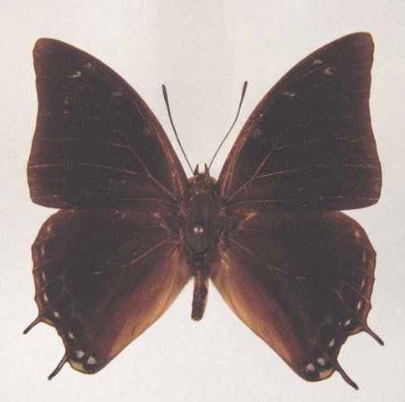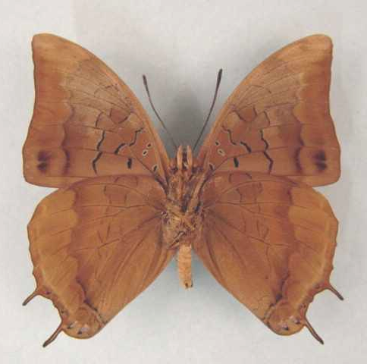

Charaxes nyikensis. Male. Left – upperside; right – underside. Wingspan: 50mm. Mugesse Forest, Malawi. 29.8.78. I. Bampton. (Henning collection - H268).

Type locality: Malawi: “Northern Malawi-Zambian border on Nyika Plateau”. Holotype (male) in the Natural History Museum, London.
Distribution: Malawi, Zambia (east).
Specific localities:
Zambia – Nyika; Mafinga Mountains; Makutu Mountains (Heath, et al., 2002).
Habitat: Montane forest, riverine forest, scrub forest and Brachystegia woodland (Henning, 1989: 296).
Early stages:

Henning, G., 1977.

Henning, S., 1989: 296.

Larval food:
Albizia gummifera (J.F. Gmel.) C.A. Smith (Fabaceae) [Henning, S., 1989: 296].
Dalbergia lactea Vatke (Fabaceae) [Henning, S., 1989: 296].

Charaxes margaretae Rydon, 1980

Charaxes margaretae Rydon, 1980 in d’Abrera, 1980. Butterflies of the Afrotropical region 396 (593 pp.). Melbourne.
Type locality: Malawi: “Malosa Stream, Mt Mlanji, S. Region, Malawi, 3000 ft”. Holotype (male) in the Natural History Museum, London.
Diagnosis: Virtually indistinguishable from congdoni as regards adult facies but the genitalia differ. The volume of the egg in margaretae is more than 60% greater than in congdoni (Congdon & Bampton, unpublished 2003).
Distribution: Malawi (south), Tanzania (south-west), ?Zambia (east) [Congdon & Bampton (unpublished 2003) state that material from Zambia referred to chintechi by Heath et al. (2002) may actually represent margaretae.]. The populations in south-west Tanzania (Bundali Hills and Tukuyu) appear to represent either an undescribed subspecies of C. margaretae or they may be conspecific with C. congdoni (Congdon and Collins, 1998).
Specific localities:
Malawi – Mlanje (TL); Bundali Hills and foothills of Rungwe Mountain at the northern end of Lake Malawi (Congdon & Bampton, unpublished 2003); below the Nyika (Congdon & Bampton, unpublished 2003).
Habitat: Forest.
Early stages:

Henning, 1989: 297.

Larval food:
Albizia gummifera (J.F. Gmel.) C.A. Smith (Fabaceae) [Henning, S., 1989: 297].
Agelaea heterophylla Gilg. (Connaraceae) [Henning, S., 1989: 297].
Dalbergia lactea (Fabaceae) [Congdon & Bampton, unpublished 2003].

Charaxes congdoni Collins, 1989

Charaxes congdoni Collins, 1989. In: Henning, 1989. The Charaxinae butterflies of Africa 297 (457 pp.). Johannesburg.
Type locality: Tanzania: “Mufindi”. Holotype (male) in the Natural History Museum, London.
Diagnosis: Closest to C. nyikensis and C. alpinus (Kielland, 1990). Also very similar to C. margaretae (see latter for differences) (Congdon & Bampton, unpublished 2003).
Distribution: Tanzania (uplands from Mufindi to Mwanihana), Malawi (Congdon & Bampton, unpublished 2003).
Specific localities:
Tanzania – Mount Nymbenitu; Dabaga; Mufindi; Njombe; Kitesa Forest; Iboma Forest, 10 km from Njombe; Tukuyu area (Kielland, 1990).
Malawi – Bundali Hills (Congdon & Bampton, unpublished 2003).
Habitat: Montane forest, from 1 600 to 2 200 m (Kielland, 1990).
Habits: Males course up and down riverbeds in search of otter or bird droppings (Kielland, 1990).
Early stages:

Henning, 1989: 298.

Larval food:
Albizia gummifera (J.F. Gmel.) C.A. Smith (Fabaceae) [Henning, S., 1989: 298].
Agelea ?pentagyna (?) [Congdon & Bampton, unpublished 2003; Bundali Hills, Malawi].

Charaxes ethalion (Boisduval, 1847)

Nymphalis ethalion Boisduval, 1847. In: Delegorgue, A., Voyage dans l’Afrique australe 2: 593 (585-602).
Type locality: South Africa: “Port Natal”.
Distribution: Uganda, Kenya, Tanzania, Democratic Republic of Congo, Malawi, Zambia, Mozambique, Zimbabwe, South Africa, Swaziland (Duke, et al., 1999).
Common name: Satyr charaxes.
Habitat: Forest and dense moist savanna, including Brachystegia woodland (Kielland, 1990). In Tanzania spp. littoralis occurs at altitudes from sea-level to 2 000 m; ssp. kitungulensis from 500 to 1 200 m; ssp. nyanzae from 800 to 1 700 m (Kielland, 1990).
Habits: They fly swiftly on the edges of forest and along forest roads, occasionally settling on muddy patches. Specimens are attracted to fermenting fruit (Pringle, et al., 1994).
Early stages:

Trimen & Bowker, 1887, Vol. 1: 345 [ssp. ethalion; given as Charaxes Cithaeron Felder (apparently in error); Natal].
“Larva. Deeper or lighter green, closely granulated with yellow, on back; light bluish-green or light bluish-grey on under surface; a chrome-yellow lateral-inferior stripe from second segment to anal extremity, which is bifid into two acute processes of the same yellow as the stripes. On sixth and eighth segments the yellow stripes are connected by a backward-curved, almost semicircular, transverse, yellow stripe; on back, just preceding the hinder portion of each transverse stripe, a dark-purple spot, composed of two small spots connected by indistinct purple lineolae. On each side of eleventh segment, a small yellow spot, just above longitudinal stripe. Head rather large, green, surmounted by four serrated green horns (of which the two middle ones are longer than the others and divergent); face and outer edge of horns bordered with yellow; between the two middle horns a pair of small, acute, black-pointed tubercles.” “Pupa. Light-green, slightly maculated with white. A silvery-white line running along curved edges of wing-covers to summit of head, interrupted on the line of the antennae. Anal segment produced, and bearing three pairs of small pointed tubercles. The above description of the larva and pupa are made from notes and drawings of Natalian specimens communicated to me by Captain H.C. Harford and Mr. W.D. Gooch. The former gentleman wrote that he found several of the larvae almost full-grown in the month of April, and that shortly before becoming pupae they changed to a very light-green. The butterflies were disclosed after thirteen days’ pupation.”

Junod, 1892: 14.

Van Someren and Rogers, 1932: 171 (ssp. kikuyensis).

Clark, in Van Son, 1979: 205 (Plate 75). (ssp. ethalion).
“The eggs are laid singly on the surface of a leaf. They are pale watery yellow darkening to a pale dull yellow with an irregular reddish-brown circlet finely edged with salmon. Eggs vary in size, but average 1,4 mm in diameter by 1,3 mm high. They have 32-38 ribs over the crown and part way down the side. These ribs have about ten moles each and are faintly cross-braced, this bracing breaks into a hexagonal pattern near the micropyle. The larva hatches in five days. It is pale green with blackish-brown, white based, forked extremity and a black head with whitish-yellow tipped horns. It is 3,5 mm and grows to 6 mm in 21 days. It lies along a leaf and is very inconspicuous. It spins a mat on this and crawls away to feed, but always returns to its mat. The second instar lasts eleven days and the larva grows to 9 mm. In the 3rd instar the larva grows to 13,5 mm in 12 days, in the 4th to 20,5 mm in 16 days. The final instar lasts some 20-25 days and the larva grows to 38-40 mm. The female has the larger larva. Throughout the larval state, the larva lives on a silken mat and crawls away to feed. The band on segments 6 and 8 may be either white or yellow. The pupa is suspended by cremastral hooks from a leaf or twig, and is 21-23 mm long. The imago emerges after some 26 days.”

Henning, S., 1989: 307 (ssp. ethalion; KwaZulu-Natal and Entabeni Forest (Limpopo Province)].

Larval food:
Acacia ataxacantha DC. (Fabaceae) [Dickson and Kroon, 1978: 64 (ssp. ethalion)].
Acacia kirkii Oliv. (Fabaceae) [Henning, S., 1989: 308 (ssp. binghami)].
Albizia adianthifolia (Schumach.) W.F. Wight (Fabaceae) [Harford & Gooch, in Trimen & Bowker, 1887, Vol. 1: 346; Natal; as Zygia fastigata (ssp. ethalion). Fountaine, 1911: 52; as Albizzia fastigata (ssp. ethalion); Henning, S., 1989: 308 (ssp. kitungulensis, ssp. fisheri, ssp. littoralis, ssp. kikuyuensis)].
Albizia adianthifolia (Schumach.) W.F. Wight (Fabaceae) var. chirindensis Swynnerton (Fabaceae) [Leigh, in Platt, 1921: 103].
Albizia coriaria Welw. ex Oliv. (Fabaceae) [Van Someren, 1967: 299 (ssp. binghami)].
Albizia gummifera C.A. Smith (Fabaceae) [Van Someren, 1967: 299; Henning, S., 1989: 308 (ssp. handmani, ssp. littoralis, ssp. kitungulensis (Kielland, 1990: 101))].
Amblygonocarpus andongensis (Welw. ex Oliv.) Exell and Torre (Fabaceae) [Henning, S., 1989: 308 (ssp. binghami)].
Cathormoin altissimum (Hook. f.) Hutch. and Dandy (Fabaceae) [Henning, S., 1989: 308 (ssp. fisheri)].
Dalbergia lactea Vatke (Fabaceae) [Pringle, et al., 1994: 96].
Dicrostachys cinerea (L.) Wight and Arn. (Fabaceae) [Henning, S., 1989: 308 (ssp. ethalion, ssp. binghami, ssp. kitungulensis, ssp. littoralis)].
Entada abyssinica Steud. ex Rich. (Fabaceae) [Mullin, in Pringle, et al., 1994: 96].
Maytenus (syn. Gymnosporia) species (Celastraceae) [Gifford, 1965: 99].
Mimosa pigra L. (Fabaceae) [Henning, S., 1989: 308 (ssp. fisheri)].
Newtonia (syn. Piptadenia) buchaninii Baker (Fabaceae) [Van Someren, 1967: 299; Henning, S., 1989: 308 (ssp. handmani, ssp. littoralis)].
Parkia africana R. Br. (syn. filicoidea Welw.) (Fabaceae) [Van Someren and Rogers, 1932: 171; Henning, S., 1989: 308 (ssp. kitungulensis, fisheri)].
Peltophorum africanum Sond. (Fabaceae) [Henning, S., 1989: 308 (ssp. binghami only)].
Pseudoprosopis fischeri (Taub.) Harms (Fabaceae) [Henning, S., 1989: 308 (ssp. fischeri)].
Scutia buxifolia Reiss. (Rhamnaceae) [Van Someren and Rogers, 1932: 171].
Scutia myrtina (Burm. f.) Kurz (syn. indica Brongn. and syn. commersoni Brongn.) (Rhamnaceae) [Van Someren and Rogers, 1932: 171; Henning, S., 1989: 308 (ssp. kitungulensis, ssp. littoralis, ssp. kikuyuensis)].
Tamarindus indica L. (Fabaceae) (exotic) [Van Someren, 1967:299; Henning, S. 1989: 308 (ssp. littoralis)].

Charaxes ethalion ethalion (Boisduval, 1847)

Nymphalis ethalion Boisduval, 1847. In: Delegorgue, A., Voyage dans l’Afrique australe 2: 593 (585-602).
Type locality: South Africa: “Port Natal”.
Diagnosis: The four female forms are discussed by Pringle, et al. (1994: 95).
Distribution: Mozambique, Zimbabwe (east), South Africa (Limpopo Province, Mpumalanga, KwaZulu-Natal), Swaziland (Duke, et al., 1999).
Specific localities:
Mozambique – Maronga Forest (Pringle, et al., 1994).
Zimbabwe – Chinhoyi; Christon Bank (Mullin).
Limpopo Province – Eastern Soutpansberg (Pringle, et al., 1994); Mpaphuli N.R.
Mpumalanga – Sabie (S.P. Wahl).
KwaZulu-Natal – Oribi Gorge (Swanepoel, 1953); Umkomaas (Swanepoel, 1953); Durban (Swanepoel, 1953); Eshowe (Swanepoel, 1953); St Lucia Bay (Swanepoel, 1953); Kosi Bay (Swanepoel, 1953); Umgeni Valley; Eshowe (Pringle, et al., 1994); Pietermaritzburg (Swanepoel, 1953).

erithalion Doubleday, 1849 in Doubleday and Westwood, [1846-52] (as sp. of Nymphalis). The genera of diurnal Lepidoptera, London: pl. 48 [1849], 309 [1850] (1: 1-250 pp.; 2: 251-534 pp.). London. South Africa: “Zoolu, Port Natal”. [Invalid; manuscript name first introduced in synonymy.]

rosae Butler, 1895 (as sp. of Charaxes). Proceedings of the Zoological Society of London 1895: 255 (250-270). No locality given.

swynnertoni Poulton, 1919 (as female f. of Charaxes ethalion). Proceedings of the Entomological Society of London 1918: 79 (79-84). Zimbabwe: “Chirinda, S.E. Rhodesia”.

aurantimacula van Someren, 1967 (as female f. of Charaxes ethalion ethalion). Bulletin of the British Museum (Natural History) (Entomology) 18: 283 (277-316). No locality given.

Charaxes ethalion binghami Henning, 1982

Charaxes ethalion binghami Henning, 1982. Miscellanea Entomologica 49: 84 (83-91).

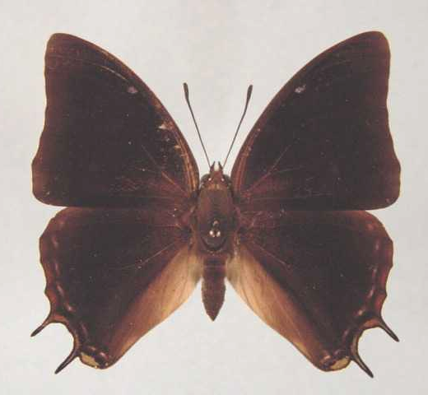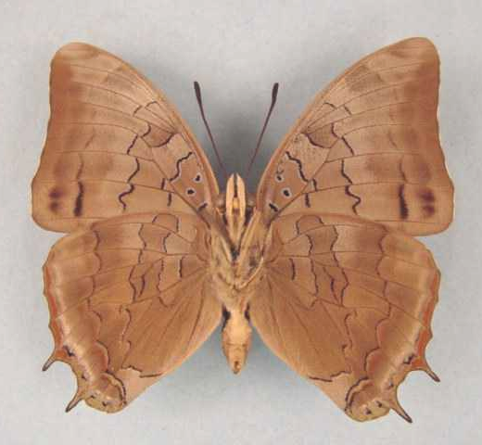

Charaxes ethalion binghami. Male. Left – upperside; right – underside. Wingspan: 45mm. Bred on Peltophorum. Lusaka, Zambia. 11 Aug 74. I Bampton. (Henning collection - H269).

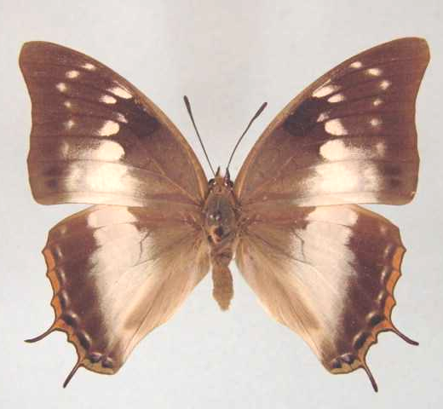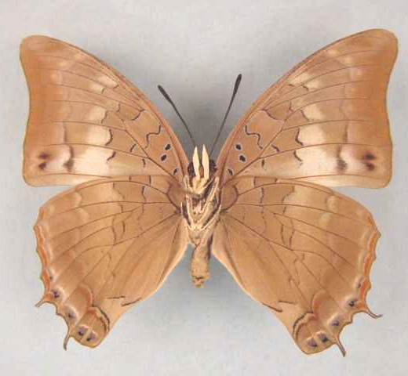

Charaxes ethalion binghami. Female. Left – upperside; right – underside. Wingspan: 55mm. Lusaka, Zambia. Em July 78. I. Bampton. (Henning collection - H269A).

Type locality: Zambia: “Lusaka”. Holotype (male) in the Natural History Museum, London.
Diagnosis: The three female forms are discussed by Pringle, et al. (1994: 96).
Distribution: Zambia (Copperbelt, central, south), Zimbabwe (north).
Specific localities:
Zambia – Mufulira; Ndola; Chisamba; Mumbwa; Lusaka; Choma; Victoria Falls (Heath, et al., 2002).
Zimbabwe – Mana Pools; confluence of the Zambezi and Save rivers (Hancock).

Charaxes ethalion fisheri Henning, 1982

Charaxes ethalion fisheri Henning, 1982. Miscellanea Entomologica 49: 88 (83-91).

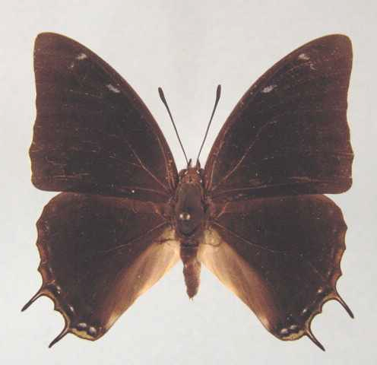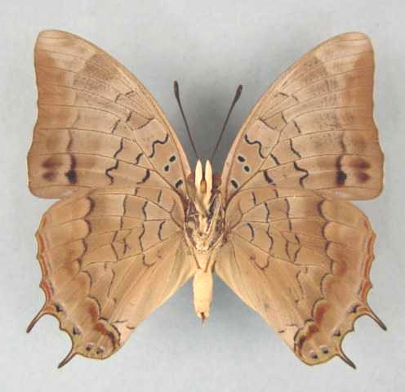

Charaxes ethalion fisheri. Male. Left – upperside; right – underside. Wingspan: 42mm. Keso Falls, Lifubu River, 2500'. 26.6.75. I. Bampton. (Henning collection - H270).

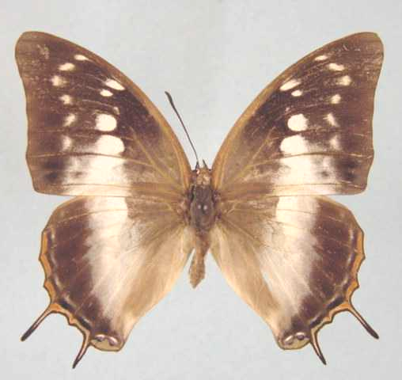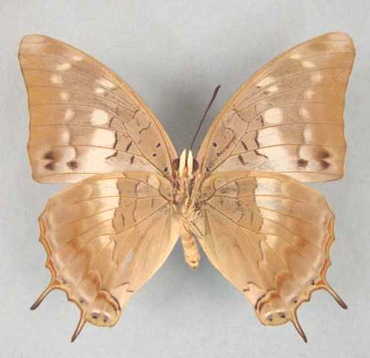

Charaxes ethalion fisheri. Male. Left – upperside; right – underside. Wingspan: 50mm. Sumbu, Zambia. 14.7.78. I. Bampton. (Henning collection - H270A).

Type locality: Zambia: “Keso Falls, Lifubu River”. Holotype (male) in the Natural History Museum, London.
Distribution: Zambia (north - southern end of Lake Tanganyika).
Specific localities:
Zambia – Keso Falls; Lufubu River; Mbala; Lumangwe Falls; Lunzua Falls; Sumbu; Nkamba Bay (Dening) (Heath, et al., 2002).

Charaxes ethalion handmani Henning, 1982

Charaxes ethalion handmani Henning, 1982. Miscellanea Entomologica 49: 86 (83-91).
Type locality: Malawi: “Mulanje Crater, 1000 m”. Holotype (male) in the Natural History Museum, London.
Distribution: Malawi (south - Mlanje district).

cithaeronides van Someren, 1967 (as female f. of Charaxes ethalion nyassana). Bulletin of the British Museum (Natural History) (Entomology) 18: 287 (277-316). Malawi: “Mlosa Stream, Lauderdale”.

suppressa van Someren, 1967 (as female f. of Charaxes ethalion nyassana). Bulletin of the British Museum (Natural History) (Entomology) 18: 288 (277-316). Malawi: “Port Herald, Mlosa Stream”.

imitans van Someren, 1967 (as female f. of Charaxes ethalion nyassana). Bulletin of the British Museum (Natural History) (Entomology) 18: 290 (277-316). Malawi: “Lauderdale Est., Mlaye, Mlosa Stream”.

Charaxes ethalion kikuyuensis van Someren, 1967

Charaxes ethalion kikuyuensis van Someren, 1967. Bulletin of the British Museum (Natural History) (Entomology) 18: 296 (277-316).
Type locality: Kenya: “Nairobi district, Karura Forest”. Holotype (male) in the Natural History Museum, London.
Distribution: Kenya (highlands east of Rift Valley).
Specific localities:
Kenya – Ngong; Nairobi; Kikuyu; Nyeri; Meru (Henning, 1989).

Charaxes ethalion kitungulensis Strand, 1911

Charaxes ethalion var. kitungulensis Strand, 1911. Mitteilungen aus dem Zoologischen Museum in Berlin 5: 288 (275-304).
Type locality: Tanzania: “Kitungulu”.
Distribution: Tanzania, Malawi, Democratic Republic of Congo (Lualaba, Shaba, Maniema).
Specific localities:
Tanzania – Tukuyu; Rukwa basin (Kielland, 1990).

nyasana van Someren, 1967 (as ssp. of Charaxes ethalion). Bulletin of the British Museum (Natural History) (Entomology) 18: 286 (277-316). Malawi: “Nkata Bay”. [Invalid; junior primary homonym of Charaxes nyasana Butler, 1895 [Charaxinae].]

demaculata van Someren, 1967 (as female f.. of Charaxes ethalion nyassana). Bulletin of the British Museum (Natural History) (Entomology) 18: 288 (277-316). Malawi: “Lugeri Stream, Mlanje”.

nyasicus van Someren, 1975 (as [unnecessary] replacement name for Charaxes ethalion nyassana). Bulletin of the British Museum (Natural History) (Entomology) 32: 109 (65-136).

Charaxes ethalion littoralis van Someren, 1967

Charaxes ethalion littoralis van Someren, 1967. Bulletin of the British Museum (Natural History) (Entomology) 18: 294 (277-316).
Type locality: Kenya: “Shimba Hills, Kwale Dist.”. Holotype (male) in the Natural History Museum, London.
Distribution: Kenya (east), Tanzania (east).
Specific localities:
Tanzania – Mikumi; Rubeho Mountains; Nguu Mountains; Nguru Mountains; Kilimanjaro (Kielland, 1990).

ethalionoides Carpenter, 1945 (as female f. of Charaxes etheocles). Proceedings of the Royal Entomological Society of London (B) 14: 87 (81-88). Kenya: “Kenya Colony, coastal zone”. Transferred to C. ethalion by Van Someren, 1947.

Charaxes ethalion marsabitensis van Someren, 1967

Charaxes ethalion marsabitensis van Someren, 1967. Bulletin of the British Museum (Natural History) (Entomology) 18: 298 (277-316).
Type locality: Kenya: “Northern Frontier Province, at Mt. Marsabit”. Holotype (male) in the Natural History Museum, London.
Distribution: Kenya (north - Mt Marsabit).

Charaxes ethalion nyanzae van Someren, 1967

Charaxes ethalion nyanzae van Someren, 1967. Bulletin of the British Museum (Natural History) (Entomology) 18: 292 (277-316).
Type locality: Uganda: “S.W. Uganda, Kikagati, Kagera River”.
Distribution: Uganda ,Democratic Republic of Congo (east - Lake Mweru), Kenya (south-west), Tanzania (west).
Specific localities:
Tanzania – Mpanda to the Ugandan border (Kielland, 1990).

howardi van Someren and Jackson, 1952 (as female f. of Charaxes ethalion). Transactions of the Royal Entomological Society of London 103: 260 (257-284). Kenya: “Chepalungu, Sotik area, Kenya”.

Charaxes baileyi van Someren, 1958

Charaxes baileyi van Someren, 1958. Novos Taxa Entomologicos (11): 4 (12 pp.).
Type locality: Kenya: “Visoi Gap, near Kilombe Hill”.
Distribution: Kenya (west of Rift Valley, north of Equator). Holotype (male) in the Natural History Museum, London.
Habitat: Riparian forest and bush.
Early stages:

Van Someren, 1958: 4.

Henning, S., 1989: 310.

Larval food:
Scutia myrtina (Burm. f.) Kurz (Rhamnaceae) [Van Someren, 1974: 320].

pseudocarpenteri van Someren, 1958 (as f. of Charaxes baileyi). Novos Taxa Entomologicos (11): 5 (12 pp.). Kenya: “Visoi Gap”.

Charaxes galawadiwosi Plantrou & Rougeot, 1979

Charaxes galawadiwosi Plantrou & Rougeot, 1979. Bulletin de la Société Entomologique de France 84: 139 (138-142).
Type locality: Ethiopia: “Ethiopie, Arba-Minch”. Holotype (male) in the Muséum national d’Histoire naturelle, Paris.
Distribution: Ethiopia.
Habitat: Thornbush savanna.
Early stages:

Henning, S., 1989: 312.

Larval food:
Albizia sp. (Fabaceae) [Henning, S., 1989: 312].

genovefae Plantrou and Rougeot, 1979 (as female f. of Charaxes galawadiwosi). Bulletin de la Société Entomologique de France 84: 141 (138-142). Ethiopia: “Ethiopie, Arba-Minch”.

alenae Plantrou and Rougeot, 1984 in Rougeot, 1984 (as female f. of Charaxes galawadiwosi). Memoires. Muséum National d’Histoire Naturelle. Paris (Zoologie) 128: 66 (1-93). Ethiopia: “Éthiopie, Arba-Minch”.

nathaliannae Plantrou and Rougeot, 1984 in Rougeot, 1984 (as female f. of Charaxes galawadiwosi). Memoires. Muséum National d’Histoire Naturelle. Paris (Zoologie) 128: 66 (1-93). Ethiopia: “Éthiopie, Arba-Minch”.

carolinae Plantrou and Rougeot, 1984 in Rougeot, 1984 (as female f. of Charaxes galawadiwosi). Memoires. Muséum National d’Histoire Naturelle. Paris (Zoologie) 128: 66 (1-93). Ethiopia: “Éthiopie, Arba-Minch”.

florae Plantrou and Rougeot, 1984 in Rougeot, 1984 (as female f. of Charaxes galawadiwosi). Memoires. Muséum National d’Histoire Naturelle. Paris (Zoologie) 128: 66 (1-93). Ethiopia: “Éthiopie, R. Godare”.

genettae Plantrou and Rougeot, 1984 in Rougeot, 1984 (as female f. of Charaxes galawadiwosi). Memoires. Muséum National d’Histoire Naturelle. Paris (Zoologie) 128: 66 (1-93). Ethiopia: “Éthiopie, Arba-Minch”.

shoayeae Plantrou and Rougeot, 1984 in Rougeot, 1984 (as female f. of Charaxes galawadiwosi). Memoires. Muséum National d’Histoire Naturelle. Paris (Zoologie) 128: 67 (1-93). Ethiopia: “Éthiopie, Arba-Minch”.

stephaniae Plantrou and Rougeot, 1984 in Rougeot, 1984 (as female f. of Charaxes galawadiwosi). Memoires. Muséum National d’Histoire Naturelle. Paris (Zoologie) 128: 67 (1-93). Ethiopia: “Éthiopie, Arba-Minch”.

jackieae Plantrou and Rougeot, 1984 in Rougeot, 1984 (as female f. of Charaxes galawadiwosi). Memoires. Muséum National d’Histoire Naturelle. Paris (Zoologie) 128: 67 (1-93). Ethiopia: “R. Godare, Éthiopie”.

katema Vingerhoedt, 2003 (as female f. of Charaxes galawadiwosi). Entomologia Africana 8 (2): 11 (7-13). Ethiopia: Dila.

leonardi Vingerhoedt, 2003 (as female f. of Charaxes galawadiwosi). Entomologia Africana 8 (2): 11 (7-13). Ethiopia: Dila.

likissa Vingerhoedt, 2003 (as female f. of Charaxes galawadiwosi). Entomologia Africana 8 (2): 11 (7-13). Ethiopia: Dila.

Charaxes turlini Minig & Plantrou, 1978

Charaxes turlini Minig & Plantrou, 1978. Bulletin de la Société Entomologique de France 83: 143 (141-146).
Type locality: Rwanda: “Rwanda, sud de Kigali, Karama Bugesera”. Holotype (male) in the Muséum national d’Histoire naturelle, Paris.
Diagnosis: Male similar to that of C. baileyi but underside slightly paler (Kielland, 1990).
Distribution: Rwanda (Karama Bugesera), Tanzania (north-west).
Specific localities:
Tanzania – Rumanyika Game Reserve (Kielland, vide Congdon and Collins, 1998); Kere Hill, Minziro Forest? (two females) (Congdon and Collins, 1998). There is also a population close to C. turlini in Brachystegia woodland at Nyakanazi, Biharamulo District (Congdon and Collins, 1998).
Habitat: Open forest (Congdon and Collins, 1998).
Early stages:

Henning, S., 1989: 313.

Larval food: Nothing published.

adelinae Minig and Plantrou, 1978 (as f. female of Charaxes turlini). Bulletin de la Société Entomologique de France 83: 144 (141-146). Rwanda: “Karama Bugesera”.

isabellae Minig and Plantrou, 1978 (as f. female of Charaxes turlini). Bulletin de la Société Entomologique de France 83: 145 (141-146). Rwanda: “Karama Bugesera”.

giselae Minig and Plantrou, 1978 (as f. female of Charaxes turlini). Bulletin de la Société Entomologique de France 83: 145 (141-146). Rwanda: “Karama Bugesera”.

foklinae Minig and Plantrou, 1978 (as f. female of Charaxes turlini). Bulletin de la Société Entomologique de France 83: 145 (141-146). Rwanda: “Karama Bugesera”.

Charaxes mafuga van Someren, 1969

Charaxes mafuga van Someren, 1969. Bulletin of the British Museum (Natural History) (Entomology) 23: 97 (75-166).
Type locality: Uganda: “Kigezi County, at Rutenga-Mafuga Forest”. Holotype (male) in the Natural History Museum, London.
Distribution: Uganda (south-west), Rwanda, Burundi.
Habitat: Montane forest.
Early stages:

Henning, G., 1977: 227.

Vingerhoedt and Thiry, 1998 [Burundi].

Larval food:
Albizia gummifera (J.F. Gmel.) C.A. Smith (Fabaceae) [Henning, S., 1989: 315].

vetuloides Mollet, 1975 (as female morph of Charaxes mafuga). Bulletin de la Société de Entomologique de France 80: 36 (32-38). Uganda: “Sud-Ouest de l’Ouganda, Kigezi, forêt de Mafuga, 1800 m”.

Charaxes chepalunga van Someren, 1969

Charaxes chepalunga van Someren, 1969. Bulletin of the British Museum (Natural History) (Entomology) 23: 90 (75-166).
Type locality: Kenya: “N.W. Kenya, lower Sotik area, Chepalungu”. Holotype (male) in the Natural History Museum, London.
Distribution: Kenya (south-east), Tanzania (north-west).
Specific localities:
Kenya – Sotik and Mara River areas.
Tanzania – Serengeti Plains (Kielland, 1990).
Habitat: Evergreen and riverine forest.
Early stages:

Henning, S., 1989: 317.

Larval food:
Scutia myrtina (Burm. f.) Kurz (Rhamnaceae) [Henning, S., 1989: 317].

Charaxes cedreatis Hewitson, 1874

Charaxes cedreatis Hewitson, 1874. Entomologist’s Monthly Magazine 10: 247 (247-248).

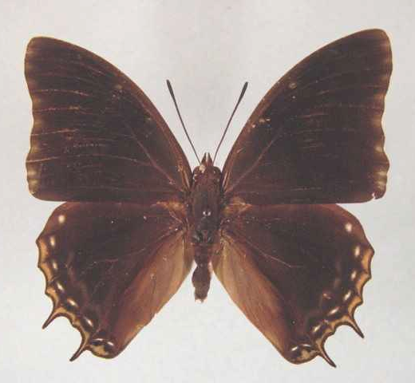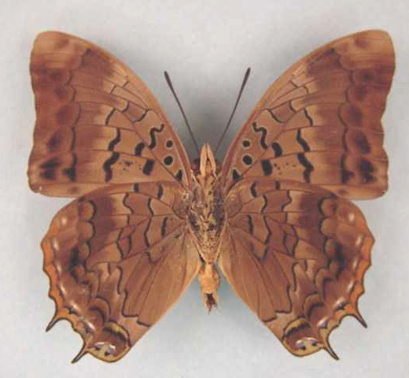

Charaxes cedreatis. Male. Left – upperside; right – underside. Wingspan: 56mm. Bangui, RCA. Dec ‘69. R. Keiser. (Henning collection - H271).

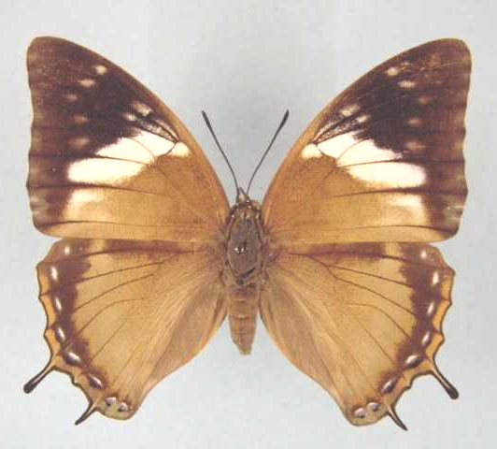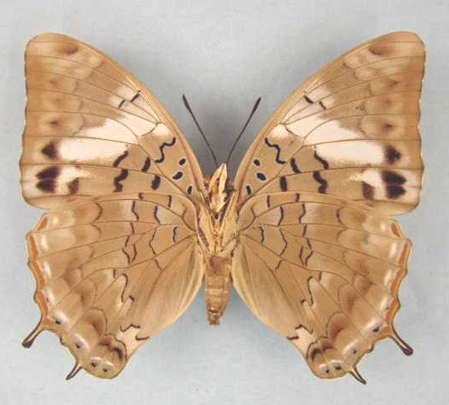

Charaxes cedreatis. Female. Left – upperside; right – underside. Wingspan: 62mm. Kibi, Ghana. 26/2//73. (Henning collection - H271).

Type locality: “West Africa”.
Diagnosis: The male differs from that of C. etheocles in the strong greenish sheen in the basal third of the upperside of the forewing (Kielland, 1990). It is possible that there are a number of female forms that have not been properly associated with this taxon (see discussion in Kielland, 1990: 113).
Distribution: Guinea, Sierra Leone, Liberia, Ivory Coast, Ghana, Nigeria (south and Cross River loop), Cameroon, Equatorial Guinea (Bioko), Gabon, Congo, Central African Republic, Sudan (south), Angola (north), Democratic Republic of Congo, Uganda, Kenya (south-west), Tanzania (west), Zambia (north-west).
Specific localities:
Sierra Leone – Freetown (Owen & Chanter, 1972).
Ivory Coast – Bossematie (H. Fermon teste Larsen, 2005a).
Ghana – Cape Coast (Larsen, 2005a); Winneba (Joly, 2003).
Nigeria – Warri (H. Boersma teste Larsen, 2005a); Kaduna (Larsen, 2005a).
Tanzania – From Ufipa to the Ugandan border, east to the Kenyan border and the northern Serengeti (Kielland, 1990).
Zambia – Lisombu River; Mwinilunga; Mbala (Heath, et al., 2002).
Common name: Green demon charaxes.
Habitat: Evergreen forest. Also in Brachystegia woodland and riverine forests (Kielland, 1990). In Tanzania it is found at altitudes from 800 to 2000 m (Kielland, 1990).
Habits: A reasonably common butterfly (Larsen, 2005a). Males are often found flying along stream beds in search of otter scats from which they feed. They are also partial to other carnivore droppings, as well as moist sand (Kielland, 1990). Females seem to prefer fermenting fruit and sap oozing from wounds in tree trunks and branches (Kielland, 1990) but males also utilize these food resources (Larsen, 2005a). Males sometimes hilltop (Larsen, 2005a).
Early stages:

Van Someren and Rogers, 1931.

Larval food:
Albizia brownei Oliver (Fabaceae) [Van Someren, 1974: 320].
Albizia grandibracteata Taub. (Fabaceae) [Van Someren, 1974: 320].
Albizia zygia (DC.) J.F. Macbride (Fabaceae) [Van Someren, 1974: 320 (East Africa); Blandin, et al., 1975 (Ivory Coast)].
Griffonia (=Bandeiraea) simplicifolia Benth. (Fabaceae) [Blandin, et al., 1975 (Ivory Coast); Henning, S., 1989: 319; as Bandeiraea simplicifolia].
Annona senegalensis Pers. (Annonaceae) [Blandin, et al., 1975 (Ivory Coast); Henning, S., 1989: 319].
Dalbergia lactea Vatke (Fabaceae) [Henning, S., 1989: 319].
Scutia myrtina (Burm. f.) Kurz (Rhamnaceae) [Henning, S., 1989: 319].

lutacea Rothschild, 1900 in Rothschild and Jordan, 1900 (as female f. of Charaxes etheocles etheocles). Novitates Zoologicae 7: 485 (287-524). Democratic Republic of Congo: “Great Forest, two and three days’ march from Ft. Beni”.

vetula Rothschild, 1900 in Rothschild and Jordan, 1900 (as female f. of Charaxes etheocles etheocles). Novitates Zoologicae 7: 488 (287-524). Gabon: “Ogoiré R”.

protocedreatis Poulton, 1926 (as female f. of Charaxes etheocles etheocles). Internationaler Entomologen-Kongress 2: 556 (518-575). Uganda: “Jinja district, Uganda”.

inexpectata van Someren, 1969 (as female f. of Charaxes cedreatis cedreatis). Bulletin of the British Museum (Natural History) (Entomology) 23: 88 (75-166). Tanzania: “N.E. of Lake Tanganyika, Kigoma district, Mukuyu Forest, 5,200 ft”.

Charaxes subrubidus van Someren, 1972

Charaxes manica subrubidus van Someren, 1972. Bulletin of the British Museum (Natural History) (Entomology) 27: 255 (215-264).
Type locality: Congo: “Brazzaville”. Holotype (male) in the collection of Dr J. Plantrou.
Distribution: Congo, Democratic Republic of Congo (Cataractes, Kinshasa, Kasai, Lualaba, Lomami, Shaba).
Habitat: Woodland savanna.
Early stages: Nothing published.
Larval food: Nothing published.

pseudosmaragdalis van Someren and Jackson, 1957 (as female f. of Charaxes cedreatis vetula). Annals of the Transvaal Museum 23: 50 (41-58). Democratic Republic of Congo: “Congo Belge, Leopoldville, Djelo-Binza”.

atribasis van Someren, 1972 (as female f. of Charaxes manica subrubidus). Bulletin of the British Museum (Natural History) (Entomology) 27: 255 (215-264). Congo: “Brazzaville”.

aubergeri van Someren, 1972 (as female f. of Charaxes manica subrubidus). Bulletin of the British Museum (Natural History) (Entomology) 27: 256 (215-264). Congo: “Brazzaville”.

sorianoi Auberger and Minig, 1975 (as female f. of Charaxes manica subrubidus). Bulletin de l’Institut Fondamental d’Afrique Noire (A) 37: 239 (239-241). Congo: “Congo, Brazzaville”.

Charaxes chintechi van Someren, 1975

Charaxes chintechi van Someren, 1975. Bulletin of the British Museum (Natural History) (Entomology) 32: 107 (65-136).

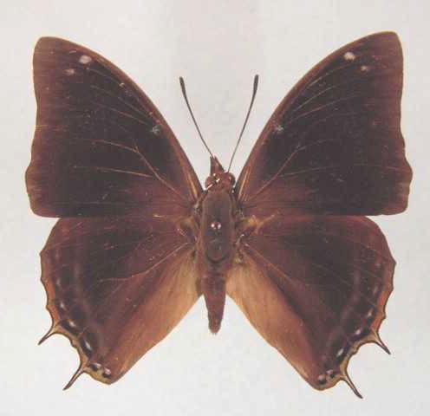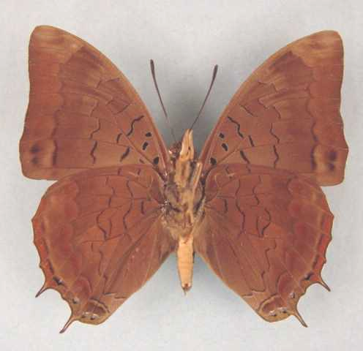

Charaxes chintechi. Male. Left – upperside; right – underside. Wingspan: 53mm. Male. Chitasira Forest, 1900', Bandawe, Malawi. 30 Jun 74. I. Bampton. (Henning collection - H272).

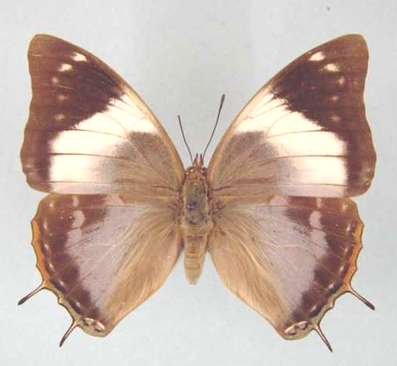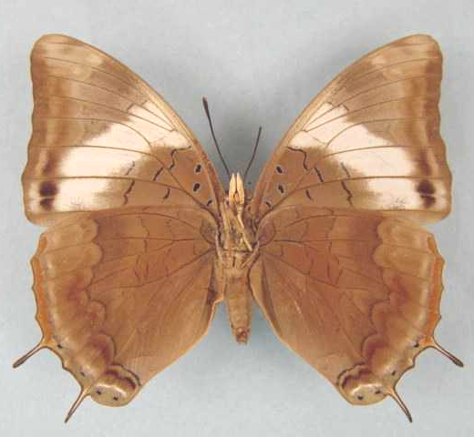

Charaxes chintechi. Female (form pseudomanica). Left – upperside; right – underside. Wingspan: 63mm. Nkhata Bay, Malawi, 2000'. 5.7.72. I. Bampton. (Henning collection - H272A).

Type locality: [Malawi: “Nyasaland, Chintechi”.]. Holotype (female) in the Natural History Museum, London.
Diagnosis: Male close to both C. manica and C. howarthi (Kielland, 1990).
Distribution: Tanzania (south-west), Zambia (east) [Congdon & Bampton (unpublished 2003) have doubts that Zambian material is chintechi and suggest that it may represent margaretae], Malawi (north), Mozambique.
Specific localities:
Tanzania – Musekera; Masukulu Forest; Chivanji (Kielland, 1990).
Zambia – Mbala; Makutu Mountains; Mafinga Mountains (Heath, et al., 2002).
Habitat: Brachystegia woodland. In Tanzania at altitudes from 600 to 1 100 m (Kielland, 1990). Congdon & Bampton (unpublished 2003) state that it is almost invariably found below 850 m.
Early stages:

Henning, S., 1989: 322.

Larval food:
Brachystegia spiciformis Benth. (Fabaceae) [Henning, S., 1989: 322].
Dalbergia lactea Vatke (Fabaceae) [Henning, S., 1989: 322].

cytila Rothschild, 1900 in Rothschild and Jordan, 1900 (as male f. of Charaxes etheocles etheocles). Novitates Zoologicae 7: 484 (287-524). Malawi: “Bandawe ... Ft. Abercorn”.

chintechi van Someren and Jackson, 1952 (as female f. of Charaxes manica). Transactions of the Royal Entomological Society of London 103: 270 (257-284). Malawi: “Nyasaland: Chintechi”.

protomanica van Someren, 1966 (as female f. of Charaxes manica). Bulletin of the British Museum (Natural History) (Entomology) 18: 91 (45-101). Malawi: “Chintechi”.

protomanica van Someren, 1975 (as sp. of Charaxes). Bulletin of the British Museum (Natural History) (Entomology) 32: 107 (65-136). [Malawi: “Chintechi”.]

pseudomanica Minig, 1976 (as sp. of Charaxes). Lambillionea 76: 13 (9-14). Maalwi: “Zomba”.

chintechi Minig, 1976 (as sp. of Charaxes). Lambillionea 76: 13 (9-14). Malawi: “Nkata Bay”. [Invalid; junior primary homonym and synonym of Charaxes chintechi van Someren.]

oriens Rydon, 1990 in Kielland, 1990 (as female f. of Charaxes chintechi). Butterflies of Tanzania 341 (363 pp.). Melbourne. Tanzania: “Tukuyu, Masukulu Forest (630 m.)”.

ochrepicta Rydon, 1990 in Kielland, 1990 (as female f. of Charaxes chintechi). Butterflies of Tanzania 342 (363 pp.). Melbourne. Tanzania: “Tukuyu”.

Charaxes pseudophaeus van Someren, 1975

Charaxes pseudophaeus van Someren, 1975. Bulletin of the British Museum (Natural History) (Entomology) 32: 107 (65-136).
Synonym of Charaxes chintechi van Someren. Ackery et al., 1995: 437.
Charaxes pseudophaeus van Someren, 1975. Pringle et al., 1994: 99.
Type locality: Mozambique: “Beira, P.E. Africa”. Holotype (female) in the Natural History Museum, London.
Diagnosis: The male resembles that of C. manica but is larger (34,5 mm vs 31,0 mm), the forewing is more falcate, the underside ground-colour is lighter, and the hindwing tails are longer and more slender. There are at least five distinct females forms (Pringle, et al., 1994).
Distribution: Mozambique, Zimbabwe (east).
Specific localities:
Mozambique – forest near Beira; Dondo Forest; Amatongas; Maronga Forest; Inchope; Xiluvo; Cidade de Chimoio; Buzi River, near Gogói (Pringle, et al., 1994).
Zimbabwe – Mutare (Hancock).
Common name: False dusky charaxes.
Habitat: Evergreen forest and the fringes of Brachystegia woodland.
Habits: Both sexes are very fond of fermenting fruit (Pringle, et al., 1994).
Flight period: Records are for August to October and March to May (Pringle, et al., 1994).
Early stages: Nothing published.
Larval food:
Brachystegia spiciformis Benth. (Fabaceae) [Bampton, in Dickson and Kroon, 1978: 67].

pseudophaeus van Someren & Jackson, 1957 (as female f. of Charaxes manica). Annals of the Transvaal Museum 23: 46 (41-58). Mozambique: “Beira, P.E. Africa”.

Charaxes manica Trimen, 1894

Charaxes manica Trimen, 1894. Proceedings of the Zoological Society of London 1894: 43 (14-82).
Type locality: Zimbabwe: “Mineni Valley and at Lusika River”. Holotype (female) in the South African Museum, Cape Town.
Diagnosis: Male similar to that of C. ethalion. The latter is darker on the upperside, lacks any greenish sheen basally, usually lacks subapical spots, and lacks the submarginal greenish lunules on the hindwing. The females of C. manica, on the upperside, resemble small females (nominate female form) or males (form helgae) of C. bohemani; on the underside they are reddish brown (Pringle, et al., 1994).
Distribution: Zimbabwe (widespread), Mozambique (west), Zambia.
Specific localities:
Zambia – Mpongwe; Chisamba; Feira; Chirundu (Heath, et al., 2002).
Zimbabwe – Mineni Valley (TL); Lusika River (Pringle, et al., 1994); Laurenceville Road (Haywood); Christon Bank (S. Henning, 1989); Harare (Pringle, et al., 1994).
Common name: Manica charaxes.
Habitat: Brachystegia woodland.
Habits: Males defend territories from perches in clearings or on the tops of rocky hills. Females are seldom observed; occasionally they can be seen searching for suitable plants on which to oviposit. Both sexes feed from sap oozing from trees and from fermenting fruit (Pringle, et al., 1994).
Flight period: All year (Pringle, et al., 1994).
Early stages:

Henning, S., 1989: 326 [as Charaxes chittyi; Christon Bank, near Harare (Zimbabwe)].

Haywood and Paré, in Pringle, et al., 1994: 99 [as Charaxes manica; Laurenceville Road, Zimbabwe].

Larval food:
Albizia antunesiana Harms. (Fabaceae) [Van Someren, 1974: 320; for C. manica].
Dalbergiella (syn. Dalbergia) nyasae Bak. f. (Fabaceae) ? [Van Someren, 1974: 320; for C. manica].
Albizia antunesiana Harms. (Fabaceae) [Henning, S., 1989: 326; for C. chittyi].
Brachystegia spiciformis Benth. (Fabaceae) [Paré, in Pringle, et al., 1994: 100; for C. chittyi].
Brachystegia boehmii Taub. (Fabaceae) [Pringle, et al., 1994: 100; for C. chittyi].
Dalbergia lactea Vatke (Fabaceae) [Pringle, et al., 1994: 100; for C. chittyi].

dewitzi Butler, 1895 (as sp. of Charaxes). Proceedings of the Zoological Society of London 1895: 255 (250-270). No locality given.

chittyi Rydon, 1980 (as sp. of Charaxes). In: d’Abrera, 1980. Butterflies of the Afrotropical region 390 (593 pp.). Melbourne. Zimbabwe: “Rhodesia, Salisbury”. Holotype (male) in the Natural History Museum, London. [Synonymized with C. manica Trimen, 1894 by Heath, et al., 2002 (The Butterflies of Zambia. ABRI and the Lepidopterists’ Society of Africa: vii, 78).]

helgae Rydon, 1980 in d’Abrera, 1980 (as female f. of Charaxes chittyi). Butterflies of the Afrotropical region 391 (593 pp.). Melbourne. Zimbabwe: “Rhodesia, Salisbury, Christon Bank”.

Charaxes howarthi Minig, 1976

Charaxes howarthi Minig, 1976. Lambillionea 76: 13 (9-14).

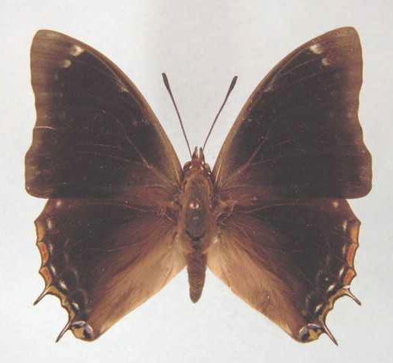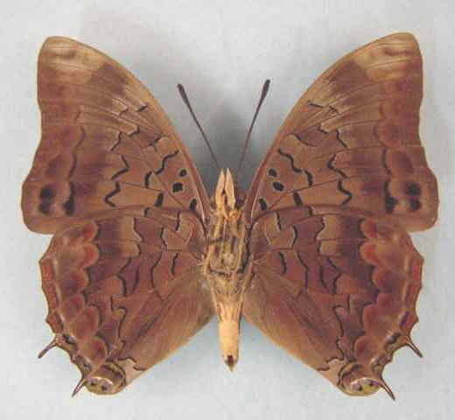

Charaxes howarthi. Male. Left – upperside; right – underside. Wingspan: 50mm. Chisamba, Zambia. 16/3/73. I. Bampton. (Henning collection - H273).

Type locality: Tanzania: “Tanzanie (Sibwesa M’Panda)”. Holotype (male) in the Minig collection.
Distribution: Tanzania, Angola (north), Zambia (north), Democratic Republic of Congo (Shaba).
Specific localities:
Tanzania – In the woodlands west of Tabora, from Tukuyu to Kigoma; Songea Region; Uzungwa Range; Mikumi National Park; Morogoro Region (Kielland, 1990).
Zambia – Mwinilunga; Ikelenge; the Copperbelt; Mumbwa; Kundalila Falls; Chiwoma; Mpongwe; Msamfu; Kasama; Mbala (Heath, et al., 2002).
Habitat: Brachystegia woodland and open forest (Kielland, 1990). In Tanzania at altitudes from 400 to 2 000 m (Kielland, 1990).
Early stages:

Henning, S., 1989: 327 (ex Bampton, Mwinilunga, Zambia).

Larval food:
Brachystegia spiciformis Benth. (Fabaceae) [Henning, S., 1989: 328].
Albizia antunesiana Harms (Fabaceae) [Henning, S., 1989: 328].

Charaxes fulgurata Aurivillius, 1899

Charaxes fulgurata Aurivillius, 1899 in Aurivillius, 1898-9. Kungliga Svenska Vetenskapakademiens Handlingar 31 (5): 236 (1-561).

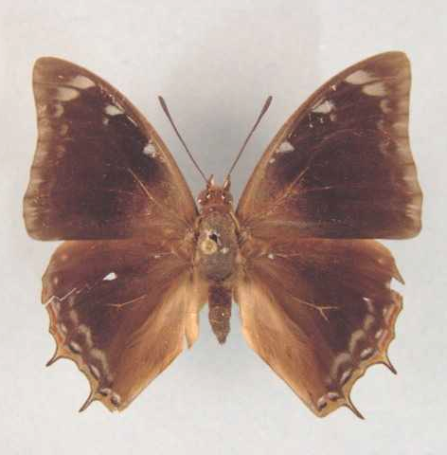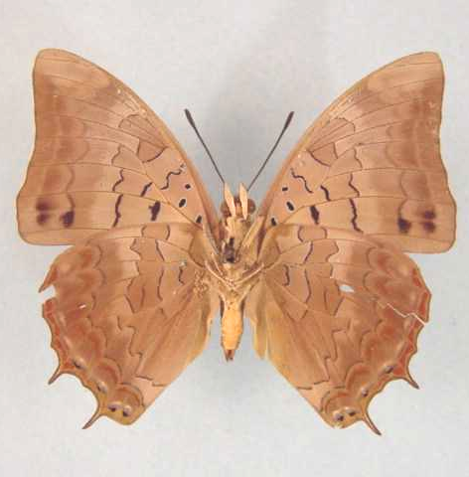

Charaxes fulgurata. Male. Left – upperside; right – underside. Wingspan: 50mm. S. R. 27/3/42. (Transvaal Museum - TM3448).

Type locality: Angola.
Diagnosis: There are at least two distinctive female forms (Pringle, et al., 1994).
Distribution: Angola (north), Democratic Republic of Congo (Lualaba, Lomami), Zimbabwe (north-west), Zambia.
Specific localities:
Zambia – 100 km south of Mwinilunga; Chingola; Mufulira; Ndola; Luanshya; Mpongwe; Musonda Falls; Chiwoma; Mpongwe; Kabwe; Lusaka; Chisamba; Lochinvar National Park; Victoria Falls (Heath, et al., 2002).
Zimbabwe – Victoria Falls; Lake Kariba; Chinhoyi (Lomagundi) (Pinhey); Bulawayo (Stevenson; single male); Gwanda (Stevenson; single female).
Common name: Lightning charaxes.
Habitat: Brachystegia woodland and other savanna woodland.
Habits: Ficq, cited by Pringle, et al., (1994) found specimens feeding on elephant dung lying in the road.
Flight period: Recorded in September, October, January and March to May (Pringle, et al., 1994).
Early stages:

Dollman, in Riley, 1921: 242 (Trans. R. Ent. Soc. Lond. 60: 234-259).

Henning, G., 1977: 224 [as Charaxes fulgurata; Chisamba (Zambia)].
“Ova: Usual Charaxes shape, greenish-yellow with a brown ring if fertile. They are laid singly on the upperside of the leaves of the foodplant. Final instar larva: Headshield green, marginal facial line cream; dorsal horns long, tipped with pinkish-brown, lateral horns strongly pinkish-brown; dorso-medial spines black. Body green, sometimes without markings but usually with a short pinkish-cream dorsal somite bare on segment 6, anteriorly edged with black; two black dorso-somitic spots are often present on segment 6. Lateral ridge yellowish. Anal processes short and square. Pupa: Green, usually without markings but sometimes with wing-cases edged with yellow along the inner margin.”

Henning, S., 1989: 329 [as Charaxes fulgurata; Zambia].

Larval food:
Erythrophleum africanum Guill. and Perr. (Fabaceae) [Van Someren, 1974: 320].
Amblygonocarpus andongensis (Welw. ex Oliv.) Exell and Torre (Fabaceae) [Henning, G., 1977: 225].

ephyra Godart; Dewitz, 1887 (as var. of Charaxes). Nova Acta Academiae Caesarea Leopoldino-Carolinae Germanicum Naturae Curiosum 50: 371 (365-372).

lunigera Rothschild, 1900 in Rothschild and Jordan, 1900 (as female f. of Charaxes etheocles etheocles). Novitates Zoologicae 7: 488 (287-524). Angola: “Northern Angola”.

mima Riley, 1921 (as female f. of Charaxes fulgurata). Transactions of the Entomological Society of London 1921: 243 (234-259). Zambia: “Solwezi”.

Charaxes phaeus Hewitson, 1877

Charaxes phaeus Hewitson, 1877. Entomologist’s Monthly Magazine 14: 82 (81-83).

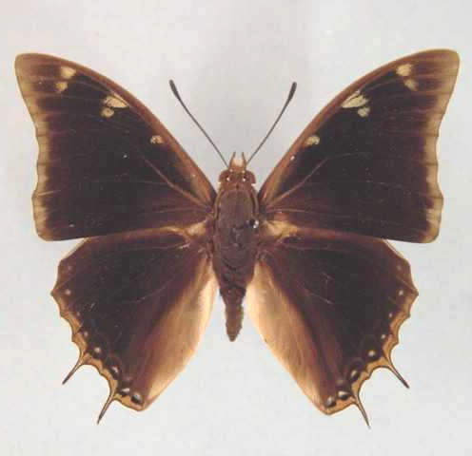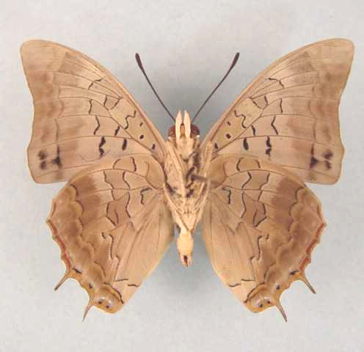

Charaxes phaeus. Male. Left – upperside; right – underside. Wingspan: 56mm. Strydom Tunnel, Transvaal. 31.12.1974. J. Boomker. (Transvaal Museum - TM3438).

Type locality: Mozambique: “Delagoa Bay”. Holotype (female) in the Natural History Museum, London.
Diagnosis: In males of C. vansoni the two subapical spots on the forewing upperside are blue, whereas in C. phaeus they are white and the ground colour of the hindwing underside is pale coppery brown, with the silvery sheen comparatively reduced, extending only from the base along the costa and cell (Van Son, 1979). The male differs from that of C. fionae in the paler underside, larger greenish spots on the upperside, and wider pale wing margins (Kielland, 1990).
Distribution: Uganda (west of Lake Victoria), Tanzania (west), Malawi, Zambia (east), Zimbabwe, Botswana (east), Mozambique, Swaziland, South Africa (Limpopo Province, Mpumalanga, North West Province, KwaZulu-Natal).
Common name: Dusky charaxes; demon charaxes.
Specific localities:
Tanzania – Western parts of the country (Kielland, 1990).
Swaziland – Mlawula N. R. (www.sntc.org.sz).
Zambia – Luangwa Valley (Bampton); Chirundu (Bingham); Chiawa on the Zambezi (Dening) (Heath, et al., 2002).
KwaZulu-Natal – Hluhluwe (Pringle, et al., 1994).
Habitat: Dry savanna woodland. Also in Brachystegia woodland (Kielland, 1990). In Tanzania it is found at altitudes between 800 and 2 000 m (Kielland, 1990).
Habits: Males establish and defend territories on hill tops and ridges during the midday hours. Females fly randomly in lower-lying areas. Both sexes are attracted to fermenting tree sap and fermenting fruit (Pringle, et al., 1994). Males are known to mud puddle and visit animal droppings (Kielland, 1990).
Flight period: All year.
Early stages:

Henning, G., 1977: 225 [as Charaxes phaeus; Big Bend (Swaziland), Saltpan, Wylliespoort and Waterpoort (Limpopo Province), Moremi, Okavango swamps and Ngwezumba (Botswana), Victoria Falls (Zimbabwe), Luanga River Valley (Zambia), Monkey Bay and Karonga (Malawi)].
“Ova: Usual Charaxes shape, yellowish with a brown ring if fertile. The ova are laid on the upper surface of the leaves of the foodplant. Final instar larva: Headshield green with yellowish facial margin; the horns are long, with the upper halves pinkish-brown and dorsomedial spines green. Body dull olive-green, with fine creamy yellow oblique lateral lines on each segment from the first to the penultimate one. Each segment has two or four small creamy-yellow dorso-somitic spots, on segment 6 there may be a short creamy-yellow dorsal somite bar and, very rarely, there is a second bar on segment 8. The skin is rough, sometimes giving the impression of fine yellow spotting. Lateral ridge yellowish and anal processes short and square, sometimes tipped with ochreous. Pupa: Green, with very faint creamy striations, especially over the abdomen. It is similar to the pupa of Charaxes jahlusa (Trimen).”

Henning, S., 1984 [as Charaxes phaeus].

Henning, S., 1989: 330 [as Charaxes phaeus].

Larval food:
Acacia nigrescens Oliv. (Fabaceae) [Henning, G., 1977: 225].
Acacia goetzei Harms. (Fabaceae) [Henning, G., 1977: 225].
Tamarindus indica L. (Fabaceae) [Henning, G., 1977: 225].
Acacia amythethophylla (Fabaceae) [Congdon & Bampton, unpublished 2003; Tanzania].

coryndoni Rothschild, 1900 in Rothschild and Jordan, 1900 (as female f. of Charaxes etheocles etheocles). Novitates Zoologicae 7: 488 (287-524). Zimbabwe: “Gazungula, Upper Zambesi”.

imitatrix Niepelt, 1924 (as female f. of Charaxes etheocles). Internationale Entomologische Zeitschrift 18: 50 (49-50). No locality given.

Charaxes fionae Henning, 1977

Charaxes fionae Henning, 1977. Annals of the Transvaal Museum 30: 232 (231-238).

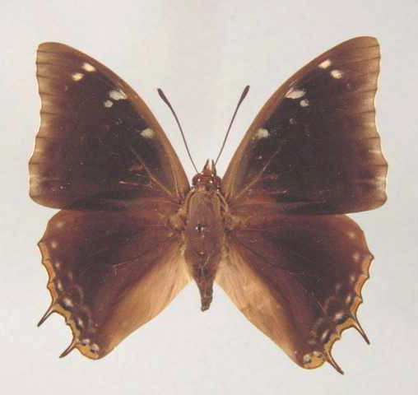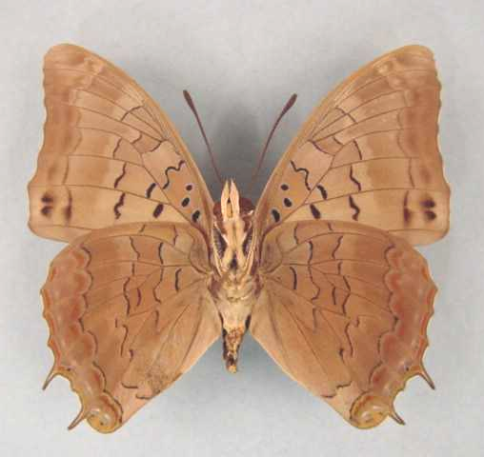

Charaxes fionae. Male. Left – upperside; right – underside. Wingspan: 49mm. Lusaka, Zambia. Bred 29.IX.76. I. Bampton. (Henning collection - H274).

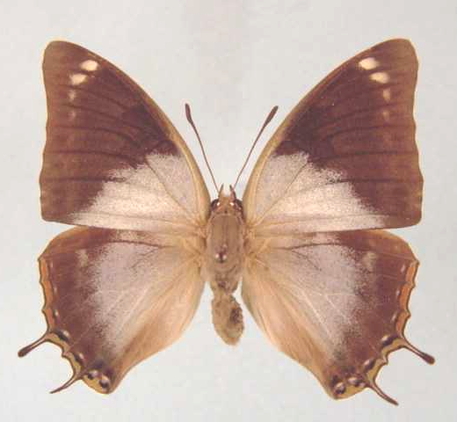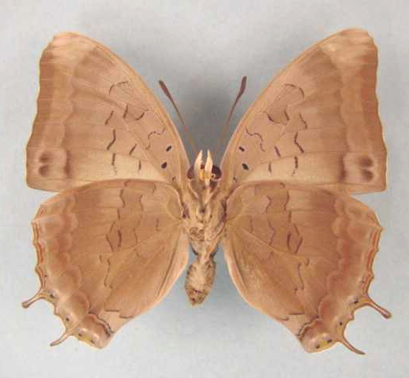

Charaxes fionae. Female. Left – upperside; right – underside. Wingspan: 47mm. Bred ex Chalnga, Zambia. Em 19/8/74. I. Bampton. (Henning collection - H274A).

Type locality: Malawi: “along the Karonga-Chipita Road, Northern Malawi”. Holotype (male) in the Transvaal Museum, Pretoria, South Africa.
Distribution: Zambia (central, south and east), Malawi, Tanzania (west).
Specific localities:
Tanzania – In the west from Gombe Stream N.P. to Ufipa; in the east from near Mozambique to Morogoro and the Nguu Mountains (Kielland, 1990).
Zambia – Ndola; Mumbwa; Lusaka; Chilanga; Mbala; Lunzua Falls; Luangwa Valley; Mafinga Mountains (Heath, et al., 2002).
Habitat: Brachystegia woodland. In Tanzania at altitudes fro 400 to 2 000 m (Kielland, 1990).
Early stages:

Henning, S., 1977: 235.

Henning, S., 1989: 332.

Larval food:
Acacia amythethophylla Steud. ex A. Rich. (syn. macrothyrsa Harms) (Fabaceae) [Henning, S., 1989: 332; Thazima, Malawi (Congdon & Bampton, unpublished 2003)].
Dalbergia boehmii Taub. (Fabaceae) [Henning, S., 1989: 332].
Entada abyssinica Steud. ex A. Rich (Fabaceae) [Henning, S., 1989: 332; Mufindi, Tanzania (Congdon & Bampton, unpublished 2003)].

Charaxes variata van Someren, 1969

Charaxes viola variata van Someren, 1969. Bulletin of the British Museum (Natural History) (Entomology) 23: 138 (75-166).

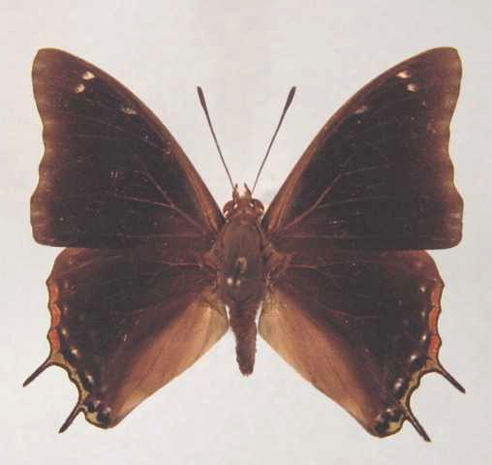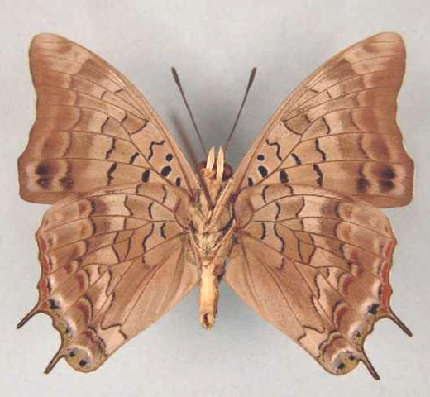

Charaxes variata. Male. Left – upperside; right – underside. Wingspan: 45mm. Chiwoma, 4500', W. Zambia. 25-7-74. I. Bampton. (Henning collection - H275).

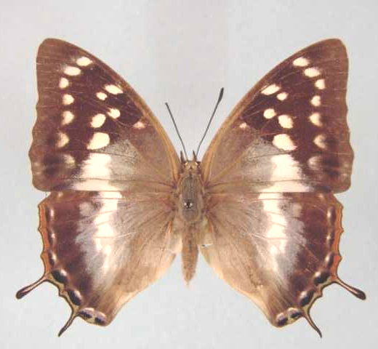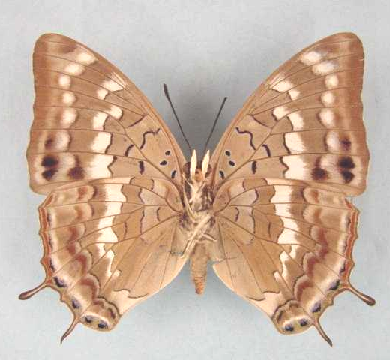

Charaxes variata. Female. Left – upperside; right – underside. Wingspan: 50mm. Chiwoma, 4500', W. Zambia. 25 July 74. I. Bampton. (Henning collection - H275A).

Type locality: Zambia: “60 miles on Mwinulunga to Kabompo Rd”. Holotype (male) in the Natural History Museum, London.
Distribution: Zambia (north-west and west).
Specific localities:
Zambia – 60, 80, and 100 km south of Mwinilunga; 50 km east of Mwinilunga; Kasangezhi; Kamapanda; Chiwoma; Kaoma, Mankoya (Heath, et al., 2002).
Habitat: Cryptosepalum forest.
Early stages:

Henning, G., 1977 (ex Bampton; Chiwoma, Zambia).

Larval food:
Cryptosepalum exfoliatum pseudotaxus (Bak. f.) Duvign and Brebab (Fabaceae) [Henning, S., 1989: 334].
Brachystegia spiciformis Benth. (Fabaceae) [Henning, S., 1989: 332; in captivity].
Brachystegia taxifolia Harms (Fabaceae) [Henning, S., 1989: 332; in captivity].
Dicrostachys cinerea (L.) Wright and Arn. (Fabaceae) [Henning, S., 1989: 332; in captivity].

tricolor van Someren, 1969 (as female f. of Charaxes viola variata). Bulletin of the British Museum (Natural History) (Entomology) 23: 140 (75-166). Zambia: “60 miles on Mwinulunga to Kabompo Rd”.

rosella van Someren, 1969 (as female f. of Charaxes viola variata). Bulletin of the British Museum (Natural History) (Entomology) 23: 140 (75-166). Zambia: “60 miles on Mwinulunga to Kabompo Rd”.

cottrelli van Someren, 1969 (as female f. of Charaxes viola variata). Bulletin of the British Museum (Natural History) (Entomology) 23: 140 (75-166). Zambia: “Mankoya”.

Charaxes diversiforma van Someren & Jackson, 1957

Charaxes viola diversiforma van Someren & Jackson, 1957. Annals of the Transvaal Museum 23: 44 (41-58).

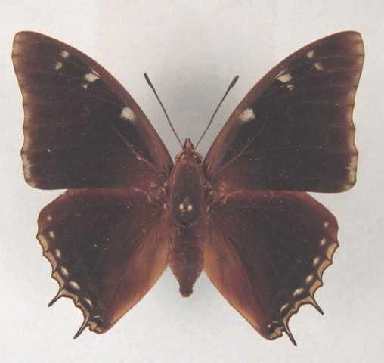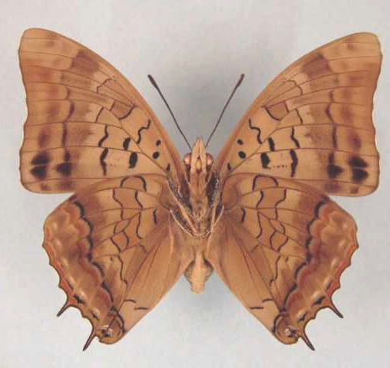

Charaxes diversiforma. Male. Left – upperside; right – underside. Wingspan: 59mm. Mwinilunga, Zambia. 28/12/73. M.N. Mitchell. (Henning collection - H276).

Type locality: Democratic Republic of Congo: “Lulua, Kapanga”. Holotype (male) in the Overlaet collection, Inst. Royal des Sciences naturelles de Belgique, Brussels.
Distribution: Democratic Republic of Congo (Lomami, Lualaba, Shaba), Zambia (north-west).
Specific localities:
Zambia – Ikelenge; Kasangezhi; Mwinilunga (Heath, et al., 2002).
Habitat: Evergreen forest.
Early stages: Nothing published.
Larval food:
Acacia amythethophylla Steud. ex A. Rich. (syn. macrothyrsa Harms.) (Fabaceae) [Henning, S., 1989: 337].
Amblygonocarpus andongensis (Welw. ex Oliv.) Exell and Torre (Fabaceae) [Henning, S., 1989: 337].

albimacula van Someren and Jackson, 1957 (as female f. of Charaxes viola diversiforma). Annals of the Transvaal Museum 23: 45 (41-58). Democratic Republic of Congo: “Kafakumba”.

ochremaculata van Someren and Jackson, 1957 (as female f. of Charaxes viola diversiforma). Annals of the Transvaal Museum 23: 45 (41-58). Democratic Republic of Congo: “Lulua, Kapanga”.

caerulescens van Someren and Jackson, 1957 (as female f. of Charaxes viola diversiforma). Annals of the Transvaal Museum 23: 45 (41-58). Democratic Republic of Congo: “Lulua, Kapanga”.

cupropurpurea van Someren and Jackson, 1957 (as female f. of Charaxes viola diversiforma). Annals of the Transvaal Museum 23: 45 (41-58). Democratic Republic of Congo: “Lulua, Kapanga”.

purpurea van Someren and Jackson, 1957 (as female f. of Charaxes viola diversiforma). Annals of the Transvaal Museum 23: 45 (41-58). Democratic Republic of Congo: “Lulua, Kapanga”.

viridicaerulea van Someren and Jackson, 1957 (as female f. of Charaxes viola diversiforma). Annals of the Transvaal Museum 23: 45 (41-58). Democratic Republic of Congo: “Lulua, Kapanga”.

albocaerulea van Someren and Jackson, 1957 (as female f. of Charaxes viola diversiforma). Annals of the Transvaal Museum 23: 45 (41-58). Democratic Republic of Congo: “Lupweshi River, Katanga”.

Charaxes williami Henning, 2002

Charaxes williami Henning, 1969. In: Heath, et al., 2002. The butterflies of Zambia: 80 (1-137).

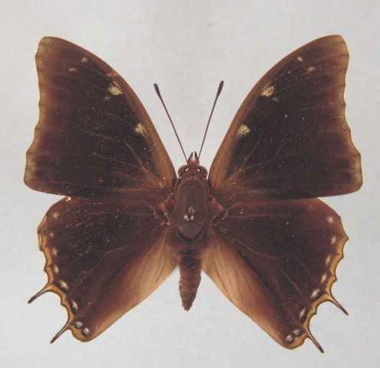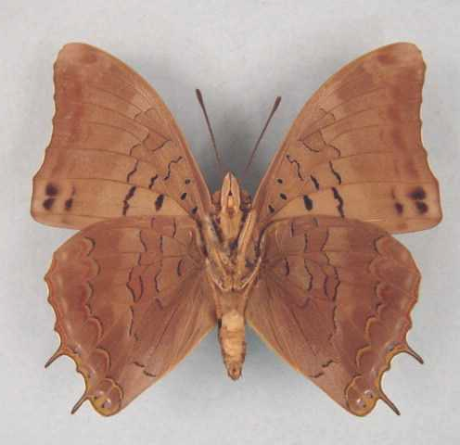

Charaxes williami. Male. Left – upperside; right – underside. Wingspan: 46mm. Bred ex Chiwoma, Zambia. Em 18/5/74. I. Bampton. (Henning collection - H277).

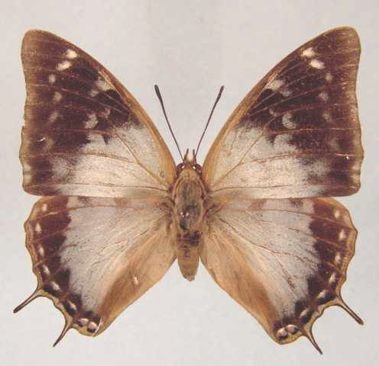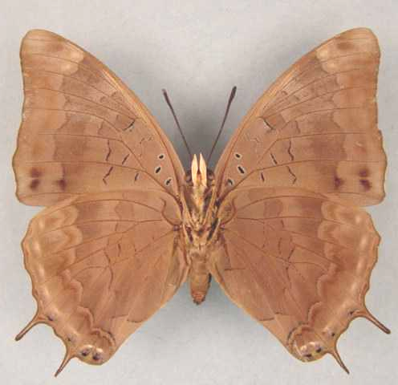

Charaxes williami. Female. Left – upperside; right – underside. Wingspan: 53mm. Chiwoma, 4500', Zambia. 31 July 75. I. Bampton. (Henning collection - H277A).

Type locality: Zambia: “Chiwoma, 1 500m, 19.v.1975, Bampton”. Holotype (male) in the Transvaal Museum, Pretoria.
Distribution: Zambia (north).
Specific localities:
Zambia – Chiwoma; Kamapanda; Lake Kashiba, Mpongwe; Chingola; Chisamba; Lunzua Falls, Mbala (Heath, et al., 2002).
Habitat: Evergreen forest.
Habits: Males establish territories along forest roads or in forest clearings. Females fly along forest roads and are also found in clearings. Both sexes are attracted to fermenting fruit and fermenting sap from injured trees (Henning, in Heath, et al., 2002).
Early stages:

Henning, G., 1977: 225 [as C. diversiforma; ex Bampton; Chiwoma, Zambia].

Larval food:
Acacia amythethophylla Steud. ex A. Rich. (syn. macrothyrsa Harms.) (Fabaceae) [Henning, S., In: Heath, et al. 2002: 80.]

Charaxes loandae van Someren, 1969

Charaxes viola loandae van Someren, 1969. Bulletin of the British Museum (Natural History) (Entomology) 23: 144 (75-166).
Type locality: Angola: “Dundo area near Loanda in the north-west district of Angola”. Holotype (male) in the Natural History Museum, London.
Distribution: Angola. Known only from the type locality.
Habitat: Brachystegia woodland.
Early stages: Nothing published.
Larval food: Nothing published.

primitiva van Someren, 1969 (as female f. of Charaxes viola loandae). Bulletin of the British Museum (Natural History) (Entomology) 23: 144 (75-166). Angola: “Dundo area near Loanda in the north-west district of Angola”.

basiviridis van Someren, 1969 (as female f. of Charaxes viola loandae). Bulletin of the British Museum (Natural History) (Entomology) 23: 145 (75-166). Angola: “Dundo area near Loanda in the north-west district of Angola”.

violitincta van Someren, 1969 (as female f. of Charaxes viola loandae). Bulletin of the British Museum (Natural History) (Entomology) 23: 145 (75-166). Angola: “Dundo area near Loanda in the north-west district of Angola”.

vansonoides van Someren, 1969 (as female f. of Charaxes viola loandae). Bulletin of the British Museum (Natural History) (Entomology) 23: 145 (75-166). Angola: “Dundo area near Loanda in the north-west district of Angola”.

protokirki van Someren, 1969 (as female f. of Charaxes viola loandae). Bulletin of the British Museum (Natural History) (Entomology) 23: 145 (75-166). Angola: “Dundo area near Loanda in the north-west district of Angola”.

instabilis van Someren, 1969 (as female f. of Charaxes viola loandae). Bulletin of the British Museum (Natural History) (Entomology) 23: 145 (75-166). Angola: “Dundo area near Loanda in the north-west district of Angola”.

Charaxes viola Butler, 1866

Charaxes viola Butler, 1866. Proceedings of the Zoological Society of London 1865: 627 (622-639).
Type locality: “West Africa”.
Distribution: Senegal, Gambia, Guinea-Bissau, Guinea, Burkina Faso, Sierra Leone, Ivory Coast, Ghana, Togo, Nigeria, Chad, Cameroon, Congo, Central African Republic, Chad, Democratic Republic of Congo, Sudan, Uganda, Kenya.
Common name: Savanna demon charaxes.
Habitat: Dry savanna and dry forest. In West Africa it is common in Sudan savanna, less so in Guinea savanna (Larsen, 2005a).
Habits: Larsen (2005a) observed thousands of specimens attracted to fallen mangoes at Ahmadu Bello University in Nigeria. Males commonly hilltop (Larsen, 2005a).
Early stages:

Henning, S., 1989: 340 (ssp. picta).

Larval food:
Entada gigas Faw. & Rand. (Fabaceae) [Van Someren, 1974: 320].
Acacia mellifera Benth. (Fabaceae) [Van Someren, 1974: 320].
Albizia adianthifolia (Schumach.) W.F. Wight (Fabaceae) [Van Someren, 1974: 320].
Albizia coriaria Welw. ex Oliv. (Fabaceae) [Van Someren, 1974: 320].
Entada abyssinica Steud. ex A. Rich. (Fabaceae) [Van Someren, 1974: 320].
Acacia amythethophylla Steud. ex A. Rich. (syn. macrothrysa Harms. (Fabaceae) [Henning, S., 1989: 340].
Albizia gummifera (J.F. Gmel.) C.A. Smith (Fabaceae) [Henning, S., 1989: 340].
Entada sudanica Schweinf. (Fabaceae) [Henning, S., 1989: 340].

Charaxes viola viola Butler, 1866

Charaxes viola Butler, 1866. Proceedings of the Zoological Society of London 1865: 627 (622-639).
Type locality: “West Africa”.
Distribution: Senegal, Gambia, Guinea-Bissau, Guinea, Burkina Faso, Sierra Leone, Ivory Coast, Ghana, Togo, Nigeria (west, north), Cameroon (lower areas), Chad (Lake Chad?).
Specific localities:
Sierra Leone – Freetown (Owen & Chanter, 1972).
Ghana – Kibi (Allyn Museum teste Larsen, 2005a).
Nigeria – Vom (Owen, 1977); Ibadan (Larsen, 2005a); Enugu (Larsen, 2005a); Kaduna (R. St Leger teste Larsen, 2005a); Zaria (Larsen, 2005a).

chiron Staudinger, 1886 in Staudinger and Schatz, 1884-8 (as sp. of Charaxes). Exotischer Schmetterlinge 1: 168 (333 pp.). Bayern. Senegal.

Charaxes viola picta van Someren & Jackson, 1952

Charaxes viola picta van Someren & Jackson, 1952. Transactions of the Royal Entomological Society of London 103: 263 (257-284).
Type locality: Uganda: “Unyoro, Uganda”. Holotype (male) in the Natural History Museum, London.
Distribution: Nigeria (east), Cameroon (mountains), Congo, Central African Republic, Democratic Republic of Congo (north-east), Sudan (south), Uganda (north), Kenya (north-west).
Specific localities:
Nigeria – Obudu Plateau (St Leger teste Larsen, 2005a).

picta Rothschild, 1900 in Rothschild and Jordan, 1900 (as male f. of Charaxes etheocles etheocles). Novitates Zoologicae 7: 483 (287-524). Uganda: “Unyoro: Kitanwa”.

vansomereni Poulton, 1926 (as female f. of Charaxes etheocles etheocles). Internationaler Entomologen-Kongress 2: 553 (518-575). Uganda: “Buyala, near Kampala, Uganda”.

splendens Rousseau-Decelle, 1938 (as f. indiv. of Charaxes etheocles). Bulletin de la Société Entomologique de France 43: 162 (161-168). Democratic Republic of Congo: “Rio Luvna (Congo belge)”.

illuminata Rousseau-Decelle, 1938 (as f. indiv. of Charaxes etheocles). Bulletin de la Société Entomologique de France 43: 163 (161-168). Democratic Republic of Congo: “Congo belge”.

Charaxes chanleri Holland, 1896

Charaxes chanleri Holland, 1896. Proceedings of the United States National Museum 18: 262 (259-264).
Type locality: [Kenya]: “Somali-Land, in the region of the Tana River”. Holotype (female) in the United States National Museum.
Distribution: Kenya (north-central, north), Ethiopia (south).
Habitat: Savanna.
Early stages: Nothing published.
Larval food: Nothing published.

Charaxes kirki Butler, 1881

Charaxes kirki Butler, 1881. Entomologist’s Monthly Magazine 18: 145 (145-146).
Type locality: Tanzania: “Mamboia, E. Africa”.
Distribution: Kenya, Tanzania, Uganda.
Habitat: Savanna and dry forest. In Tanzania the nominate subspecies is found at altitudes of 300 to 1 600 m (Kielland, 1990).
Early stages:

Henning, S., 1989: 343 (ssp. kirki).

Larval food:
Acacia mellifera (Vahl) Benth. (Fabaceae) [Henning, S., 1989: 344 (ssp. kirki)].
Albizia adianthifolia (Schumach.) W.F. Wight (Fabaceae) [Henning, S., 1989: 344].
Albizia coriaria Welw. ex Oliv. (Fabaceae) [Henning, S., 1989: 344].
Albizia schimperiana Oliv. (Fabaceae) [Henning, S., 1989: 344].
Entada abyssinica Steud. ex A. Rich. (Fabaceae) [Henning, S., 1989: 344].
Entada leptostachys Harms. (Fabaceae) [Henning, S., 1989: 344].
Entada africana Guill. And Perr. (Fabaceae) [Henning, S., 1989: 344].
Entada phaseoloides Merr. (Fabaceae) [Henning, S., 1989: 344].
Tamarindus indicus L. (Fabaceae) [Henning, S., 1989: 344].
Acacia caffra (Fabaceae) [Kielland, 1990: 105].
Albizia sassa (Fabaceae) [Kielland, 1990: 105].
Albizia gummifera (Fabaceae) [Kielland, 1990: 105].
Entada gigas (Fabaceae) [Kielland, 1990: 105].

Charaxes kirki kirki Butler, 1881

Charaxes kirki Butler, 1881. Entomologist’s Monthly Magazine 18: 145 (145-146).
Type locality: Tanzania: “Mamboia, E. Africa”. Holotype (female) in the Natural History Museum, London.
Distribution: Kenya (central and east), Tanzania (central, north and east; also Pemba Island (Kielland, 1990)).

rogersi Poulton, 1919 (as female f. of Charaxes etheocles). Proceedings of the Entomological Society of London 1918: 81 (79-84). Kenya: “Dabida, about 100 miles W.N.W. of Mombasa”.

albifascia Poulton, 1926 (as female f. of Charaxes etheocles etheocles). Internationaler Entomologen-Kongress 2: 553 (518-575). Kenya: “Dabida Mountain, Kenya Col.”.

handari Poulton, 1926 (as female f. of Charaxes etheocles etheocles). Internationaler Entomologen-Kongress 2: 555 (518-575). Tanzania: “Handari about 10 miles E. of Mvumi and 250 m. W. of Dar-es-Salaam, Tang. Terr.”.

Charaxes kirki daria Rothschild, 1903

Charaxes kirki daria Rothschild, 1903
Charaxes etheocles etheocles female form daria Jordan, 1903. Novitates Zoologicae 10: 542 (491-542).
Type locality: Ethiopia: “Jabalo and Gugura, Abyssinia”. Holotype (female) in the Natural History Museum, London.
Distribution: Ethiopia (east of the Rift Valley).

Charaxes kirki suk Carpenter & Jackson, 1950

Charaxes etheocles suk Carpenter & Jackson, 1950. Proceedings of the Royal Entomological Society of London (B) 19: 98 (97-108).
Type locality: Uganda: “at foot of small kopje in the Suk country of Uganda, one mile north of the crossing of the Swam River”. Holotype (male) in the Natural History Museum, London.
Distribution: Uganda (central and north - west of Lake Rudolf).

kirkoides Carpenter and Jackson, 1950 (as female f. of Charaxes etheocles). Proceedings of the Royal Entomological Society of London (B) 19: 98 (97-108). Uganda: “at foot of small kopje in the Suk country of Uganda, one mile north of the crossing of the Swam River”.

intermedia Carpenter and Jackson, 1950 (as female f. of Charaxes etheocles). Proceedings of the Royal Entomological Society of London (B) 19: 98 (97-108). Uganda: “at foot of small kopje in the Suk country of Uganda, one mile north of the crossing of the Swam River”.

achaemenesopsis Carpenter and Jackson, 1950 (as female f. of Charaxes etheocles). Proceedings of the Royal Entomological Society of London (B) 19: 99 (97-108). Uganda: “at foot of small kopje in the Suk country of Uganda, one mile north of the crossing of the Swam River”.

Charaxes figini van Someren, 1969

Charaxes viola figini van Someren, 1969. Bulletin of the British Museum (Natural History) (Entomology) 23: 149 (75-166).
Type locality: [Ethiopia: “Eritaea, Setit, El Eghin”.]. Holotype (male) in the Natural History Museum, Genova.
Distribution: Ethiopia (west Eritrea).
Habitat: Thornveld savanna.
Early stages: Nothing published.
Larval food: Nothing published.

figini Storace, 1948 (as male f. of Charaxes etheocles). Annali del Museo Civico di Storia Naturale (di Genova) Giacomo Doria 63: 139 (132-141). Ethiopia: “Setit (Eritraea occidental)”.

Charaxes larseni Rydon, 1982

Charaxes larseni Rydon, 1982 in Larsen, 1982. Biologiske Skrifter 23 (3): 74 (76 pp.).
Type locality: Ethiopia: “S.W. Ethiopia, Jambo area, Nanji (?Uanji) Hill”. Holotype (male) in the Natural History Museum, London.
Distribution: Ethiopia. Known only from the type locality.
Habitat: Thornveld savanna.
Early stages: Nothing published.
Larval food: Nothing published.

Charaxes bernstorffi Rydon, 1982

Charaxes bernstorffi Rydon, 1982 in Larsen, 1982. Biologiske Skrifter 23 (3): 63 (76 pp.).
Type locality: Yemen: “Jabal Bura, Suq as Sabt (900 m)”. Holotype (male) in the Natural History Museum, London.
Distribution: Yemen (type locality, Hajja, Wadi Sharas, Turbah Road).
Habitat: Dry savanna.
Early stages: Nothing published.
Larval food: Nothing published.

Charaxes vansoni van Someren, 1975

Charaxes vansoni van Someren, 1975. Bulletin of the British Museum (Natural History) (Entomology) 32: 108 (65-136).
Type locality: South Africa: “Transvaal, Pretoria”. Holotype (female) in the Transvaal Museum, Pretoria, South Africa.
Diagnosis: In males of C. vansoni the two subapical spots on the forewing upperside are blue, whereas in C. phaeus they are white and the ground colour of the hindwing underside is pale coppery brown, with the silvery sheen comparatively reduced, extending only from the base along the costa and cell (Van Son, 1979). In females of C. vansoni the median band on the upperside may be white, greenish white or bluish. The spots on the forewing upperside vary from white to orange-ochre (Pringle, et al., 1994).
Distribution: Zimbabwe, Botswana (east), Swaziland, South Africa (Limpopo Province, Mpumalanga, North West Province, Gauteng, KwaZulu-Natal).
Specific localities:
Mpumalanga – Buffelskloof Nature Reserve (Williams).
Gauteng – Buffelsdrif Conservancy (Williams).
Common name: Van Son’s charaxes.
Habitat: Dry savanna.
Habits: Males are often found hilltopping.
Flight period: All year.
Early stages:

Henning, G., 1977: 226 [as Charaxes vansoni; various localities in Limpopo Province, North West Province, Botswana and Zimbabwe].
“Ova: Usual Charaxes shape, pale green, with reddish-brown ring if fertile. The ova are laid on the upper surface of the leaves of the foodplant. Final instar larva: Headshield green with creamy lateral facial margin extending up into the lateral horns; horns long and sometimes tipped with pinkish-brown; dorsomedial spines pinkish-brown. Body green, with creamy dorsolateral somite bars on segments 6, 8 and 10 and with faint blue dorso-somitic spots. The inter-somite membrane can be creamy, giving the impression of extra bands. Lateral ridge ochreous, with anal processes creamy-yellow and pointed. The larva resembles that of Charaxes ethalion (Boisduval). Pupa: Pale green, usually immaculate but the wing-cases are sometimes finely bordered with creamy-yellow.”

Henning, S., 1979: 182 (Ent. Rec. J. Var. 91: 182).

Henning, S., 1984.

Henning, S., 1989: 346 [as Charaxes vansoni].

Larval food:
Peltophorum africanum Sond. (Fabaceae) [Henning, G., 1977: 226].
Other relevant literature:
Vane-Wright, R.I. 1976. Annals of the Transvaal Museum 30: 105-107.

vansoni van Someren and Jackson, 1957 (as female f. of Charaxes viola phaeus). Annals of the Transvaal Museum 23: 43 (41-58). South Africa: “Transvaal, Pretoria”.

Charaxes brainei van Son, 1966

Charaxes viola brainei van Son, 1966. Novos Taxa Entomologicos (49): 3 (7 pp.).
Type locality: Namibia: “Kombat, S.W. Africa”. Holotype (male) in the Transvaal Museum, Pretoria, South Africa.
Diagnosis: The female differs from that of C. vansoni in the marked suffusion of blue into the postdiscal spots of the forewing upperside and the discal band of the hindwing, and the slight violaceous shade on the hindwing underside (Pringle, et al., 1994).
Distribution: Namibia (north-east), Angola (south), Botswana (north-west).
Specific localities:
Botswana – Okavango Swamps (Pinhey).
Namibia – between Otavifontein and Grootfontein (Pennington); Kombat (J. Braine; TL); western Caprivi (S. Braine) ; Waterberg Plateau Park (Swart, 2004).
Common name: Braine’s charaxes.
Habitat: Dry savanna.
Habits: Similar to those of C. vansoni but seems to be more readily attracted to fermenting fruit than vansoni.
Flight period: October to June; commonest in March and April (Pringle, et al., 1994).
Early stages:

Henning, S., 1989: 348 [as Charaxes brainei].

Larval food:
(Probably) Peltophorum africanum Sond. (Fabaceae) [Van Son, 1979: 210].
Peltophorum africanum Sond. (Fabaceae) [Henning, S., 1989: 348].

Charaxes berkeleyi van Someren & Jackson, 1957

Charaxes berkeleyi van Someren & Jackson, 1957. Annals of the Transvaal Museum 23: 52 (41-58).
Type locality: Kenya: “Ngong”. Holotype (male) in the Natural History Museum, London.
Diagnosis: Similar, externally, to C. aubyni but the genitalia are distinctive. Compared to C.aubyni the male forewing marginal spots are bluer and the underside is darker; in the female the forewing has two rows of pale yellow to ochreous spots and the median band of the hindwing is white, blue-bordered and narrower than in C. aubyni (Kielland, 1990). There are two female forms: the usual form with brownish underside and yellowish spots on the upperside; form ngonga with whitish median band on upperside and silvery grey underside that has strongly contrasted black markings (Kielland, 1990).
Distribution: Kenya, Tanzania.
Habitat: Montane and riverine forest. In Tanzania it is found in dry evergreen forest at high altitudes (1 900 to 2 600 m) (Kielland, 1990).
Habits: Strongly attracted to fermented bananas (Kielland, 1990).
Early stages:

Van Someren and Jackson, 1957 (ssp. berkeleyi).

Henning, S., 1989: 349.

Larval food:
Albizia gummifera (J.F. Gmel.) C.A. Smith (Fabaceae) [Van Someren, 1974: 320].
Scutia myrtina (Burm. f.) Kurz. (Rhamnaceae) [Van Someren, 1974: 320].
Ochna holstii Engl. (Ochnaceae) [Henning, S., 1989: 350].
Ochna insculpta Scleumer (Ochnaceae) [Henning, S., 1989: 350].

Charaxes berkeleyi berkeleyi van Someren & Jackson, 1957

Charaxes berkeleyi van Someren & Jackson, 1957. Annals of the Transvaal Museum 23: 52 (41-58).
Type locality: Kenya: “Ngong”. Holotype (male) in the Natural History Museum, London.
Distribution: Kenya (central and south), Tanzania (north).
Specific localities:
Kenya – Ngong Hills (TL); Loita Hills; Namanga; Longido (Congdon and Collins, 1998).
Tanzania – Mount Longido; Loliondo (Kielland, 1990).

ngonga van Someren, 1969 (as f. of Charaxes berkeleyi). Bulletin of the British Museum (Natural History) (Entomology) 23: 80 (75-166). No locality given.

Charaxes berkeleyi marci Congdon & Collins, 1998

Charaxes berkeleyi marci Congdon & Collins, 1998. In: Supplement to Kielland’s butterflies of Tanzania: 52 (143 pp.). Abri and Lambillionea.
Type locality: Tanzania: “West Mt. Kilimanjaro, 7000 ft, iii. 1993. S.C. Collins.” Holotype (female) in African Butterfly Research Institute, Nairobi.
Diagnosis: The female differs from those of the other subspecies, on the forewing upperside, in that the postdiscal spotting is reduced, and in the hindwing upperside, in that the discal band is broader. The bands on the upperside of both wings are the same colour in females of marci, whereas, in other subspecies, the hindwing markings are paler than those on the forewing (Congdon and Collins, 1998).
Distribution: Tanzania (north). Known only from the type locality.

Charaxes berkeleyi masaba van Someren, 1969

Charaxes berkeleyi masaba van Someren, 1969. Bulletin of the British Museum (Natural History) (Entomology) 23: 82 (75-166).
Type locality: Kenya: “East Mt. Elgon, Teldet Estate”. Holotype (female) in the collection of Mr Lloyd.
Distribution: Kenya (west - from Kaptagat to eastern slopes of Mt Elgon).

Charaxes aubyni van Someren & Jackson, 1952

Charaxes aubyni van Someren & Jackson, 1952. Transactions of the Royal Entomological Society of London 103: 272 (257-284).
Type locality: Kenya: “Dabida, Teita Hills, Kenya”. Holotype (female) in the Natural History Museum, London.
Distribution: Kenya, Tanzania, Malawi, Zambia.
Habitat: Montane and semi-montane forest. In Tanzania the nominate subspecies is found at altitudes of 400 to 2 400 m; ssp. australis occurs at altitudes of 350 to 1 800 m (Kielland, 1990).
Early stages:

Henning, S., 1989: 352 (ssp. ecketti and ssp. australis).

Larval food:
Albizia gummifera (J.F. Gmel.) C.A. Smith (Fabaceae) [Van Someren, 1974: 320].
Albizia adianthifolia (Schumach) W.F. Wight (Fabaceae) [Henning, S., 1989: 353].
Albizai schimperana Oliv. (Fabaceae) [Henning, S., 1989: 353].

Charaxes aubyni aubyni van Someren & Jackson, 1952

Charaxes aubyni van Someren & Jackson, 1952. Transactions of the Royal Entomological Society of London 103: 272 (257-284).
Type locality: Kenya: “Dabida, Teita Hills, Kenya”. Holotype (female) in the Natural History Museum, London.
Distribution: Kenya (south-east), Tanzania (north-east).
Specific localities:
Kenya – Teita; Mbololo; Sagala Hills; Dabida (TL) (Henning, 1989).
Tanzania – Mount Kilimanjaro; Monduli; Usambara Mountains; Uluguru Mountains (Henning, 1989); Kwaraha Mountain; Lossoganeu Mountain; Pare Mountains; North Nguu Mountains; Nguru Mountains; Ukaguru Mountains; Rubeho Mountains (Kielland, 1990).

aubyni Poulton, 1926 (as female f. of Charaxes etheocles). Internationaler Entomologen-Kongress 2: 552 (518-575). Kenya: “Dabida Mountain”.

Charaxes aubyni australis van Someren & Jackson, 1957

Charaxes aubyni australis van Someren & Jackson, 1957. Annals of the Transvaal Museum 23: 47 (41-58).

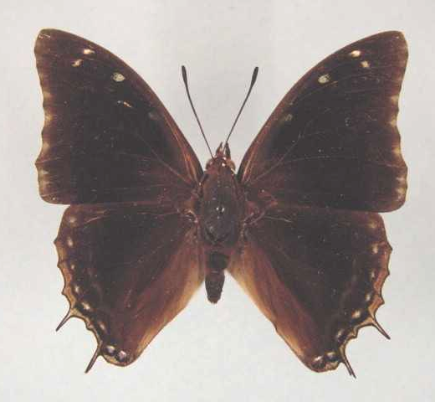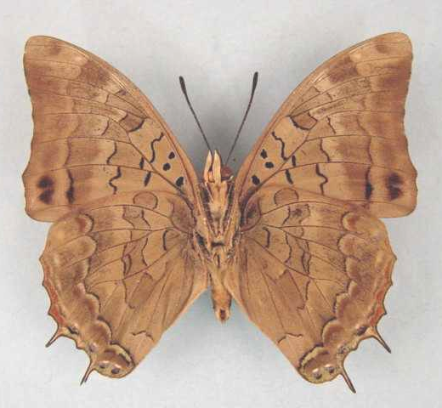

Charaxes aubyni australis. Male. Left – upperside; right – underside. Wingspan: 58mm. Zomba Mt, Malawi. Apr ‘71. Dr. McCleery. (Henning collection - H278).

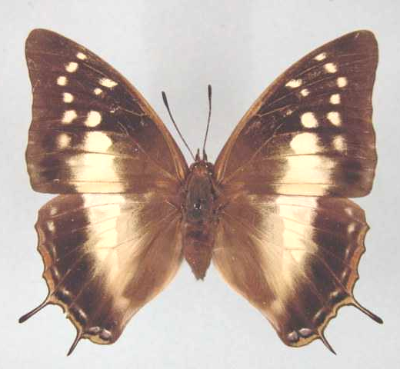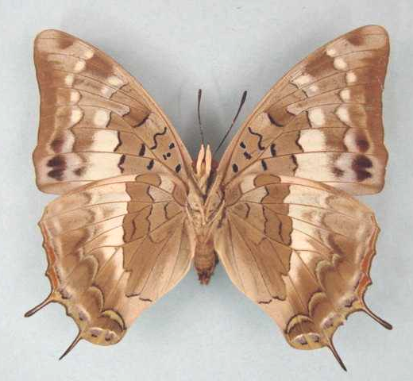

Charaxes aubyni australis. Female. Left – upperside; right – underside. Wingspan: 65mm. Zomba, Malawi. March 72. Dr C. McCleery. (Henning collection - H278A).

Type locality: Malawi: “Nyamkowa Mt., N. Nyasaland”. Holotype (male) in the Bulawayo Museum, Zimbabwe.
Diagnosis: Very similar to the nominate subspecies (Kielland, 1990).
Distribution: Malawi, Tanzania (south and south-central), Zambia.
Specific localities:
Tanzania – Uzungwa Range; Mount Rungwe; Kitesa Forest (Kielland, 1990).
Malawi – Nyamkoma Mt. (TL), Mt. Mulanje; Blantyre; Limbe; Zomba; Nyika Plateau (Henning, 1989).
Zambia – Mafinga Mountains (Heath, et al., 2002).

Charaxes aubyni ecketti van Someren & Jackson, 1957

Charaxes aubyni ecketti van Someren & Jackson, 1957. Annals of the Transvaal Museum 23: 48 (41-58).
Type locality: Kenya: “Ngong”. Holotype (male) in the Natural History Museum, London.
Distribution: Kenya (central and south-west).
Specific localities:
Kenya – Ngong (TL); Nairobi; Kikuyu; Aberdares; Mt Kenya; Mau; Sotik; upper Mara River; Lower Imenti Forest (Henning, 1989).

ochreotincta van Someren and Jackson, 1957 (as female f. of Charaxes aubyni ecketti). Annals of the Transvaal Museum 23: 49 (41-58). Kenya: “Ngong”.

Charaxes sidamo Plantrou & Rougeot, 1979

Charaxes aubyni sidamo Plantrou & Rougeot, 1979. Bulletin de la Société Entomologique de France 84: 141 (138-142).
Type locality: Ethiopia: “Ethiopie, Kébré-Mengist”. Holotype (male) in the Muséum national d’Histoire naturelle, Paris.
Distribution: Ethiopia (south, north-east).
Habitat: Thornbush savanna.
Early stages: Nothing published.
Larval food: Nothing published.

smilesi Rydon, 1982 (as sp. of Charaxes). In: Larsen, 1982. Biologiske Skrifter 23 (3): 68 (76 pp.). Ethiopia: “S.W. Ethiopia, Jimma (Djimma), Kankati”. [Also known from Adola in north-east Ethiopia.].

Charaxes contrarius van Someren, 1969

Charaxes contrarius van Someren, 1969. Bulletin of the British Museum (Natural History) (Entomology) 23: 119 (75-166).
Type locality: Tanzania: “Deutsch-Ostafrika”. Holotype (male) in the Berlin Museum.
Distribution: Kenya (coast), Tanzania (coast).
Diagnosis: Related to C. etheocles, C. grahamei and C. petersi. The female has two main forms (Kielland, 1990). The populations in the Kitonga Gorge and at the Lumuma Mission may represent an undescribed subspecies (Kielland, 1990: 100).
Specific localities:
Kenya – Lamu (Mundane Range); Arabuko-Sokoke Forest; Rabai Hills; Shimba Hills; Zombo; Marima Hill (Henning, 1989).
Tanzania – Usambara Mountains; Ruga Forest (south of Lindi) (Henning, 1989); lower parts of the Uluguru Mountains; Nguru Mountains; Kanga Mountains; Nguu Mountains; Kitonga Gorge on the Ruaha River; Lumuma Mission on the banks of the Lukozi River in the Rubeho Mountains (Kielland, 1990).
Habitat: Lowland forest, heavy coastal woodland and riverine vegetation, from near sea-level to 700 m (Kielland, 1990).
Early stages:

Henning, 1989: 355.

Larval food:
Albizia species (Fabaceae) [Henning, S., 1989: 355].

contrarius Weymer, 1907 (as var. of Charaxes etheocles). Deutsche Entomologische Zeitschrift, Iris 20: 44 (1-51). Tanzania: “Deutsch-Ostafrika”.

subargentea van Someren and Rogers, 1932 (as male f. of Charaxes etheocles). Journal of the East Africa and Uganda Natural History Society 1931 (42, 43): 167 (141-172). No locality given.

conjugens van Someren, 1969 (as f. of Charaxes contrarius). Bulletin of the British Museum (Natural History) (Entomology) 23: 121 (75-166). Kenya: “Forests of the Shimba Hills, Kwale District”.

tenebrosus Kielland, 1990 (as ssp. of Charaxes contrarius). Butterflies of Tanzania 321 (363 pp.). Melbourne. Nomen nudum.

Charaxes pembanus Jordan, 1925

Charaxes etheocles pembanus Jordan, 1925. Novitates Zoologicae 32: 289 (288-289).
Type locality: Tanzania: “Pemba Island”. Holotype (male) in the Natural History Museum, London.
Diagnosis: Similar to C. usambarae but with shorter tails, less dentate wing margins and the females with larger pale forewing spots (Kielland, 1990).
Distribution: Tanzania (Pemba Island).
Specific localities:
Tanzania – confined to Pemba Island (Kielland, 1990).
Habitat: Forest margins and woodland (Kielland, 1990).
Early stages: Nothing published.
Larval food:
(Probably) Albizia (Fabaceae) [Kielland, 1990: 107].

coelestissima Turlin, 1987 (as female f. of Charaxes pembanus). Bulletin de la Société Scientifique Naturelle (53): 24 (19-25). Tanzania: “Ile Pemba”.

Charaxes usambarae van Someren & Jackson, 1952

Charaxes pembanus usambarae van Someren & Jackson, 1952. Transactions of the Royal Entomological Society of London 103: 275 (257-284).
Type locality: Tanzania: “Usambara”. Holotype (male) in the Joicey bequest, Natural History Museum, London.
Distribution: Tanzania.
Habitat: Lowland, submontane and montane forest. The nominate subspecies occurs at altitudes above 800 m and ssp. maridadi from 400 to 2 100 m (Kielland, 1990).
Early stages:

Henning, S., 1989: 357 (ssp. usambarae).

Larval food:
Albizia zimmermannii Harms. (Fabaceae) [Henning, S., 1989: 357].
Albizia gummifera (J.F. Gmel.) C.A. Smith (Fabaceae) [Henning, S., 1989: 357].

Charaxes usambarae usambarae van Someren & Jackson, 1952

Charaxes pembanus usambarae van Someren & Jackson, 1952. Transactions of the Royal Entomological Society of London 103: 275 (257-284).
Type locality: Tanzania: “Usambara”. Holotype (male) in the Joicey bequest, Natural History Museum, London.
Distribution: Tanzania (north-east)
Specific localities:
Tanzania – Usambara Mountains (Kielland, 1990).

mariae Mollet, 1974 (as female f. of Charaxes usambarae). Bulletin de la Société Entomologique de France 79: 215 (215-216). Tanzania: “Nord de la Tanzanie, Monts Usambara, Amani, 1800 m”.

collinsi van Someren, 1975 (as female f. of Charaxes usambarae). Bulletin of the British Museum (Natural History) (Entomology) 32: 105 (65-136). Tanzania: “Usambara Mts, Amani”.

Charaxes usambarae maridadi Collins, 1987

Charaxes usambarae maridadi Collins, 1987. Lambillionea 87: 95 (92-96).
Type locality: Tanzania: “Kwadiboma-Nguu Mtn”.
Diagnosis: Smaller than nominate subspecies; tails shorter; wing margins less dentate; forewing outer margin less concave (Kielland, 1990).
Distribution: Tanzania (north-east)
Specific localities:
Tanzania – Nguru Mountains, North Nguu Mountains, Kanga Mountain (Kielland, 1990).

pseudorosae Collins, 1987 (as f. of Charaxes usambarae maridadi). Lambillionea 87: 95 (92-96). Tanzania: “Mkombola Nguru Mtn”.

bella Collins, 1987 (as f. of Charaxes usambarae maridadi). Lambillionea 87: 96 (92-96). Tanzania: “Kwadiboma Nguu Mtn”.

Charaxes martini van Someren, 1966

Charaxes martini van Someren, 1966. Bulletin of the British Museum (Natural History) (Entomology) 18: 96 (45-101).
Type locality: Malawi: “Mlosa stream, Mlange”.
Distribution: Malawi.
Habitat: Riparian forest.
Early stages:

Henning, S., 1982 (ssp. martini).

Henning, S., 1989: 359 (ssp. helenae).

Larval food:
Diospyros natalensis natalensis (Harv.) Brenan (Ebenaceae) [Henning, S., 1989: 360].

Charaxes martini martini van Someren, 1966

Charaxes martini van Someren, 1966. Bulletin of the British Museum (Natural History) (Entomology) 18: 96 (45-101).
Type locality: Malawi: “Mlosa stream, Mlange”. Holotype (male) in the Natural History Museum, London.
Distribution: Malawi (Mt Mlanje). Known only from the type locality.

Charaxes martini helenae Henning, 1982

Charaxes martini helenae Henning, 1982. Miscellanea Entomologica 49: 94 (93-97).
Type locality: Malawi: “Chingwes Hole, Zomba Mountain”. Holotype (male) in the Natural History Museum, London.
Distribution: Malawi (to the west and north of the Zomba Plateau).

Charaxes gallagheri van Son, 1962

Charaxes gallagheri van Son, 1962. Journal of the Entomological Society of Southern Africa 25: 146 (140-148).

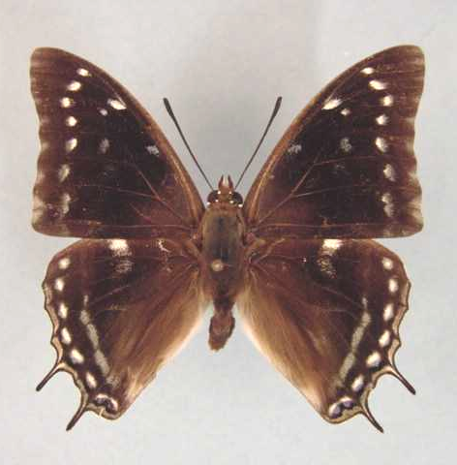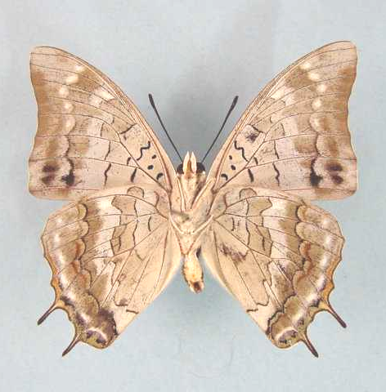

Charaxes gallagheri. Male. Left – upperside; right – underside. Wingspan: 51mm. Christon Bank, S. Rhodesia. 23/3/62. A.J. Duke. (Transvaal Museum - TM3418).

Type locality: Zimbabwe: “Mapembi (Umtali Dist., S. Rhodesia)”. Holotype (male) in the Transvaal Museum, Pretoria, South Africa. The female was described by van Son in 1963: 9.
Distribution: Zimbabwe (central and east), Zambia.
Specific localities:
Zambia – A single female taken by Dening at Kundalila Falls, at the top of the Luano Valley escarpment (Heath, et al., 2002); Mutinondo Wilderness Area near Mpika (Congdon & Bampton, unpublished 2003).
Zimbabwe – Mapembi, Mutare district (TL); Odzi River Basin (Gallagher and Schofield); Christon Bank and Bromley, near Harare (Duke, Chitty and Cottrell); near Masvingo (Pringle, et al., 1994); Chitora Hills; Mutare; Bikita (Pinhey); near Mutare (Barnes).
Common name: Gallagher’s charaxes.
Habitat: Granite-boulder hills, in ‘msasa’ savanna.
Habits: Males hilltop, using low bushes as perches. Females are seldom seen and appear to fly at random on the lower slopes of hills. Both sexes have a rather leisurely flight for the genus (Pringle et al., 1994).
Flight period: Apparently double-brooded, flying in November and December and again from late February to April (Mullin, cited by Pringle, et al., 1994).
Early stages:

Henning, G., 1977: 223 [as Charaxes gallagheri; Kyle Dam and Christon Bank (near Harare), both Zimbabwe].
“Ova: Usual Charaxes shape, yellowish-white with a brown ring if fertile. They are laid singly on both the upper and undersides of the leaves of the foodplant. Final instar larva: Headshield green, with a faint, light green facial margin; horns long, with the upper two thirds dark pinkish-brown; dorso-medial spines black. Body green, with broad dorso-lateral somite bars on segments 6, 8 and sometimes 10. The somite bars are pinkish-white, anteriorly edged with black spotted with blue; the dorso-somitic spots on segments 6 and 8 are blue. Lateral ridge green and anal processes short and square. Pupa: Plain green in colour.”

Chitty, 1982: 147. (Ent. Rec. J. Var. 94: 147-150).

Henning, S., 1989: 361.

Larval food:
Diospyros natalensis (Harv.) Brenan subsp. nummularia (Brenan) F. White (Ebenaceae) [White, 1962].

Charaxes guderiana (Dewitz, 1879)

Nymphalis guderiana Dewitz, 1879. Nova Acta Academiae Caesarea Leopoldino-Carolinae Germanicum Naturae Curiosorum 4 (2): 200 (173-212).

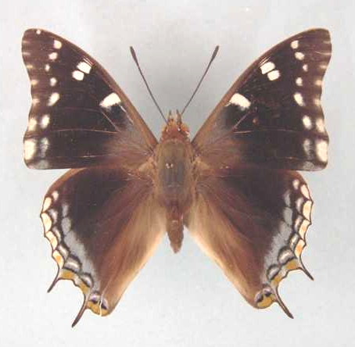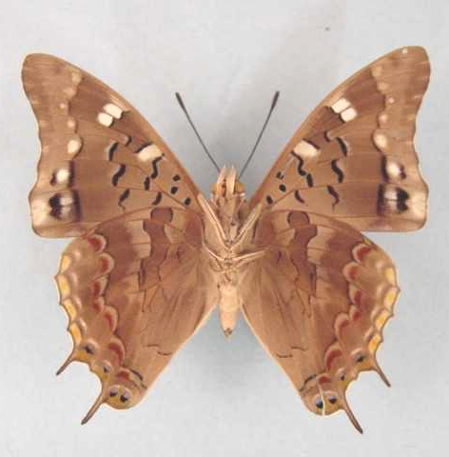

Charaxes guderiana guderiana. Male. Left – upperside; right – underside. Wingspan: 58mm. Bomponi, Vumba, S. R. 8:8:60. H. Cookson. (Transvaal Museum - TM3419).

Type locality: Angola: “10° S.B. und zwischen dem 17-22° O.C van Greenw.”.
Distribution: Angola, Namibia, Botswana, Zimbabwe, Zambia, Democratic Republic of Congo, Kenya, Rwanda, Tanzania, Malawi, Mozambique, South Africa.
Common name: Blue-spangled charaxes.
Habitat: Brachystegia woodland. In Tanzania from near sea-level to 2 300 m (Kielland, 1990). Also found, on occasion, in montane forest (Kielland, 1990).
Habits: Males do not appear to show hilltopping behaviour. Both sexes have a propensity for settling on the trunks of trees. Both sexes are also strongly attracted to fermenting fruit (Pringle, et al., 1994). Larsen (cited by Pringle, et al., 1994) has observed males of this species imbibing the moisture from lion dung.
Flight period: All year (Pringle, et al., 1994).
Early stages:

Fountaine, 1911: 51 [C. guderiana guderiana as C. guderiana; Mutare, Zimbabwe].

Van Someren and Rogers, 1931: 28 [ssp. rabaiensis].
“The eggs of this species are laid on the leaves of two species of Brachystegia, they are deposited either on the upper- or underside. They are creamy-white, with a slight depression on the top which is fluted, the ridges being rather ill-defined. Eight to ten days elapse before the larva emerges; it eats the shell and then rests for an hour or two. The first stage colour is olive-green, with the head black, and tail whitish. When the larva becomes about 7 mm it moults and then is green with very fine papillary marks; the head is now green also, with dark tips to the horns. At the third stage, a yellowish lateral line is developed, as also dorsal ornamentation on the sixth and eighth segments. These dorsal marks are not very apparent until the last stage, when they appear as slightly raised spots arranged in the form of a triangle, the apex pointing forward. The head is darker green than the body, rather elongate, though the facial disc is rather markedly convex, and the horns are strong, somewhat divergent, green at the bases and only slightly darker at the tip. The facial line, not very pronounced, is yellowish. The two central pairs of short spines are bluish. The pupa is small, about 20 mm, light green in colour, without any dark markings except at the anal end where at the front of the pedicle, two rows of three tubercles, ochreous in colour, the distal rather further set out than the others and larger, enclose a double forked yellow excrescence. The whole surface of the pupal case has a “frosted” appearance, accentuated on the upper margins of the wing scutae. The spiracular dots are yellowish. Pupal stage lasts a fortnight to three weeks.”

Henning, S., 1989: 363 [ssp. guderiana; material from Zimbabwe and Zambia].

Larval food:
Amblygonocarpus andongensis (Welw. ex Oliv.) Excell and Torre (Fabaceae) [Dickson and Kroon, 1978: 62 (ssp. guderiana)].
Brachystegia appendiculata Benth. (Fabaceae) [Fountaine, 1911: 51 (ssp. guderiana); Mutare, Zimbabwe].
Brachystegia boehmii Taub. (Fabaceae) [Dickson and Kroon, 1978: 62 (ssp. guderiana)].
Brachystegia glaucescens Burtt Davy and Hutch. (Fabaceae) [Henning, S., 1989: 364(ssp. guderiana)].
Brachystegia longifolia Benth. (Fabaceae) [Henning, S., 1989: 364 (ssp. guderiana)].
Brachystegia manga De Wild. (Fabaceae) [Henning, S., 1989: 364 (ssp. guderiana)].
Brachystegia microphylla De Wild. (Fabaceae) [Pringle, et al., 1994: 94 (ssp. guderiana)].
Brachystegia randii Baker (Fabaceae) [Van Someren and Rogers, 1931: 28 (ssp. rabaiensis)].
Brachystegia spiciformis Benth. (syn. edulis Hutch. and Burtt Davy) (Fabaceae) [Van Someren and Rogers, 1931: 28 (ssp. rabaiensis); Henning, S., 1989: 364 (ssp. guderiana)].
Brachystegia taxifolia Harms. (Fabaceae) [Dickson and Kroon, 1978: 62 (ssp. guderiana)].
Brachystegia utilis Burtt Davy and Hutch. (Fabaceae) [Pringle, et al., 1994: 94 (ssp. guderiana)].
Dalbergia lactea Vatke (Fabaceae) [Pringle, et al., 1994: 94 (ssp. guderiana)].
Dalbergia melanoxylon Guill. and Perr. (Fabaceae) [Van Someren, 1974: 319 (ssp. rabaiensis); Henning, S. 1989: 364 (ssp. guderiana)].
Julbernardia globiflora (Benth.) Troupin (Fabaceae) [Dickson and Kroon, 1978: 62 (ssp. guderiana)].
Julbernardia paniculata (Benth.) Troupin (Fabaceae) [Pringle, et al., 1994: 94 (ssp. guderiana)].

Charaxes guderiana guderiana (Dewitz, 1879)

Nymphalis guderiana Dewitz, 1879. Nova Acta Academiae Caesarea Leopoldino-Carolinae Germanicum Naturae Curiosorum 4 (2): 200 (173-212).

Charaxes guderiana guderiana. Male. Left – upperside; right – underside. Wingspan: 58mm. Bomponi, Vumba, S. R. 8:8:60. H. Cookson. (Transvaal Museum - TM3419).

Type locality: Angola: “10° S.B. und zwischen dem 17-22° O.C van Greenw.”.
Distribution: Angola, Namibia (north-east), Botswana (north-east), Zimbabwe, Zambia, Democratic Republic of Congo (Uele, Kivu, Sankuru, Lualaba, Lomami, Shaba), Rwanda, Tanzania (south and west), Malawi, Mozambique, South Africa (Limpopo Province).
Specific localities:
Tanzania – In most parts except the Northern Highlands (Kielland, 1990).
Botswana – Kasane (Larsen).
Limpopo Province – Gundani.

tanganyika Robbe, 1892 (as var. of Charaxes pelias). Annales de la Société Entomologique de Belgique 36: 133 (132-134). Tanzania: “region du Tanganika”.

burtti Carpenter, 1945 (as ab. of Charaxes guderiana). Proceedings of the Royal Entomological Society of London (B) 14: 85 (81-88). Tanzania: “70 miles north of Kondoa Irangi, Kikori”.

Charaxes guderiana rabaiensis Poulton, 1929

Charaxes guderiana rabaiensis Poulton, 1929 in Eltringham, et al., 1929. Transactions of the Entomological Society of London 77: 482 (475-504).
Type locality: Kenya: “Rabai”.
Distribution: Kenya (coast).

Charaxes kheili Staudinger, 1896

Charaxes kheili Staudinger, 1896. Deutsche Entomologische Zeitschrift, Iris 9: 216 (193-240).
Type locality: Central African Republic: “Njamnjam-Gebiet”. Holotype (male) in the Berlin Museum.
Distribution: Cameroon, Gabon, Central African Republic, Democratic Republic of Congo (north-west).
Recorded, in error, from Nigeria (Larsen, 2005a).
Habitat: Woodland savanna.
Early stages: Nothing published.
Larval food: Nothing published.

curvilinea Basquin and Turlin, 1986 (as female f. of Charaxes kheili). Bulletin de la Société Scientifique Naturelle (52): 1 (1-2). Central African Republic: “Bangui”.

flavimacula Basquin and Turlin, 1986 (as female f. of Charaxes kheili). Bulletin de la Société Scientifique Naturelle (52): 2 (1-2). Central African Republic: “Bangui”.

caeruleolinea Basquin and Turlin, 1986 (as female f. of Charaxes kheili). Bulletin de la Société Scientifique Naturelle (52): 2 (1-2). Central African Republic: “Bangui”.

Charaxes northcotti Rothschild, 1899

Charaxes northcotti Rothschild, 1899. Entomologist 32: 171 (171-172).
Type locality: Ghana: “Gambaga, northern territories of the Gold Coast”. Holotype (male) in the Natural History Museum, London.
Distribution: Guinea, Burkina Faso, Ivory Coast (north), Ghana, Nigeria.
Specific localities:
Guinea – Fouta Djalon (Larsen, 2005a); Park National du Haut Niger (Larsen, 2005a).
Burkina Faso – Bobo Diallassou (Larsen, 2005a).
Ghana – Gambaga (TL); Boabeng-Fiema (Larsen, 2005a); near Kaduna (H. Boersma teste Larsen, 2005a).
Nigeria – Vom (Owen, 1977); Gashaka-Gumpti (Larsen, 2005a); Shaki (Larsen, 2005a); Kaduna (R. St Leger teste Larsen, 2005a).
Common name: Northcott’s charaxes.
Habitat: Dense woodland savanna and gallery forest (Larsen, 2005a).
Habits: A relatively uncommon butterfly (Larsen, 2005a).
Early stages: Nothing published.
Larval food: Nothing published.

PLEIONE GROUP

Charaxes pleione (Godart, 1824)

Nymphalis pleione Godart, 1824 in Latreille and Godart, [1819], [1824]. Encyclopédie Méthodique. Histoire Naturelle [Zoologie] 9 Entomologie: 366 (1-328 [1819], 329-828 [1824]). Paris.
Type locality: “Antilles”. [False locality.]
Diagnosis: Similar to C. paphianus but but forewing apex not attenuated (Kielland, 1990).
Distribution: Guinea, Sierra Leone, Liberia, Ivory Coast, Ghana, Nigeria, Cameroon, Gabon, Congo, Central African Republic, Angola, Democratic Republic of Congo, Uganda, Kenya, Rwanda, Tanzania.
Common name: Square-winged red charaxes.
Habitat: Forest and woodland savanna. In Tanzania ssp. bebra occurs at altitudes from 800 to 1 500 m and ssp. oriens from 250 to 1 600 m (Kielland, 1990). In West Africa it has been found in cola plantations and other agricultural settings where a closed canopy of trees is present (Larsen, 2005a).
Habits: The flight is weak for a charaxes and it is a fairly unobtrusive species (Larsen, 2005a). Specimens frequently settle on the leaves of tall bushes. Seldom attracted to fermenting bananas but males have been observed on otter droppings (Kielland, 1990) and monkey dung (Larsen, 2005a).
Early stages:

Henning, S., 1989: 370 (ssp. oriens).

Larval food:
Acacia pennata Willd. (Fabaceae) [Van Someren, 1974: 320].
Acacia brevispica Harms (Fabaceae) [Henning, 1989: 370].

Charaxes pleione pleione (Godart, 1824)

Nymphalis pleione Godart, 1824 in Latreille and Godart, [1819], [1824]. Encyclopédie Méthodique. Histoire Naturelle [Zoologie] 9 Entomologie: 366 (1-328 [1819], 329-828 [1824]). Paris.
Type locality: “Antilles”. [False locality.]
Distribution: Guinea, Sierra Leone, Liberia, Ivory Coast, Ghana, Nigeria.
Specific localities:
Sierra Leone – Freetown (Owen & Chanter, 1972).
Ivory Coast – Bossematie (H. Fermon teste Larsen, 2005a).
Ghana – Atewa Range (Joly, 2003); Bia National Park (Larsen, 2005a).

lichas Doubleday, 1849 in Doubleday and Westwood [1846-52] (as sp. of Philognoma). The genera of diurnal Lepidoptera, London: pl. 49 [1849], 311 [1850] (1: 1-250 pp.; 2: 251-534 pp.). London. Ghana: “Ashanti”.

othello Suffert, 1904 (as ab. female of Charaxes lichas). Deutsche Entomologische Zeitschrift, Iris 17: 123 (108-123). Togo.

Charaxes pleione bebra Rothschild, 1900

Charaxes lichas bebra Rothschild, 1900 in Rothschild and Jordan, 1900. Novitates Zoologicae 7: 507 (287-524).
Type locality: Democratic Republic of Congo: “Great Forest of the upper Congo: Diapanda, six days’ march from Ft. Beni”.
Distribution: Democratic Republic of Congo (north-east), Uganda, Kenya (south-west), Tanzania (north-west).
Specific localities:
Tanzania – Ntakatta Forest; Mukuyu Forest; Kemfu Forest (the latter two forests have been cut down) (Kielland, 1990).

Charaxes pleione congoensis Plantrou, 1989

Charaxes pleione congoensis Plantrou, 1989. In: Henning, 1989. The Charaxinae butterflies of Africa 368 (457 pp.). Johannesburg.
Type locality: Central African Republic: “Bangui”. Holotype (male) in the Muséum national d’Histoire naturelle, Paris.
Distribution: Nigeria (extreme south-east), Cameroon, Gabon, Congo, Central African Republic, Angola, Democratic Republic of Congo (except the north-east).
Specific localities:
Nigeria – Oban Hills (Larsen, 2005a).

pallida Lathy, 1925 (as female ab. of Charaxes pleione). Encyclopédie Entomologique (B.3. Lepidoptera) 1: 95 (93-97). Cameroon: “Bitje”.

Charaxes pleione delvauxi Turlin, 1987

Charaxes pleione delvauxi Turlin, 1987. Bulletin de la Société Scientifique Naturelle (53): 21 (19-25).
Type locality: Rwanda: “Route Delvaux, Km 14, Forêt Nyungwe”. Holotype (male) in the Muséum national d’Histoire naturelle, Paris.
Distribution: Rwanda (south-west).

Charaxes pleione oriens Plantrou, 1989

Charaxes pleione oriens Plantrou, 1989. In: Henning, 1989. The Charaxinae butterflies of Africa 369 (457 pp.). Johannesburg.
Type locality: Tanzania: “Tanzanie, Amani, Mts Usambara 1000 m”. Holotype (male) in the Muséum national d’Histoire naturelle, Paris.
Diagnosis: Darker than ssp. bebra and with a narrower black margin in the lower part of the forewing upperside (Kielland, 1990).
Distribution: Kenya (coast), Tanzania (east).
Specific localities:
Kenya – Shimba Hills (Henning, S., 1989).
Tanzania – Usambara Mountains; Morogoro; Turiani; Nguru Mountains; Uluguru Mountains; Ifakara (Henning, 1989); Nguu Mountains; Uzungwa Rift; Magombera Forest (Kielland, 1990); Rau Forest, near Moshi (Cordeiro vide Kielland, (1990).

Charaxes paphianus Ward, 1871

Charaxes paphianus Ward, 1871. Entomologist’s Monthly Magazine 8: 120 (34-36, 58-60, 81-82, 118-122).
Type locality: Cameroon: “Cameroons”.
Distribution: Sierra Leone, Guinea, Liberia, Ivory Coast, Ghana, Togo, Nigeria, Cameroon, Gabon, Congo, Central African Republic, Angola, Democratic Republic of Congo, Uganda, Sudan, Kenya.
Common name: Falcate red charaxes.
Habitat: Primary lowland evergreen forest.
Habits: Quite scarce west of the Dahomey Gap but commoner in Nigeria (Larsen, 2005a). Males are usually encountered on forest edges or in forest clearings, where they perch with the wings two-thirds open. From these perches they defend territories pugnaciously (Larsen, 2005a). Owen & Owen (1973) noted males on goat droppings in Sierra Leone.
Early stages:

Van Someren and Van Someren, 1926: 346 (ssp. subpallida).

Henning, S., 1989: 372 (ssp. subpallida).

Larval food:
Acacia spp. (Fabaceae) [Van Someren, 1974: 320].
Acacia brevispica Harms (Fabaceae) [Henning, 1989: 372].

Charaxes paphianus paphianus Ward, 1871

Charaxes paphianus Ward, 1871. Entomologist’s Monthly Magazine 8: 120 (34-36, 58-60, 81-82, 118-122).
Type locality: Cameroon: “Cameroons”.
Distribution: Nigeria (Cross River loop), Cameroon (except west), Gabon, Congo, Central African Republic, Angola (north), Democratic Republic of Congo (except the north-east).

renati Rousseau-Decelle, 1938 (as ssp. of Charaxes paphianus). Bulletin de la Société Entomologique de France 43: 163 (161-168). Democratic Republic of Congo: “Katanga (Congo Belge)”.

Charaxes paphianus falcata (Butler, 1872)

Philognoma falcata Butler, 1872 in Butler, 1869-74. Lepidoptera Exotica, or descriptions and illustrations of exotic lepidoptera 120 (190 pp.). London.
Type locality: Ghana: “Gold Coast. Ashanti”.
Distribution: Sierra Leone, Guinea, Liberia, Ivory Coast, Ghana, Togo, Nigeria, Cameroon (west).
Specific localities:
Sierra Leone – Kasabere Hills (Owen & Owen, 1973).
Ivory Coast – Bossematie (H. Fermon teste Larsen, 2005a).
Ghana – Ashanti (TL); Atewa Range (Joly, 2003)..

hamulosa Weymer, 1892 (as f? of Palla falcata). Stettiner Entomologische Zeitung 53: 95 (79-125). Ghana: “Addah, Goldkuste”.

Charaxes paphianus subpallida Joicey & Talbot, 1925

Charaxes paphianus subpallida Joicey & Talbot, 1925. Annals and Magazine of Natural History (9) 16: 645 (633-653).
Type locality: Democratic Republic of Congo: “Ituri Forest, bordering long grass country, 30 miles south of Irumu”. Holotype (male) in the Natural History Museum, London.
Distribution: Democratic Republic of Congo (north-east), Sudan (south), Uganda, Kenya (west).

ZOOLINA GROUP

Charaxes kahldeni Homeyer & Dewitz, 1882

Charaxes kahldeni Homeyer & Dewitz, 1882. Berliner Entomologische Zeitschrift 26: 381 (381-383).
Type locality: Angola: “Pungo Andongo (Angola)”.
Distribution: Angola (north), Democratic Republic of Congo (Ubangi, Mongala, Uele, Kivu, Ituri, Tshopo, Tshuapa, Maniema), Congo, Gabon, Cameroon, Central African Republic, Uganda (west - Bwamba Valley), Sudan (extreme south).
Habitat: Forest.
Early stages: Nothing published.
Larval food: Nothing published.

homeyeri Homeyer and Dewitz, 1882 (as sp. of Charaxes). Berliner Entomologische Zeitschrift 26: 382 (381-383). Angola: “Pungo Andongo (Angola)”.

w-brunnea Bethune-Baker, 1908 (as sp. of Charaxes). Annals and Magazine of Natural History (8) 2: 478 (469-482). Democratic Republic of Congo: “Mawamba-Makala”.

bellus Strand, 1914 (as f. of Charaxes homeyeri). Lepidoptera Niepeltiana [1]: 33 (1-64). Cameroon: “Kamerun”.

apicalis Röber, 1925 (as ssp. of Charaxes kahldeni). Stettiner Entomologische Zeitung 86: 169 (167-175). Cameroon: “Süd-Kamerun”.

Charaxes zoolina (Westwood, [1850])

Nymphalis zoolina Westwood, [1850] in Doubleday and Westwood, [1846-52]. The genera of diurnal Lepidoptera, London: 309 (1: 1-250 pp.; 2: 251-534 pp.). London.

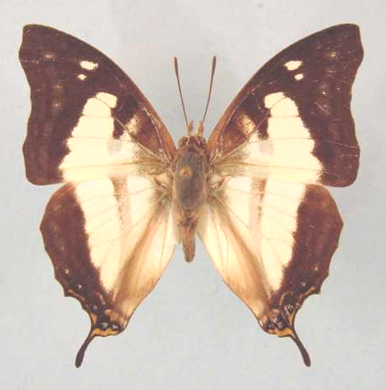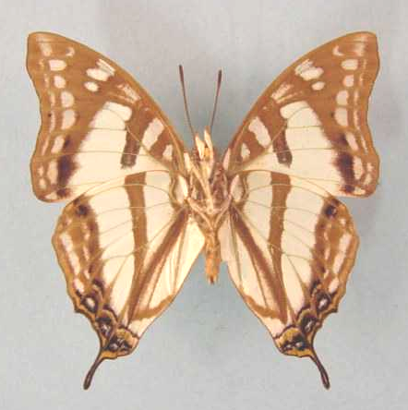

Charaxes zoolina zoolina. Male WSF. Left – upperside; right – underside. Wingspan: 48mm. Pafuri, Transvaal. 6.4.80. I.A. Coetzer. (Transvaal Museum - TM3406).

Type locality: South Africa: “Amazoulu, Port Natal”.
Diagnosis: The only species of Charaxes with distinctive seasonal forms.
Distribution: Sudan, Ethiopia, Somalia, Uganda, Rwanda, Burundi, Democratic Republic of Congo, Kenya, Tanzania, Malawi, Zambia, Angola, Mozambique, Zimbabwe, Botswana, Namibia, South Africa, Swaziland (Duke, et al., 1999), Madagascar.
Common name: Club-tailed charaxes.
Habitat: Found in a variety of habitats including, forest, woodland savanna and thornveld savanna. In Tanzania the nominate subspecies occurs from near sea-level to 2 140 m (Kielland, 1990).
Habits: The flight is not very fast and males may be found flying about a particular tree for hours on end. Both sexes are attracted to fermenting fruit and, occasionally also flowers (Pringle, et al., 1994). Sap oozing from wounds in tree trunks and branches also attracts specimens.
Flight period: All year with very distinct seasonal forms (unique among the genus). Transitional forms occur but are rare.
Early stages:

Leigh, 1903: xxii [as Charaxes neanthes; (ssp. zoolina); Durban, KwaZulu-Natal] (Proc. R. ent. Soc. Lond. 1903: xxi-xxv).
“Of all the Charaxes larvae with which I am acquainted, none equal C. neanthes in the perfection of its protective disguise. The larva when at rest upon the stem – its characteristic position during the last two stages – is so well concealed by colour and markings that it is almost impossible to detect. The small green dumpy pupae of this species exactly resemble some of our berries.”

Van Someren and Rogers, 1929: 40 (ssp. zoolina).

Clark, in Van Son, 1979: 178 (Plate 71).
“The eggs are laid singly on the surface of a leaf, and are 1 mm in diameter by 0,95 mm high. They are pale yellow when laid, darkening with time and developing a purple-brown circlet and a spot of the same colour on the micropyle. There are some 34 ribs radiating from the micropyle and extending over its flat edge and part way down the side. The larva hatches after six to eight days. The young larva eats its way out near the top and eats the discarded shell. It is 2,5-3 mm long at hatching and grows to 6 mm in six days when it moults. The second instar lasts seven days and the larva grows to 8,5 mm. The third instar lasts 10-11 days the larva growing to 12,5 mm. The fourth instar lasts 13-14 days, and the larva grows to 23 mm. The final instar is of 20 days duration, and the length of the full-grown larva is 42,5 mm. The larva rests along the stalk supporting the leaves or may sew adjacent leaves together to form a flat mat. It crawls away to feed, but returns to its mat. The markings of the body make a very good camouflage pattern. The pupa is suspended by cremastral hooks, the colour pattern provides a good camouflage, it is 17-18 mm long. The imago emerges after 14-18 days.”

Henning, S., 1989: 378 (ssp. zoolina; Northern Transvaal (sensu lato)).

Vingerhoedt and Thiry, 1997 [ssp. mafugensis; Burundi].

Larval food:
Acacia ataxacantha (Fabaceae) [Henning, S., 1989: 378].
Acacia brevispica Harms. (syn. pennata Willd.) (Fabaceae) [Van Someren and Rogers, 1929: 40].
Acacia karroo Hayne (syn. natalitia E. Mey.) (Fabaceae) [Platt, 1921. Williams, in Pringle, et al., 1994: 92 regards this record to be erroneous].
Acacia kraussiana Meissn. ex Benth. (Fabaceae) [Clark, in Van Son, 1979: 178].
Acacia natalitia (Fabaceae) [Kroon, 1999].
Acacia pentagona (Schumach.) J.D. Hook (Fabaceae) [Henning, S., 1989: 378].
Acacia schweinfurthi Brenan and Excell (Fabaceae) [Henning, S., 1989: 378].
Entada abyssinica Steud. ex A. Rich. (Fabaceae) [Gifford, 1965].
Entada spicata (E. Mey.) Presl (syn. natalensis Benth.) (Fabaceae) [Leigh, 1908: lxiv; as sp. of Entada].

Charaxes zoolina zoolina (Westwood, [1850])

Nymphalis zoolina Westwood, [1850] in Doubleday and Westwood, [1846-52]. The genera of diurnal Lepidoptera, London: 309 (1: 1-250 pp.; 2: 251-534 pp.). London.

Charaxes zoolina zoolina. Male WSF. Left – upperside; right – underside. Wingspan: 48mm. Pafuri, Transvaal. 6.4.80. I.A. Coetzer. (Transvaal Museum - TM3406).

Type locality: South Africa: “Amazoulu, Port Natal”.
Distribution: Sudan (south), Ethiopia (south), Somalia, Uganda, Kenya, Tanzania, Malawi, Zambia, Mozambique, Zimbabwe, Botswana (north), Namibia (north-east), South Africa (Limpopo Province, Mpumalanga, North West Province, KwaZulu-Natal, Eastern Cape Province), Swaziland (Duke, et al., 1999).
Specific localities:
Tanzania – Widespread (Kielland, 1990).
Zambia – Mpongwe; Mumbwa; Chismaba; Livingstone; Chipata; Lunagwa Valley; Lake Mweru (Heath, et al., 2002).
Limpopo Province – Acornhoek (Swanepoel, 1953); Legalameetse Nature Reserve (“Malta Forest”) (Swanepoel, 1953); Tubex (Swanepoel, 1953); Mokeetsi (Swanepoel, 1953); Sibasa (Swanepoel, 1953); Wyliespoort (Swanepoel, 1953); Waterpoort (Swanepoel, 1953); Saltpan (Swanepoel, 1953); Blouberg (Swanepoel, 1953).
Mpumalanga – Komatipoort (Swanepoel, 1953); Barberton (Swanepoel, 1953); Marieps Kop (Swanepoel, 1953); Lydenburg district (Swanepoel, 1953).
KwaZulu-Natal – Oribi Gorge (Swanepoel, 1953); Umkomaas (Swanepoel, 1953); Durban (Swanepoel, 1953); Empangeni (Swanepoel, 1953); Hluhluwe (Swanepoel, 1953); St Lucia Bay (Swanepoel, 1953); False Bay (Swanepoel, 1953); Mkuze (Swanepoel, 1953).
Eastern Cape Province – Bashee River (Swanepoel, 1953).
Swaziland – Mlawula N. R. (www.sntc.org.sz).

neanthes Hewitson, 1854 in Hewitson, 1851-6 (as sp. of Nymphalis). Illustrations of new species of exotic butterflies 1: 88 (124 pp.). London. South Africa: “Natal”.

obscuratus Suffert, 1904 (as ssp. of Charaxes neanthes). Deutsche Entomologische Zeitschrift, Iris 17: 123 (108-123). Tanzania: “Mhonda”.

homochroa Le Cerf, 1923 (as f. indiv. of Charaxes zoolina-neanthes). Bulletin du Muséum National d’Histoire Naturelle. Paris 29: 429 (360-367, 428-429). Mozambique: “Delagoa Bay, Lourenco-Marques”.

pallidior Rousseau-Decelle, 1938 (as f. indiv. of Charaxes neanthes). Bulletin de la Société Entomologique de France 43: 164 (161-168). Ethiopia: “Harrar (Abyssinie)”.

Charaxes zoolina betsimisaraka Lucas, 1872

Charaxes betsimisaraka Lucas, 1872. Annales des Sciences Naturelles (5) 15 (No. 22): 3 (4 pp.).
Type locality: Madagascar. Type in the Muséum national d’Histoire naturelle, Paris.
Distribution: Madagascar.

betanimena Lucas, 1872 (as sp. of Charaxes). Annales des Sciences Naturelles (5) 15 (No. 22): 3 (4 pp.). Madagascar.

andriba Ward, 1873 (as sp. of Charaxes). Entomologist’s Monthly Magazine 9: 210 (209-210). Madagascar.

relatus Butler, 1880 (as sp. of Charaxes). Annals and Magazine of Natural History (5) 5: 394 (333-344, 384-395). Madagascar.

freyi Brancsik, 1892 (as sp. of Nymphalis). Jahresheft des Naturwissenschaftlichen Vereins des Trencsiner Komitäts 13: 162 (122-167). Madagascar: “Nossibé”..

firmus Le Cerf, 1923 (as f. (?an ssp.) of Charaxes zoolina-betsimisaraka). Bulletin du Muséum National d’Histoire Naturelle. Paris 29: 429 (360-367, 428-429). Madagascar.

lambertoni Lathy, 1925 (as sp. of Charaxes). Encyclopédie Entomologique (B.3. Lepidoptera) 1: 96 (93-97). Madagascar: “Bejofo, Madagascar”.

franouxi Rousseau-Decelle, 1938 (as f. indiv. of Charaxes zoolina). Bulletin de la Société Entomologique de France 43: 165 (161-168). Madagascar: “Fôret de Lambomakandro ... environs de Tulear, côte S.-O. de Madagascar”.

Charaxes zoolina ehmckei Homeyer & Dewitz, 1882

Charaxes ehmckei Homeyer & Dewitz, 1882. Berliner Entomologische Zeitschrift 26: 382 (381-383).
Type locality: Angola: “Pungo Andongo”. Female first described by Bivar de Sousa, 1992 (Boletim da Sociedade Portuguesa de Entomologia Supplement No. 3: 531 (523-541).).
Distribution: Angola.

phanera Jordan, 1908 (as f. of Charaxes zoolina). Proceedings of the Entomological Society of London 1908: 69 (69-70). Angola: “Canhoca”.

lineata Bivar de Sousa, 1992 (as f. of Charaxes zoolina ehmckei). Boletim da Sociedade Portuguesa de Entomologia Supplement No. 3: 531 (523-541).

Charaxes zoolina mafugensis Jackson, 1956

Charaxes zoolina mafugensis Jackson, 1956. Journal of the East Africa Natural History Society 23: 67 (63-102).
Type locality: Uganda: “Kigezi District, Mafuga Forest”.
Distribution: Uganda (south-west), Rwanda, Burundi, Democratic Republic of Congo (south, east and north-east), Tanzania (north-west).
Specific localities:
Tanzania – Rumanyika Game Reserve (Congdon and Collins, 1998).

kivu Turlin, 1980 (as f. of Charaxes zoolina mafugensis). Bulletin de la Société Scientifique Naturelle (25): 16 (13-22). Rwanda.

wincka Turlin, 1980 (as f. of Charaxes zoolina mafugensis). Bulletin de la Société Scientifique Naturelle (25): 16 (13-22). Rwanda: “Forêt de Nyungwe”.

NICHETES GROUP

Charaxes nichetes Grose-Smith, 1883

Charaxes nichetes Grose-Smith, 1883. Entomologist’s Monthly Magazine 20: 58 (57-58).
Type locality: Cameroon: “Cameroons”.
Diagnosis: This species is easily identified by the absence of tails (Pringle, et al., 1994).
Distribution: Guinea, Sierra Leone, Liberia, Ivory Coast, Ghana, Chad, Nigeria, Cameroon, Gabon, Congo, Democratic Republic of Congo, Central African Republic, Uganda, Tanzania, Malawi, Mozambique, Zambia, Zimbabwe, Angola.
Common name: Manx charaxes; Water charaxes.
Habitat: Forest, low altitude woodland savanna and Brachystegia woodland. Often occurs near rivers and streams (Pringle, et al., 1994). In Tanzania ssp. pantherinus is found at altitudes of 800 to 1 600 m and ssp. leoninus from 600 to 1 000 m (Kielland, 1990). Subspecies bouchei flies in forest, ssp. leopardinus, leoninus and pantherinus in savanna, and ssp. nichetes in forest and gallery forest (Larsen, 2005a).
Habits: In West Africa this is a scarce species (Larsen, 2005a). The flight is fast. Specimens are attracted to fermenting fruit and males mud-puddle (Pringle, et al., 1994).
Flight period: Most months of the year with most emergences in spring and autumn (Pringle, et al., 1994).
Early stages:

Henning, G., 1977: 227 (ssp. leoninus; Harare (Zimbabwe)).
“Ova: Usual Charaxes shape, white, developing a brown ring if fertile. They are laid singly on the upper surface of the leaves of the foodplant. Final instar larva: Headshield green paling to greyish on the margins; horns short and slender, dark brown in colour, covered with greyish-white tubercles. The body is green with a pair of greyish-white dorso-somite spots, the dorsal mark on segment 6, and sometimes segment 8, is greyish-white and somewhat similar in shape to that of Charaxes varanes (Cramer). Lateral ridge and anal processes greyish-green.”

A.J. Duke, in Van Son, 1979: 211 (ssp. leoninus).
“I have no description of the larva as my only example died. However, I have found a pupa and this can be described as follows: brilliant shining green with wide and heavy bands of partly translucent silver. The wing-cases are heavily marked with silver, leaving only a small central green area. The abdomen has two narrow silver stripes and the head and surrounding area have silvery blotches. I expect the amount of silvery marking is a variable factor. The pupa was found hanging from the centre of a large leaf of the food-plant and was very conspicuous.”

Henning, S., 1989: 382 (ssp. leoninus).

Larval food:
Uapaca nitida Mull. Arg. (Euphorbiaceae) [Henning, G., 1977: 227 (ssp. leoninus)].
Uapaca kirkiana Mull. Arg. (Euphorbiaceae) [Henning, G., 1977: 227 (ssp. leoninus)].
Uapaca sansibarica Pax (Euphorbiaceae) [Pringle, et al., 1994: 101 (ssp. leoninus)].

Charaxes nichetes nichetes Grose-Smith, 1883

Charaxes nichetes Grose-Smith, 1883. Entomologist’s Monthly Magazine 20: 58 (57-58).
Type locality: Cameroon: “Cameroons”.
Distribution: Nigeria (south), Cameroon, Gabon, Congo, Angola (north), Democratic Republic of Congo (north), Central African Republic, Uganda (western and northern shores of Lake Victoria).
Specific localities:
Nigeria – Cross River loop (Larsen, 2005a); Oban Hills (Larsen, 2005a); Nsukka (Larsen, 2005a); Igala (Larsen, 2005a); Obudu Plateau (Larsen, 2005a); Okomu (Larsen, 2005a); Warri (H. Boersma teste Larsen, 2005a); Kaduna (R. St Leger teste Larsen, 2005a).

hamatus Dewitz, 1884 (as sp. of Charaxes). Entomologische Nachrichten. Berlin 10: 285 (285-286). Democratic Republic of Congo: “auf den 6° s.B. und zwischen dem 20 und 26° ö.L. von Greenw. Erbeutet”.

ogovensis Holland, 1886 (as sp. of Charaxes). Transactions of the American Entomological Society 13: 330 (325-332). Gabon: “Ogové River, W. Africa”.

Charaxes nichetes bouchei Plantrou, 1974

Charaxes nichetes bouchei Plantrou, 1974. Bulletin de la Société Entomologique de France 79: 128 (125-131).
Type locality: Ivory Coast: “Adiopodoumé, env. d’Abidjan, Cote d’Ivoire Sud”. Holotype (male) in the Muséum national d’Histoire naturelle, Paris.
Distribution: Sierra Leone, Liberia, Ivory Coast (south), Ghana, Nigeria (west).
Specific localities:
Sierra Leone – Freetown (Owen & Chanter, 1972).
Ivory Coast – Adiopoudoume (TL).
Ghana – Atewa Range (Joly, 2003).
Nigeria – Ilaro Forest (Larsen, 2005a).

veronicae Plantrou, 1974 (as female f. of Charaxes nichetes bouchei). Bulletin de la Société Entomologique de France 79: 129 (125-131). No locality given.

Charaxes nichetes leoninus Butler, 1895

Charaxes leoninus Butler, 1895. Proceedings of the Zoological Society of London 1895: 253 (250-270).
Type locality: Malawi: “Zomba”.
Diagnosis: Paler with lighter markings than in ssp. pantherinus (Kielland, 1990).
Distribution: Democratic Republic of Congo (Shaba), Tanzania (south), Malawi, Mozambique, Zimbabwe (east).
Specific localities:
Tanzania – Tukuyu District, north to Ulanga District (Kielland, 1990).
Mozambique – Amatongas (Pennington).
Zimbabwe – Bomponi, below the Vumba Mountains; Honde River, north of Mutare(Pringle, et al., 1994); Pungwe Gorge (R. Plowes); Chinhoyi; Mazowe; Bindura; Harare; Glenlivet; Mount Selinda; Bikita (Mullin).
Note: The subspecies leoninus Butler, 1895, pantherinus Rossoeau-Decelle, 1934 and leopardinus Plantrou, 1974 may constitute a single subspecies (Larsen, 2005a: 325).

Charaxes nichetes leopardinus Plantrou, 1974

Charaxes nichetes leopardinus Plantrou, 1974. Bulletin de la Société Entomologique de France 79: 130 (125-131).
Type locality: Ivory Coast: “Kakpin, Sud de la réserve de Bouna, Cote d’Ivoire Nord-Est”. Holotype (male) in the Muséum national d’Histoire naturelle, Paris.
Distribution: Guinea, Ivory Coast (north-east), Nigeria, Cameroon (north), Chad.
Specific localities:
Guinea – Park National du Haut Niger (Larsen, 2005a); Fouta Djalon (Larsen, 2005a); northern slopes of Nimbas (Larsen, 2005a).
Ivory Coast – Kakpin (TL).
Nigeria – Kaduna (Larsen, 2005a); Kagoro (Larsen, 2005a); Birnin Gwari (Larsen, 2005a).
Note: The subspecies leoninus Butler, 1895, pantherinus Rossoeau-Decelle, 1934 and leopardinus Plantrou, 1974 may constitute a single subspecies (Larsen, 2005a: 325).

Charaxes nichetes pantherinus Rousseau-Decelle, 1934

Charaxes nichetes pantherinus Rousseau-Decelle, 1934. Bulletin de la Société Entomologique de France 39: 234 (228-236).

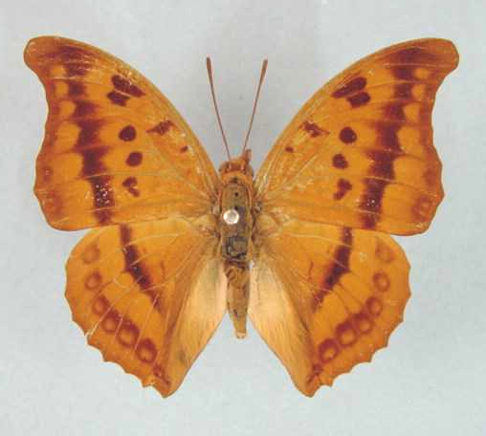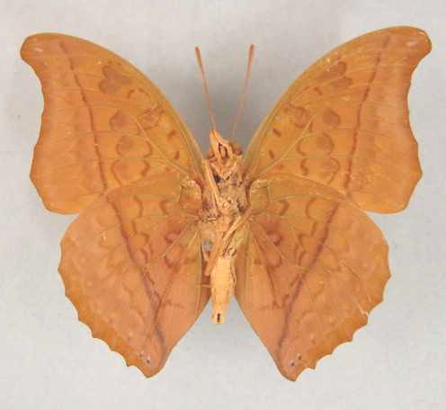

Charaxes nichetes pantherinus. Male. Left – upperside; right – underside. Wingspan: 60mm. Kitwe, Zambia. 64.04.24. A.I. Curle. (Curle Trust Collection - 122).

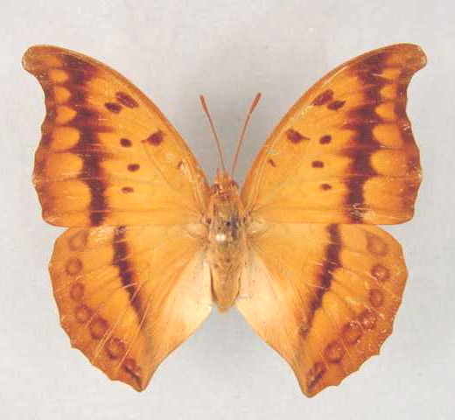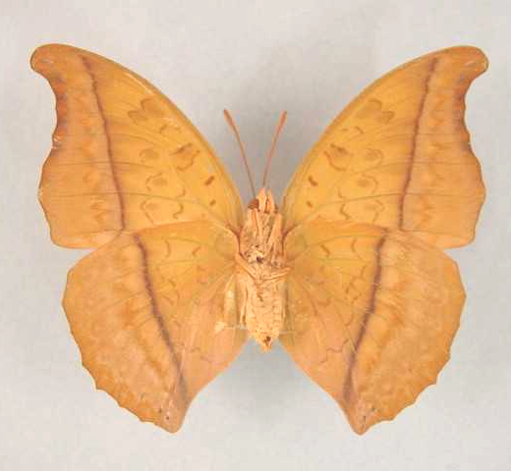

Charaxes nichetes pantherinus. Female. Left – upperside; right – underside. Wingspan: 69mm. Kitwe, Zambia. 66.04.17. A.I. Curle. (Curle Trust Collection - 124).

Type locality: Democratic Republic of Congo: “Kafakumba-Katanga, Congo belge”. Holotype (male) was in the collection of Mr G. Rousseau-Decelle, France.
Distribution: Democratic Republic of Congo (south - Lualaba), Zambia (north-east), Tanzania (north-west).
Specific localities:
Tanzania – Mpanda District; Kigoma; Gombe (Kielland, 1990).
Zambia – Ikelenge; Kasangezhi; Kamapanda; Kabompo Gorge; 50 km east of Mwinilunga; Chingola; Mufulira; Kitwe; Ndola; Rufunsa; Serenje; Kundalila Falls; Mkushi River; Musonda Falls; Kasama; Chambeshi River; near Chipata (Heath, et al., 2002).
Note: The subspecies leoninus Butler, 1895, pantherinus Rossoeau-Decelle, 1934 and leopardinus Plantrou, 1974 may constitute a single subspecies (Larsen, 2005a: 325).

Charaxes nichetes ssese Turlin & Lequeux, 2002

Charaxes nichetes ssese Turlin & Lequeux, 2002. Lambillionea 102 (1) (Tome I): 70 (69-76).
Type locality: Uganda: Ssese Islands, Lake Victoria.
Distribution: Uganda.

bugalla Turlin and Lequeux, 2002 (as form of Charaxes nichetes ssese). Lambillionea 102 (1) (Tome I): 72 (69-76).

LYCURGUS GROUP

Charaxes lycurgus (Fabricius, 1793)

Papilio lycurgus Fabricius, 1793. Entomologia Systematica emendata et aucta 3 (1): 67 (488 pp.).
Type locality: “in Africa”.
Diagnosis: Differs from C. zelica in the deeply concave margin of the forewing, the hindwing blue spots are closer to the margin and the presence of submarginal blue spots on the forewing (Kielland, 1990).
Distribution: Guinea, Sierra Leone, Liberia, Ivory Coast, Ghana, Togo, Nigeria, Cameroon, Equatorial Guinea, Gabon, Congo, Central African Republic, Angola, Democratic Republic of Congo, Sudan, Uganda, Tanzania.
Common name: Laodice untailed charaxes.
Habitat: Lowland evergreen forest and riverine forest. In Tanzania at altitudes from 800 to 1 500 m (Kielland, 1990). It occurs also in degraded habitats, such as cocoa plantations (Larsen, 2005a).
Habits: This is the commonest species in the group but is uncommon west of Ghana (Larsen, 2005a). Males fly along river beds in search of otter and bird droppings from which to feed (Kielland, 1990). Specimens come readily to fermented fruit, unlike other members of the group (Larsen, 2005a).
Early stages: Nothing published.
Larval food:
Pterocarpus santlinoides L’Herit. ex DC. (Fabaceae) [Vuattoux and Blandin, 1977 (Ivory Coast)].
Paullinia pinnata L. (Sapindaceae) [Vuattoux and Blandin, 1977 (Ivory Coast)].
Albizia zygia (DC.) J.F. Macbride (Fabaceae) [Henning, S., 1989: 385].
Lonchocarpus cyanescens (Schum. & Thonn.) Benth. (Fabaceae) [Henning, S., 1989: 385].
Dalbergia species (Fabaceae) [Larsen, 2005a].
Millettia species (Fabaceae) [Larsen, 2005a].
Dichapetalum species (Dichapetalaceae) [Larsen, 2005a].
Trachyphrynium species (Marantaceae) [Larsen, 2005a].

Charaxes lycurgus lycurgus (Fabricius, 1793)

Papilio lycurgus Fabricius, 1793. Entomologia Systematica emendata et aucta 3 (1): 67 (488 pp.).
Type locality: “in Africa”.
Distribution: Guinea, Sierra Leone, Liberia, Ivory Coast, Ghana, Togo, Nigeria (west).
Specific localities:
Ivory Coast – Bossematie (H. Fermon teste Larsen, 2005a).
Ghana – Atewa Range (Joly, 2003).
Nigeria – Warri (H. Boersma teste Larsen, 2005a).

laodice Drury, 1782 (as sp. of Papilio). Illustrations of Natural History 3: index et 34 (76 pp.). London. “Coast of Africa, near Sierra Leone”. [Invalid; junior primary homonym of Papilio laodice Pallas, 1771 [Nymphalidae].]

nesiope Hewitson, 1854 in Hewitson, 1851-6 (as sp. of Nymphalis). Illustrations of new species of exotic butterflies 1: 88 (124 pp.). London. Sierra Leone.

Charaxes lycurgus bernardiana Plantrou, 1978

Charaxes laodice bernardiana Plantrou, 1978. Annales de la Société Entomologique de France (N.S.) 14: 526 (515-533).
Type locality: Congo: “Brazzaville, R.P. du Congo”. Holotype (male) in the Muséum national d’Histoire naturelle, Paris.
Distribution: Nigeria (north and east), Cameroon, Gabon, Equatorial Guinea (Bioko), Congo, Central African Republic, Angola (north), Democratic Republic of Congo, Sudan (south), Uganda (west), Tanzania (eastern shores of Lake Tanganyika).
Specific localities:
Nigeria – Kagoro Forest (Larsen, 2005a).
Cameroon – Korup (Larsen, 2005a).
Congo – Brazzaville (TL).
Tanzania – North-west Mpanda District; Kigoma; Gombe Stream National Park (Kielland, 1990).

Charaxes zelica Butler, 1869

Charaxes zelica Butler, 1869. Entomologist’s Monthly Magazine 6: 28 (28-29).
Type locality: Ghana: “West Africa (Ashanti)”. Holotype (male) in the Natural History Museum, London.
Diagnosis: Differs from the related C. lycurgus in the straighter hindwing distal border (Kielland, 1990).
Distribution: Guinea, ?Sierra Leone, Ivory Coast, Ghana, Nigeria, Cameroon, Gabon, Congo, Central African Republic, Democratic Republic of Congo, Angola, Sudan, Uganda, Kenya, Tanzania.
Common name: Zelica untailed charaxes.
Habitat: Forest, at altitudes between 800 and 1 000 m (Henning, 1989). Blandin et al. (1975) record it in dense savanna in Ivory Coast. In Tanzania ssp. toyoshimai occurs at altitudes from 800 to 1 500 m (Kielland, 1990).
Habits: Nearly as rare as C. porthos (Larsen, 2005a). Males patrol stream beds in search of otter droppings. Individuals, as for those of C. porthos, are rarely attracted by fermenting fruit (Kielland, 1990; (Larsen, 2005a).
Early stages: Nothing published.
Larval food: Nothing published.

Charaxes zelica zelica Butler, 1869

Charaxes zelica Butler, 1869. Entomologist’s Monthly Magazine 6: 28 (28-29).
Type locality: Ghana: “West Africa (Ashanti)”. Holotype (male) in the Natural History Museum, London.
Distribution: Guinea, ?Sierra Leone, Ivory Coast, Ghana, Nigeria (west).
Specific localities:
Guinea – Nimba (Larsen, 2005a).
Ivory Coast – Bossematie (H. Fermon teste Larsen, 2005a).
Ghana – Ashanti (TL); Atewa Range (Joly, 2003).

Charaxes zelica depuncta Joicey & Talbot, 1921

Charaxes zelica depuncta Joicey & Talbot, 1921. Bulletin of the Hill Museum, Witley 1: 68 (40-166).
Type locality: Uganda: “Uganda, Mabira Forest”. Holotype (male) in the Natural History Museum, London.
Distribution: Sudan (south), Uganda, Kenya (west).
Specific localities:
Uganda – Mabira Forest (TL).

Charaxes zelica rougeoti Plantrou, 1978

Charaxes zelica rougeoti Plantrou, 1978. Annales de la Société Entomologique de France (N.S.) 14: 521 (515-533).
Type locality: Central African Republic: “Bangui, E.C.A.”. Holotype (male) in the Muséum national d’Histoire naturelle, Paris.
Distribution: Nigeria (east), Cameroon, Gabon, Congo, Central African Republic, Democratic Republic of Congo (Ubangi, Mongala, Tshopo, Kwango, Lualaba), Angola (north).
Specific localities:
Central African Republic – Bangui (TL).

Charaxes zelica toyoshimai Carcasson, 1964

Charaxes zelica toyoshimai Carcasson, 1964. Journal of the East Africa Natural History Society & Coryndon Museum 24 (4): 63 (62-67).
Type locality: Tanzania: “Makuyu, Kigoma, Tanganyika”. Holotype (male) in the Natural History Museum, London.
Distribution: Tanzania (north-west).
Specific localities:
Tanzania – Ntakatta Forest; Kasye Forest; Mihumu Forest (Kielland, 1990).

Charaxes porthos Grose-Smith, 1883

Charaxes porthos Grose-Smith, 1883. Entomologist’s Monthly Magazine 20: 57 (57-58).
Type locality: Cameroon: “Camaroons”.
Distribution: Guinea, Sierra Leone, Ivory Coast, Ghana, Nigeria, Cameroon, Central African Republic, Gabon, Congo, Democratic Republic of Congo, Uganda, Tanzania.
Misattributed to the Kenya butterfly fauna on numerous occasions (Congdon & Collins, 1998).
Common name: Porthos untailed charaxes.
Habitat: Lowland evergreen forest (nominate subspecies); drier forests (ssp. gallayi) (Larsen, 2005a).
Habits: Subspecies gallayi is very rare and the nominate subspecies is scarce (Larsen, 2005a). Attracted to fermented bananas (Congdon and Collins, 1998).
Early stages: Nothing published.
Larval food: Nothing published.

Charaxes porthos porthos Grose-Smith, 1883

Charaxes porthos Grose-Smith, 1883. Entomologist’s Monthly Magazine 20: 57 (57-58).
Type locality: Cameroon: “Camaroons”.
Distribution: Nigeria (east), Cameroon, Central African Republic, Gabon, Congo, Democratic Republic of Congo (Ubangi, Mongala, Uele, Tshopo, Kinshasa, Sankuru).
Specific localities:
Nigeria – Oban Hills (Larsen, 2005a).

midas Staudinger, 1891 (as sp. of Charaxes). Deutsche Entomologische Zeitschrift, Iris 4: 135 (61-157). Cameroon: “Barombi-Station im Hinterlande von Kamerun”.

dunkeli Röber, 1939 (as sp. of Charaxes). Entomologische Rundschau 56: 357 (357-358). Cameroon: “Kamerun”.

Charaxes porthos dummeri Joicey & Talbot, 1922

Charaxes porthos dummeri Joicey & Talbot, 1922. Bulletin of the Hill Museum, Witley 1: 338 (335-338).
Type locality: Uganda: “Mabera Forest”.
Diagnosis: Male of this subspecies characterized, on the forewing upperside, by an indistinct blue spot at the end of the cell (Congdon and Collins, 1998).
Distribution: Uganda, Tanzania (north-west). [Reported from north-west Kenya by Henning (1989) but apparently a misidentification (Congdon and Collins, 1998)].
Specific localities:
Tanzania – Muenene Forest (common); Minziro Forest (scarce) (Congdon and Collins, 1998).

Charaxes porthos gallayi van Someren, 1968

Charaxes porthos gallayi van Someren, 1968. Bulletin de l’Institut Fondamental d’Afrique Noire 30: 223 (221-225).
Type locality: Ivory Coast: “Ivory Coast, Divo”. Holotype (male) in the Muséum national d’Histoire naturelle, Paris.
Distribution: Guinea, Sierra Leone, Ivory Coast, Ghana, Nigeria (west).
Specific localities:
Guinea – near Conakry, Nimba (Larsen, 2005a).
Ivory Coast – Divo (TL); Banco (H. Warren-Gash teste Larsen, 2005a).
Ghana – Atewa Range (Joly, 2003).
Nigeria – Olokemeji near Ibadan (Larsen, 2005a).
Nigeria – Warri (H. Boersma teste Larsen, 2005a).

Charaxes porthos katangae Rousseau-Decelle, 1931

Charaxes katangae Rousseau-Decelle, 1931. Bulletin de la Société Entomologique de France 1931: 87 (87-90).
Type locality: Democratic Republic of Congo: “Katanga (Congo belge)”. Holotype (male) in the collection on Mr. I. Grahame.
Distribution: Democratic Republic of Congo (Lualaba).

Charaxes doubledayi Aurivillius, 1899

Charaxes doubledayi Aurivillius, 1899 in Aurivillius, 1898-9. Kungliga Svenska Vetenskapakademiens Handlingar 31 (5): 244 (1-561).
Type locality: Sierra Leone: “Sierra Leona”; Ghana: “Ashanti”; Togo; Nigeria: “Old Calabar”; Cameroon: “Kamerun”; Gabon: “Ogowe”.
Distribution: Sierra Leone, Ivory Coast, Ghana, Togo, Nigeria (south and Cross River loop), Cameroon, Equatorial Guinea (Bioko), Congo, Central African Republic, Democratic Republic of Congo, Tanzania (west).
Specific localities:
Sierra Leone – Tiwai Island (Larsen, 2005a).
Ivory Coast – Mt Tonkoui (H. Warren teste Larsen, 2005a); Yeale (H. Warren-Gash teste Larsen, 2005a).
Ghana – Atewa Range (Joly, 2003).
Common name: Doubleday’s untailed charaxes.
Habitat: Lowland evergreen forest.
Habits: A very rare butterfly (Larsen, 2005a).
Early stages: Nothing published.
Larval food: Nothing published.

viridis Röber, 1936 (as ab. of Charaxes doubledayi). Entomologische Rundschau 53: 576 (575-580). No locality given.

Charaxes mycerina (Godart, 1824)

Nymphalis mycerina Godart, 1824 in Latreille and Godart, [1819], [1824]. Encyclopédie Méthodique. Histoire Naturelle [Zoologie] 9 Entomologie: 369 (1-328 [1819], 329-828 [1824]). Paris.
Type locality: No locality given (probably Sierra Leone (Larsen, 2005a)).
Distribution: Sierra Leone, Liberia, Ivory Coast, Ghana, Nigeria, Cameroon, Central African Republic, Congo, Gabon, Democratic Republic of Congo, Equatorial Guinea.
Common name: Mycerina untailed charaxes.
Habitat: Lowland evergreen forest.
Habits: An uncommon species (Larsen, 2005a).
Early stages: Nothing published.
Larval food: Nothing published.

Charaxes mycerina mycerina (Godart, 1824)

Nymphalis mycerina Godart, 1824 in Latreille and Godart, [1819], [1824]. Encyclopédie Méthodique. Histoire Naturelle [Zoologie] 9 Entomologie: 369 (1-328 [1819], 329-828 [1824]). Paris.
Type locality: No locality given.
Distribution: Sierra Leone, Liberia, Ivory Coast, Ghana, Nigeria (west).
Specific localities:
Sierra Leone – Freetown (Owen & Chanter, 1972).
Ghana – Atewa Range (Joly, 2003).

Charaxes mycerina nausicaa Staudinger, 1891

Charaxes nausicaa Staudinger, 1891. Deutsche Entomologische Zeitschrift, Iris 4: 137 (61-157).
Type locality: Cameroon: “Barombi-Station, im Hinterlande von Kamerun”.
Distribution: Nigeria (east), Cameroon, Central African Republic, Congo, Gabon, Democratic Republic of Congo, Equatorial Guinea (Bioko Island).
Specific localities:
Nigeria – Oban Hills (Larsen, 2005a).
Cameroon – Korup (Larsen, 2005a).

vietti Plantrou, 1978 (as ssp. of Charaxes mycerina). Annales de la Société Entomologique de France (N.S.) 14: 517 (515-533). Central African Republic: “Bangui, R.C.A.”.

TAXA NOT IN HENNING, 1989

Charaxes amandae Rydon, 1989

Charaxes amandae Rydon, 1989. Lambillionea 89: 64 (62-67).
Type locality: Sudan: “Southern Sudan, Acholi Mts., Yambio, ex coll. N. Venters.” Holotype in NHM, London.
Distribution: Sudan. Known only from the type locality.
Habitat:
Early stages: Nothing published.
Larval food: Nothing published.

Charaxes bernardii Minig, 1978

Charaxes bernardii Minig, 1978. Bulletin de la Société Entomologique de France 82: 149 (145-150).
Type locality: Central African Republic: “Bangui”.
Distribution: Central African Republic.
Habitat:
Early stages: Nothing published.
Larval food: Nothing published.

Charaxes carteri Butler, 1881

Charaxes carteri Butler, 1881. Entomologist’s Monthly Magazine 18: 108 (107-108).
Type locality: Ghana: “Accra”.
Distribution: West Africa (Sierra Leone, Ghana).
Habitat:
Early stages: Nothing published.
Larval food: Nothing published.
Note: Treated by Henning (1989: 278) as a male form of Charaxes etheocles etheocles (Cramer).

fulgens Rothschild, 1900 in Rothschild and Jordan, 1900 (as female f. of Charaxes etheocles etheocles). Novitates Zoologicae 7: 487 (287-524). Sierra Leone. [Treated by Henning (1989: 278) as a female form of Charaxes etheocles etheocles (Cramer).

Charaxes dubiosus Röber, 1936

Charaxes dubiosus Röber, 1936. Entomologische Rundschau 53: 576 (575-580).
Type locality: Cameroon: “Süd Kamerun (Lolodorf)”.
Distribution: Cameroon. Of doubtful status (Ackery, et al., 1995: 441).
Habitat:
Early stages: Nothing published.
Larval food: Nothing published.

Charaxes ephyra Godart, 1824

Charaxes ephyra Godart, 1824 in Latreille and Godart, [1819], [1824]. Encyclopédie Méthodique. Histoire Naturelle [Zoologie] 9 Entomologie: 355 (1-328 [1819], 329-828 [1824]). Paris.
Type locality: “De la côte occidental d’Afrique”.
Distribution: West Africa.
Habitat:
Early stages: Nothing published.
Larval food: Nothing published.
Note: Treated by Henning (1989: 277) as a junior synonym of Charaxes etheocles etheocles (Cramer).

alladinus Butler, 1869 (as sp. of Charaxes). Cistula Entomologica 1: 5 (1-16). No locality given. [Treated by Henning (1989: 278) as a female form of Charaxes etheocles etheocles (Cramer), and spelt as alladinis.].

Charaxes galleyanus Darge & Minig, 1984

Charaxes galleyanus Darge & Minig, 1984. Bulletin de la Société des Sciences Naturelles (44): 7 (7-10).
Type locality: Congo: “Congo: Brazzaville”.
Distribution: Congo (in the vicinity of Brazzaville).
Habitat:
Early stages: Nothing published.
Larval food: Nothing published.

styx Darge and Minig, 1984 (as female f. of Charaxes galleyanus). Bulletin de la Société des Sciences Naturelles (44): 8 (7-10). Congo: “Congo: Brazzaville”.

Charaxes gerdae Rydon, 1989

Charaxes gerdae Rydon, 1989. Lambillionea 89: 121 (121-124).
Type locality: Tanzania: “Mpanda, Sibweza”. Female described by Bouyer (2002: 11).
Diagnosis: Close to C. fionae but smaller; hind wing submarginal green line less prominent (Kielland, 1990).
Distribution: Tanzania (west ), Democratic Republic of Congo (Katanga; Bouyer, 2002).
Specific localities:
Democratic Republic of Congo – Katanga (Bouyer, 2002).
Tanzania – From Sibweza in Mpanda to Malagarazi River in Kigoma; Biharamulo (Kielland, 1990).
Habitat: Brachystegia woodland, from 900 to 1 400 m (Kielland, 1990).
Early stages: Nothing published.
Larval food: Nothing published.

Charaxes matakall Darge, 1985

Charaxes matakall Darge, 1985. Bulletin de la Société des Sciences Naturelles (47): 11 (9-15).
Type locality: Congo: “Matakall (République Populaire du Congo)”.
Distribution: Congo, Democratic Republic of Congo.
Habitat:
Early stages: Nothing published.
Larval food: Nothing published.

fabiennae Darge, 1985 (as male f. of Charaxes matakall). Bulletin de la Société des Sciences Naturelles (47): 13 (9-15). Congo: “Matakall (République Populaire du Congo)”.

franceoisixavieri Darge, 1985 (as male f. of Charaxes matakall). Bulletin de la Société des Sciences Naturelles (47): 13 (9-15). Congo: “Matakall (République Populaire du Congo)”.

collinsianus Darge, 1985 (as male f. of Charaxes matakall). Bulletin de la Société des Sciences Naturelles (47): 13 (9-15). Congo: “Matakall (République Populaire du Congo)”.

smaragdaliformis Darge, 1985 (as female f. of Charaxes matakall). Bulletin de la Société des Sciences Naturelles (47): 13 (9-15). Congo: “Matakall (République Populaire du Congo)”.

Charaxes nicati Canu, 1991

Charaxes nicati Canu, 1991. Bulletin de la Societe Sciences Nat No. 72: 23 (22-23).
Type locality: Comoro Islands.
Distribution: Comoro Islands.
Habitat:
Early stages: Nothing published.
Larval food: Nothing published.

Charaxes phenix Turlin & Lequeux, 1993

Charaxes phenix Turlin & Lequeux, 1993. Lambillionea 93 (1) (Tome II): 107 (107-113).
Type locality: Tanzania: “Tamota, Kilindi forest, Mts Nguu, Nord Nguru Mountains district de Handeni, 1000 m, Tanzania; XI.1991.” Holotype in MNHN, Paris.
Distribution: Tanzania.
Habitat:
Early stages: Nothing published.
Larval food: Nothing published.

Charaxes phenix phenix Turlin & Lequeux, 1993

Charaxes phenix Turlin & Lequeux, 1993. Lambillionea 93 (1) (Tome II): 107 (107-113).
Type locality: Tanzania: “Tamota, Kilindi forest, Mts Nguu, Nord Nguru Mountains district de Handeni, 1000 m, Tanzania; XI.1991.” Holotype in MNHN, Paris.
Distribution: Tanzania (Nguu Mountains).

Charaxes phenix daniellae White, 1996

Charaxes phenix daniellae White, 1996. Lambillionea 96 (Numero Special): 50 (49-51).
Type locality: Tanzania: “Mwanihana forest, Sanje, Ifakara, Tanzania. 2000 m. 8th April 1981. Leg. J. Kielland”. Holotype (female) in the author’s collection. Described from a single female but according to Roger White (pers. comm., 2003) Steve Collins has additional specimens, both males and females.
Diagnosis: The female differs from that of the nominate subspecies in the following respects: smaller; forewing less acuminate; hindwing rounder; tails shorter, thicker and with rounded ends; forewing upperside white band wider; hindwing upperside ochreous band wider and extended distally; forewing underside with the white in area 1 extended basad (in nominate subspecies only the discal part of area 1 is white); hindwing underside discal band much paler (Congdon and Collins, 1998).
Distribution: Tanzania (Uzungwa Range).

Charaxes prettejohni Collins, 1990

Charaxes prettejohni Collins, 1990 in Kielland, 1990. Butterflies of Tanzania 338 (363 pp.). Melbourne.
Type locality: Tanzania: “Rubondo Island, 8/89”. Holotype male in the Natural History Museum, London.
Original description:
“Holotype Male. Forewing length 37 mm (bigger than cedreatis). The recto surface is black suffused basally with a greenish tinge. The forewing costa has a well-developed bluish-green spot in the cell, a further spot on the radial branch of the subcosta veins, and two less well-developed subapical spots which are more palish and correspond to similar marks in the 3 known forms of 7 females. Hindwing has a well-defined margin tinged reddish in the median veins and greenish olive anally, a well-developed line of submarginal white spots as in cedreatis and a line of submarginal green lunules. The underside is strongly ochreous brown in the holotype male and in ten other males examined. The [fe]males are of 3 forms: A dewitzi-like form. The specimens are enormous, [fe]male forewing length 47 mm (2 specimens). The median forewing band is bright purplish-blue with a large hind wing bluish median patch. B vetula-like (4 specimens examined), where the forewing has a large white discal band and blue hindwing median band. C protocedreatis-like (4 specimens examined) where the blue patches are replaced by tawny olive, one specimen has the outer edge tinged purple, and one female vetula-like has the scales mixed olive and blue.”
Etymology: Named for Mike Prettejohn.
Distribution: Tanzania (north-west - Geita district).
Specific localities:
Tanzania – Rubondo Island, Geita district (TL).
Habitat:
Early stages: Nothing published.
Larval food: Nothing published.

Charaxes schiltzei Bouyer, 1991

Charaxes schiltzei Bouyer, 1991. Lambillionea 91 (4) (Tome I): 314, 317 (313-317).
Type locality: Rwanda: “Nyungwe”.
Distribution: Democratic Republic of Congo (Kivu) (R. White, pers. comm., 2003), Uganda, Rwanda, Burundi.
Habitat:
Early stages: Nothing published.
Larval food: Nothing published.

Charaxes teissieri Darge & Minig, 1984

Charaxes teissieri Darge and Minig, 1984. Bulletin de la Société des Sciences Naturelles (44): 8 (7-10).
Type locality: Congo: “Congo: Brazzaville”.
Distribution: Congo (Brazzaville region).
Habitat:
Early stages: Nothing published.
Larval food: Nothing published.

obliteratus Darge and Minig, 1984 (as female f. of Charaxes teissieri). Bulletin de la Société des Sciences Naturelles (44): 8 (7-10). Congo: “Congo: Brazzaville”.

Charaxes viossati Canu, 1991

Charaxes viossati Canu, 1991. Bulletin de la Societe Sciences Nat No. 72: 22 (22-23).
Type locality: Comoro Islands.
Distribution: Comoro Islands.
Habitat:
Early stages: Nothing published.
Larval food: Nothing published.

Charaxes virescens Bouyer, 1991

Charaxes virescens Bouyer, 1991. Lambillionea 91 (4) (Tome I): 315, 317 (313-317).
Type locality: Democratic Republic of Congo: “Shaba, Kafakumba”.
Distribution: Democratic Republic of Congo (Shaba).
Habitat:
Early stages: Nothing published.
Larval food: Nothing published.

Charaxes zambeziensis Henning & Henning, 1994

Charaxes zambeziensis Henning & Henning, 1994. In: Pringle, Henning, and Ball [eds]. Pennington’s butterflies of southern Africa 2nd edition: 100 (800pp.). Struik-Winchester, South Africa.
Type locality: Zimbabwe: “Zimbabwe, Victoria Falls, 26 Dec. 1974, I. Willem.” Described from a single male and female. Holotype (female) in the Transvaal Museum, Pretoria.
Diagnosis: Closest to C. brainei but, in the male, the wings are slightly broader, the underside is reddish brown with little sheen, and the inner tail is longer than the outer one. The female has smaller, more diffuse white spots on the upperside, which are partially obscured by strong blue scaling covering more than half of the base of the wings (Pringle, et al., 1994).
Distribution: Zimbabwe. Known only from the type locality.
Common name: Zambezi charaxes.
Habitat: Specimens are attracted to fermenting elephant dung (Pringle, et al., 1994).
Flight period: So far it has been recorded in February and December.
Early stages: Nothing published.
Larval food: Nothing published.

